On-board Process Document

*[Note: The following template is provided for use with all ADC systems development projects. Text enclosed in square brackets and displayed in blue italics (style=InfoBlue) is included to provide guidance to the author and should be deleted before publishing the document. A paragraph entered following this style will automatically be set to normal (style=Body Text).]*

*[To customize automatic fields (which display a gray background when selected), select File>Properties and replace the Title, Subject and Company fields with the appropriate information for this document. After closing the dialog, automatic fields may be updated throughout the document by selecting Edit>Select All (or Ctrl-A) and pressing F9, or simply click on the field and press F9. This must be done separately for Headers and Footers. Alt-F9 will toggle between displaying the field names and the field contents. See Word help for more information on working with fields.*

*The following data is stored in the corresponding fields:*

*Client Name: Custom.Client*

*Project Name: Custom.Project*

*Author: Summary.Author*

*Approver Custom.Checked by*

*Version Custom.Disposition]*

**Document Control**

**Revision History**

|  |  |  |  |
| --- | --- | --- | --- |
| **Date** | **Version** | **Author** | **Description** |
| 24-Feb-2017 | 0.1 | Amrita/Divya | Initial Draft |
| 1-Mar-2017 | 0.2 | Amrita |  |
| 12-Apr-2017 | 0.3 | Divya |  |
| 28-May-2017 | 0.4 | Amrita |  |
| 1-Jul-2017 | 0.5 | Divya |  |
| 5-Sep-2017 | 0.6 | Divya/Amrita |  |
| 6-Oct-2017 | 0.7 | Amrita/Divya |  |
| 3-Nov-2017 | 08 | Divya |  |

**Table of Contents**

1. Introduction and Tagging 4

2. Access Providing Process 4

2.1. Local Project Share location access 4

*2.2. Mobile Pass access* 4

*2.3. Ikea User Id Creation and VDI access* 5

*2.4. Idesk access* 5

*2.5. Visibility to application group* 5

*2.6. Application access/Granting Role* 5

3. Training Process 6

3.1 Capgemini trainings 6

3.2 Retail over view 6

3.3 Application over view 6

3.4 Wiki trainings 6

4. Application Set Up Process 6

4.1 Installing the Software’s 6

4.2 Setting up tools 6

4.3 Code set up 7

5. Ticket allocation process 7

6. Shift and Support Handover Process 7

7. Daily Stand Up Updates 8

8. Incident Management Process 8

9. Problem management Process 8

10. FMA maintaining process. 9

11. Links and Responsibilities. 9

# Introduction and Tagging

Introduction to team and team member is made on the first day of joining. Process of filling personal information and official details are done as per Capgemini rules.

After proper approval project tagging is done and fallowing set of actions are initiated

Work Location/Seat Allocation

System Allocation

VPN and Mobile Pass

Admin Rights in laptop (for USB port)

Note: Respective link is present is the document.

# Access Providing Process

Note: Respective link is present is the document.

## 2.1. Local Project Share location access

Local Project share location will have required projects documents like overview documents, functionality specification document, project training documents, Sop documents, any project activity information, reports, project process trackers.

Request is raised by PM to Admin

Enables the access to Local Project location

Admin process the request

## 2.2. Mobile Pass access

Mobile pass access enables to access the Capgemini network outside the organization. Which enables the 24/7 support

Mobile pass enabler link is passed to individual’s mail along with steps document

Ticket will be passed to N+1 for approval

Request ticket is created in Service Desk by individual

## 2.3. Ikea User Id Creation and VDI access

Ikea User id is created along with Ikea mail id. Ikea VDI access enables the access to IKEA application network. Individual VDI is created per team member. Which will have required infrastructure to perform the application set up.

VDI password is shared to N+1 and same will be shared to member

After the approval VDI is crated

Request is raised by PM to IKEA Manger

## 2.4. Idesk access

Service request is raised to get Idesk Access. Also one more request is raised for application group access.

## 2.5. Visibility to application group

Service request is raised for application group access. Which will give the visibility and read, write access.

## 2.6. Application access/Granting Role

A separate request is raised for granting specific role and also the required access to different application tools by specifying the tools/application specification.

Request format will specify all the information

After the approval , application set up can be initiated

Request is raised by TL/PM in Service desk.

Application request Example Template:

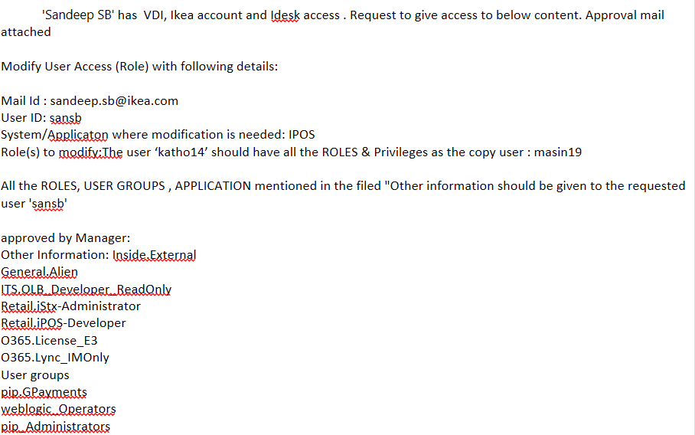

# Training Process

Note: Respective link is present is the document.

## 3.1 Capgemini trainings

Different business oriented training will be held in Capgemini my learning under every ones account and will be communicated through mail for completion. This also will be ensured by N+1 and reminded in daily dstum.

## 3.2 Retail over view

Periodic retail overview sessions are given from experienced person to new joiners. Also encouraged to attend the organization retails over view sessions.

## 3.3 Application over view

Application overview sessions are given from experienced person to new joiners and also documents and recorded videos are shared.

## 3.4 Wiki trainings

Ikea Wiki guidelines are taken care as part of ticket solving and investigation process.

# Application Set Up Process

Note: Respective link is present is the document.

## 4.1 Installing the Software’s

Different set of application, software and tools are installed using software catalogue which will raising a ticket in service desk

Placed order will create on ticket in service desk. And request will be processed

Search for the software and place order.

GO to Software catalogue in VDI

## 4.2 Setting up tools

For the issue investigation certain set of tools must be set up. Tools credentials will be present in SOP documents

Respective credentials will be set up using SOP document

Test will be made to check if the tools are functioning

After the software installation, set up will be made

## 4.3 Code set up

Clear case is downloaded from the software catalogue and code view is created. SOP document is present for setup in clear quest.

# Ticket allocation process

Note: Respective link is present is the document.

Ticket allocation is the process of assigning the ticket in daily basis. Every day new ticket is pulled from the idesk with respect to application and assignment is made to the team member. The tickets are worked based on SLA.

Sending the report to team members and ticket will be addressed in SLA

Assigning the Ticked based on the priority.

Pulling report from Idesk

# Shift and Support Handover Process

Shift handover is the process where the oncall Mobile and data card will be handed over to the next on Call member on rotation manner. Application has 24/7 support

1. Shift Planning will be done 2 months ahead and placed in below location.

\\ntblrfs001\IKEA$\iPOS\02 Resources\01 Team Calendar\2017

1. Each shift handover will be done with proper communication over mail.
2. The process of handling the ticket is part of application training.

# Daily Stand Up Updates

Daily stand up meeting will be handled and day to day activity status will be updated. Below is the link

\\ntblrfs001\IKEA$\iPOS\DSTUM\2017

# Incident Management Process

* Incident management is the part of application training process.
* Each incident is handled with respect to SLA
* Daily/Weekly/Monthly report will be created for different trend analysis and as part of Incident traction under

\\ntblrfs001\IKEA$\iPOS\05 Reports

* Biweekly report is also part of Incident Mangement process where the incident trend , ongoing activity will be showcased to client in the form of PPT

\\ntblrfs001\IKEA$\iPOS\05 Reports\Bi-Weekly Reports

# Problem management Process

Problem Management focuses on

1) Identifying and eliminating the root cause(s) of isolated or recurring incidents (reactive Problem Management)

2) Potential incidents (proactive Problem Management).

Which will directly improve the quality of our products and IT Services.

* Re-occurring incidents,
* A critical/MBCI incident
* A proactive measure
* The investigation of an error in a service.

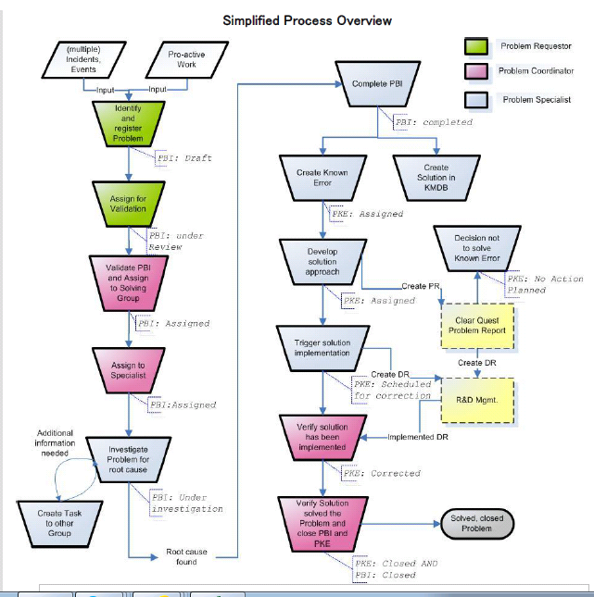

# FMA maintaining process.

Failure more analysis is made for each type of issue reported to iPOS by defining a unique string. This string is used to link to the each incident having similar type of issue in individuals FMA sheet. These sheets is useful in identifying the trend of incidents and also makes use in solving the issue on priority.

# Links and Responsibilities.

All the respective links for each of the process mentioned above is documented in excel attached.

