

**Mobile Application Development**

**W2021 MAD400-75**

**IOS DEVELEOPMENT**

**ASSIGNMENT 1**

**PART-2**

***Submitted By*:**

**DIVYA BASAVALA**

**STUDENT ID: - A00117731**

***Submitted To*:**

**Prof. MANHAR KAPOOR**

**XCode:**

XCode is Apple's fused improvement environment (IDE) that you use to create applications for Apple things including the iPad, iPhone, Apple Watch, and Mac. XCode offers gadgets to manage your entire progression work measure—from making your application, to testing, improving, and submitting it to the App Store.

The XCode interface joins code adjusting, UI plan, asset the board, testing, and investigating inside a lone workspace window. The window reconfigures its substance as you work. For example, select a record in one district, and an appropriate article administrator opens in another space. Select a picture or UI thing, and its documentation appears in a nearby sheet.

You can focus in on an endeavour by showing exactly what you need, for instance, simply your source code or simply your UI plan. Then again you can work with your code and UI plan one close to the next. You can moreover change your present condition by opening various windows and different tabs per window.

XCode, all through the long haul, has made a lot of striking new development, and the invigorated transformations are throughout equipped with all of the features that are required. The essential lingos used with XCode are Swift, Objective-C, C, and C++. In any case, XCode maintains various tongues. It maintains C, C++, Objective-C, Objective-C++, Java, AppleScript, Python, Ruby, Rez, and Swift source code with a combination of programming models, including yet not limited to Cocoa, Carbon, and Java.

Speedy is a mind blowing and intuitive programming language for macOS, iOS, WATCHOS and past. Fast fuses current features that the originators love.

Speedy is a generally helpful, multi-perspective, requested programming language made by Apple Inc. for iOS, IPADOS, macOS, WATCHOS, TVOS, and Linux. Speedy is proposed to work with Apple's Cocoa and Cocoa Touch structures and the huge gathering of existing Objective-C code created for Apple things.

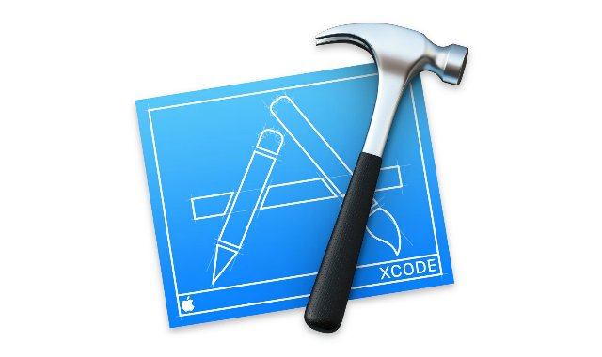

**how to install XCode:**

XCode is an IDE that is used to make applications for different working structures. As we presumably know, we have different programming gadgets and systems that can be used to make applications for working structures like Windows and Linux. On the uncommonly another hand, with respect to making Mac applications, it is everything except a basic work. We can without a very remarkable stretch present any item gadget on a functioning system like Windows to make applications on it. However, Mac requires SDK that is XCode. This is a phase that can be used to make applications on Mac or iOS. In this post, we will reveal to you the most ideal approach to present XCode on Windows PC.

Before installing we need to check our pc as follows:

Mac OS X Virtual machine

Intel processor with twofold focus dependability

Gear virtualization

XCode application present pack

Memory of the system with fundamentally 2GB

Here you will become acquainted with how you can introduce the bundle to your virtual machine to get the establishment of XCode finished. You can download the most recent XCode application bundle from the authority website of Apple. All you need is going to the XCode site, putting your Apple ID, and downloading the bundle. Presently in case you are prepared for the establishment cycle, view this interaction.

Stage 1: You should download VirtualBox on your Windows OS running machine. You can without an entirely amazing stretch download this contraption from the force site page of VirtualBox.

Stage 2: After downloading VirtualBox on your framework, get OSX Mavericks ISO as a virtual machine.

Stage 3: Now open the present VirtualBox on your framework. On the upper left corner, you will see the new choice. Snap on it.

Stage 4: Here you can make a virtual machine on your design. You should enter the Name as OSX, Type as Mac OS X and Version as Mac OS X (32 digit).

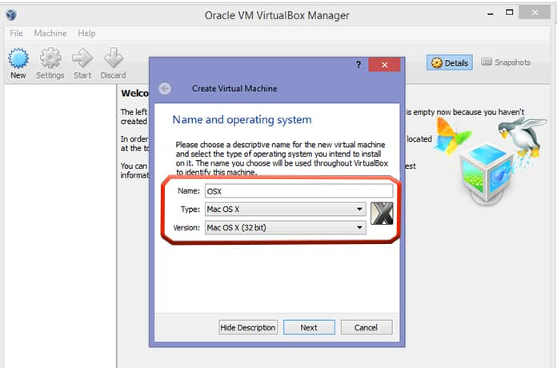

Stage 5: After setting the significant information in it, click on near proceed to the accompanying stage.

Stage 6: Now you will see Memory Size decision. This elective allows your system to give adequate Ram to the virtual machine.

Stage 7: Select the size as essentially 1GB and snap Next.

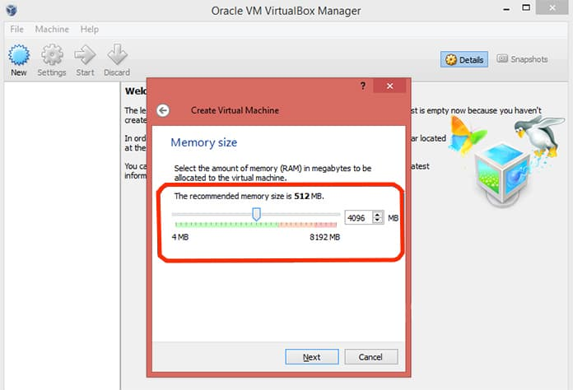

Stage 8: Now you will see the kind of virtual hard drive. Pick the primary decision named as VDI (VirtualBox Disk Image) and snap Next.

Stage 9: Now select the hard drive space you need to disseminate to the virtual machine and snap Create.

Stage 10: The virtual machine has viably been made on your VirtualBox.

Stage 11: In the head left corner, you will see the Settings image. Snap on it. By and by click on Storage then Load iOS File and snap OK.

Stage 12: After that, you basically follow the on-screen steps of OSX boot.

Stage 13: Now open the Safari program in your VirtualBox and sign in with your Apple ID.

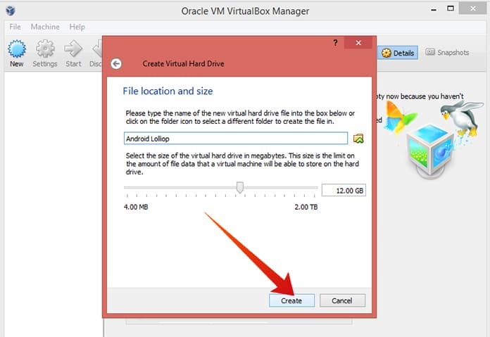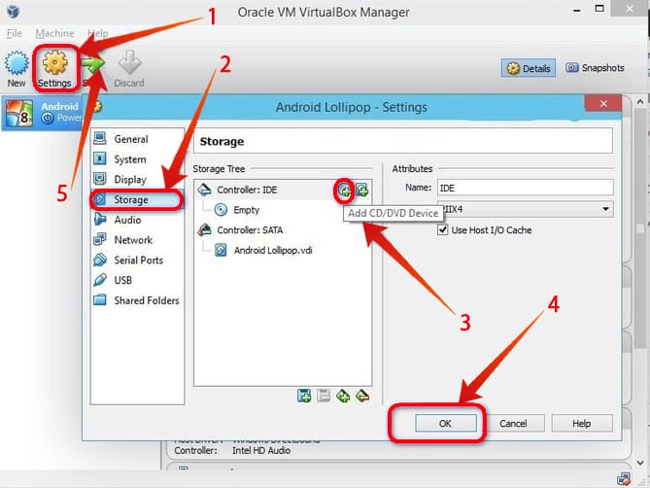

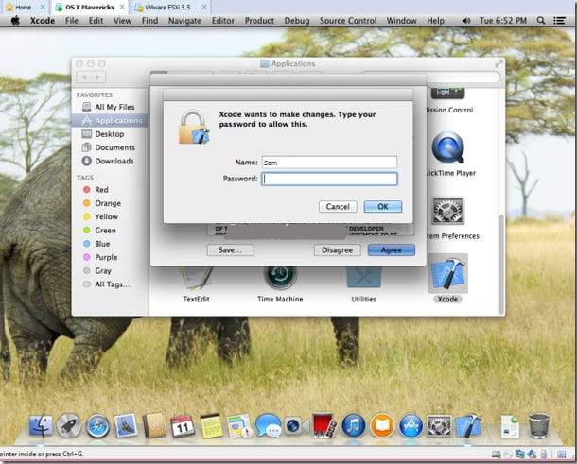

successfully installed XCode in pc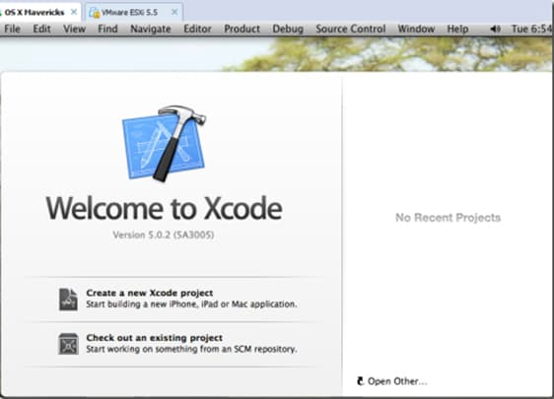

**Explain XCode and its capabilities**

1)It is the most ideal alternative of originators when they need to encourage iOS or macOS applications. This is because it is the equitable maintained IDE by Apple. While there are various other untouchable options open and they do not need XCode in any case, it is not maintained by Apple and moreover has normal issues with the plans.

2) It moreover has an organized device for researching and designers can use this segment to find expedient responses for issues. Some various decisions like endeavour the board gadgets are inconceivably helpful to manage the image assets and code records capably.

3) It is incredibly simple to use and can in like manner be used by fashioners who are youngsters. Its source code checker feature gets, and standards botches experienced while forming codes and a short time later proposes answers for handling the issue.

4) It has a store of arrangements and sections of code which helps novices during the time spent development. Planners moreover have a choice to save their own arrangements if there ought to emerge an event of repeated use of a comparable code. These formats have shown to be helpful for engineers who are juveniles and have confined data on application progression.

5) XCode editor allows the fashioners to see various records at the same time and it saves time. Fashioners do not have to flip between isolates case any movements are to be made. The part furthermore permits the planners to use the find and replace ability to make changes to any line of the code.

6) There is no prerequisite for any additional undertakings to save the code records. In XCode, work is saved, therefore.

7) Developers moreover have a decision to use the interface producer and plan menus and windows. They furthermore have a decision to use the library available in XCode. The overview of features does not end here. Another captivating segment is an Auto plan using which, specialists can make applications that change their size and position as indicated by the size of the screen on which they are used.

XCode IDE is an essential segment that goes probably as a middle for the wide scope of different parts open in the XCode pack. It shows the records on which work is in progress and moreover the Windows for various instruments. The interface resembles various conditions where the code is made into a record on the principal window. IDE moreover grows backing and guarantees the codes formed by customers are clear and missteps are restricted. Architects get thoughts regarding what they may have to go into a space. It moreover includes issues when any of the typical pictures are missing, or names of limits are not entered precisely. All around, answers for fix these issues are moreover suggested. Planners also have a choice to keep different tabs open and switch between these tabs. The interface is revived by the record being worked on. There is moreover a side library see available that licenses to move beginning with one record then onto the following and besides selects all the archives and coordinators being utilized for a particular undertaking. The once-over of benefits does not end here. During the pattern of headway of the code, customers have a decision to run various tests with the code. There are several pre-arranged to use projects which is valuable for educating customers. Specialists have a lot of choices of programming lingos concerning creating a code in XCode. The overview of programming lingos maintained by XCode goes from Swift, AppleScript, C, C++, Objective C, Python, etc Among this heap of vernaculars, Apple unequivocally proposes Swift language for development of through the whole of its establishment. It is judicious to use the latest variation of XCode. Various customers went up against a screw up while making with their Apple id that Apple architect record could not be added and XCode 7.3 or later structure was expected to continue with the Apple id.

**explore the XCode interface**

the organized improvement environment for architects of macOS, iOS, WATCHOS, and TVOS applications. The material in XCode grants you to rapidly see and team up with Swift applications, which thinks about quick development of UIs. XCode has a grouping of ways to deal with manage source control. Interface Builder is the basic application for building UIs in XCode.

**Conclusion:**

Cultivating an iOS application is connected to being familiar with XCode.

This article is an irrefutable necessity examined for people who need to encourage iOS applications. Here, where we have explained what XCode, and the cycle is to download it. There is a bare essential region revealing how to use XCode. Some confident specialists of iOS applications who do not have a Mac ought not miss this article. We have moreover talked about how it might be used on Windows PCs under the heading XCode for Windows. While a segment of these decisions may be hardly astounding yet these are decisions that have been used and upheld by engineers across the world.

**References:**

[**https://www.alltechbuzz.net/install-xcode-on-windows-for-ios-sdk/**](https://www.alltechbuzz.net/install-xcode-on-windows-for-ios-sdk/)

[**https://developer.apple.com/library/archive/documentation/ToolsLanguages/Conceptual/Xcode_Overview/**](https://developer.apple.com/library/archive/documentation/ToolsLanguages/Conceptual/Xcode_Overview/)

[**https://developer.apple.com/xcode/**](https://developer.apple.com/xcode/)