Student Inquiry and Research

Final Paper Cover Page

Use this form or a facsimile to verify that your advisor has read your final paper.

Turn in a hard copy or place in your SIR drop box. Your advisor may also email an SIR staff member with this information.

Student Name: Ram Koganti

Title of Paper: Using EEG and MRI to Localize Regions of Epilepsy in the Brain

Advisor Name: Dr. Todd Parrish

Date: 4/26/2016

Advisor Signature ______________________________________________________

Abstract

Our project attempts to determine the effects of combining both EEG and FMRI to pinpoint the regions of epilepsy in the human brain. On their own, MRIs and EEGs are each useful in diagnosis, but the combination of the two is expected to be even more powerful in terms of spatial and temporal resolution. In order to collect our data, tests were run on a patient diagnosed with epilepsy using both the fMRI and EEG. The patient was instructed to lay down and remain still while the tests were running. The data collected was processed using the software packages NUNDA and Analyze and then analyzed. We did not gather enough plausible data to draw definite results or conclusions but expect to see a correlation between the EEG and the fMRI data. If a correlation exists, then we could localize regions of epilepsy in the brain.

Focusing Question

Can EEG and fMRI be used together to identify regions of epileptic seizures in the brain?

Introduction

Magnetic Resonance Imaging (MRI) is a technique used to generate scans of the tissues and organs of the body. The machine itself is a cylindrical magnet capable of housing a person inside. One of the defining characteristics of an MRI is its spatial resolution (Doerr, 2015). Spatial resolution is partially determined by the size of the voxels, three-dimensional spaces that act as pixels for an MRI. A smaller voxel size leads to a greater spatial resolution. The MRI uses a process called Blood-Oxygenation-Level-Dependent (BOLD) imaging in order to generate high-resolution scans. BOLD imaging utilizes the natural hemodynamics of the brain combined with the magnetic fields generated by the MRI (Rosa et al., 2011). Cerebral blood flow is dependent on the levels of oxygen and carbon dioxide present, which in turn is determined by regional activity in the brain. When one area is activated in response to a task, such as the motor cortex when a person moves his/her finger, the region uses up the oxygen nearby. Oxygen is usually taken from the region’s local capillaries. As the oxygen is used up, the ratio of oxygenated hemoglobin (Hb) to deoxygenated hemoglobin drops rapidly. Due to this decline in the ratio, the levels of carbon dioxide increase in the brain. Blood flow is then sent to the brain to replenish oxygen levels and increase the amount of oxygenated Hb present. Hemoglobin also exhibits different properties depending on how saturated it is with oxygen. Deoxygenated hemoglobin is paramagnetic, but oxygenated Hb is not. The MRI functions by capturing this change in local brain tissue oxygen, since its magnetic fields can sense the levels of paramagnetic deoxygenated Hb. By collecting scans in this manner, the MRI can create high-quality tissue scans while remaining noninvasive and completely safe.

An electroencephalogram (EEG) is a test that is used to measure the electrical activity of the brain (Lopes da Silva, 2013). The machine itself is made up of electrodes, metal disks that are attached to the skull. The electrodes are usually attached to a cap, with 32 electrodes being the standard number. Brain cells constantly communicate using electrical impulses, even while the human is asleep. Since an EEG measures this electrical activity, it generates data with great temporal resolution. Unlike the MRI, the EEG does not use intervals when collecting data (Kaiser, 2005). The data appears as multiple wavy lines on a screen that are sensitive to changes in time. Despite the EEG’s quality of temporal resolution, it has poor spatial resolution. Each wavy line present corresponds to an electrode on the brain. However, the spatial resolution is limited to this alone. While an MRI can identify regions of interest down to the nearest millimeter, an EEG can only discern the region of interest to a regional level, such as pre-frontal cortex, amygdala, superior parietal lobe, etc. EEGs are commonly used to diagnose epilepsy, brain tumors, sleep disorders, and more. Like the MRI, EEGs are both painless and safe to conduct. To perform an EEG test, the electrodes must be attached to both the patient’s head and a computer. This is done through the use of electroconductive gel which joins the electrodes on the cap firmly to the skull (Bathelt et al., 2014). Once the EEG is collecting data, the patient can be asked to perform a wide variety of movements, such as closing their eyes, opening their hand, or nothing at all. In certain cases, the patient may be induced to undergo a seizure intentionally in order to discover the region seizures usually occur in. Before the EEG data can be utilized, artifacts must be removed from it. Artifacts can include bodily processes such as heartbeat or breathing. However, these types of artifacts are easily removable as they occur on regular intervals. Software programs can splice this repeating artifact out with relative ease.

Epilepsy is a neurological disorder that is characterized by frequent, random seizures. These seizures are subdivided into three categories: generalized, partial (focal), and absence (Mullinger, 2013). During a generalized seizure, disturbances occur in all of the brain. Seizures such as these have noticeable symptoms. They may stiffen or perform uncontrolled rhythmic movements. Confusion is a common occurrence following a generalized seizure. Despite the various symptoms that can occur, generalized seizures affect the entire body. Partial seizures, on the other hand, only disrupt one region of the brain. Symptoms are highly dependent on and can be correlated with the specific region of the brain affected. For example, if the motor cortex is affected, then the patient could potentially experience jerky motions of their hands or legs. Seizures residing in sensory regions produce odd sensations that can leave the patient feeling disoriented (Iper, 1993). Finally, absence seizures occur most often during childhood, but they can persist well into adulthood. The patient suffering an absence seizure loses consciousness briefly. However, people with absence seizures often do not notice that they undergo them given their quick nature,

Combining an MRI and EEG can make up for the weaknesses of each while maximizing their relative strengths (Murta, 2005). An MRI has great spatial resolution but poor temporal resolution, while an EEG has poor spatial resolution but great temporal resolution. However, combining the two presents a new set of problems as the MRI creates new artifact in the EEG data, obscuring its usefulness. Various protocols have been used to reduce the artifact present (Sadeh et al., 2014). While some have been met with success, no universal protocol has been implemented as of yet.

Materials and Methods

An EEG-compatible MRI was used to conduct the experiment. A patient with epilepsy wore a 32-electrode EEG cap and entered the MRI machine. The subject was instructed to lie still and could close his/her eyes if needed. However, the patient could not fall asleep. A resting state MRI was simultaneously run on the patient. The test protocol was 10 minutes and 25 seconds long with the MRI collecting slices at 2.5 second intervals. The IRB of our advisor, Dr. Parrish, was used in order to run tests on human subjects.

The EEG data was processed using Analyze, a software package. Noise from the MRI and the artifacts produced by bodily processes, such as heartbeat and breathing, were removed. The MRI data was processed using a pipeline built on QUEST in the NUNDA interface. The data was corrected for head motion and slice timing. The pre-processing also removed motion errors, and the scans were normalized. The EEG and MRI data were then analyzed and searched for indicators of epileptic activity. These markers were abnormal peaks in the EEG data or disturbances in the ROI for the MRI data.

Results

Regarding the MRI data, mean ALFF measurements were greater in the epileptic patient than in the control (Figures 2 and 3). This trend held constant for every region of the brain tested. Mean ALFF was near the minimal level for the control patient, as evidenced by the dark blue hue covering the majority of the brain. The epileptic patient had relatively greater connectivity, as seen by the milder blue-green hue of the scans. Numerical values for the ALFF of the two test subjects demonstrated this trend as well (Table 1). There was a positive change in ALFF for every region of the brain tested when comparing the control to the epileptic patient. Though the degree of the changes varied considerably, as differences ranged from hundredths to thousands, all were positive.

The EEG data of the patient followed fairly consistent patterns (Figures 4 and 5). Generalized seizures did not appear to occur, since uniform disturbances across all of the electrodes did not occur. The rare cases that occurred were due to noise or artifacts that were removed via processing. Locations of hypothetical focal seizures were indicated with a red marker and were present infrequently in the EEG of the epileptic patient.

Conclusion

Unfortunately, we were unable to generate a large sample size for our investigation. We were promised many patients by Northwestern University’s Epileptology Department, but we were able to recruit only subject. To make matters even more difficult, our test subject had the part of his brain primarily responsible for his epilepsy removed. Due to this, his seizures were rare and manageable; in most cases, he was unaware that they were occurring if they did. Since our sample size was one patient and his degree of epilepsy was questionable, we were unable to draw any significant conclusions to our investigation. Differences were present and notable between the epileptic patient and the control, but the significance of those differences remains unknown. Rather than concluding that EEG and MRI are unable to be used together to localize regions of epilepsy in the brain, we simply were unable to test our hypothesis with the proper number and type of test subjects. The hypothesis is not invalid but merely untested as of yet.

Discussion

Since we were unable to fully test our hypothesis and draw conclusions from it, our current results have little value. However, that is not to suggest that they could not be significant if tested properly. Our preliminary results can provide the opportunity for a little speculation. The epileptic brain carried a greater ALFF value across all regions in comparison to the control results, indicating greater activity overall. This may have been due to epileptic seizures increasing activity beyond normal levels. However, there are other reasons that could explain why this occurred. The epileptic patient had part of his brain resected, and other regions of the brain may be more active to compensate for the loss of connectivity. Alternatively, the patient could have possessed a greater ALFF during rest than the control, regardless of his condition. It is difficult to determine which could be the underlying reason without a greater sample size. A sample size of one has a tendency to skew the data drastically and should not be used as evidence to support or refute a hypothesis.

The EEG data was likewise ambiguous for the test subject. For the majority of the scan, his readings indicated a standard response to a resting state and were not out of the ordinary. Factors that skewed the data, such as bodily processes or inadvertent head motion, were removed. With the major sources of error removed, we could determine that no generalized seizures had occurred during the duration of the test. This is consistent with how the patient appeared when inside of the MRI. He did not exhibit any jerky motions or seize up unnaturally. The few regions of local seizure were speculative at best and did not immediately stand out to us during our data analysis. When looking at the corresponding regions on the MRI scan, no visible disturbances were present apart from his resection. However, this lack of seizure activity was partially expected as his seizures had become rare and benign. Using patients with more active cases of epilepsy may lead to more definitive results and should be tested in the future.

Apart from conducting the experiment with the appropriate test subjects, there are additional ways that this experiment could and should be modified in the future in order to obtain definitive results. The artifact produced by the MRI proved difficult to remove fully. This warped the EEG data to some extent and has been noted in studies of a similar design (Scheeringa et al., 2011). Various methods that can better remove or reduce MRI-induced artifacts have been tested, possibly through the use of better software algorithms (Huang et al., 2012). While these algorithms have been met with some initial success, they are still in developmental stages and not used universally (Dell’Orso, 2014). Improvements to existing are expected to result in the reduction of MRI-induced artifact and improve the quality of combined EEG-MRI scans. Initial studies have been promising, and we still believe that ours has the potential to demonstrate the enhanced data that can arise from using both tests simultaneously.

Inquiry Process

My SIR investigation taught me a great deal about how I learn and the areas I need to improve. I learned that I am a visual learner. Drawing pictures and diagrams in my notebook that I could visualize later was much more beneficial to me than simply writing down notes. As my SIR was heavily based in neurology, I had to learn a large amount of information in a short time to get over the initial learning curve. Towards the end of the semester, I tended to draw more often in my notebook in order to learn new information more quickly. Also, I had to direct my own learning quite often during my investigation. There were a few instances where my advisor was out of the country or could not meet with us. On those days, I researched about neurobiology on my own and benefited a great deal from the experience. Sometimes, it is important to take a step back from continuously learning new information and spend time solidifying your foundations. Occasionally I felt overwhelmed at the plethora of information I had to learn in order to understand my SIR. These days were useful in increasing my comfort level with the new material which allowed me to remember more weeks after I learned it. The SIR program allowed me to go at my own pace, unlike a traditional science course. As aforementioned, I had the ability to slow things down and focus on understanding what I had previously learned. That aspect combined with the freedom of my self research made the experience very rewarding. Unfortunately, due to circumstances that were out of our hands, we did not accomplish what we set out to do. This was a matter of not acquiring test subjects with epilepsy. We were led to believe that the Epileptology Department would provide us with patients. However, we were only able to run tests using the MRI-EEG on one epileptic patient but even he had part of his brain resected in order to alleviate his symptoms. As a result, we could not draw any conclusions or fully answer our focusing question. By the same token, however, our project was not a failure. It is possible that our question could be answered given a sufficient amount of data.

References

Akoum, N., Daccarett, M., McGann, C., Segerson, N., Vergara, G., Kuppahally, S., Marrouche, N. (2011). Atrial fibrosis helps select the appropriate patient and strategy in catheter ablation of atrial fibrillation: A DE‐MRI guided approach.*Journal of Cardiovascular Electrophysiology, 22*(1), 16-22. doi:10.1111/j.1540-8167.2010.01876.x.

Bathelt, J., O'Reilly, H., & de Haan, M. (2014). Cortical source analysis of high-density EEG recordings in children.*Journal of Visualized Experiments : JoVE,*(88), e51705.

Dell’Orso, A., De Felice, C. (2014). An Algorithm for Orthogonal Correction of Phase-Encoding Derived artifacts in Magnetic Resonance. *International Journal of Computer Assisted Radiology and Surgery, 9*(Suppl 1), S15-S20. Doi: DOI 10.1007/s11548-014-1014-z.

Doerr, A. (2015). Shape-shifting MRI probes.*Nature Methods, 12*(5), 386-386.

Huang, C., Ju, M., & Lin, C. K. (2012). A robust algorithm for removing artifacts in EEG recorded during FMRI/EEG study.*Computers in Biology and Medicine, 42*(4), 458-467. doi:10.1016/j.compbiomed.2011.12.014

Iper, J. (1993). EEG + MRI: A sum greater than the parts.*Science, 261*(5121), 559-559. doi:10.1126/science.8342019

Kaiser, D. (2005). Basic Principles of Qualitative EEG. Journal of Adult Development, 12(2), 99-104. doi:10.1007/s10804-005-7025-9.

Lopes da Silva, F. (2013). EEG and MEG: Relevance to neuroscience.*Neuron, 80*(5), 1112-1128. doi:10.1016/j.neuron.2013.10.017

Mullinger, K., Castellone, P., & Bowtell, R. (2013). Best current practice for obtaining high quality EEG data during simultaneous fMRI.*Jove-Journal of Visualized Experiments,*(76) doi:10.3791/50283

Murta, T. (2005). Electrophysiological correlates of the BOLD signal for EEG-informed fMRI. *Human Brain Mapping, 36*(1), 391-414. DOI: 10.1002/hbm.22623.

Rosa, M., Kilner, J., & Penny, W. (2011). Bayesian comparison of neurovascular coupling models using EEG-fMRI.*Plos Computational Biology, 7*(6), e1002070. doi:10.1371/journal.pcbi.1002070

Sadeh, B., & Yovel, G. (2014). Extracting visual evoked potentials from EEG data recorded during fMRI-guided transcranial magnetic stimulation.*Journal of Visualized Experiments : JoVE,*(87)

Scheeringa, R., Fries, P., Petersson, K., Oostenveld, R., Grothe, I., Norris, D. G.. . Bastiaansen, M. C. M. (2011). Neuronal dynamics underlying high- and low-frequency EEG oscillations contribute independently to the human BOLD signal.*Neuron, 69*(3), 572-583. doi:10.1016/j.neuron.2010.11.044

Acknowledgements

I would like to thank Dr. Todd Parrish for his extensive help on our investigation. He gave us our investigation question and provided us with the background knowledge necessary to help us conduct our project. Neurobiology is a complex field, but he worked hard and patiently to teach us the fundamentals. He also provided us with continued guidance throughout the investigation, particularly with data collection and analysis.

I would like to thank Dr. Xue Wang for also teaching us about neurobiology. She taught us how to analyze data and did the processing for us using NUNDA, Analyze, Curry, and other software packages. She was patient and always ready to answer any questions that we had.

I would like to thank Dr. Jenny Chen for showing us the facility and the campus as a whole. She gave us familiarity with the area and took us to lab meetings. On the first day, she also made sure we received Northwestern Guest IDs, so we could access Dr. Parrish’s Lab.

I would like to thank the SIR Department as a whole for making this investigation possible. They have provided transportation to and from Northwestern every Wednesday. They have given us guidance on how to conduct our project properly and made sure we got the most out of our experience. They checked our notebooks and helped us write a paper, make a poster, and much more. They also looked over our initial email to our advisor and instructed us on how to improve it. Without the program, this investigation would have been impossible to conduct.

Figures and Tables

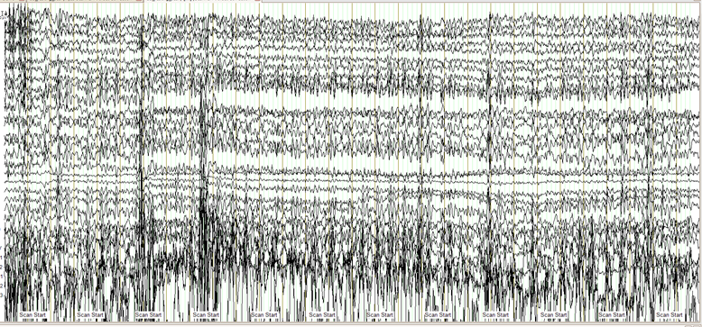

Figure 1. The results of the EEG test before data processing. Noise caused by subject motion and bodily processes are still present. Lines for each electrode are displayed.

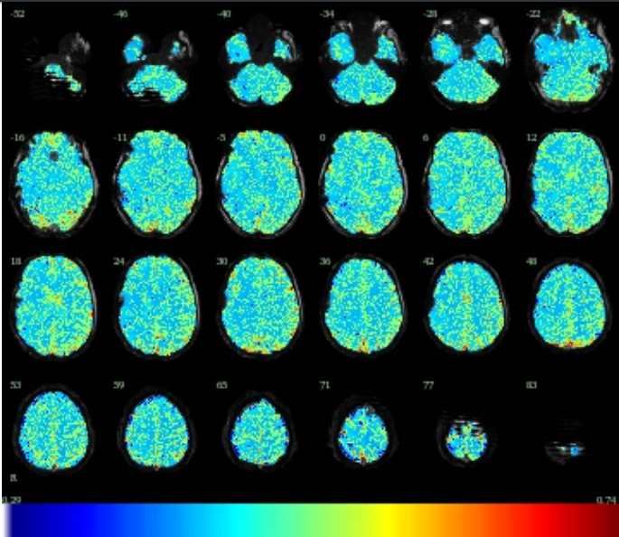

Figure 2. MRI data displaying slices of the epileptic patient’s brain displaying the total connectivity (ALFF). Connectivity is measured by color using the key at the bottom of the figure.

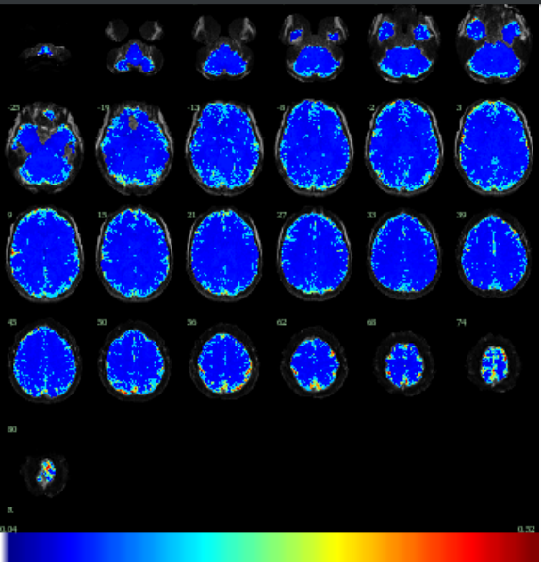

Figure 3. MRI data displaying slices of the control subject’s brain displaying the total connectivity (ALFF). Connectivity is measured by color using the key at the bottom of the figure.

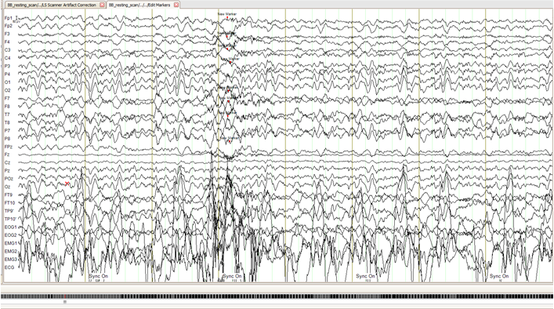

Figure 4. Section 1 of the EEG data of the epileptic patient post-processing. Hypothetical regions of seizure are indicated with red markers.

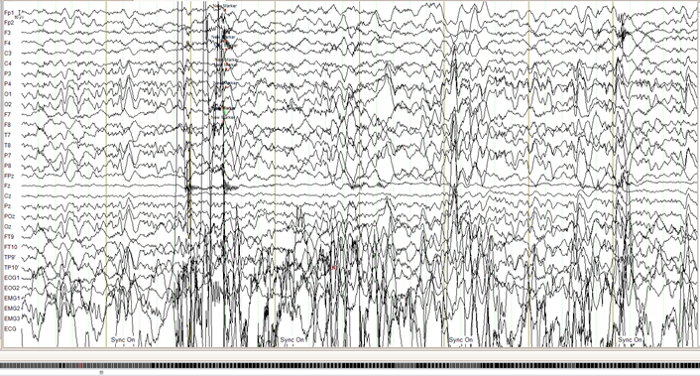

Figure 5. Section 2 of the EEG data of the epileptic patient post-processing. Hypothetical regions of seizure are indicated with red markers.

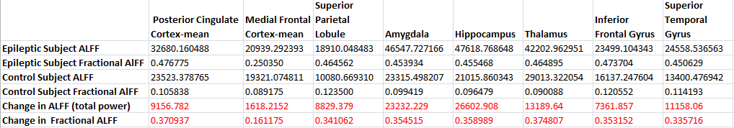

Table 1. Numerical representation of ALFF data. ALFF and Fractional ALFF for each region of the brain are given for the epileptic patient and the control. Changes in each type of ALFF are also given. Positive changes from the control to the patient are highlighted in red.