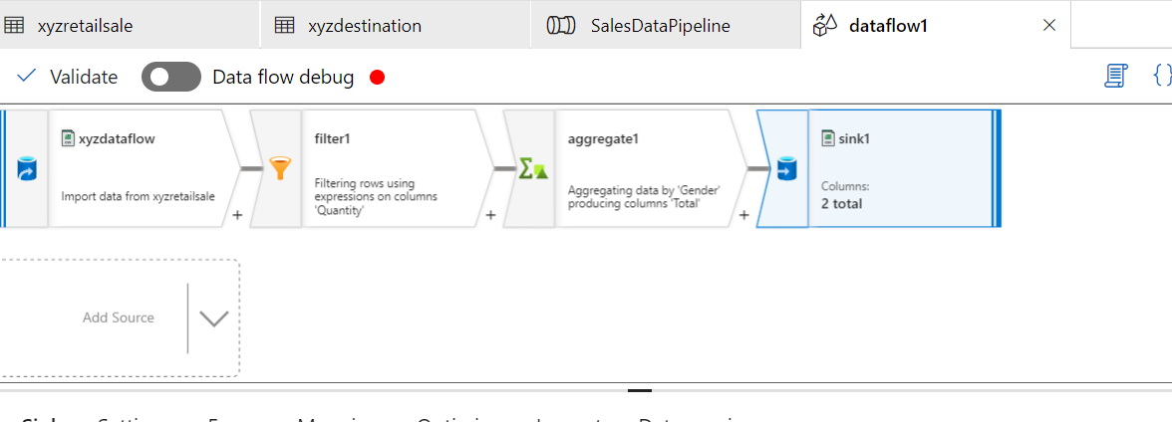

CASESTUDY2

CASESTUDY3

