PHASE-1

BRAINSTORMING AND IDEATION

Project Title: Exploratory Analysis of Rainfall Data in India for Agriculture

Description:
Rainfall Prediction Using Machine Learning is an advanced AI-driven weather intelligence system designed to enhance forecasting accuracy and support data-driven decision-making. By leveraging powerful machine learning algorithms—including Random Forest, Gradient Boosting, and XGBoost—the platform delivers reliable predictions of next-day rainfall based on historical meteorological data and real-time atmospheric conditions.
From agricultural planning and disaster preparedness to water resource management and climate trend analysis, the system integrates predictive analytics into practical environmental applications while maintaining high standards of accuracy and performance. Its intelligent modeling capabilities analyze temperature variations, humidity levels, wind patterns, atmospheric pressure, and prior rainfall conditions to generate precise rainfall forecasts.
By transforming raw weather data into actionable insights, the platform assists individuals, farmers, and organizations in proactive planning, risk reduction, and optimized resource utilization, making it a robust solution for modern weather prediction challenges.
.Team ID : LTVIP2026TMIDS90231
Team Size : 4
Team Leader : Jaldani Divya Devi
Team member : Jyothula Sri lakshmi
Team member : Karedla Sandeep kumar
Team member : Kiran Kumar Salluri

Project Considerations

1. Objectives
Problem Statement:

Accurate rainfall forecasting remains a significant challenge due to complex atmospheric patterns, rapidly changing weather conditions, and limitations of traditional statistical prediction methods. Inconsistent rainfall predictions can negatively impact agriculture, water resource management, disaster preparedness, and urban planning. The absence of intelligent predictive systems reduces the ability to make proactive decisions, leading to economic losses and risk to public safety.

Purpose and Impact of the Project:

This project aims to leverage machine learning techniques to enable accurate next-day rainfall prediction using historical weather data and atmospheric indicators. By analyzing temperature, humidity, wind patterns, pressure levels, and prior rainfall conditions, the system provides data-driven insights to support better planning and risk management. The project seeks to improve forecasting reliability, assist in proactive decision-making, and reduce uncertainty in weather-dependent sectors such as agriculture and environmental management.

2. Key Points
i. Problem Statement:
Weather forecasting systems face challenges in handling large-scale meteorological data, identifying complex weather patterns, and delivering accurate rainfall predictions due to atmospheric variability and climate dynamics.
ii. Solution Proposed:
The system integrates advanced machine learning algorithms—including Random Forest and XGBoost—to develop an intelligent rainfall prediction model. It processes historical weather records, performs data preprocessing (imputation, encoding, scaling), and analyzes key meteorological parameters to generate accurate next-day rainfall predictions. The system transforms raw weather data into meaningful predictive insights through automated modeling and evaluation techniques.
iii. Target Users:
Farmers, agricultural planners, meteorological departments, environmental researchers, disaster management authorities, and policy-makers—particularly those operating in regions where rainfall variability significantly impacts economic and environmental stability.
iv. Expected Outcome:
An intelligent and scalable rainfall prediction system capable of delivering accurate next-day forecasts, improving agricultural planning, supporting water resource management, minimizing climate-related risks, and enhancing data-driven environmental decision-making processes.

PHASE-2

REQUIREMENT ANALYSIS

Key Points:

Technical Requirements:
- Languages: Python
- Frameworks & Libraries: Scikit-learn for machine learning modelling, XGBoost for advanced gradient boosting, Pandas & NumPy for data preprocessing and analysis, Flask
- Tools: Google Colab (T4 GPU), GitHub, Matplotlib/Seaborn for visualization, Joblib for model persistence

Functional Requirements:
- User-friendly interface for entering weather parameters (temperature, humidity, rainfall, wind speed, pressure, etc.)
- Machine learning–based next-day rainfall prediction
- Data preprocessing pipeline including missing value handling, encoding, and scaling
- Accurate prediction output (Rain Tomorrow: Yes/No) based on trained ML model
- Real-time prediction capability through web-based interface

Constraints & Challenges:
- Managing missing and inconsistent meteorological data
- Handling class imbalance in rainfall dataset (more “No” than “Yes” cases)
- Ensuring model generalization across different geographic locations
- Maintaining prediction accuracy under varying seasonal and climate conditions
- Preventing overfitting while training on historical weather data

PHASE-3

PROJECT DESIGNING

Architecture Diagram:

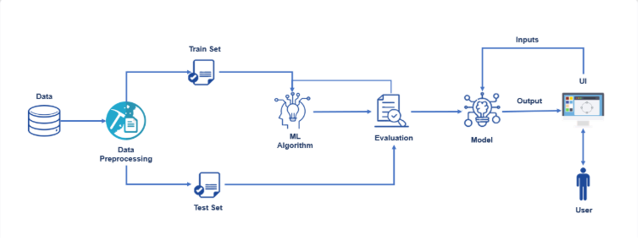

Key Points:
i. System Architecture Diagram
The system architecture consists of the following components:
- Frontend Interface: Built using a Flask-based web application to allow users to input weather parameters such as temperature, humidity, wind speed, pressure, and rainfall indicators for next-day rainfall prediction.
- Data Processing Layer: Utilized Pandas and NumPy for data cleaning, missing value handling, categorical encoding, feature engineering (date decomposition into year/month/day), and preparation of structured input data.
- ML Model Layer: Implemented using ensemble machine learning algorithms including Random Forest and XGBoost, combined with StandardScaler normalization to improve prediction accuracy and maintain model stability across varying climatic conditions.
- Deployment Infrastructure: Model training conducted using Google Colab with trained models saved using Joblib and integrated into a Flask web application for real-time rainfall prediction.

ii. Flow Diagram:
User (Farmer / Researcher / General User)
↓
Flask Web Interface
↓
Weather Parameter Input & Validation
↓
Data Preprocessing (Imputation + Encoding + Feature Scaling)
↓
ML Model Prediction (Best Trained Model – Random Forest / XGBoost)
↓
Rainfall Classification (Yes / No)
↓
Prediction Result Display with Forecast Insight

iii. User Flow
- Parameter Input: Users enter weather parameters such as temperature, humidity, wind speed, pressure, rainfall, and date through structured input fields on the web interface.
- Submit & Predict: Click the Predict button to trigger the machine learning prediction pipeline.
- Data Processing: The system performs missing value handling, categorical encoding, and feature scaling before passing data to the trained model.
- Prediction Output: The model generates a next-day rainfall prediction displayed clearly as: Rain Tomorrow: Yes / No
- Forecast Insight: Based on the prediction, users can make informed decisions related to agricultural planning, water management, or risk preparedness.

PHASE-4

PROJECT PLANNING (AGILE METHODOLOGY)

Sprint Planning & Task Allocation:
(i). Technical Architecture & Dataset Design:
- K Veera Manikanta
- K Sai Vikas
- K Sathvik
(ii). Milestone 1: Model Selection & Training Pipeline:
- K. Veera Manikanta
(iii). Milestone 2: Prediction Logic & Integration:
- K Alekhya
(iv). Web Interface Development (Flask UI):
- K. Veera Manikanta
- K Sathvik
(v). UI Design & Styling Implementation:
- K. Veera Manikanta
- K Alekhya
(vi). Testing, Deployment & Documentation:
- K. Veera Manikanta
- K Sai Vikas
- K Sathvik
- K Alekhya

PHASE-5

PROJECT DEVELOPMENT

TOOLS AND TECHNOLOGY USED:
Various tools and technologies were utilized during development. Key components include:
Python:
A high-level programming language widely used for machine learning, data analysis, and scientific computing. It was selected due to its extensive ecosystem of ML libraries and strong community support.
Flask:
A lightweight Python web framework used to build the user interface for rainfall prediction. It enables real-time input handling and seamless integration with the trained machine learning model.
Scikit-learn:
A robust machine learning library used for:
- Random Forest classification
- Data preprocessing (StandardScaler, LabelEncoder, SimpleImputer)
- Model evaluation (Accuracy, ROC-AUC, Confusion Matrix)
XGBoost:
An optimized gradient boosting framework that improves predictive accuracy on structured weather datasets. It enhances model performance through boosting techniques.
Pandas & Numpy:
- Data cleaning and transformation
- Handling missing values
- Feature engineering (Date → Year, Month, Day)
- Numerical computations
- necessary libraries
Dataset used:
A robust machine learning library used for:
- Temperature
- Humidity
- Wind Speed
- Pressure
- Rainfall
- RainToday
- RainTomorrow (Target variable)
- Model evaluation (Accuracy, ROC-AUC, Confusion Matrix)

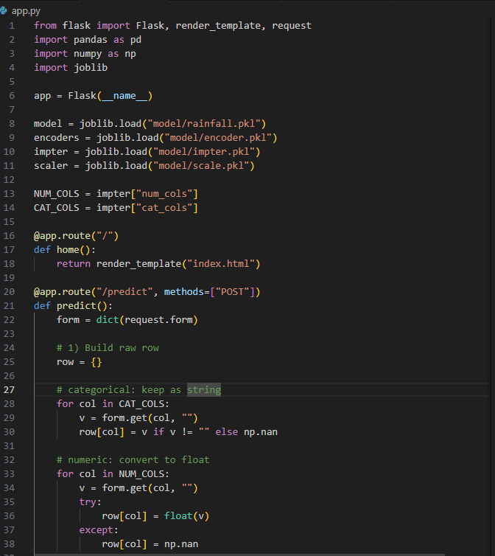

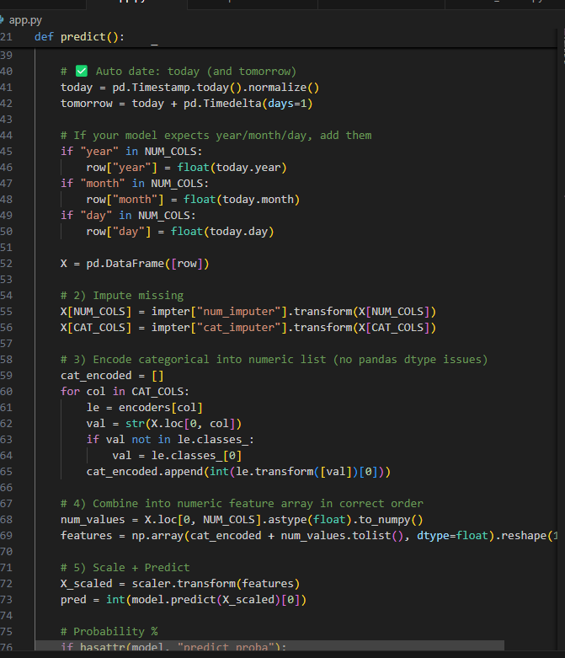

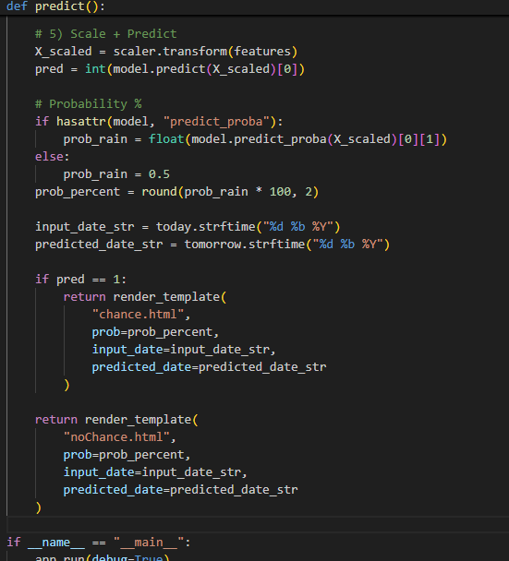

Key Points:
i. Technology Stack Used:
- Frontend: Flask-based web application with responsive UI for weather parameter input
- ML Framework: Scikit-learn (Random Forest), XGBoost
- Data Processing: Pandas, NumPy, SimpleImputer, LabelEncoder, StandardScaler
- Visualization: Matplotlib, Seaborn for exploratory data analysis
- Infrastructure: Matplotlib, Seaborn for exploratory data analysis
ii. Development Process:
- Defined project scope focusing on next-day rainfall prediction using historical weather data
- Performed data cleaning, feature engineering (date decomposition into year/month/day), and missing value handling
- Built a complete ML pipeline including imputation, encoding, scaling, model training, evaluation, and model comparison
- Trained multiple models (Random Forest, XGBoost) and selected the best-performing model based on accuracy and ROC-AUC score
- Integrated trained model into a Flask web application for real-time rainfall prediction
- Tested the end-to-end workflow from user input to prediction output
iii. Challenges and Fixes:
- Challenge: Model showed bias toward predicting “No Rain” due to class imbalance in dataset.
- Fix: Applied stratified train-test split and tuned model hyperparameters to improve detection of “Yes” (Rain) cases.
- Challenge: Inconsistent predictions during inference due to preprocessing differences between training and deployment.
- Fix: Ensured unified preprocessing pipeline by saving and reusing the same imputer, encoders, and scaler during prediction phase.

PHASE-6

FUNCTIONAL & PERFORMANCE TESTING

Test Case Scenarios:
Scenario 1 – Dry Weather Condition (No Rain Prediction):
A user inputs weather parameters representing stable atmospheric conditions: low humidity (40%), high pressure (1025 hPa), zero rainfall, moderate wind speeds, and clear sky indicators.
The system predicts RainTomorrow: No, classifies the forecast as stable weather, and provides a summary indicating favorable conditions for outdoor planning and agricultural operations.
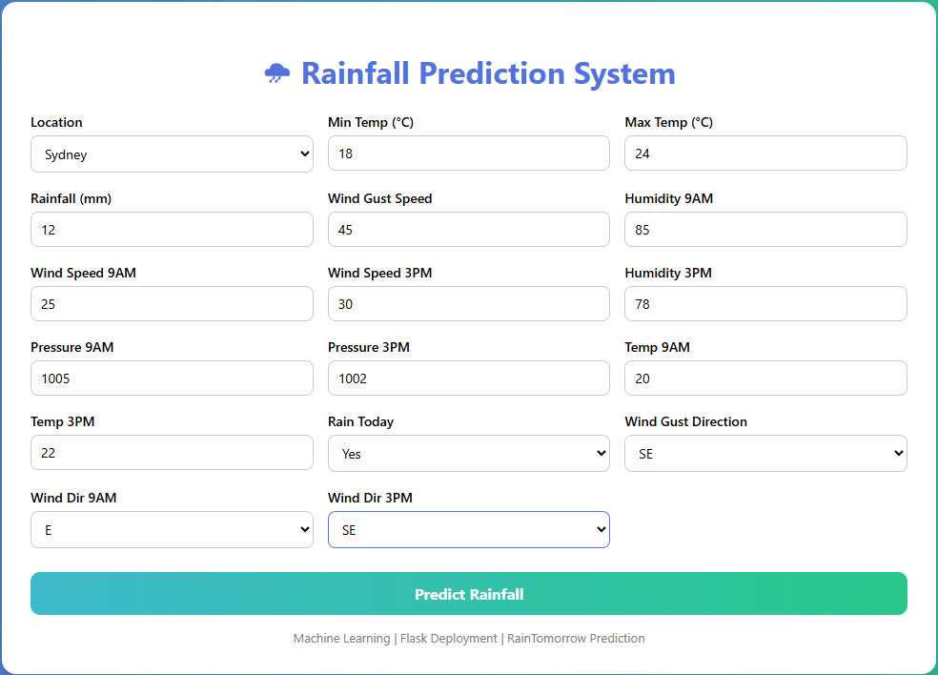
Output:
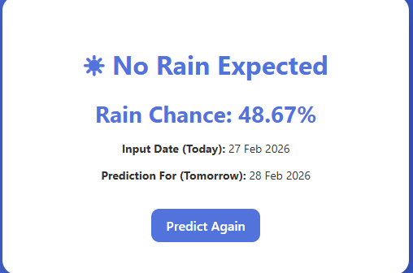
Scenario 2 – Warning Condition (Elevated Temperature):
A user enters weather conditions with high humidity (92%), low atmospheric pressure (998 hPa), significant rainfall (30 mm), strong winds, and RainToday marked as “Yes.”
The system predicts RainTomorrow: Yes, indicating high rainfall probability. The output assists in proactive planning such as crop protection, water management adjustments, and disaster preparedness measures.
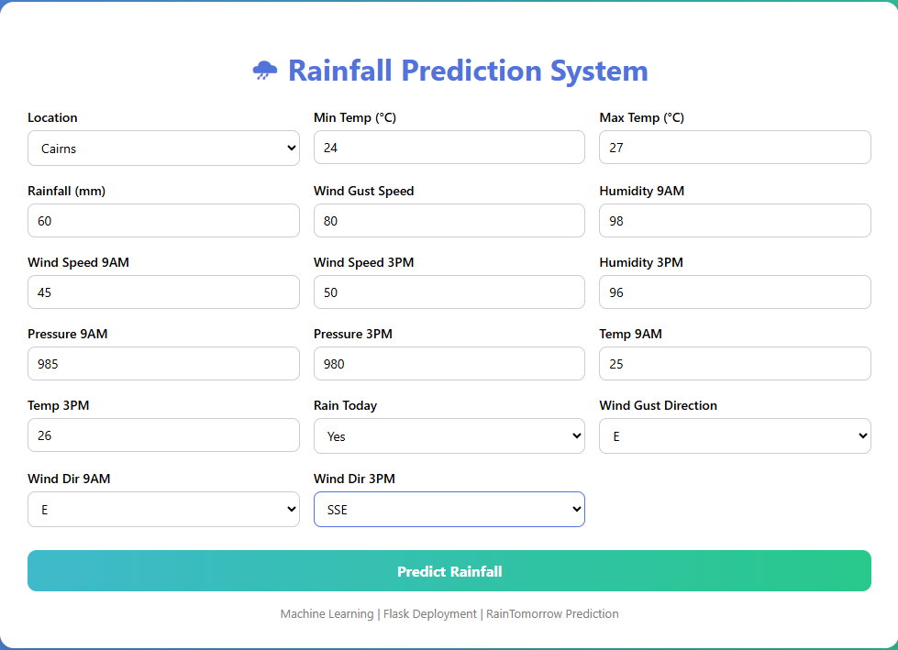
Output:
. 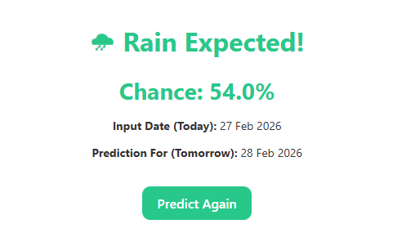

Conclusion:
The Rainfall Prediction Using Machine Learning project demonstrates the effective application of ensemble machine learning models for accurate next-day rainfall forecasting. By integrating advanced algorithms such as Random Forest and XGBoost, the system transforms historical meteorological data into actionable weather insights.
The project successfully implements a structured ML pipeline that includes data preprocessing, feature engineering, model comparison, performance evaluation, and real-time deployment through a web-based interface. By maintaining consistency in preprocessing and model inference, the system ensures stable and reliable predictions across diverse weather conditions.
Through intelligent analysis of temperature, humidity, wind speed, atmospheric pressure, and prior rainfall data, the platform supports informed decision-making for agriculture, environmental planning, and climate risk management. The architecture is scalable and can be extended to incorporate time-series forecasting models, real-time weather API integration, and cloud-based deployment for broader accessibility.
This project highlights how machine learning can enhance forecasting reliability, reduce uncertainty in weather-dependent sectors, and contribute to data-driven environmental planning in modern predictive systems.

