**SCREENSHOTS FOR REVIEW 2**

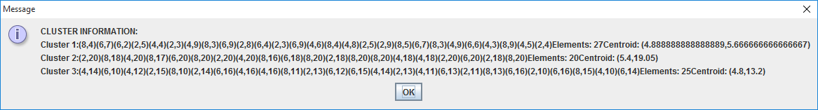

Fig.1. Cluster Information

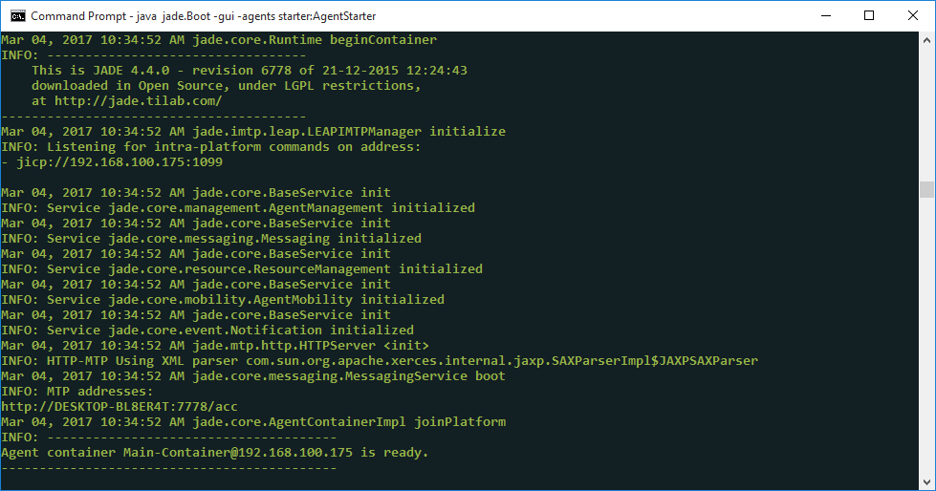

Fig.2. Agent starting information

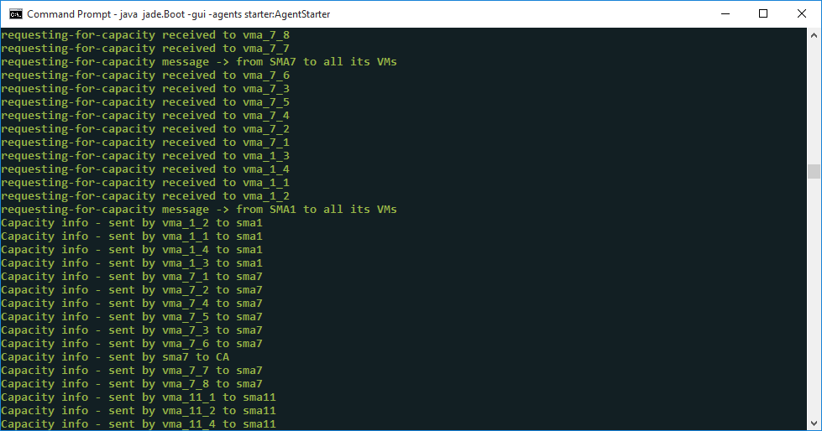

Fig.3. Communication among agents

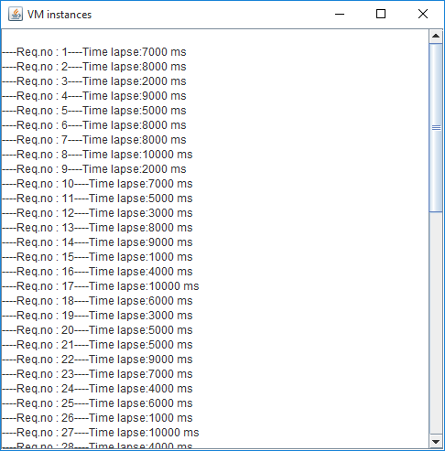

Fig.4. VM Request Automation

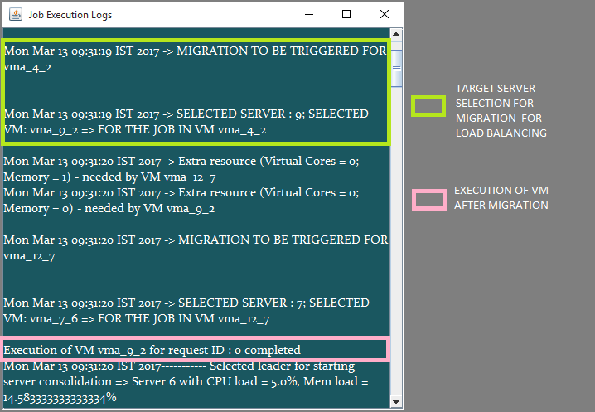

Fig.5. Target Server Selection for Migration for Load Balancing

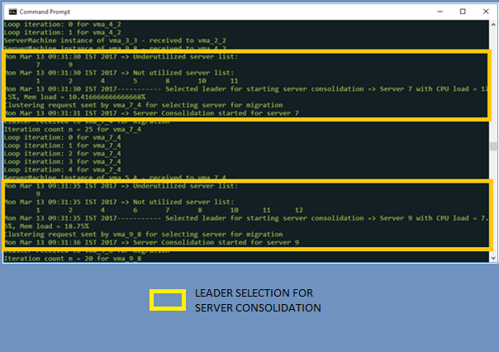

Fig.6. Leader Selection for Server Consolidation

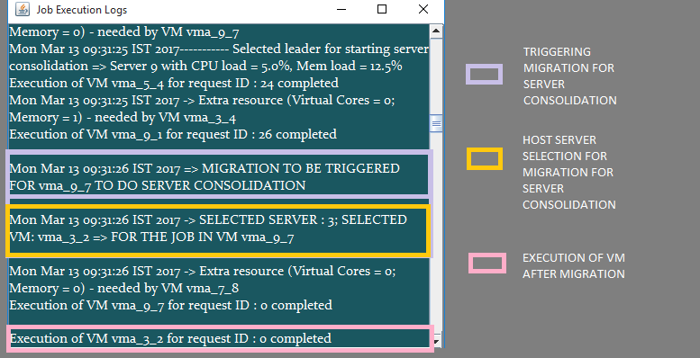

Fig.7. Migration for Server Consolidation