**PREPARING FOR RESUME**

**1 INTRODUCTION**

* 1. **OVER VIEW**

TIPS TO PRESENT YOUR PROJECTS

PROVIDE SPECIFIC DETAILS. INSTEAD OF ADDING GENERAL STATEMENT,PROVIDE SPECIFIC DETAILS ABOUT THE PROJECT TASK,YOUR ROLE AND QUANTIFIABLE RESULTS.FOR EXAMPLE ,YOU COULD SA,IMPLEMENTED NEW MORKETING STRATEGIES TO INCREASE SALES BY 12% IN TWO MONTHS . KEEP IT SHORT.

* 1. **PURPOSE:**

THE GOAL AND OVERALL PURPOSE OF A RESUME TO INTRODUCE YOUR QUALIFICTION AND SKILLS TO EMPLOYERS. IT’S AND INFORMATIONAL DOCUMENT THAT TELLS YOUR CARRER STORY, OUTLINING ALL DETAILS IN AND EASILY READ FORMATE.RESUME ALSO HOLD MEANING WITH IN THEMESELVES.

1. **PROBLEM DEFINITION& DESIGN THINKING**
   1. **EMPATHY MAP**

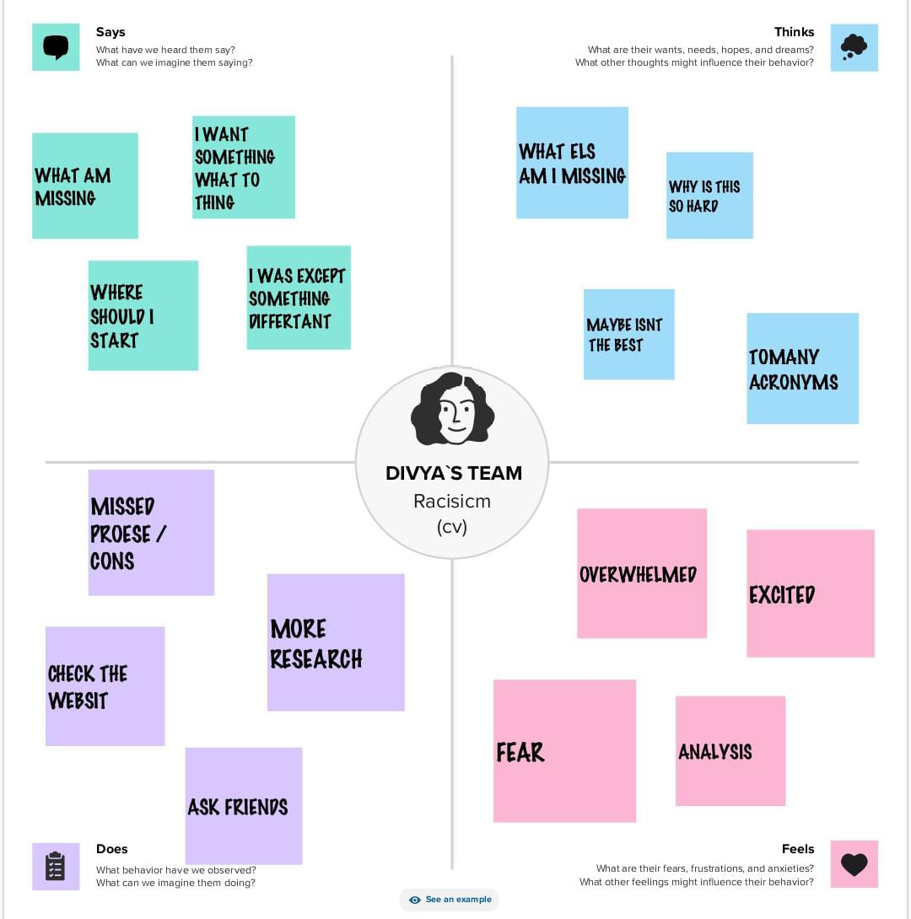

* 1. **IDEATION & BRAINSTROMING MAP:**

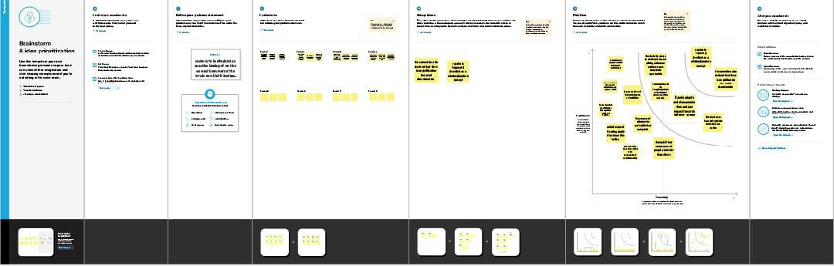

**3. RESULT :**

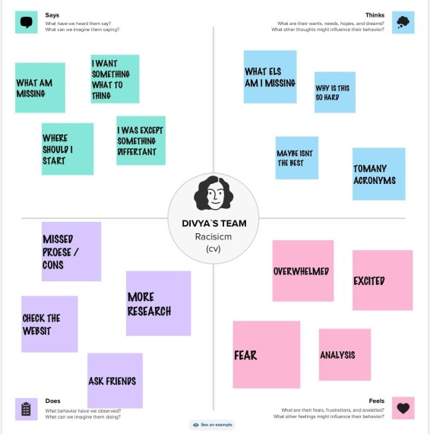



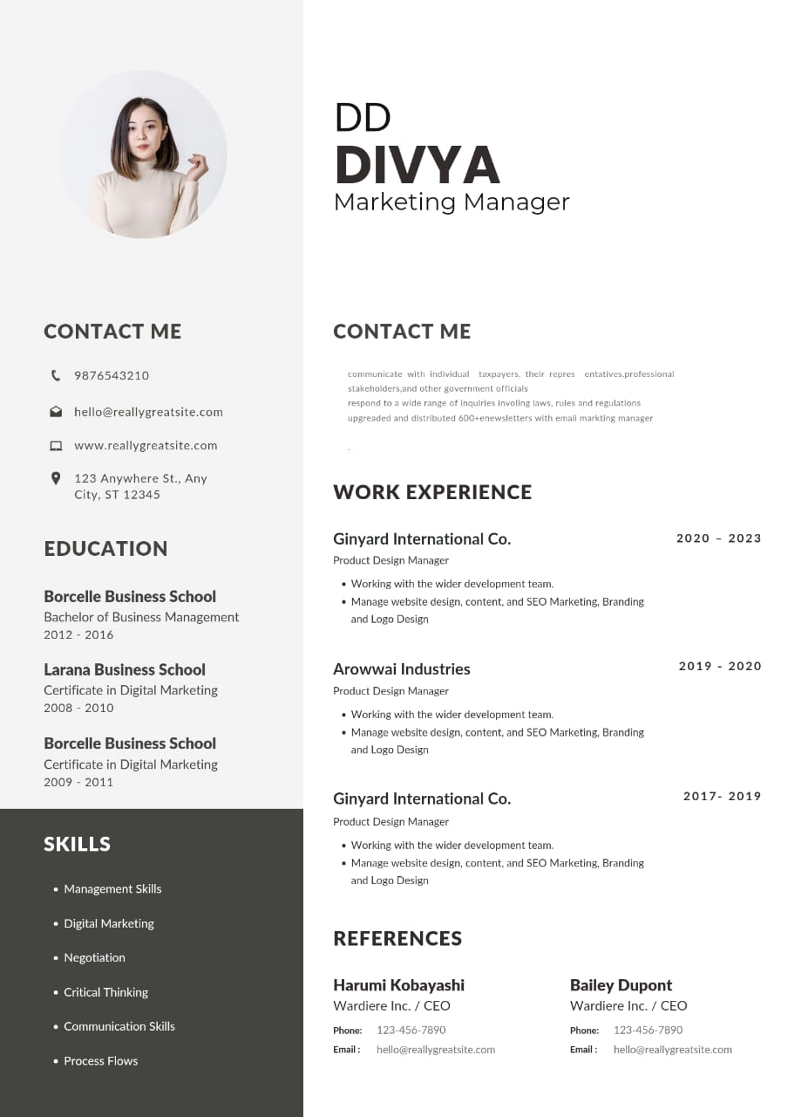

1. **ADVANTAGES & DISADVANTAGES**

INDUSTRIAL VALVES(EXPECT ENGINEERED VALVES)ARE CONSIDERED AS C CLASS ITEAMS / WEAKEST LINK OF ANY EQUIPMENT IN A POWER ,PROCESS PLANT AND ARE AT END OF THE PURCHASE DEPARTMENT OF THE CLIENT( EPC ,OEM) LIST OF PROCUREMENT. BUT THE FACT IS THAT THE VALVE IS THE MOST IMPORTANT LINK OF ANY EQUIPMENT AS IF IT’S FAILS THE WHOLE EQUIPMENT FAILS ,POWER PLANT COMES TO STAND STILL.

**ADVANTAGES.**

1. NO DUPILICITY

ONE OFFER TO THE ENQUIRY RECD FROM MANY EPC/OEM FOR THE SAME PROJECT. SAVING & I\UNIFORMITY.

**DISADVANTAGES:**

1. LACK OF SUPPORT.

IF THE PERPOSAL TEAM DOES NOT PROVIDES THE OFFER WITHIN THE TEAM DEADLINE , AND SALES TEAMS HA TO FOLLOW WITH THEM CONTINUOUSLY

1. **APPLICATIONS**

AREA OF APPLICATION MENS THE ENTIRE LAND TERRITORY OF THE STATUS PRTIES IN EUROPE FROM THE ATLANTIC OCEAN TO THE URAL MOUNTAINS WHICH INCLOUDS ALL THE EUROPEN ISLAND TERRITORIES OF THE STATES PARATIESINCLUTING THE FAROE ISLAND OF THE KINGDOM OF DENMARK SYALBARD INCLUTING BEAR ISLAND OF THE KINGDOM OF NORWAY.

1. **CONCLUSION**

**ELEMENTS OF THE CONCLUSION**

* STATE YOUR TOIC
* STATE YOUR THESIS STATEMENT
* BRIEFLY SUMMARIZE YOUR MAIN POINTS
* ADD THE POINTS UP
* MAKE A CALL TO ACTION WHEN APPROPRIATE

1. **FUTURE SCOPE**

THIS IS WHERE YOU’LL INCIDATE THAT IT’S A FUTURE JOB.FOR INSTANCE, IF IT’S JANUARY OF 2023 BUT YOUR ROLE DOESN’T BEGIN UNTIL JUNE OF THAT YEAR WRITE”ANTICIPATED START DATE : JUNE , 2023”. DON’T FUDGE THE DATE AND PRETEND YOU’RE ALREADY WORKING THERE; IT’S BETTER TO BE HONEST.