DIVYA DISHA

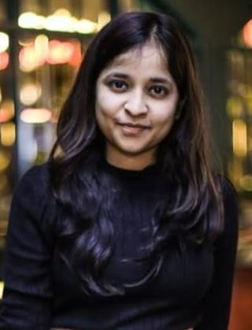

**Computer Science Engineer**

[divyadisha004@gmail.com](mailto:divyadisha004@gmail.com)

8826332428

[LinkedIn](https://www.linkedin.com/in/divya-disha-ba30981b8/) - [GitHub](https://github.com/DivyaDisha004)

# PROJECTS

**EDUCATION**

2020-2024

B.Tech in CSE(7.4 cg-7th sem) Jaypee Institute of Information Technology,Sector 62 ,Noida

2018-2020

Class 12th (CBSE)-94.8%

Vishwa Bharti Public School,Noida

2018-2018

Class 10th (CBSE)-96.2%

Vishwa Bharti Public School,Noida

**INTERNSHIPS**

**Software Engineering Intern at PNB**[Jun-Aug 2023]

* Helped in the designing the official website(.Net) for Punjab National Bank working with **CyFutureworks** -their **third party website management firm.**

**ACHIEVEMENTS**

* Qualified for **Google Step Internship** 2022 Finalist.
* **Google Cloud Program Member** & Conducted two sessions as Google DSC coordinator.
* Qualified for **TalentSprint WE by Google**, offered 50% Scholarship
* **Academic Excellence Award** – Scholarship and Cash Prize - 2018
* **Certificate of Merit from CBSE** for scoring 100/100 in Sanskrit AISSCE exams.

Aug 2022– present

**SIGN LANGUAGE PREDICTION USING HAMNOSYS AND SIGML -**

[GITHUB LINK](https://github.com/DivyaDisha004/Sign-Language-Synthesis)

* **Automated** a process to convert a technical video into sign language gestures using **SIGML player** and **HamnoSys** using **NLP**

Oct 2021–Jan 2022

## TRADE ANALYSIS USING PYTHON ,ML –

[GITHUB LINK](https://github.com/DivyaDisha004/tradeanalysis)

* Analyzing historical data of past trades(in CSV format)calculated various parameters (Total Trades,Profitable Trades ,loss making trades )using **python(pandas and numpy**)to identify whether to execute these trades or not.

Jan 2021– Feb 2021

**FITMATCH:FASHION RECOMMENDATION SYSTEM –** [GITHUB LINK](https://github.com/DivyaDisha004/FitMatch_fashion_recommender)

* Created a recommendation system that generates 5 most closely resembling image for any clothing piece using **feature extraction** on an already trained model using **ResNet** using **CNN.**

# RESPONSIBILITIES

* + Google Developers Student Club –Technical coordinator for

two consecutive years-2021-2023

* + Council Member,Incharge of Cleanliness & Hygience-School

## TECHNICAL SKILLS

* + Languages – Python , C++/C
  + Database – MySql, MongoDB
  + Development – React , Angular , HTML, CSS , Node
  + Data Science - ML , NLP, Data Analysis
  + Cloud – AWS , GCP
  + Excel, Canva , Powerpoint

## SOFT SKILLS

* + - Problem Solving
    - Leadership & Organisation - technical sessions , hackathons, youtube technical tutorials.
    - Classical Dance