

PROJECT AND TEAM INFORMATION

Project Title
(Try to choose a catchy title. Max 20 words).

MediQueue: Intelligent Patient Flow System

Student/Team Information

Team Name:  Team # (Mentor needs to assign) | SheTech (DBMS-V-T127)
Team member 1 (Team Lead)  (Last Name, name: student ID: email, picture): | Hans, Tiya – 23022024  tiyahans91@gmail.com  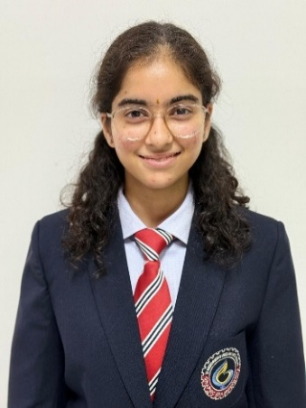
Team member 2  (Last Name, name: student ID: email, picture): | Ahuja, Sneha – 23022665  snehaahuja21305@gmail.com  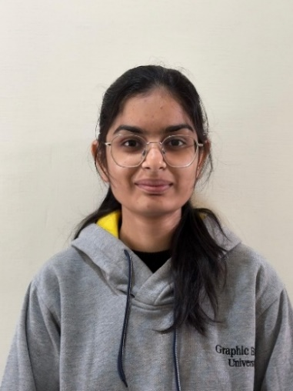
Team member 3  (Last Name, name: student ID: email, picture): | Bhardwaj, Shreya– 230221059  bhardwajshreya999@gmail.com  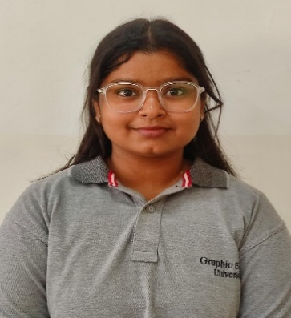
Team member 4  (Last Name, name: student ID: email, picture): | Garg, Divya - 230221186  divyagarg0801@gmail.com  

PROJECT PROGRESS DESCRIPTION (35 pts)

Project Abstract (2 pts)
(Brief restatement of your project’s main goal. Max 300 words).
The MediQueue project aims to develop an efficient, database-driven clinic management system that minimizes patient waiting time and enhances the overall workflow of healthcare operations. The system integrates multiple clinic functions — including patient registration, doctor scheduling, appointment booking, queue management, consultation tracking, and billing — into a single, centralized platform.
The main objective of MediQueue is to ensure smooth coordination between patients and medical staff through automation and real-time updates. It manages appointment scheduling with proper time slot allocation, maintains an organized live queue that automatically updates as patients are attended, and prioritizes emergency cases to ensure critical patients receive timely attention. Additionally, it generates billing records linked directly to patient appointments, ensuring transparency and accuracy in financial transactions.
The system is powered by a robust Database Management System (DBMS) that ensures data integrity, reliability, and efficient performance. This enables concurrency control for multiple bookings and ensures that all operations are secure and consistent.
Furthermore, MediQueue is designed with scalability in mind — allowing for the future integration of features such as appointment reminders, analytics, and automated notifications. By centralizing all clinic data and automating core processes, MediQueue not only reduces administrative workload but also significantly improves patient satisfaction and clinic efficiency.

Updated Project Approach and Architecture (2 pts)
(Describe your current approach, including system design, communication protocols, libraries used, etc. Max 300 words).
The MediQueue system is designed using a three-tier architecture comprising the Frontend, Backend, and Database layers, ensuring modularity, scalability, and ease of maintenance. Each layer communicates efficiently through RESTful APIs to deliver a seamless and real-time clinic management experience.
The frontend is built using React.js, providing an interactive and responsive interface for patients and administrators. Patients can register, log in, book appointments, and track their live queue position, while administrators can manage schedules, view patient details, and generate billing information. The interface is styled with Tailwind CSS, ensuring a clean and adaptive user experience across devices.
The backend is integrated using Flask (Python), acting as the communication bridge between the frontend and the database. The Flask application handles core functionalities such as appointment booking, queue updates, billing generation, and data retrieval through well-defined RESTful APIs. Flask ensures lightweight, fast, and secure backend processing, making it ideal for handling multiple requests efficiently.
The database layer uses MySQL, designed with normalization to eliminate redundancy and maintain consistency. It includes entities for patients, doctors, appointments, queues, and billing. Advanced DBMS features are used to ensure data integrity and quick access. For example, triggers automatically update queue positions when appointments are modified, and stored procedures calculate wait times dynamically.
Real-time queue updates are facilitated, ensuring that patients and staff view live queue changes instantly. Role-based authentication is implemented to maintain data privacy and secure access.
Overall, MediQueue employs a robust, API-driven architecture that combines React.js, Flask, and MySQL to deliver a reliable, real-time, and efficient clinic management solution.

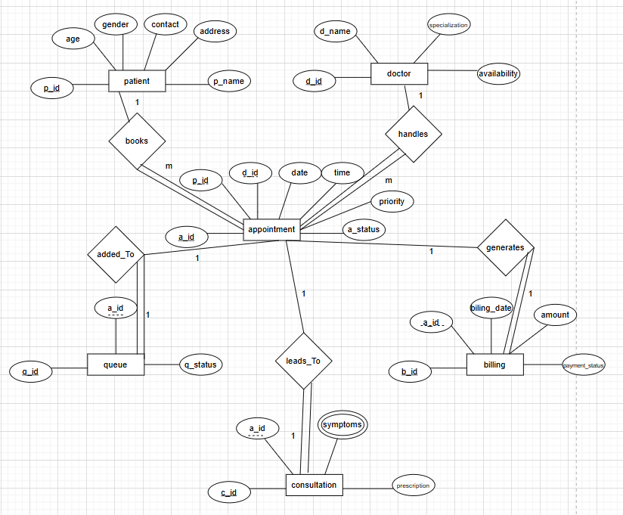

Tasks Completed (7 pts)
(Describe the main tasks that have been assigned and already completed. Max 250 words).
Task Completed | Team Member
Database Setup: Created the hospital database and designed tables for patients, doctors, appointments, queues, consultations, and billing.  Backend Configuration: Set up the Flask framework and established a successful connection with the MySQL database.  API Development: Implemented CRUD APIs for all major modules and tested them using Postman.  Frontend Progress: Designed frontend and began integrating them with backend APIs.  Frontend–Backend Integration: Connect all frontend pages fully with the Flask APIs for dynamic data flow. | Tiya Hans and Divya Garg  Divya Garg  Shreya Bhardwaj  Sneha Ahuja  Tiya Hans

Challenges/Roadblocks (7 pts)
(Describe the challenges that you have faced or are facing so far and how you plan to solve them. Max 300 words).
During the development of MediQueue, several technical and implementation challenges were encountered across different stages of the project.
1.Database Design Complexity: Designing a normalized MySQL database to handle patients, doctors, appointments, queues, consultations, and billing without redundancy was challenging. Ensuring proper relationships and data integrity required multiple iterations.
Solution: Using transactions, indexing, and triggers ensures data consistency and efficient query performance.
2. Real-Time Queue Management:
Implementing a live queue system that updates automatically for all users without delays was complex. Ensuring synchronization between multiple users accessing the system simultaneously required careful backend handling.
Solution: Flask-SocketIO or short-interval API polling is used to broadcast queue updates instantly, ensuring real-time synchronization.
3. UI Responsiveness and User Experience:
Ensuring consistent performance across devices and handling dynamic updates like queues and emergency prioritization posed design challenges.
Solution: Improved frontend using Tailwind CSS and modular React components for adaptability.
4. Future Feature Scalability: Planning for analytics, reminders, and notifications requires designing a flexible architecture.
Solution: Structured the system in a modular way to allow smooth integration of future features.

Tasks Pending (7 pts)
(Describe the main tasks that you still need to complete. Max 250 words).
Task Pending | Team Member (to complete the task)
1.UI Enhancements: Improve user experience, including responsive adjustments and minor design fixes.  2.Advanced Concurrency Control: Enhance booking system to fully handle simultaneous appointment requests without conflict.  3.Real-Time Queue Synchronization: Implement live updates for queue positions to replace API polling.  4.Analytics Module: Implement basic analytics dashboards for doctors/admins to track patient flow, appointment trends, and queue statistics.  5.Future Feature Integration Planning: Plan and implement placeholders for features like automated reminders, analytics dashboards, and notifications.  6.Final Testing & Deployment: Conduct end-to-end testing and prepare the project for deployment. | Sneha Ahuja  Shreya Bhardwaj  Tiya Hans  Divya Garg  All members  All members

Project Outcome/Deliverables (2 pts)
(Describe what are the key outcomes / deliverables of the project. Max 200 words).
The MediQueue project successfully delivers a fully functional, database-driven clinic management system that streamlines patient flow and improves clinic efficiency. The key outcomes include:
- Centralized Management System:
A unified platform to manage patient records, doctor schedules, appointments, queues, consultations, and billing efficiently.
- Appointment and Queue Module:
A real-time queue management system that automatically updates as patients are attended, along with appointment booking, rescheduling, and cancellation features.
- Priority Handling:
Automatic prioritization of emergency cases to ensure timely attention without disrupting scheduled appointments.
- Billing Integration:
A billing system linked with patient appointments, providing transparency and accuracy in payment records.
- Database Implementation:
A robust MySQL database with tables, and stored procedures ensuring data consistency, integrity, and quick access.
- User Interfaces:
Interactive and role-based dashboards for both patients and administrators built using React.js, ensuring smooth usability.
- Backend Services:
RESTful APIs developed with Flask (app.py) for seamless communication between frontend and database.

Progress Overview (2 pts)
(Summarize how much of the project is done, what's behind schedule, what's ahead of schedule. Max 200 words.)
The development of MediQueue is progressing steadily, with most of the core components already implemented and tested. The frontend interface using React.js is nearly complete — including pages for patient registration, appointment booking, queue display, and the admin dashboard. The backend, built using Flask (app.py), is fully functional with RESTful APIs handling patient data, appointment scheduling, queue updates, and billing operations. Integration between the frontend and backend has been successfully established.
The database design in MySQL, including tables, relationships, and stored procedures, has been completed and tested for data integrity and consistency. The real-time queue management feature is under active development, with basic updates functioning through API polling is still in progress.
Documentation, testing, and deployment setup are scheduled for the next phase. So far, all major milestones such as requirement analysis, database setup, and core functionality have been completed on time. However, real-time synchronization and advanced concurrency control are slightly behind schedule due to integration complexity.

Codebase Information (2 pts)
(Repository link, branch, and information about important commits.)
The MediQueue project is maintained in a GitHub repository that tracks all development progress, version history, and collaboration updates.
- Repository Link: https://github.com/DivyaGarg0801/MediQueue-Intelligent-Patient-Flow-System
- Main Branch: main – contains the latest stable version of the project.
Important Commits:
- Initial Commit – Set up the project structure with React frontend and Flask backend folders.
- Database Setup Completed – Added MySQL schema, relationships, and triggers for appointments, queues, and billing.
- Flask API Integration – Implemented RESTful APIs in app.py for appointment booking, queue updates, and billing generation.

Testing and Validation Status (2 pts)
(Provide information about any tests conducted)
Test Type | Status (Pass/Fail) | Notes
Database Connectivity  Patient Registration  Appointment Booking  Frontend-Backend Integration | Pass  Pass  Pass  Pass | Successfully connected Flask backend with MySQL database.  New patients can register and data is stored correctly.  Appointments can be booked, rescheduled, and canceled without errors.  React frontend successfully  communicates with Flask APIs.

Deliverables Progress (2 pts)
(Summarize the current status of all key project deliverables mentioned earlier. Indicate whether each deliverable is completed, in progress, or pending.)
1. Centralized Management System: Completed – All modules for patients, doctors, appointments, queues, consultations, and billing are integrated.
2. Appointment and Queue Module: In Progress – Appointment booking and basic queue updates work; real-time queue synchronization .
3. Priority Handling for Emergencies: In Progress – Emergency cases are automatically prioritized in the queue.
4. Billing Integration: In Progress – Billing is linked with appointments and generates accurate records.
5. Database Implementation: Completed – MySQL database with normalized tables, relationships, triggers, and stored procedures is fully functional.
6. User Interfaces (Frontend): In Progress – React.js dashboards for patients and admins are fully functional and responsive.
7. Backend Services (Flask APIs): Completed – RESTful APIs in app.py handle core operations and communicate effectively with the frontend.

