**Assignment 2.1**

**Task 1:**

Check whether /user/acadgild directory exists or not in the HDFS.

If it doesn't exist, then create this.

Create a directory /user/acadgild/hadoop.

**Solution:**

1. Hadoop directory exists or not.

Hadoop directory is not exists,so create directory ‘hadoop’.

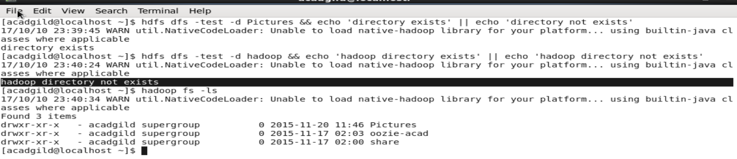

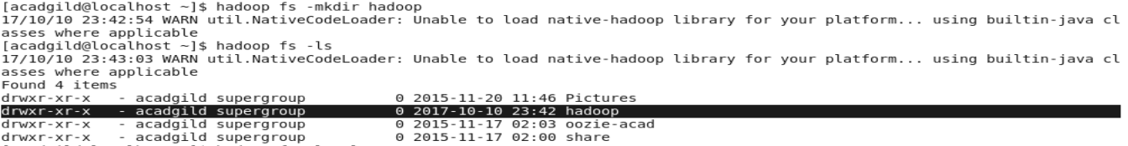

**Task 2:**

Create a file in HDFS under directory /user/acadgild/hadoop, with name word-count.txt.

Whatever we type on screen should get appended to the file.

Try to type (on screen) few lines from any online article or textbook.

1. Using touchz and put

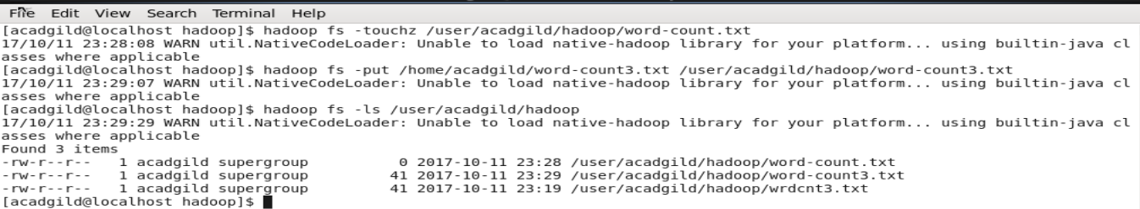

**Other Examples:**

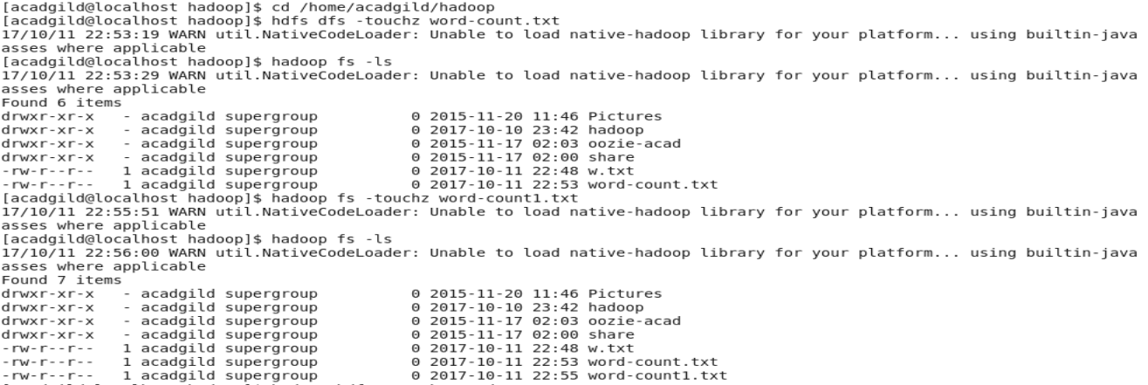

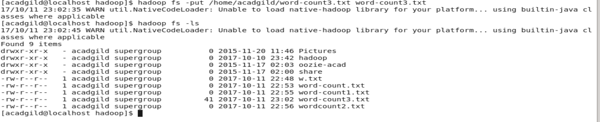

**Append text from command prompt to file-word-count.txt**

