1) Write a java code with the class named ‘acad’ and a method ‘main’. Hard Code the program

with two integers and print the sum of those two.

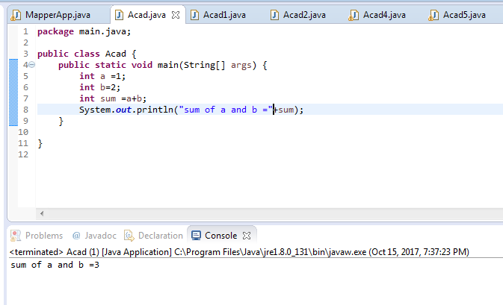

2) Rewrite the above code, where, inputs are provided by the user at runtime and the output is

printed.

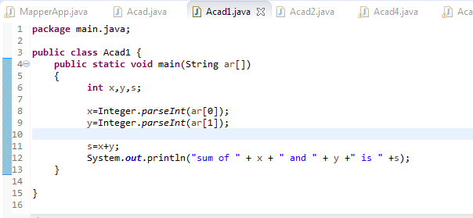

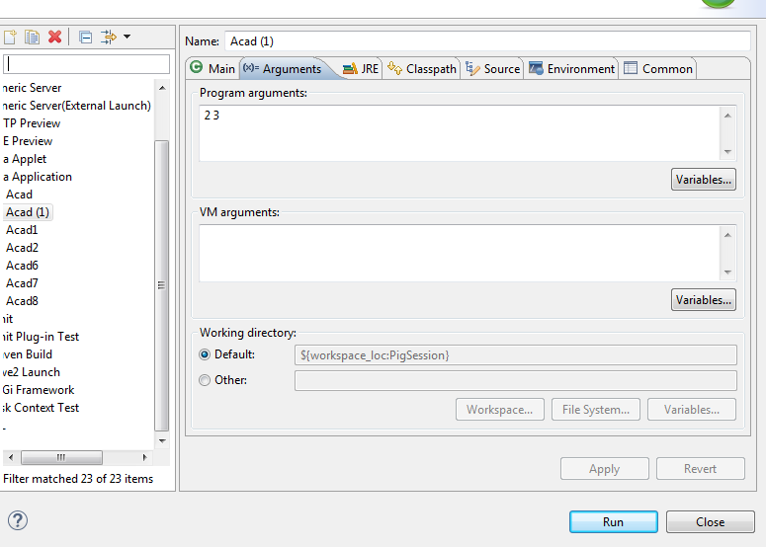

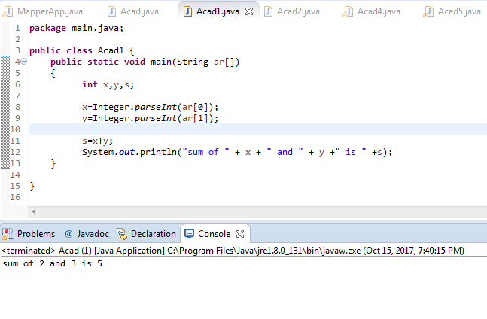

3) Write a program with method name sum() that accepts two parameters from user and print

the sum of two numbers. Output format should be as:

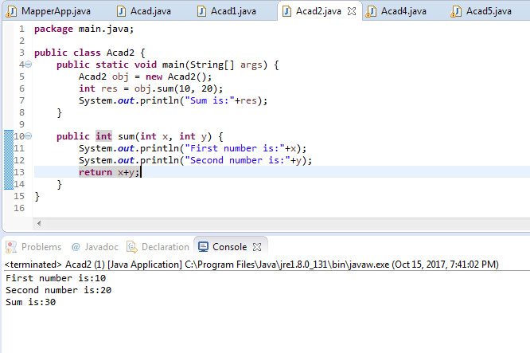

4) Write a program to accepts two numbers from stdin and find all the odd as well as even

numbers present in between them.

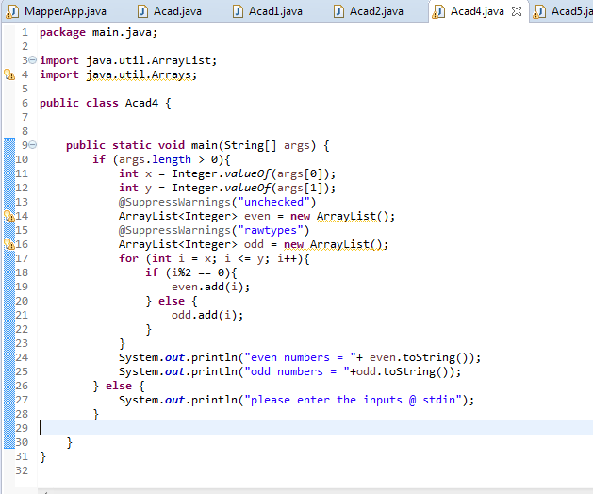

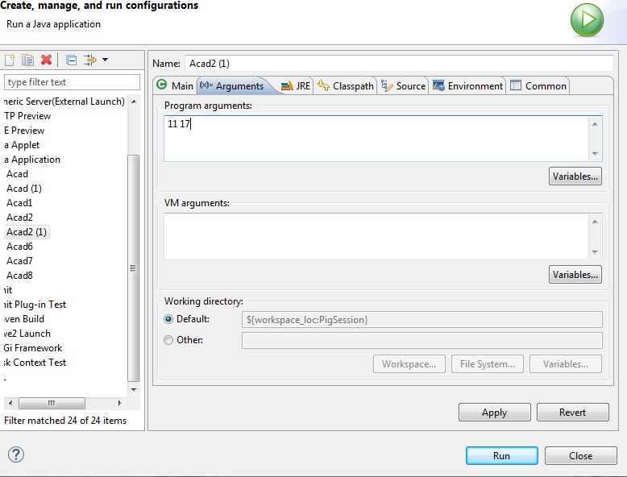

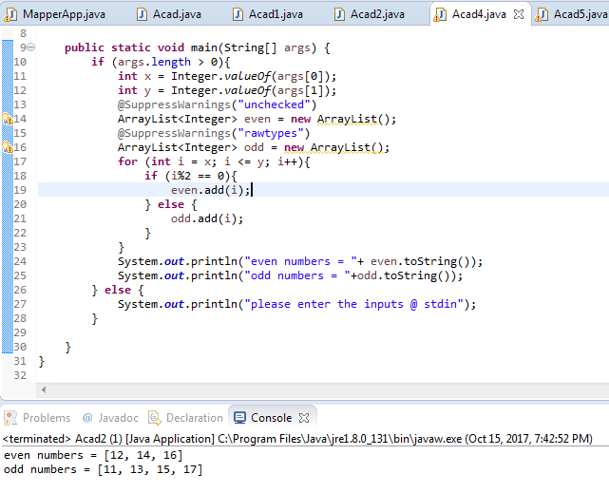

5) Joe is scared to go to school. When her dad asked the reason, joe said she is unable to

complete the task given by her teacher. The task was to find the “first 10 multiples” of the

number entered from stdin .

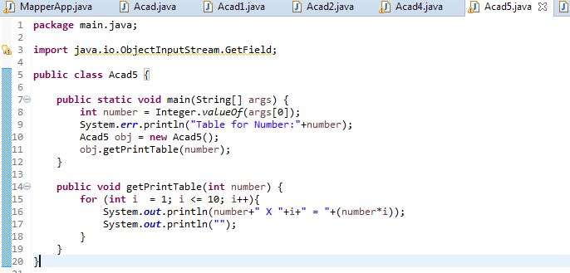

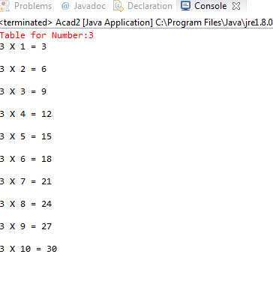

6) Write a program consisting method sum() and demonstrate the concept of method

overloading using this method.

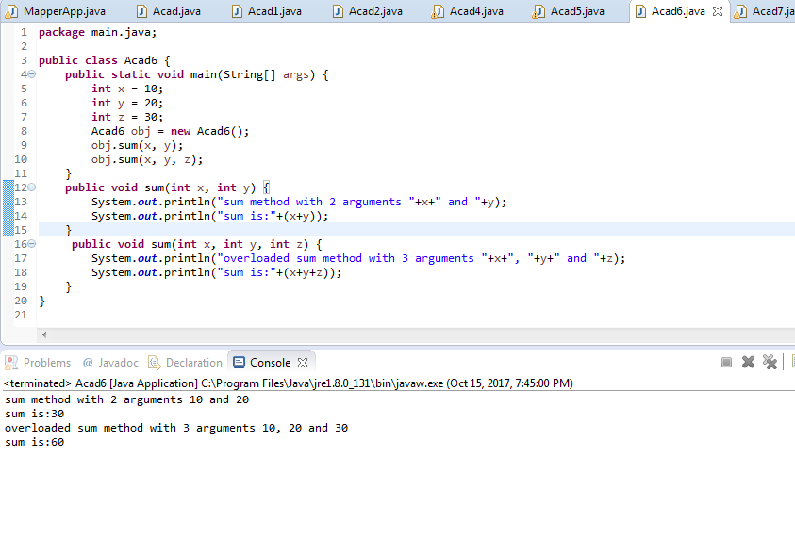

7) Can you overload a method with same return type.? Explain your answer with proper logic.

Yes we can overload

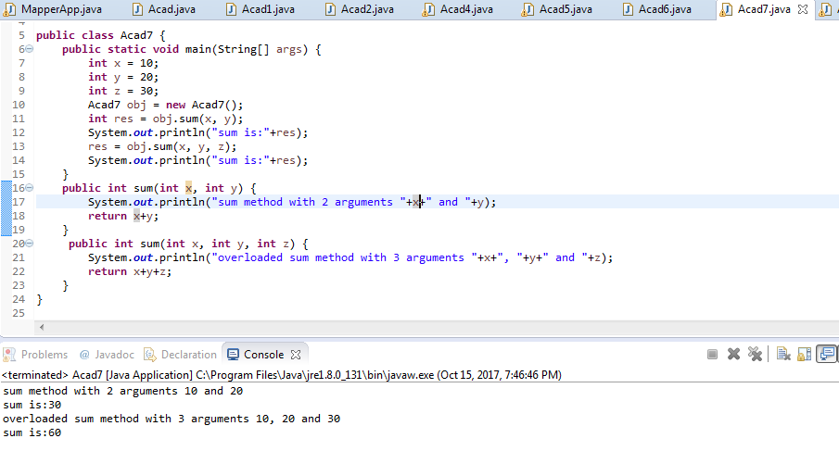

8) Write a program in java using Arrays, that sorts the element in descending order.

