**Assignment 1.1**

**Installation of Acadgild VM into Oracle Virtual box**

**Step1:** Install the virtual box into local machine and import the Acadgild vm to virtual box.

Start the imported VM by clicking on start button.

While starting VM, it asks for password. Enter “acadgild” as password.

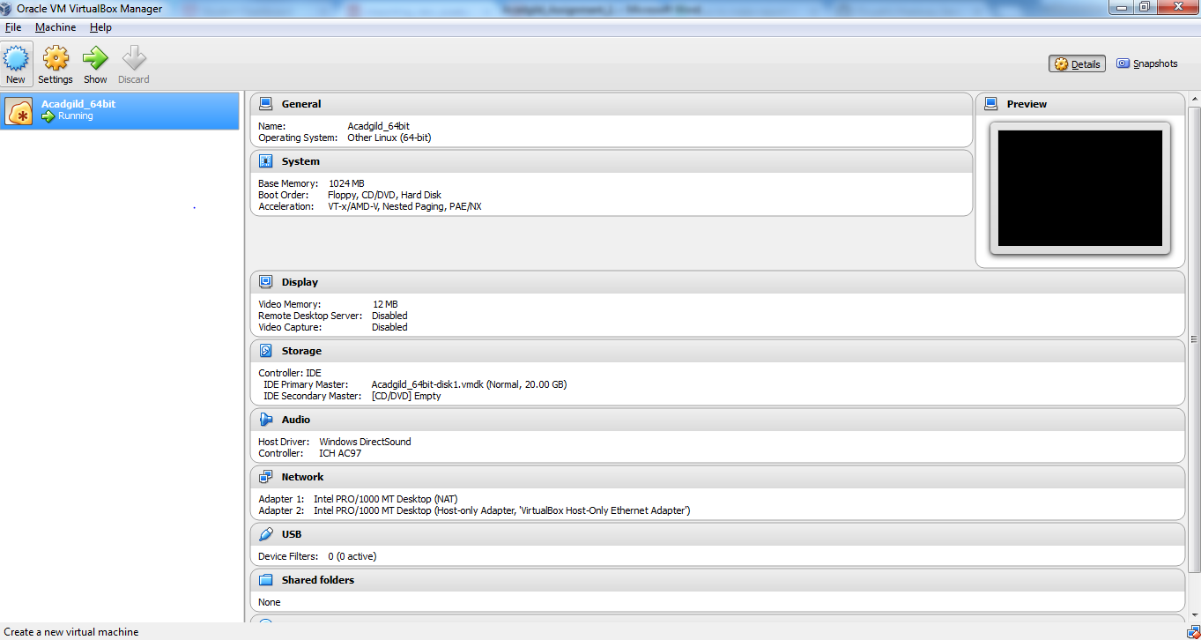

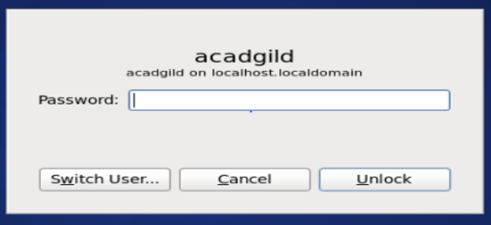

**Step 2:** Once you logged into VM, open the terminal and type jps in order to check the running services (daemons) in VM.

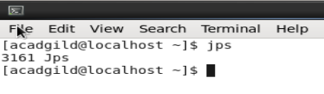

**Step 3:**

SSH is a secure protocol used as the primary means of connecting to Linux servers remotely.

Starts the ssh server by giving password ‘acadgild’ for authentication.

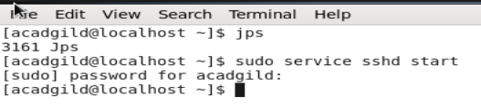

**Step 4:**

Start all the daemons by typing command **‘start-all.sh’**.

Type jps command to list out the running daemons.

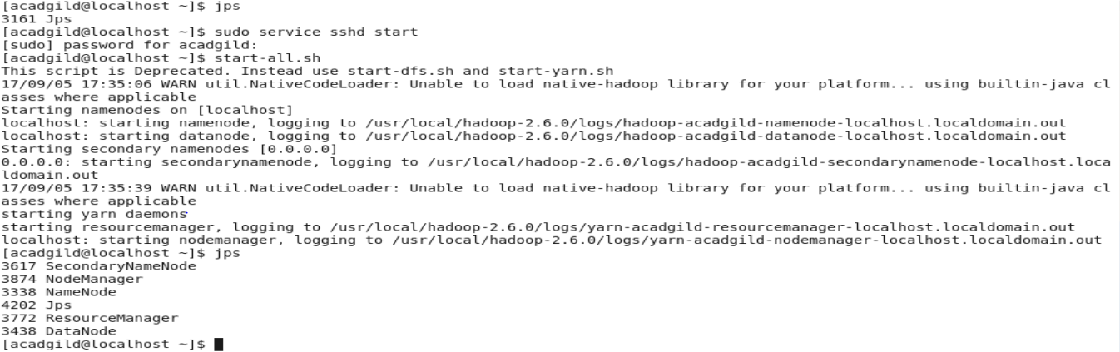

**Step 5:**

HistorySever maintains information of MapReduce applications executed over the cluster.

Start the history server.

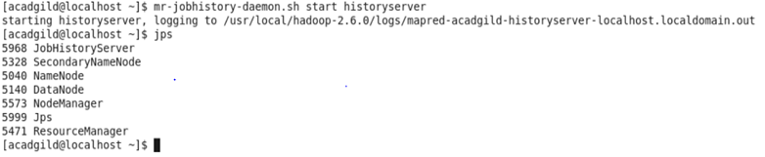

**Step 6:**

Type ‘pig’ in terminal to start the pig in hdfs mode.

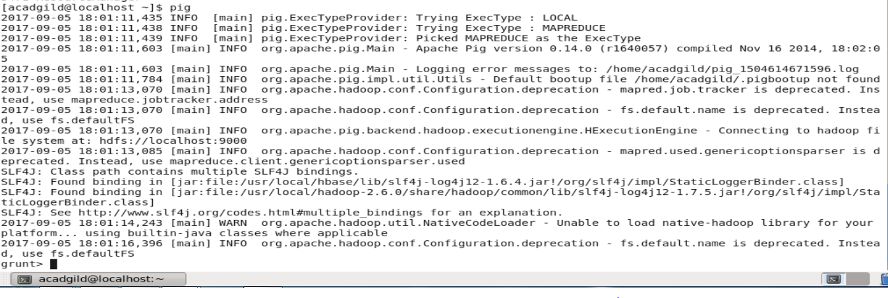

**Step 7:**

**To start hive, we need to start mysql service first and then type hive in command prompt.**

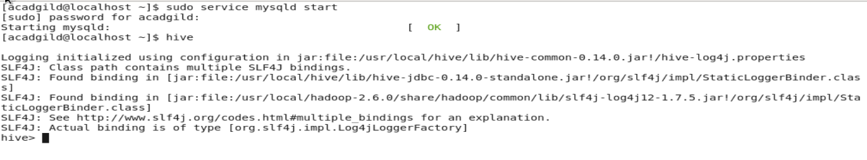

**Step 8:**

To start the hbase, type the command start-hbase.sh in command prompt.

