Project Name: The House of Crafts

Presented by: Divya Janaki

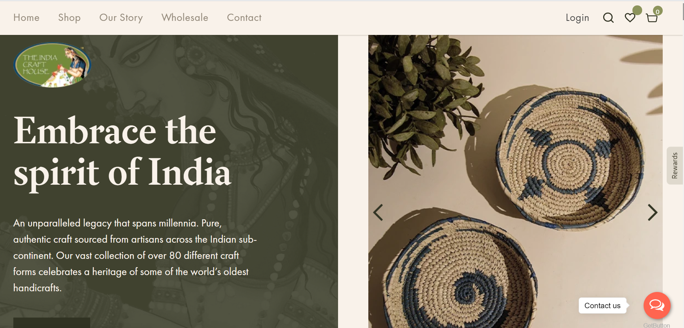

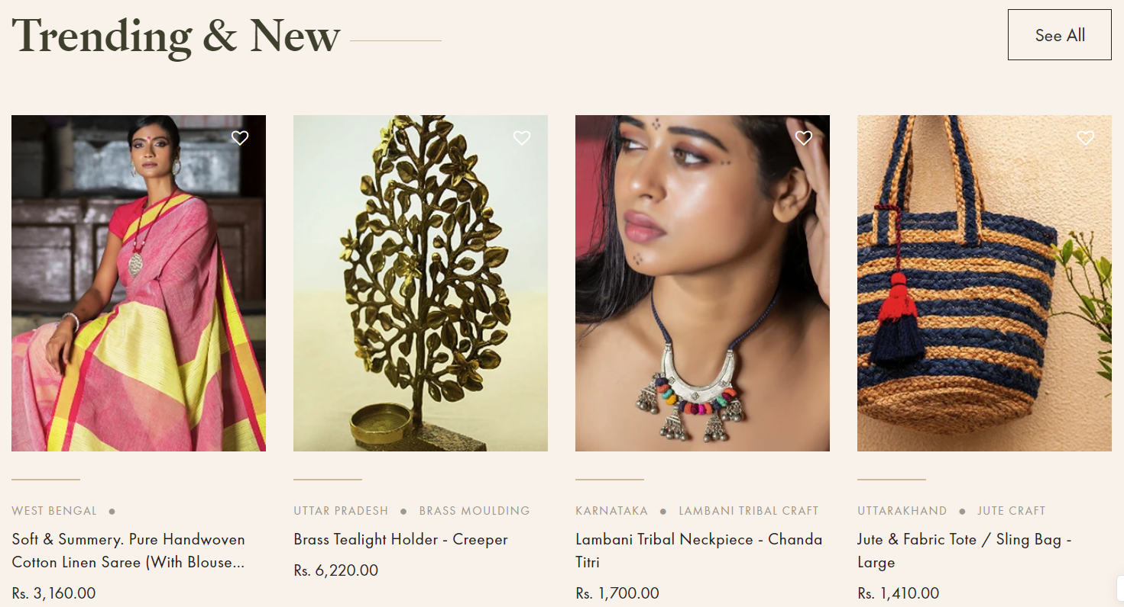

Overview

The House of Crafts is a digital platform for some of the world’s oldest and most intricate craft forms. We started this social enterprise in order to preserve, showcase and share the talent of India’s artisans with the world. We hope to be able to raise the dignity of the Indian artisan in our own way and kindle an interest and support for an unsurpassed legacy of craft that spans millennia and spreads across the length and breadth of the land. It is our effort to curate an undeniably unique selection of traditional art and craft translated into a range of beautiful, contemporary products.

Goals

* Home Page
* Login/SignUp Page
* Cart and Wishlist
* Product Page
* Checkout Page
* Customer Details Page
* Share your story Page
* Contact us Page

TechnologyUsed

Front-End:

* Html
* Css
* Bootstrap
* React

Dynamic:

* Javascript
* Ci/cd with AWS
* Login and logout (oauth and jwt)

Database:

* Mongodb
* Json Data

Code Compiler:

* Visual studio code
* Git bash
* Git hub
* Node js.