Amazon EC2
Amazon EC2 is a web service that provides secure, resizable compute capacity in the cloud. With this service, you can provision virtual servers called EC2 instances.
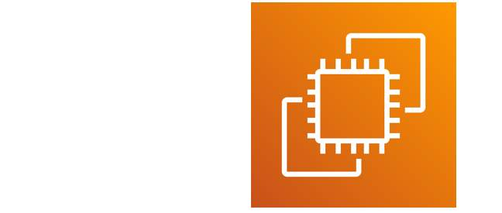
With Amazon EC2, you can do the following:
- Provision and launch one or more EC2 instances in minutes.
- Stop or shut down EC2 instances when you finish running a workload.
- Pay by the hour or second for each instance type (minimum of 60 seconds).
To create an EC2 instance, you must define the following:
- Hardware specifications: CPU, memory, network, and storage
- Logical configurations: Networking location, firewall rules, authentication, and the operating system of your choice

AMI
An AMI is a pre-configured template that contains:
- An operating system (like Linux, Windows)
- Application server (like Apache, Nginx)
- Applications (like a web app or database)
- Custom configurations and permissions
It is used to launch EC2 instances (virtual servers) in AWS.
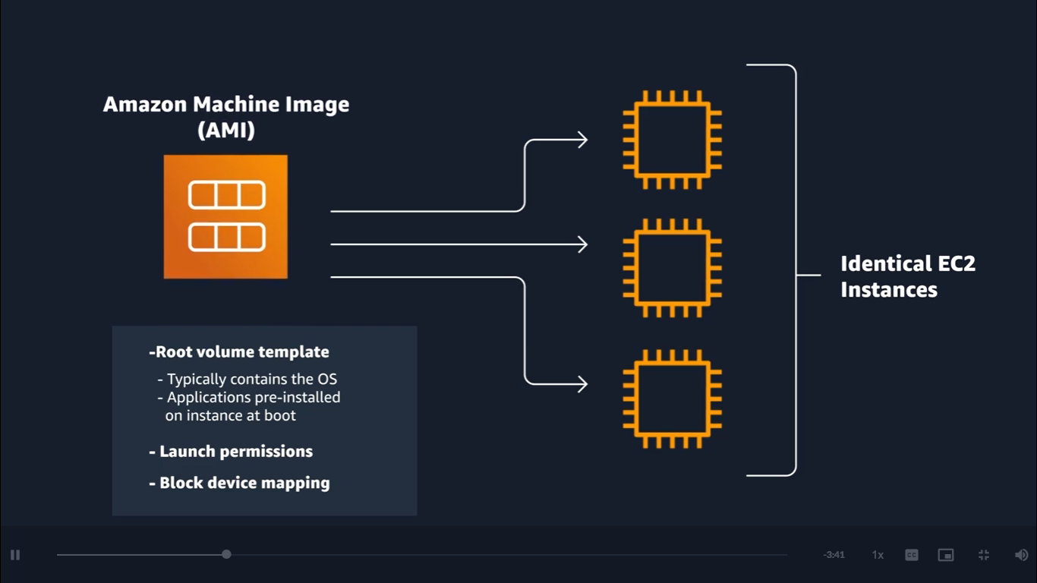
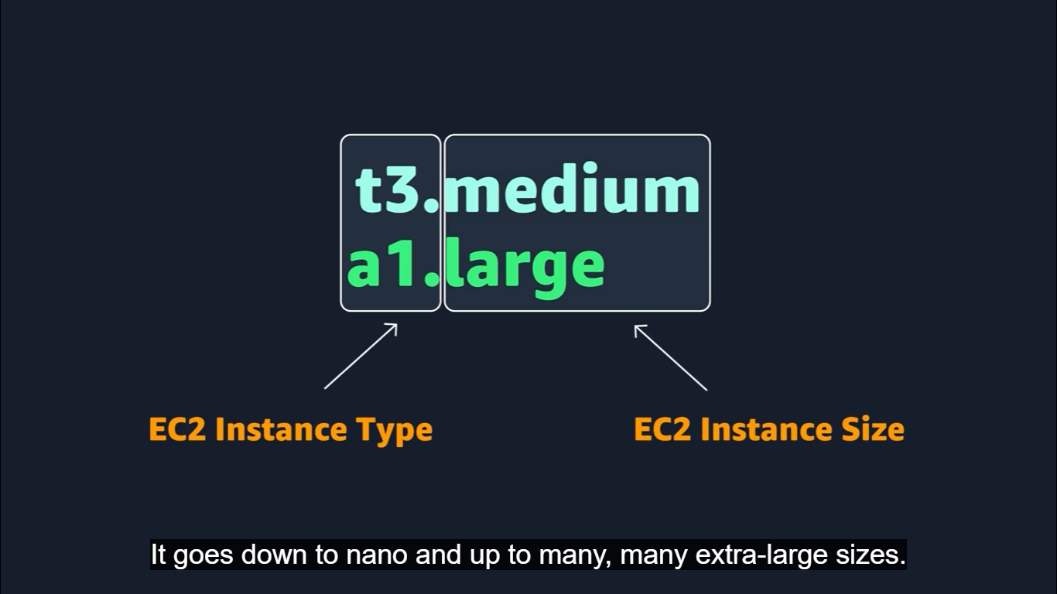

An AMI includes the operating system, storage mapping, architecture type, launch permissions, and any additional preinstalled software applications.

Relationship between AMIs and EC2 instances
EC2 instances are live versions of what is defined in an AMI.
AMI – is a how you model and define your instance
EC2 – is entity where you interact with, or where you can install the web server and serve your content to users.
the AMI that you selected is copied to the root device volume, which contains the image that is used to boot the volume.
When you launch a new instance, AWS allocates a virtual machine that runs on a hypervisor.
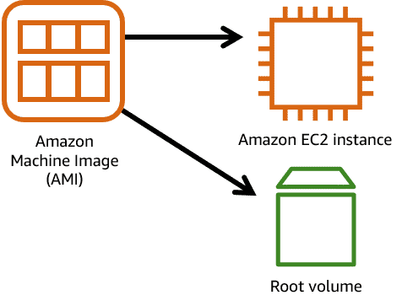

Advantages of AMI: Reusable
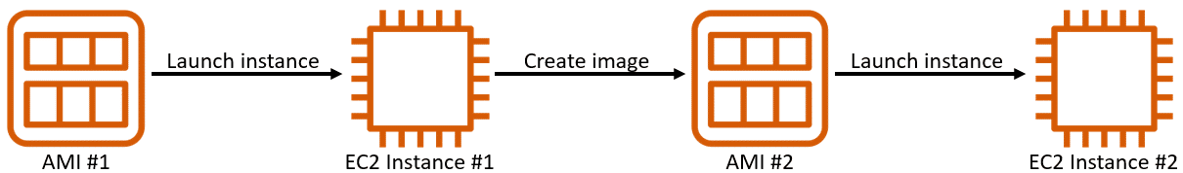

There are multiple ways to select an AMI.
- Quick Start AMIs: - commonly used AMIs created by AWS that you can select to get started quickly.
- AWS Marketplace AMIs: - This provides popular open-source and commercial software from third-party vendors.
- My AMIs: - created from your EC2 instances.
- Community AMIs: - provided by the AWS user community.
- Custom image: - Build your own custom image with EC2 Image Builder.

AMI consists of AMI ID, which is prefixed by ami-, followed by a random hash of numbers and letters. The IDs are unique to each AWS Region.

Configuring EC2
Amazon EC2 instance types
EC2 instances are a combination of virtual processors (vCPUs), memory, network, and, in some cases, instance storage and graphics processing units (GPUs).
When you create an EC2 instance, you need to choose how much you need of each of these components.
AWS offers a variety of instances that differ based on performance.
Instance types consist of a prefix identifying the type of workloads they’re optimized for, followed by a size.
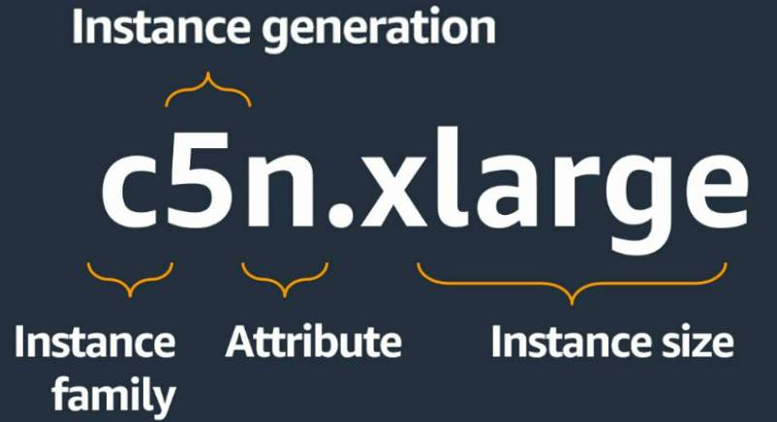
Instance Family
Each instance family is optimized to fit different use cases.
- General purpose
- Compute optimized
- Memory optimized
- Accelerated computing
- Storage optimized
- HPC optimized
EC2 instance locations
When you launch EC2 instances, they are placed in a default virtual private cloud (VPC).
The default VPC is suitable for getting started quickly and launching public EC2 instances without having to create and configure your own VPC.
Any resource that you put inside the default VPC will be public and accessible by the internet
Resources
For more information, see the following resources:
- AWS website: Amazon EC2(opens in a new tab)
- AWS user guide: Amazon Machine Images (AMI)(opens in a new tab)
- AWS user guide: Creating an Amazon EBS-Backed Linux AMI(opens in a new tab)
- AWS user guide: What Is EC2 Image Builder?(opens in a new tab)
- AWS user guide: Default VPCs(opens in a new tab)
- AWS whitepaper: Reliability Pillar - AWS Well-Architected Framework

