Git init – initialize the git project
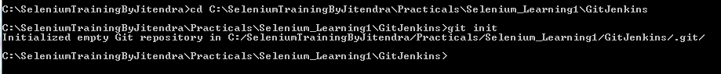
Git status – u will get all the files ()
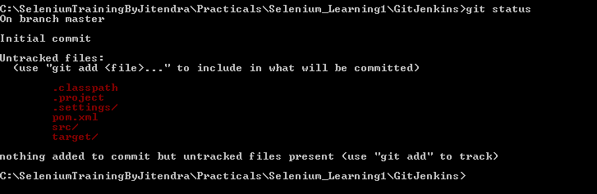

Untracked – “git status” all are untraceked file
Staged
Committed
Git has auto checkin – out functionality.

Working directory staging area repo
|--------- git add --------|----git commit---|
Git commit happen in ur local system.

Git add ---
Through that you can add the file inside git.
No class file & executable file never get checkinto git. (using “git add” command)
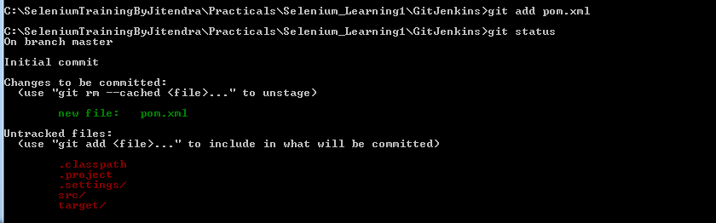

For untracked
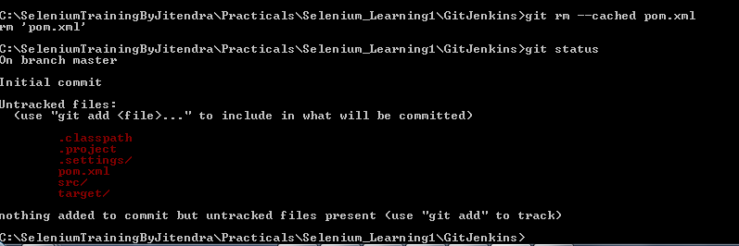

Staging area :
If u want to go Staging area add the file into the git using below command:
Git add pom.xml (1 by 1 all file)
Git add . (all together)
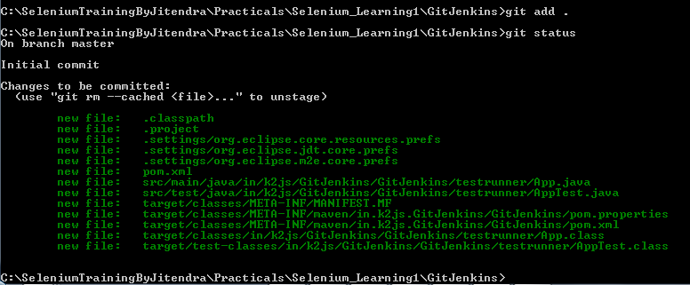

Git config global username ‘Trishna’
Git config global user email ‘trisharoy.009@gmail.com’
Then commit : -- it will unique identifier.
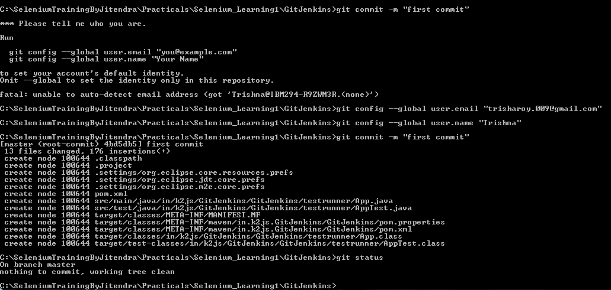

Git log :
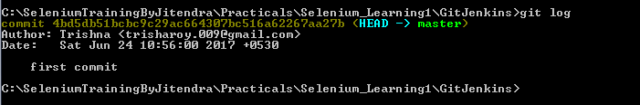
Modify in a file – git status – git add – angain modify file – git status
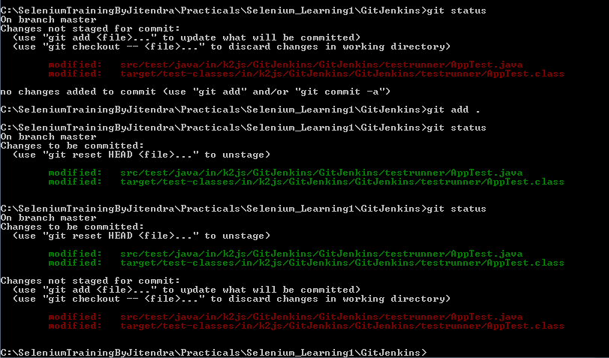
Checkout all the file (means all will be working area after this command)
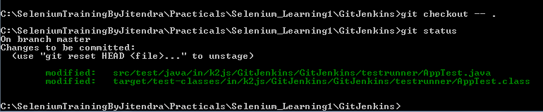
Reset HEAD – menas it checkout the source code.
Reset the HEAD – checkout --- status
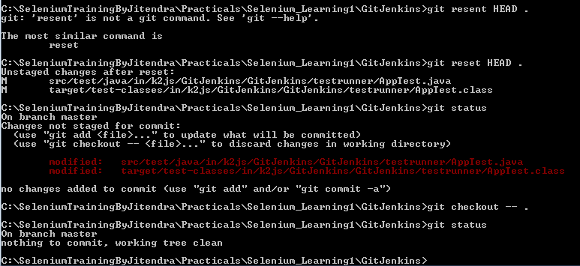

Git add --- git commit for deleting the file permanentlay from repo
Git commit :
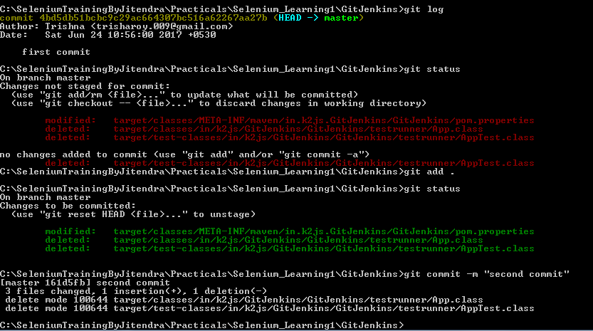

We have to push the changes to the server.
Client1---- control repository (bitbucket)
Client2---- |
Client3---- |-------C1 build server
Jenkins (jar,war … etc)
|
|-----------------Repo (released for production)

Git init – initialize the repository.its a 1 time activity.
.gitignore – whatever file u want to ignore you have to gv the file name with extension or u have to gv the folder name in the .gitignore file. Separated by new line for multiple
Git init
Git add
Git status
Git log ---
Git commit
Git checkout
Git reset
Git stash
Git diff

Created .gitignore file
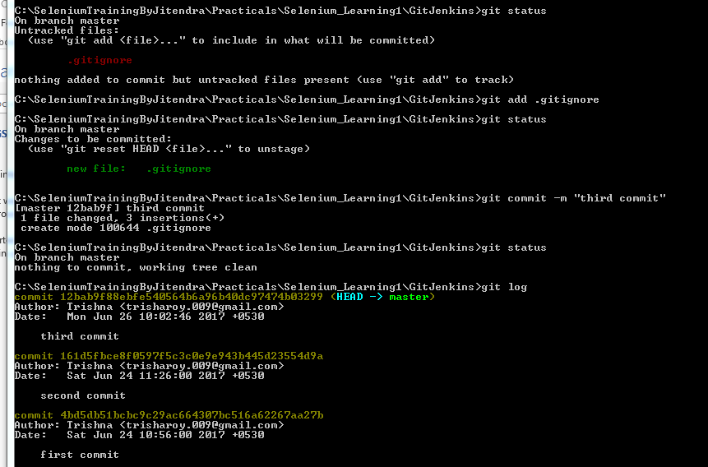

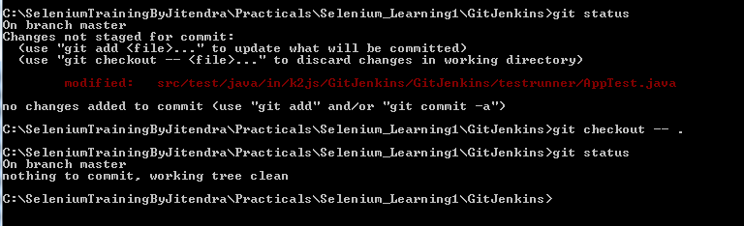

Working directory -------------------> staging area ---------------→ Repo

Working directory --------add-----------> staging area
Working directory <--------reset---------- staging area
Outside the everything←------checkout-------- working directory

Each commit =
Head / Master
Commit1 --- > commit2 --- > commit3|

Change file
Add
Commit < --- head
Change file
Add
Commit < --- head
Change file
Add
Reset HEAD~1
Checkout –m .
Then we will get the 1st changes what we have did. Commit will work like linklist keep on backside.
Last commit is the head point. HEAD~1 will be imidiate backside one. HEAD~2 will be imidiate backside 2nd one. Like that .

Stash – snapshot --- > store away.
Capture the current state of your code that is working or statging.
Working directory will be clean.

Make changes in 3 files
Git add 2 files
Git stash – cleaning the working & staging area.
Git status
Git stash list
Git pop / apply <stash no>

Git diff:
Git diff : (move working to repo)
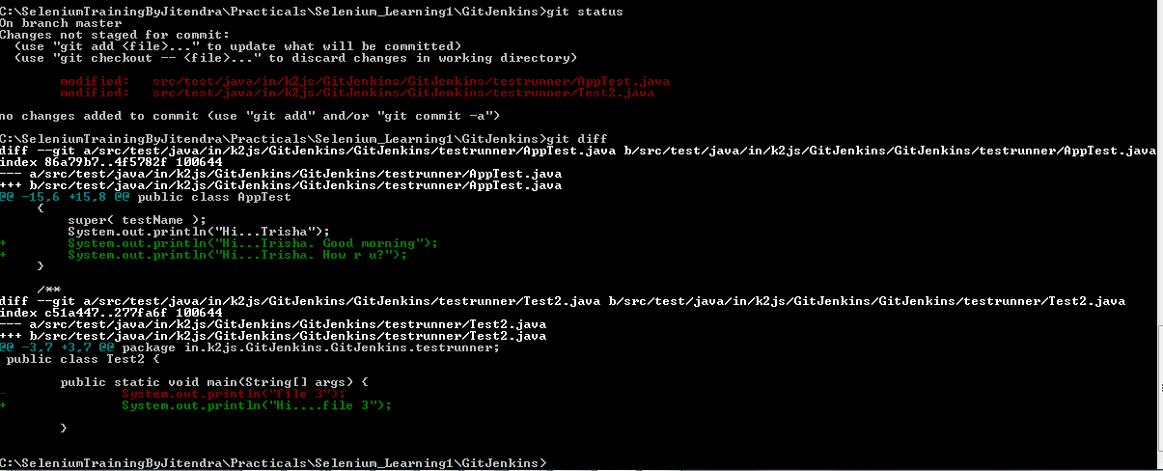

Add the file and diff it :
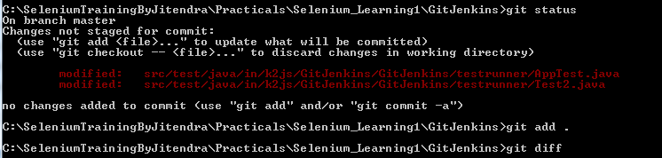

Git diff –cached : (move staging to repo)
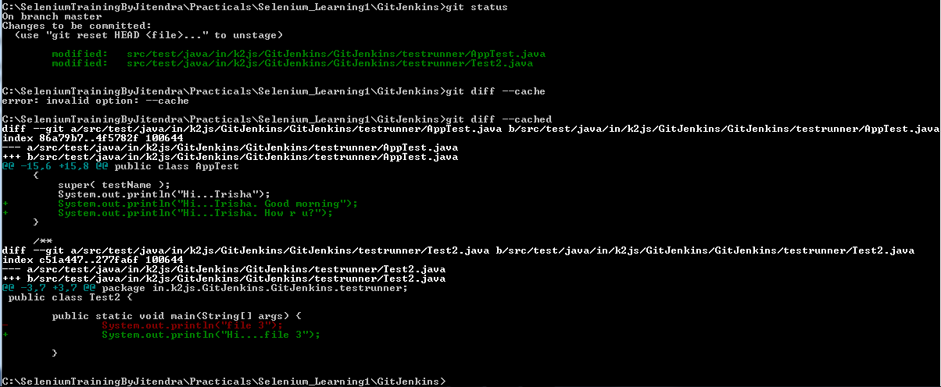

Git revert :
Reverting the commit.
Commit commit
File 1 ------------ > file 1
Git revert <log id>

As a developer we are working :
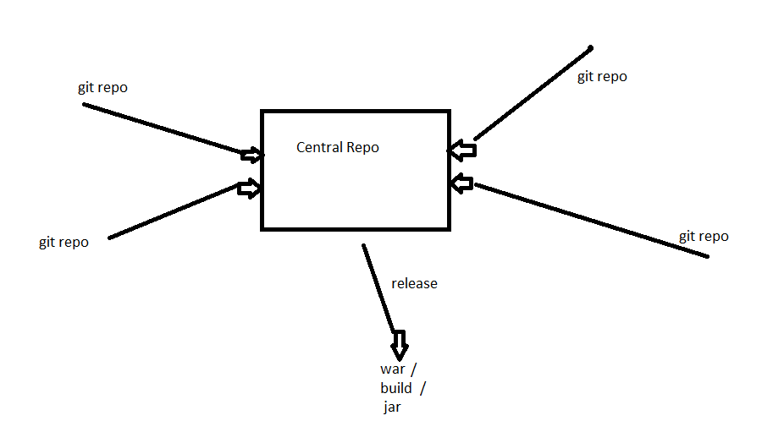

CI ------------------- > CD
Continuous Continuous
Integration Deployment
jenkins

