1. Use Cases:
   1. Vehicle owner Registration
   2. Vehicle owner Login
   3. Vehicle Registration
   4. Vehicle user registration
   5. Vehicle User Login
   6. Vehicle booking
2. Class Diagrams:

Classes:

1. VehicleeApplication.java

1. Resources:

Applicaton.properties:

Templates:

Home.html: Login Page

Welcome.html: Displays when login is successful

Register.html: Contains Vehicle details for registration

Success.html: Displays when vehicle is registered successfully

1. Logging/Error Handling:
2. DB install:

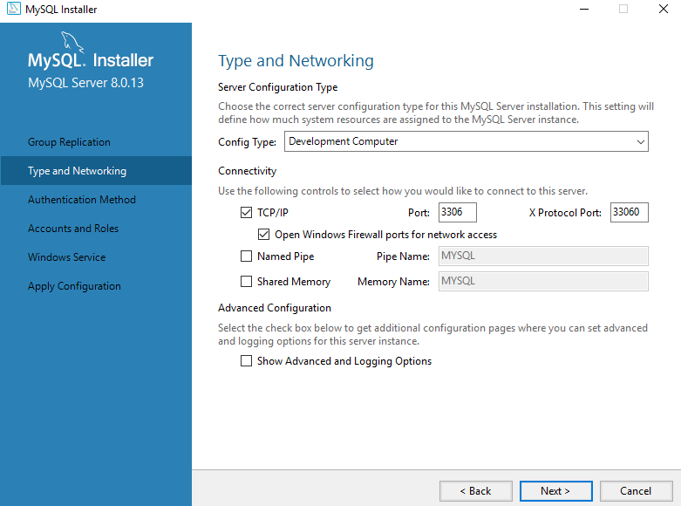

Password: abc@123

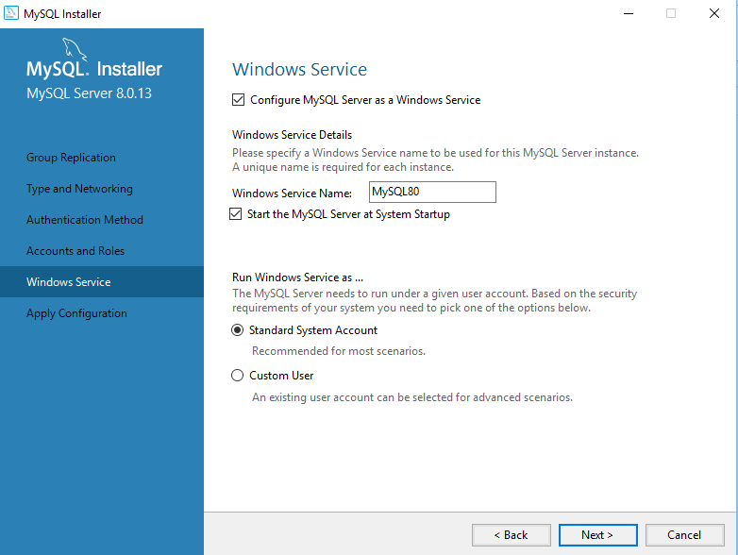

User

Name

Email

phone

Vehicle