**MOBILE SEGMENTATION ANALYSIS USING POWER BI**

A minor project report submitted to

**DEPARTMENT OF**

**ELECTRONICS AND COMMUNICATION ENGINEERING**



**By**

21MQ1A0414 PUPPALA DIVYA JYOTHI

21MQ1A0487 KATAKAM LAVANYA

22MQ5A0401 BUSANABOYINA DHANALAKSHMI

*Under the Esteemed Guidance of*

**S. AKSHAY KUMAR**

*Technical Trainer, ICT Academy*

**DECLARATION**

I **PUPPALA DIVYA JYOTHI (21MQ1A0414)** declared that the dissertation report entitled **“MOBILE SEGMENTATION ANALYSIS”** is no more than 1,00,000 words in length including quotes and exclusive of tables, figures, bibliography, and references. This dissertation contains no material that has been submitted previously, in whole or in part, for the award of any other academic degree or diploma. Except where otherwise indicated this dissertation in our own work.

**Roll No Name Signature**

21MQ1A0414 PUPPALA DIVYA JYOTHI

Date :

Place : Nandamuru

**ACKNOWLEDGEMENT**

We express our sincere thanks to **S. AKSHAY KUMAR** , technical trainer for providing support and simulating environment for developing the project.

We express deep sense of reverence and profound gratitude to **SH. AHMED MOHIDDHIN, M.Tech(Ph.D**), Associative Proffessor, ICT CO-ORDINATOR for providing us the great support in carrying out the project.

It plunges us in exhilaration in taking privilege in expressing our heartfelt gratitude

**SK. ZELANI M.Tech, Ph.D,** Head of the Department ELECTRONICS AND COMMUNICATION ENGINEERING for providing us every facility and for constant supervision.

We are thankful and grateful to **DR. B R S REDDY, M.Tech , Ph.D,** Principal Sri Vasavi Institute of Engineering and Technology for his encouragement, suggestions, supervision and abundant support throughout the project.

Thanks to all the teaching and non-teaching staff and lab technicians for their support and also to our team mates for their valuable Co-operation.

**Roll No Name Of The Student**

21MQ1A0414 PUPPALA DIVYA JYOTHI

21MQ1A0487 KATAKAM LAVANYA

22MQ5A0401 BUSANABOYINA DHANALAKSHMI

**TABLE OF CONTENTS**

Abstract  **5**

Problem Statement **6**

Feasibility Study **7**

1. Introduction  **9**

2. Motivation & Objective  **10**

* 1. Motivation **11**
  2. Objective **11**

3. Software and Hardware Requirements **12**

* 1. Software Requirements **13**
  2. Hardware Requirements  **13**

4. Keywords & Definitions **14**

* 1. Keywords **15**

4.2 Definitions **16**

5. Designing & Proposed System **18**

5.1 Designing  **18**

5.2 Proposed System  **18**

6. Methodology **20**

7. Result **22-23**

8. Conclusion **25**

9. Future Scope **27**

**ABSTRACT**

This abstract presents a comprehensive analysis of mobile segmentation based on various attributes, including brand, memory, model, storage, selling value, buying value, year, day, and colour. The study aims to identify distinct consumer segments within the mobile market, focusing on how these attributes influence purchasing decisions and consumer preferences. By employing statistical methods and data visualization techniques, the analysis reveals patterns in consumer behaviour linked to specific brands and models, highlighting the impact of memory and storage options on perceived value. Additionally, the research examines the temporal aspects of mobile purchases, analysing how year and day of purchase affect market trends and consumer choices. Colour preferences are also explored, demonstrating their significance in branding and marketing strategies. The findings provide valuable insights for manufacturers and retailers, enabling them to tailor their offerings and marketing efforts to align with consumer demands and maximize sales potential. Overall, this segmentation analysis contributes to a deeper understanding of the mobile market landscape and consumer dynamics.

**PROBLEM STATEMENT**

Problem Statement: In the rapidly evolving mobile market, understanding consumer preferences is crucial for effective marketing and product development. However, there is a lack of comprehensive analysis that examines how various factors such as brand, memory, model, storage, selling value, buying value, year, day, and colour contribute to mobile segmentation. This study aims to fill this gap by investigating the relationships among these attributes to identify distinct consumer segments, uncovering insights that can inform strategic decisions for manufacturers and retailers in a competitive landscape.

**FEASIBILITY STUDY**

**Introduction:**

The mobile phone industry is dynamic and competitive, necessitating a deep understanding of consumer preferences to drive business success. This feasibility study aims to assess the practicality of conducting a mobile segmentation analysis to identify distinct consumer segments based on various attributes such as brand, memory, model, storage, selling value, buying value, year, day, and colour.

**Market Analysis:**

The mobile market is characterized by diverse consumer needs and preferences. With numerous brands and a wide range of models, understanding how different factors influence purchasing decisions is crucial. A segmentation analysis can reveal patterns and trends that inform product development and marketing strategies. The growing reliance on mobile devices makes this analysis increasingly relevant for manufacturers and retailers.

**Data Availability:**

For effective segmentation analysis, data must be collected from reliable sources. This includes sales data, consumer surveys, and market research reports. Information on consumer demographics, preferences for specific brands and models, memory and storage requirements, and pricing can be gathered. Additionally, temporal data related to the year and day of purchase can help identify seasonal trends in consumer behaviour.

**Methodology**:

The analysis will employ statistical techniques such as clustering and regression analysis to segment the market effectively. By grouping consumers based on their preferences and behaviours, the study can identify distinct market segments. Data visualization tools will also be utilized to present findings in an accessible manner, making it easier for stakeholders to understand consumer trends.

**Cost and Resources:**

The feasibility of this study will depend on the resources required for data collection and analysis. Initial costs may include purchasing data sets, employing data analysts, and utilizing software tools for analysis. However, the potential benefits, such as improved targeting of marketing efforts and increased sales, can outweigh these costs, making the study a worthwhile investment.

**Conclusion:**

Conducting a mobile segmentation analysis is feasible and offers valuable insights into consumer behaviour in the mobile market. By leveraging available data and employing effective methodologies, businesses can enhance their understanding of market dynamics and make informed decisions to improve their competitive positioning. This analysis has the potential to drive growth and enhance customer satisfaction in a rapidly changing industry.

**CHAPTER 1**

**1. INTRODUCTION**

In the rapidly evolving landscape of the mobile phone industry, understanding consumer behaviour is essential for brands to tailor their strategies effectively. Mobile segmentation analysis, particularly when conducted through advanced data visualization tools like Power BI, allows businesses to dissect consumer preferences based on various attributes such as brand, memory, model, storage capacity, selling value, buying value, year of purchase, day of acquisition, and colour choices. This chapter introduces the concept of mobile segmentation analysis and highlights the transformative role of Power BI in deriving actionable insights from complex datasets.

As consumers navigate an extensive array of mobile devices, brands must identify distinct segments to cater to diverse preferences. The analysis begins with brand loyalty, which plays a significant role in influencing purchasing decisions. By examining memory and storage preferences, businesses can understand the technological needs of different consumer groups, whether they prioritize high-performance models for gaming or devices with ample storage for multimedia content. Furthermore, analysing selling and buying values sheds light on consumer willingness to pay, enabling brands to position their products strategically in the market

**CHAPTER 2**

**2**. **MOTIVATION & OBJECTIVE**

The motivation and objectives of mobile segmentation analysis are quite significant for businesses looking to optimize their mobile strategies. Here’s a breakdown:

**2.1 Motivation:**

1. Understanding Diverse User Needs

2. Improving User Experience

3. Effective Marketing

4. Staying Competitive

5. Resource Optimization

**2.2 Objectives:**

1. Segment Identification

2. Behavioural Analysis

3. Trend Forecasting

4. Enhancing Customer Engagement

5. Informing Strategic Decisions

**CHAPTER 3**

## SOFTWARE & HARDWARE REQURIMENTS

* 1. **SOFTWARE REQURIMENTS**

**Operating System :** Windows

**Platform** : Microsoft Power Bi Desktop

**Modules :** Own Modules created by the programmer for the based on the management system to develop both Window and Web Application.

## 3.2 HARDWARE REQURIMENTS

**Processor :** 11th Gen Intel(R) core (TM) i5-1155G7@ 2.50GH

**RAM :** 8.00GB

**Version :** 22H2

**CHAPTER 4**

**4**. **KEYWORDS & DEFINITIONS**

**4.1 KEYWORDS**

Here are some keywords and their definitions related to mobile segmentation analysis:

**Segmentation**: The process of dividing a market into distinct groups of consumers with similar needs or characteristics to target marketing efforts more effectively.

**Demographics**: Statistical data relating to the population, including age, gender, income level, and education, which can help identify different consumer segments.

**Psychographics:** The study of consumer personality, values, attitudes, interests, and lifestyles, providing deeper insights into why consumers prefer certain mobile devices.

**Behavioural Segmentation:** Dividing consumers based on their behaviours, such as purchasing habits, brand loyalty, and usage frequency, to tailor marketing strategies.

**Geographic Segmentation:** Categorizing consumers based on their location, which can influence preferences for mobile devices based on regional trends and availability.

**Market Trends:** Patterns and changes in consumer behaviour and preferences over time, helping to identify emerging opportunities in mobile device sales.

**Target Audience:** A specific group of consumers identified as the intended recipients of marketing messages, based on segmentation analysis.

**Value Proposition:** The unique value that a mobile device offers to consumers, highlighting features, benefits, and competitive advantages that appeal to different segments.

**User Experience (UX):** The overall experience a consumer has with a mobile device, encompassing design, usability, and satisfaction, which can vary across different segments.

**Competitive Analysis:** Evaluating competitors in the mobile market to understand their strengths, weaknesses, and strategies, aiding in positioning and segmentation efforts.

**4.2 DEFINITIONS**

Mobile segmentation analysis refers to the process of dividing a mobile market into distinct groups based on various criteria, such as demographics, psychographics, behaviours, and geographic locations. This analysis helps businesses understand different consumer segments and their specific needs, preferences, and behaviours regarding mobile devices. By identifying these segments, companies can tailor their marketing strategies, product offerings, and user experiences to better meet the demands of each group, ultimately enhancing customer satisfaction and driving sales.

**CHAPTER 5**

**5. DESIGNING & PROPOSED SYSTEM**

## 5.1 DESIGINING

Designing a mobile segmentation analysis involves a systematic approach to categorizing and understanding the mobile user base to enhance engagement and drive targeted strategies. The process begins by defining clear objectives and key performance indicators (KPIs) to measure success, such as user engagement and conversion rates. Data collection is crucial, encompassing user demographics, behavioral patterns, and device information, which helps create a comprehensive user profile. After gathering the data, it needs to be cleaned and enriched for accuracy and depth. Segmentation criteria can then be established based on demographics, geography, behavior, and technology usage. Analytical techniques, including statistical methods and machine learning algorithms, are applied to identify distinct user segments, supplemented by visualizations to convey insights effectively.

**5.2 PROPOSED SYSTEM**

The proposed system for mobile segmentation analysis aims to leverage advanced data analytics and machine learning techniques to effectively categorize and understand mobile users. This system will begin with a robust data collection framework that aggregates diverse datasets, including demographic information, user behavior metrics, and device characteristics, sourced from mobile applications and analytics tools. Once the data is collected, it will undergo a thorough cleaning and preprocessing stage to ensure accuracy and consistency. The core of the system will employ clustering algorithms, such as k-means or hierarchical clustering, to identify distinct user segments based on predefined criteria, including demographics, usage patterns, and engagement levels.

**CHAPTER 6**

**METHODOLOGY**

**Define Objectives**: Clearly outline the goals of the analysis. Determine what you want to achieve, such as improving marketing strategies, enhancing user experience, or increasing customer retention.

**Data Collection**: Gather relevant data from various sources. This can include:

- User demographics (age, gender, income)

- Behavioural data (app usage patterns, frequency of mobile interactions)

- Geographic data (location of users)

- Psychographic data (interests, lifestyle choices)

**Data Preparation**: Clean and preprocess the collected data to ensure accuracy. This may involve removing duplicates, handling missing values, and standardizing formats.

**CHAPTER 7**

**RESULT**

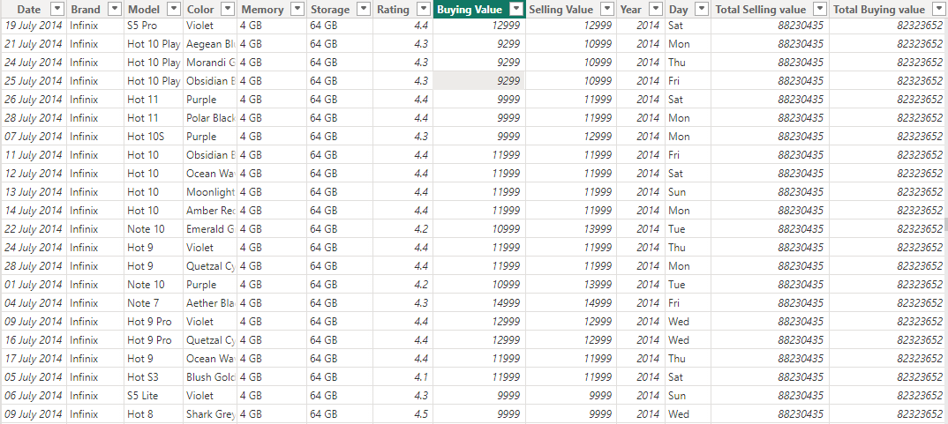

**Fig.7.1-Dataset**

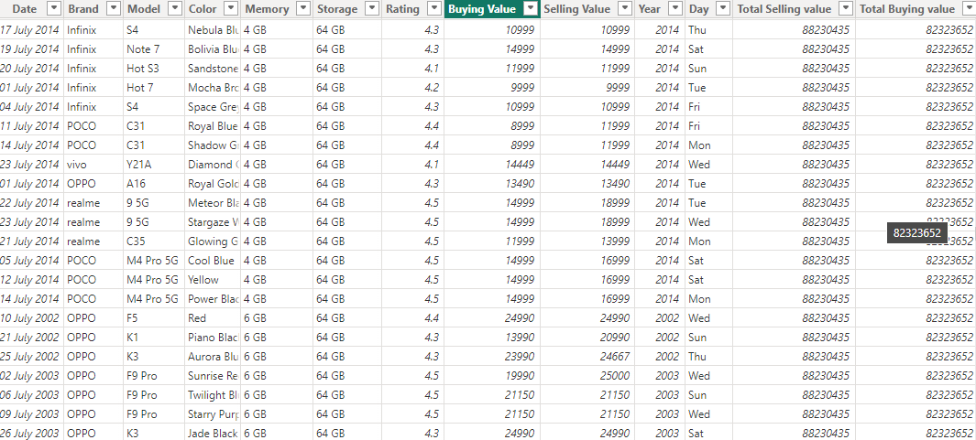

**Fig.7.2-Dataset**

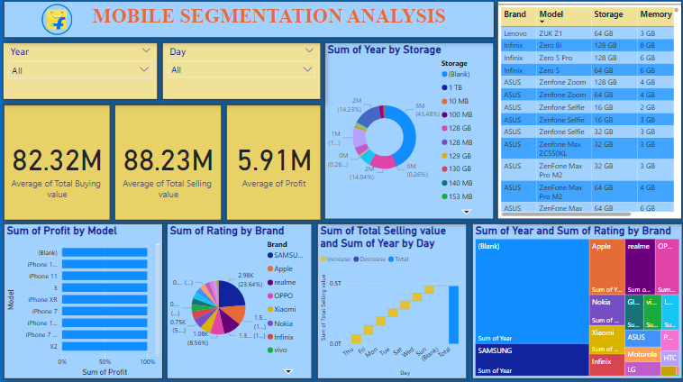

**Fig.7.3-Dashboard**

**CHAPTER 8**

**8. CONCLUSION**

The mobile segmentation analysis revealed distinct user groups with unique needs and preferences. Targeted marketing and product optimization opportunities were identified. Personalized experiences can drive customer loyalty and retention. Continuous monitoring and refinement are crucial due to the dynamic mobile market. By embracing these insights, we can unlock growth opportunities and strengthen customer relationships.

**CHAPTER 9**

**9. FUTURE SCOPE**

The future of mobile segmentation analysis lies in leveraging advanced AI and machine learning for more precise, real-time insights. Emerging data collection methods will provide granular details like location and predictive behaviours, allowing highly personalized and adaptive segmentation. Privacy-compliant data analysis will become crucial, balancing user insights with regulatory requirements. Integrating mobile data with other channels will enable a 360-degree view of customers for seamless, cross-channel engagement. Real-time analytics and visualization tools will drive faster, data-driven decision-making, positioning segmentation analysis as essential for innovation and growth in mobile strategies.