Bike Renting

Divya Monish
28 August 2018

Table of Contents
Chapter 1: Introduction 3
1.1. Problem Statement 3
1.2 Data 3
Chapter 2: Methodology 3
2.1 Data Cleaning 3
2.1.1 Outlier Analysis 3
2.2 Comparisons 5
2.2.1 Season Vs Count Vs Holiday 5
2.2.2 Month v/s Count. 6
2.2.3 Weekday v/s Count 6
2.2.4 Weathersit V/s Count 7
2.2.5 Date vs Total count 7
2.3 Correlation between variables 8
2.4 Modelling 9
Chapter 3: Suggestion 9

Chapter 1: Introduction

Problem Statement

The objective of the case is to predict bike rental count on daily basis based upon the Environmental and seasonal settings.

1.2 Data

The data has the following characteristics
- Dataset Characteristics: Regression series
- Number of Attributes: 16

Chapter 2: Methodology

Data Cleaning
This process usually involves in understanding, cleaning and filling in Missing (NA) values in the dataset and then finding the Outlier Analysis. In the given dataset there are no missing values hence we directly proceed with outlier analysis.

- Dimension of Dataset is 731 rows and 16 variables.

Outlier Analysis

Below graphs for each variable shows the outlier using boxplot.

- Temp has no outlier

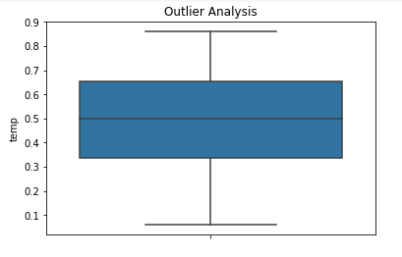

- Atemp variable has no outlier

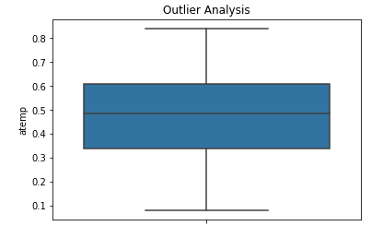

- Humidity has outlier

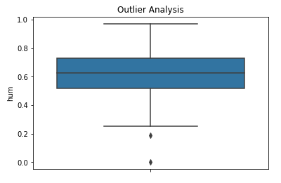

- Windspeed has outlier

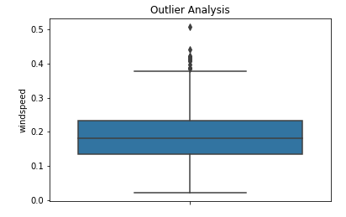

- Cnt varibale has no outlier

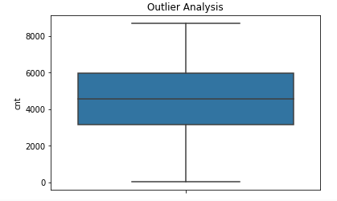

Figure 2.1.1 : Oulier Analysis

There are outliers in humidity, wind speed .Treating the extreme outliers Humidity can’t be zero, so replaced the zero value based on mean value

    - Replacing Outlier Analysis values

The outlier in humidity variable are replaced with the mean value of Humidity variable

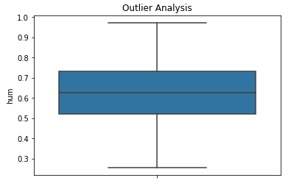

Comparisons

Season Vs Count Vs Holiday

In the below figure, the comparison of the count of rental was compared against the season and holidays.
- Holiday: 0 – Yes ,1 – No
- Season : 1 -springer, 2- summer, 3-fall, 4-winter

From below graph it can be inferred that the most bike rental happened only during Holiday and the season didn’t matter much though but the most no of rental happened during summer and on a holiday.

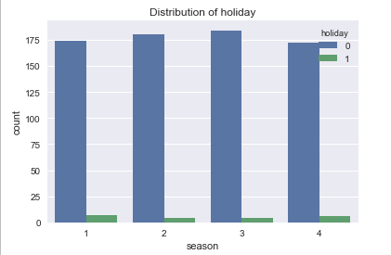

Month v/s Count.

From the below graph it can be inferred that count of bike rentals were almost equal in all the months. Just February had a little less than 60 count of rentals.

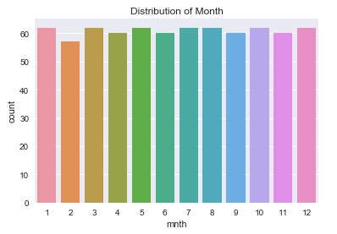

Weekday v/s Count
The below graph is comparison between the count of bike rental during the weekday. It can be inferred that no of rental is almost the same irrespective of the day of the week.

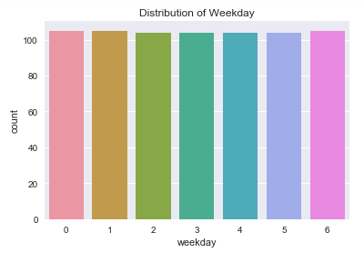

Weathersit V/s Count

Below graph shows the count of rentals based on various weather situation.
Weather situation are as followed.

- Clear, Few clouds, Partly cloudy, Partly cloudy
- Mist + Cloudy, Mist + Broken clouds, Mist + Few clouds, Mist
- Light Snow, Light Rain + Thunderstorm + Scattered clouds, Light Rain + Scattered clouds
- Heavy Rain + Ice Pallets + Thunderstorm + Mist, Snow + Fog

From the below graph it can be inferred that during the weather situation no 1 there was max no of bike rental has taken place.

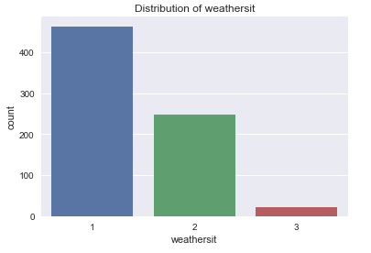

Date vs Total count

According to the below graph most of the bike rental occurred between the dates 2011-01-19 until 2011-01-22

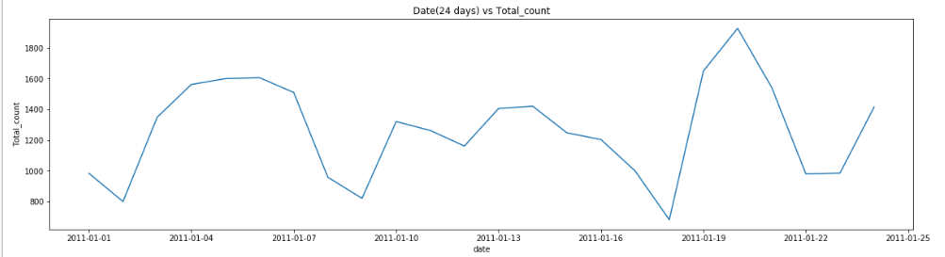

Correlation between variables

From the below it can be observed that there is high correlation between temp and atemp

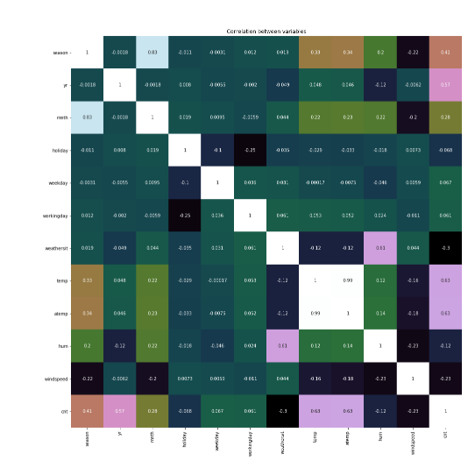
Correlation Plot

Modelling

In order to predict the model, we divide the dataset into train and test data. It can be 70 to t
80 percent of train data and the remaining will be the test data. After training the model with the train data we apply the test data to the model and check the out in form of MSE (Mean Square Error) and RMSE( Root mean square error).

I have used various model for prediction they are as below

- Linear Regression
- Decision Tree
- Random Forest
- Adaboost
- Xgboost

Chapter 3: Suggestion

From the below results it can be observed that Random forest predicts the most accurate results and the next best is Xgboost algorithm

Models | Mean Square root | R score
Linear Regression | 904.91 | 0.76
Decision Tree | 708.82 | 0.85
Random Forest | 611.64 | 0.89
Adaboost | 676.4 | 0.87
Xgboost | 641.64 | 0.88

