**MiniProject**

**(Basic Market Basket Analysis – By Divya Karotra TYBCA-A)**

1. **Data Exploration**

**Q1. Load the given dataset into a Dataframe.**

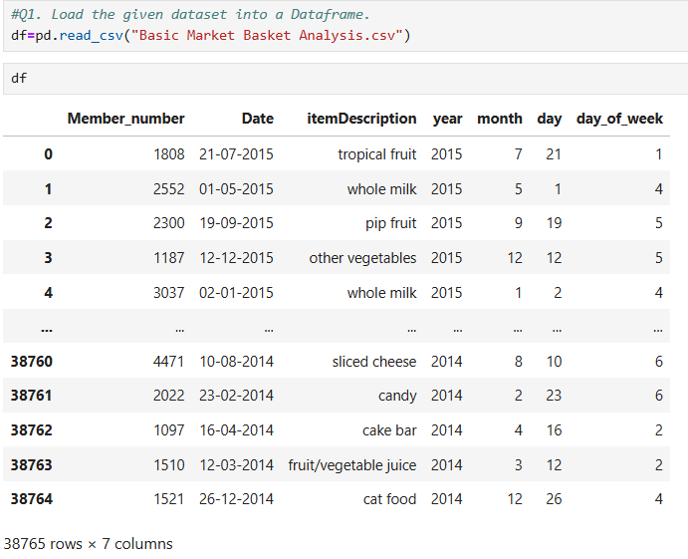

**Q2. Display the first 5 and last 5 rows of the dataset.**

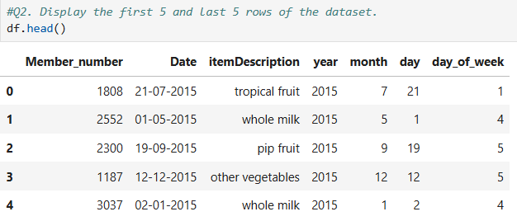

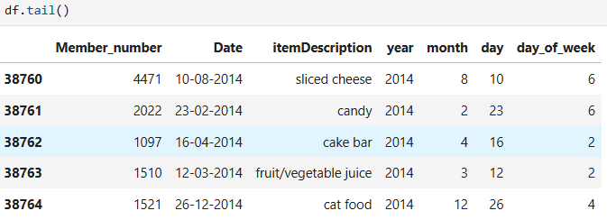

**Q3. Check the shape of the dataset(rows and columns).**

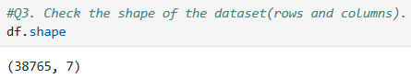

**Q4. List the column names and datatypes of the dataset**

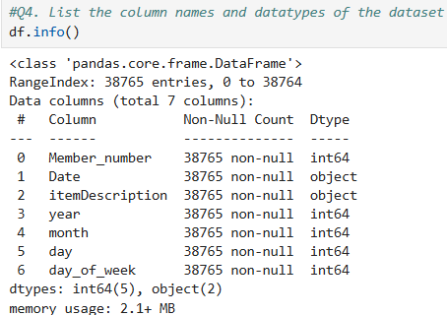

**Q5. Check for missing values in the dataset and count them.**

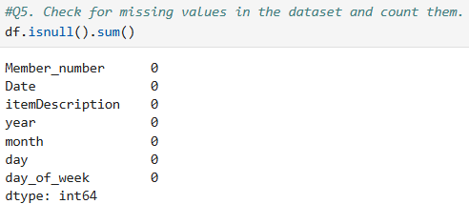

**Q6. Display summary statistics (mean,median,std,etc.)for the numerical columns.**

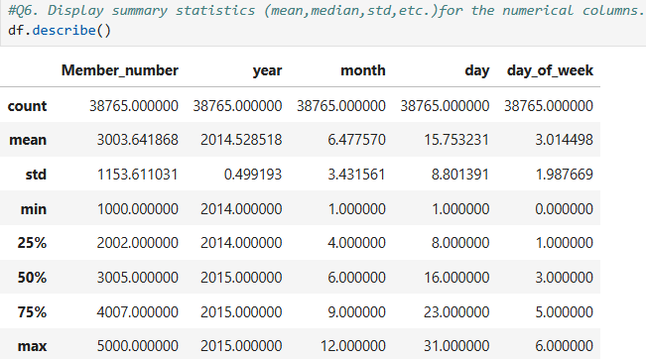

**Q7. Identify any duplicate rows in the dataset and remove them.**

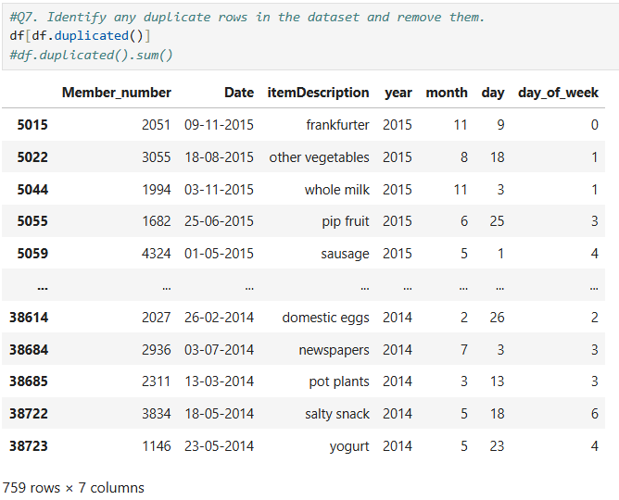

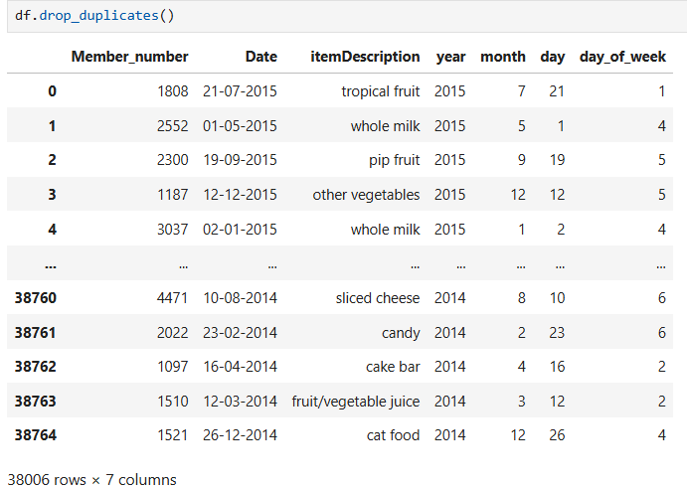

**Q8. Get the number of unique values in each column.**

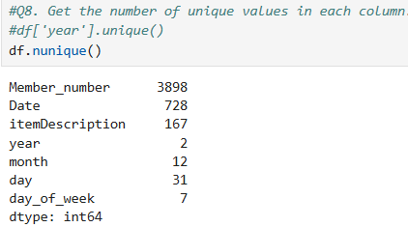

1. **Data Cleaning**

**Q9. Fill any missing values in numerical columns with the mean of the respective column.**

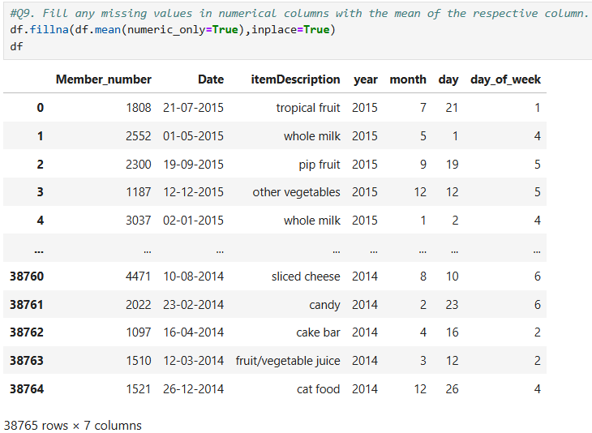

**Q10. Drop rows with any missing values**

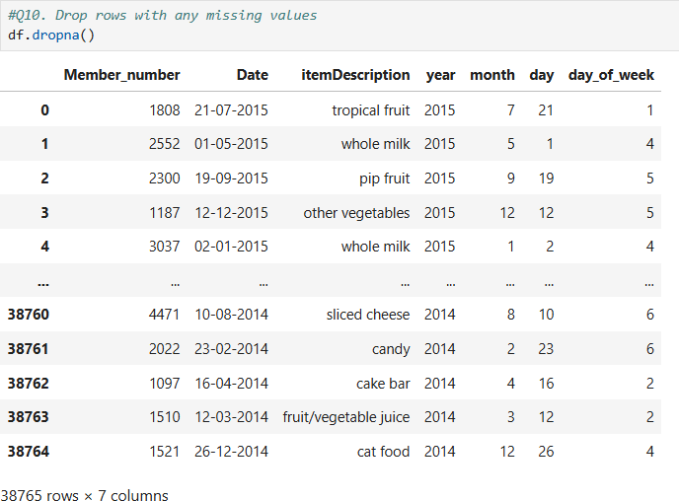

**Q11. Replace all occurrences of a specific value in a column(e.g.replace 'NA' with NaN).**

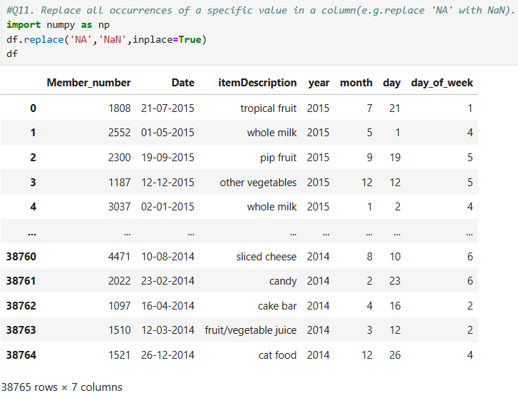

**Q12. Remove a specific column from the dataset**

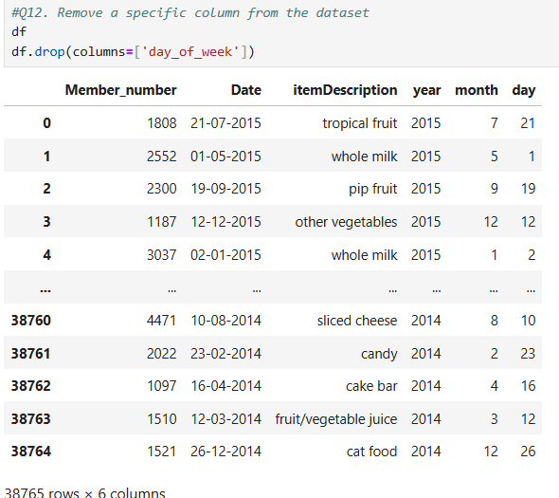

**Q13. Rename a column from itemDescription to Item_Name**

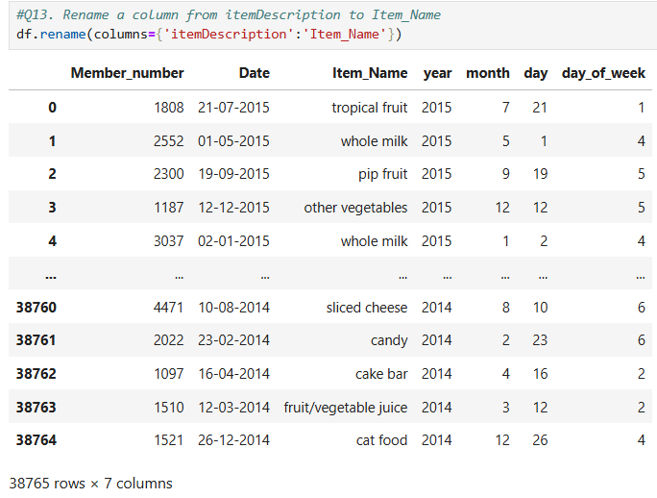

**Q14. Convert a column from string format to date format**

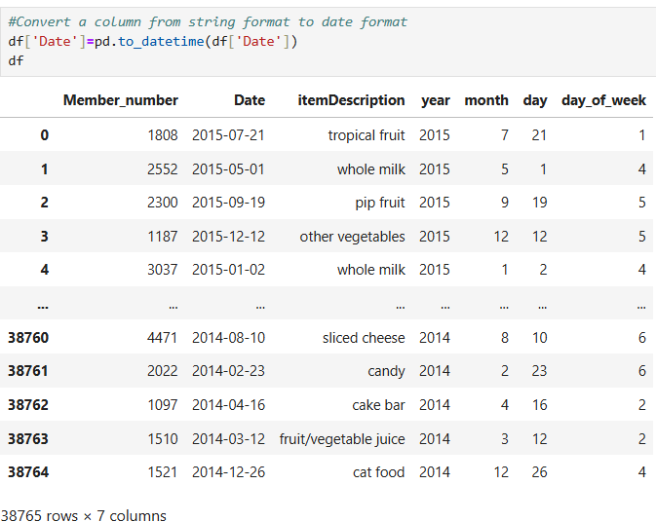

**Q15. Normalize a numerical column to scale the values between 0 and 1.**

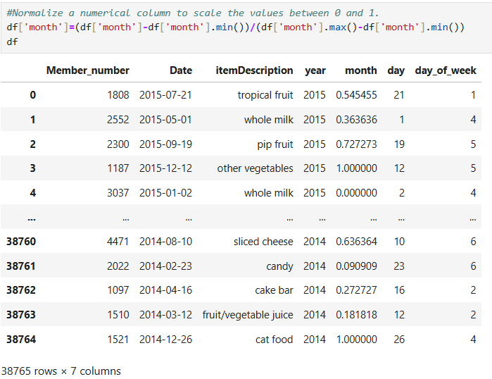

1. **Data Selection and Filtering**

**Q16. Select the "itemDescription" column from the dataframe**

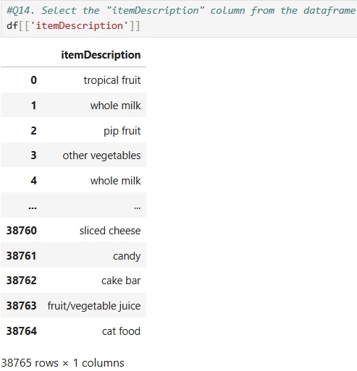

**Q17. Select the "Member_number" and "itemDescription" columns from the dataframe**

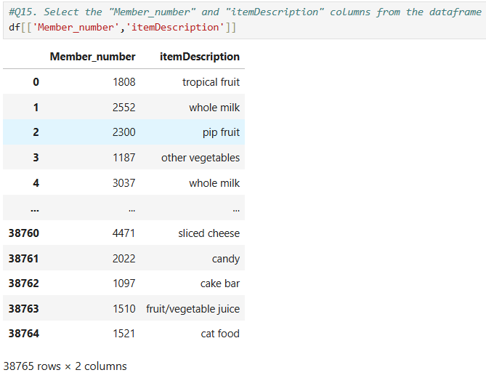

**Q18. Filter the Dataframe to show rows where the 'month' is greater than 6.**

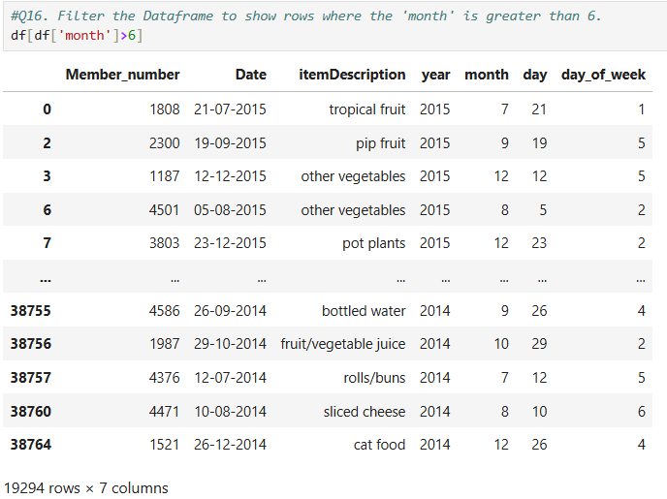

**Q19. Filter the dataset to display only rows where the 'itemDescription' is "whole milk".**

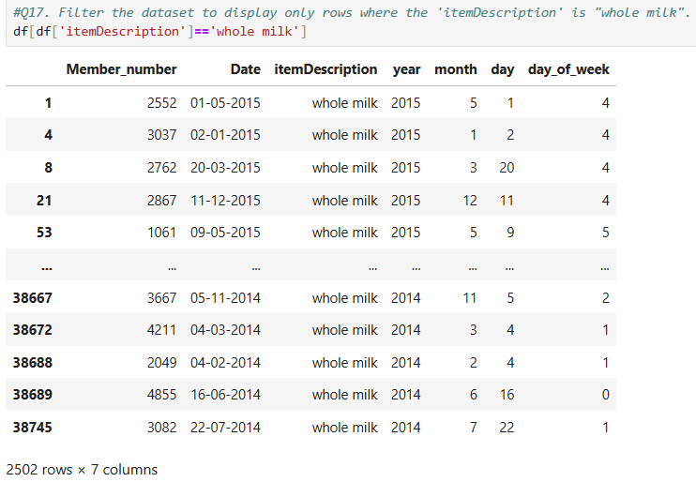

1. **Sorting and Ordering**

**Q20. Sort the dataframe by "month" in ascending order**

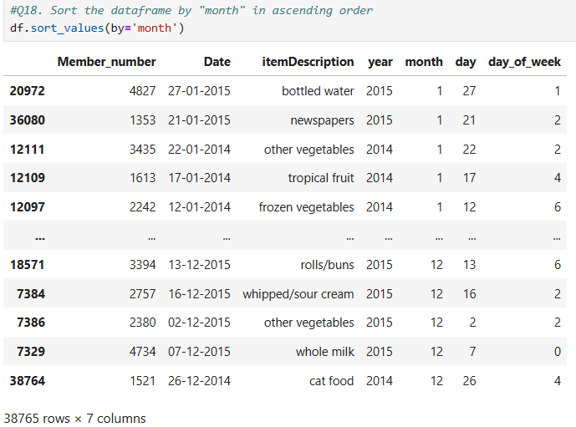

**Q21. Sort the column alphabetically (for eg. itemDescription)**

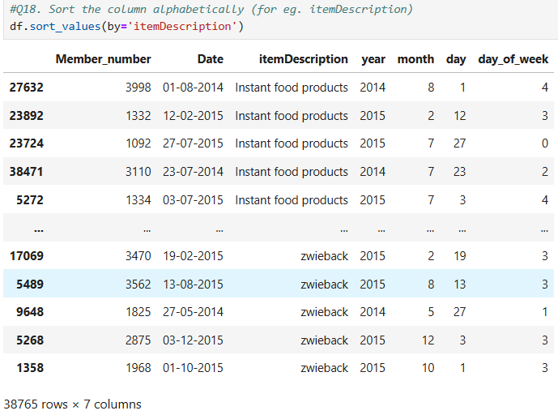

**Q22. Sort the column in descending order (for eg. month)**

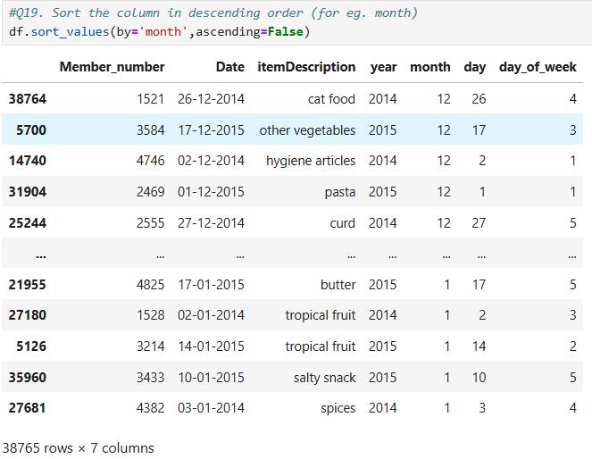

**Q23. Sort the dataframe by "itemDescription" first and then by "month"**

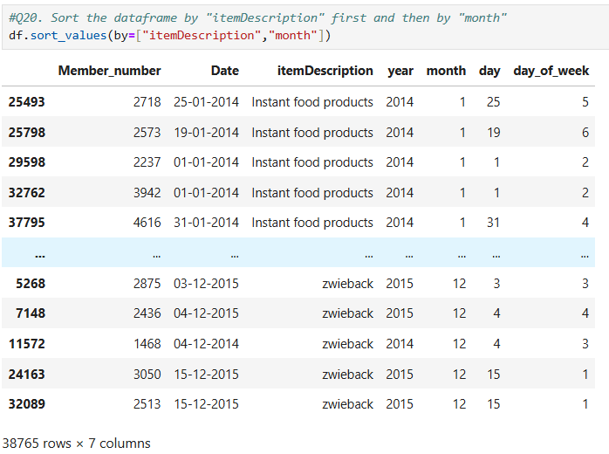

**Q24. Sort the dataframe by "day" and keep only the first 3 rows.**

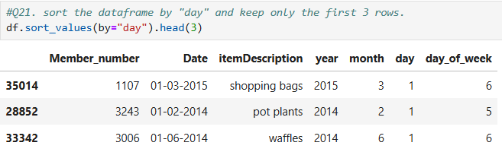

1. **Renaming Columns**

**Q25. Rename the "itemDescription" column to "Item_Name"**

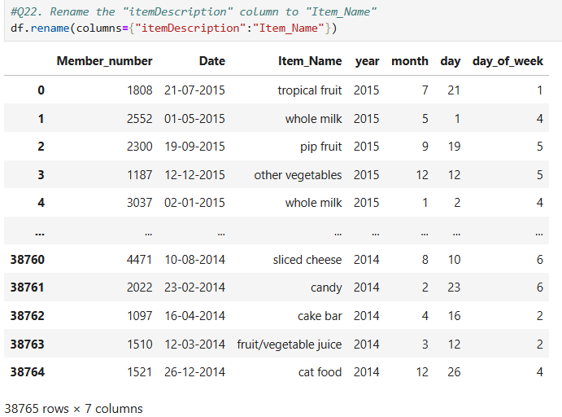

**Q26. Rename the "month" column to "No_of_Month"**

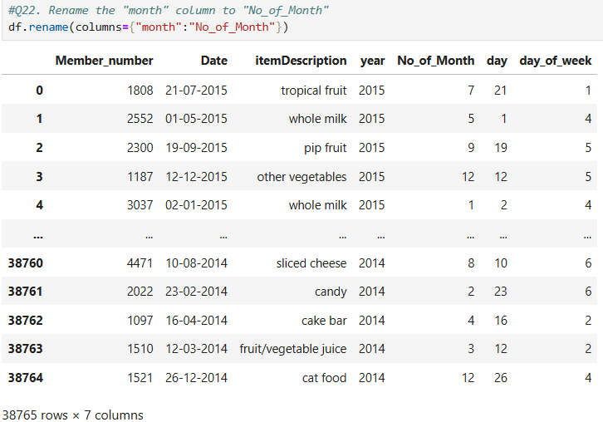

**Q27. Rename multiple columns at once (eg. "day" to "Day_No" and "day_of_week" to "day_of_week_No")**

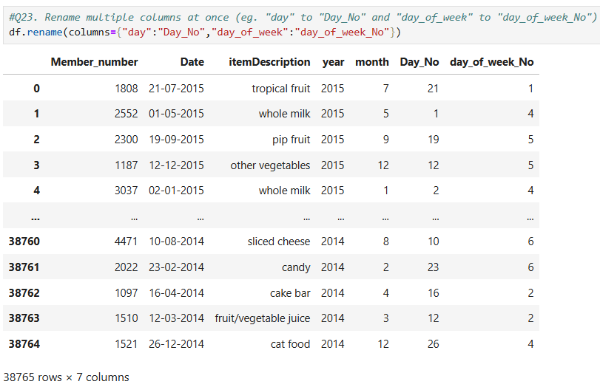

**Q28. Change the column name to a simpler one(eg. itemDescription to Item).**

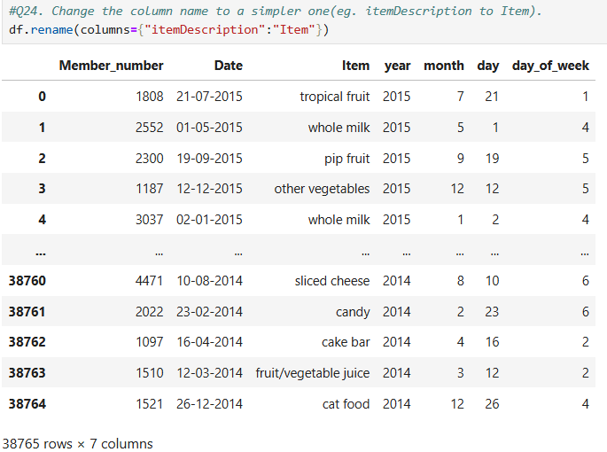

1. **Data Aggregation**

**Q29. Find the average of the "month" column**

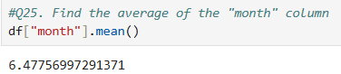

**Q30. Find the total sum of the "day" column**

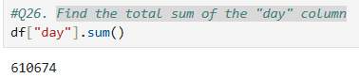

**Q31. Count how many times each value appear in the "month" column**

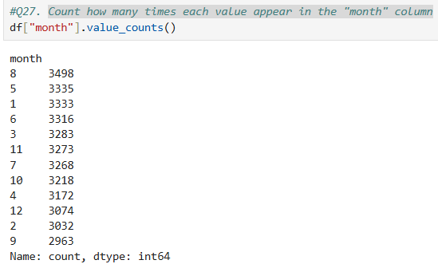

**Q32. Calculate the total sum of "month" for each unique value in the "itemDescription" column**

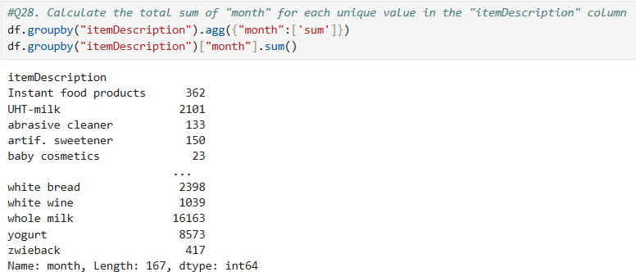

**Q33. Find the highest "month" in the dataset**

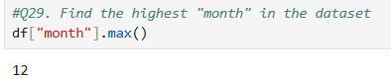

**Q34. Calculate the minimum "month" in the dataset**

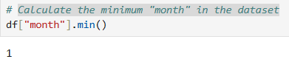

1. **Simple Data Visualization**

**Q35. Create a simple bar plot of "itemDescription" vs "month"**

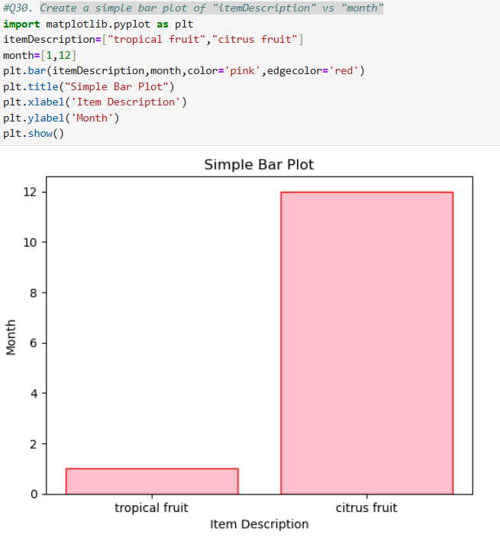

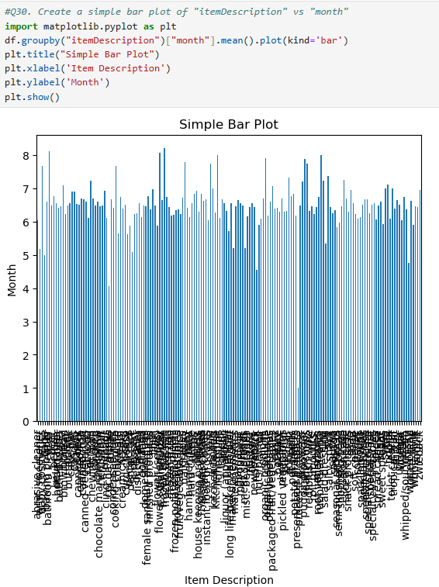

**Q36. Create a line plot for "day" over an index**

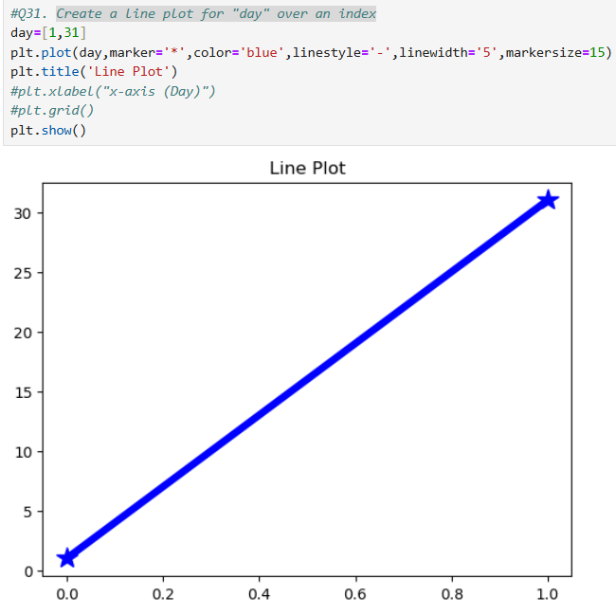

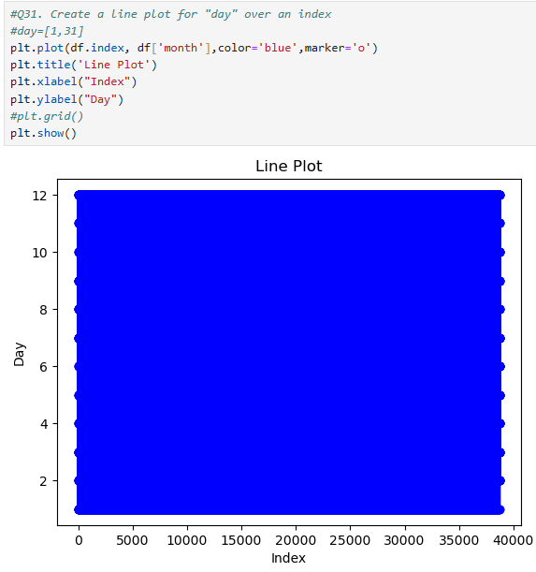

**Q37. Create a histogram for the "month" column**

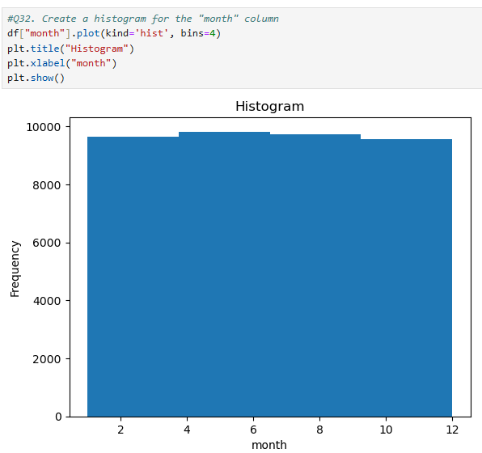

**Q38. Create a pie chart to show the distribution of values in the "itemDescription" column**

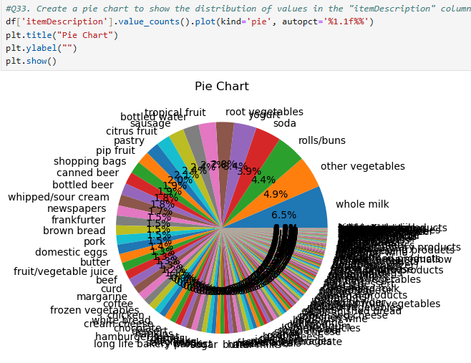

**Q39. Create a scatter plot between "day" and "month"**

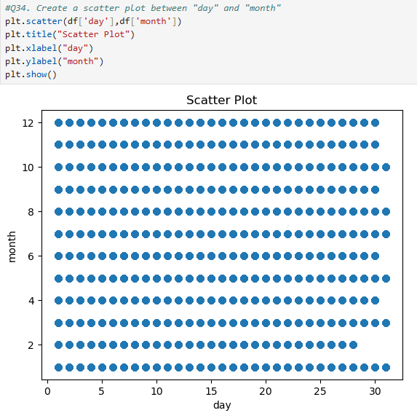

**Q40. Display a box plot for the "month" column**

1. **Basic String Manipulation**

**Q41. Convert the "itemDescription" column values to lowercase**

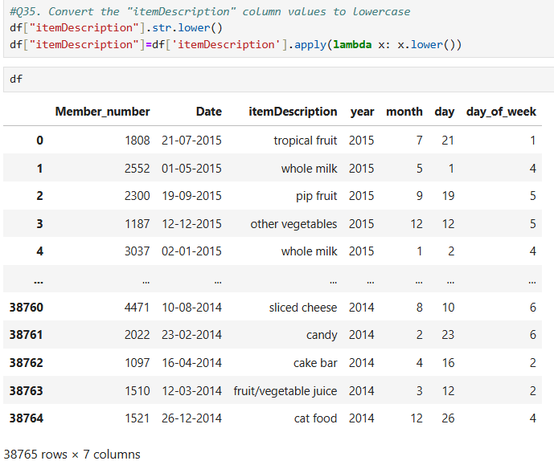

**Q42. Extract the first 3 characters of the "itemDescription" column**

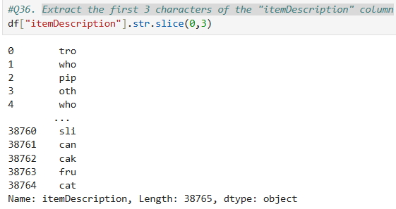

**Q43. Split the "itemDescription" column into two columns: "first" and "second"**

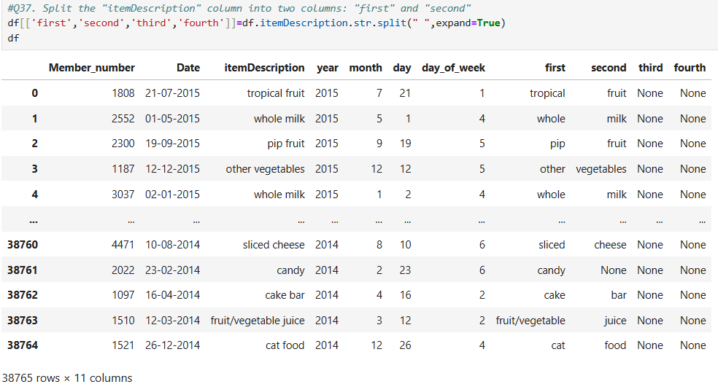

**Q44. Concatenate the "firstHalf" and "secondHalf" columns into a new column "Item".**

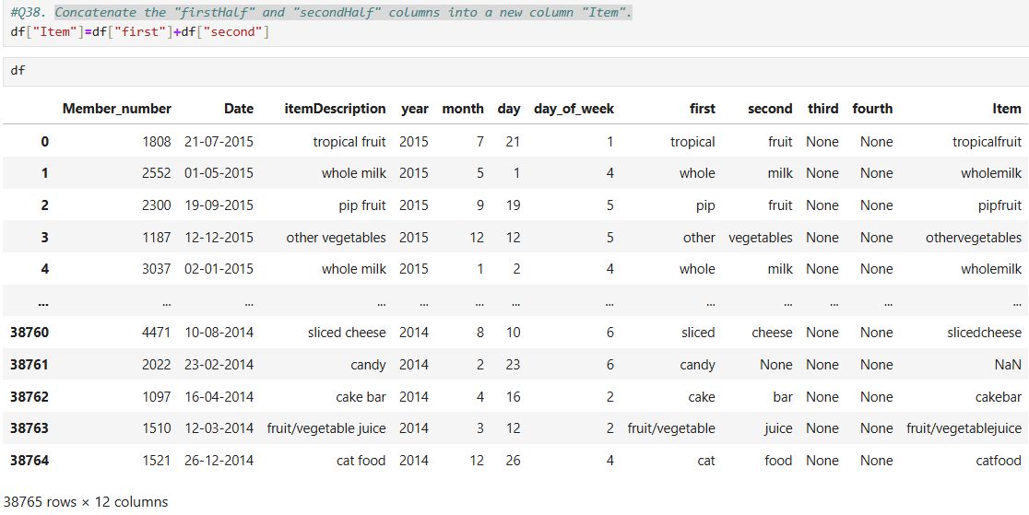

**Q45. Replace all spaces in the "itemDescription" column with underscores.**

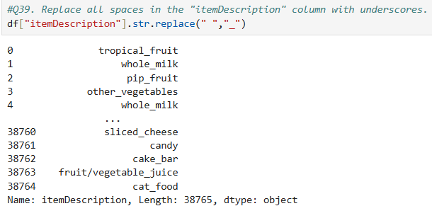

1. **iloc – Integer-location based indexing**

**Q46. Select the first row of the dataset using iloc**

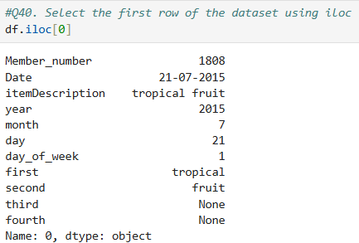

**Q47. Select the last 3 rows of the dataset using iloc**

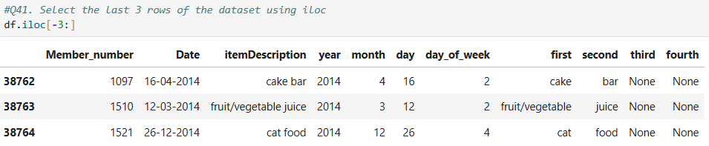

**Q48. Select the first 5 rows and the first 3 columns of the dataset using iloc**

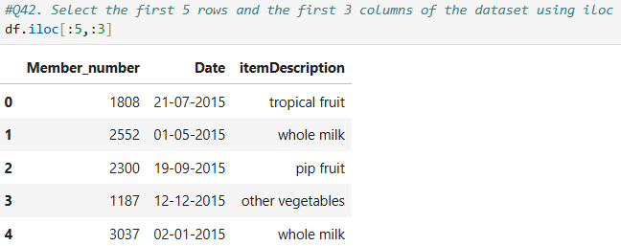

**Q49. Select all rows of the dataset but only the 2nd and 3rd columns using iloc.**

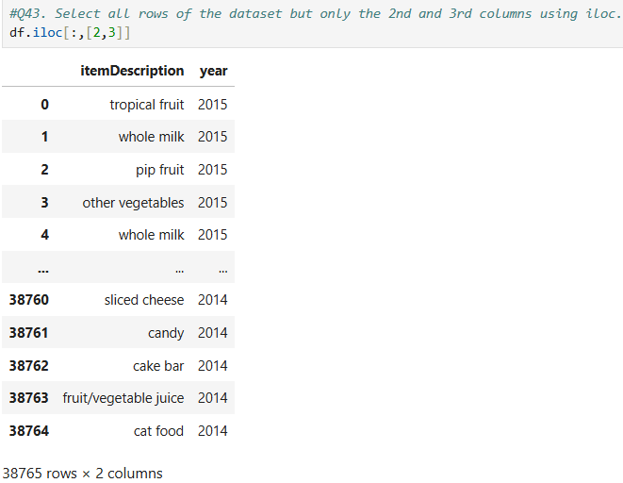

**Q50. Select the value at the 4th row and 2nd column using iloc**

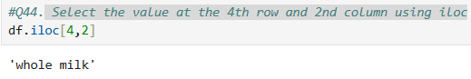

**Q51. Use iloc to select rows 2 to 5 and columns 1 to 4**

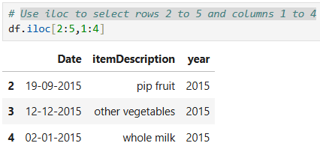

1. **loc – Label – based indexing**

**Q52. Select the row where the "itemDescription" is "whole milk" using loc**

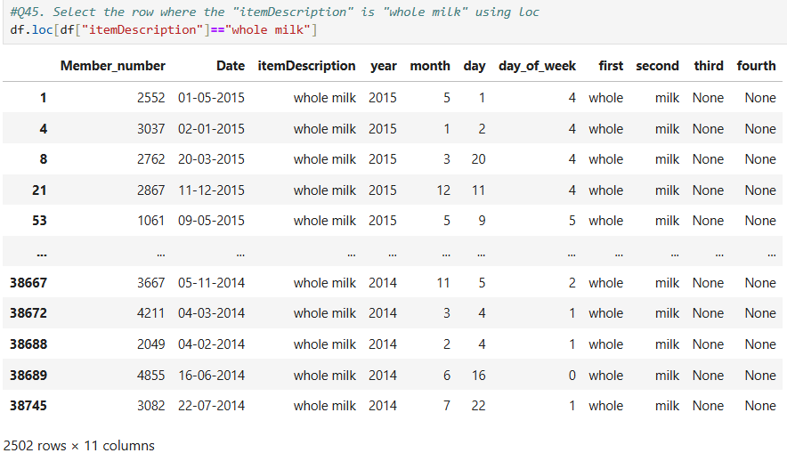

**Q53. Select the "itemDescription" column for rows where "month" is between 4 and 9 using loc.**

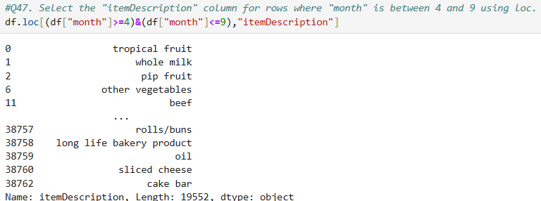

**Q54.** **Select all rows and columns where "itemDescription" is "whole milk" using loc**

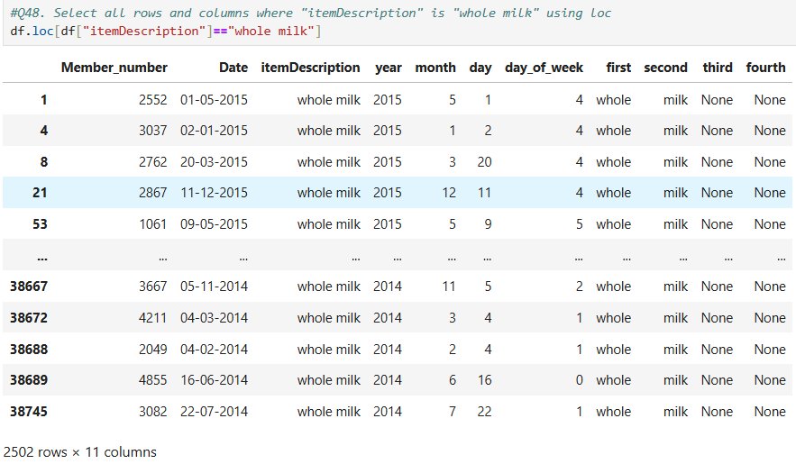

**Q55. Select rows where "month" is greater than 6 using loc**

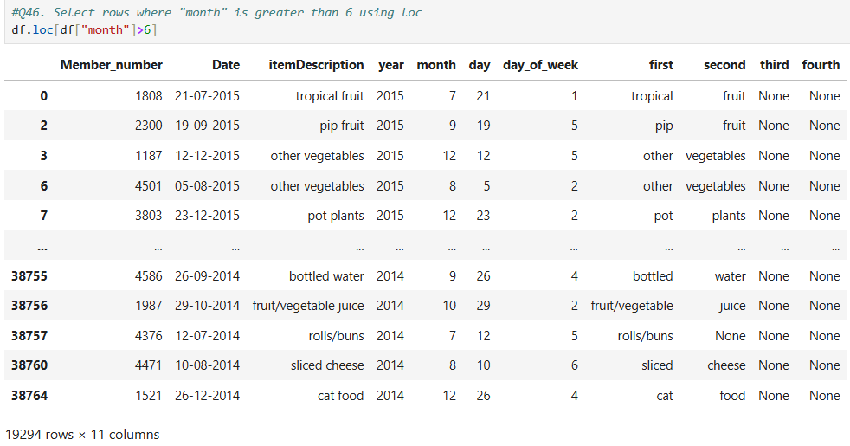

**Q56. Select multiple columns("itemDescription","month") for a specific row with loc.**

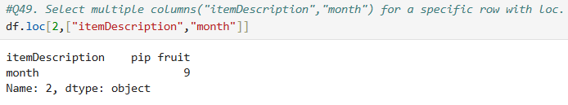

**Q57. Use loc to select the row where "month" is greater than 9 and the "itemDescription" is "whole milk"**

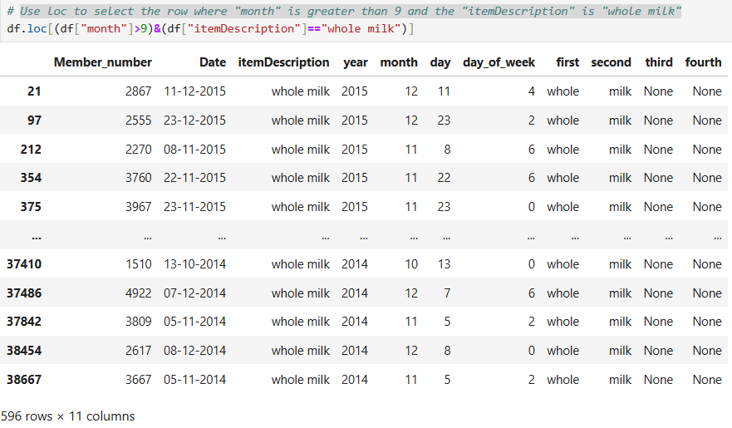

1. **Replace - Replacing values in a DataFrame**

**Q58. Replace all occurrences of the value "whole milk" with "milk" in the "itemDescription" column.**

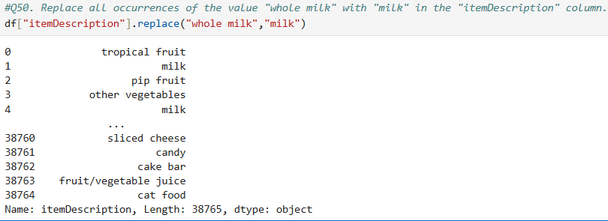

**Q59. Replace the value 0 with NaN in a specific numerical column.**

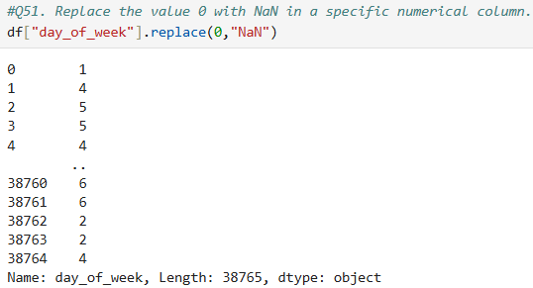

**Q60. Replace a value in the entire DataFrame (eg. replace all 5s with 0s)**

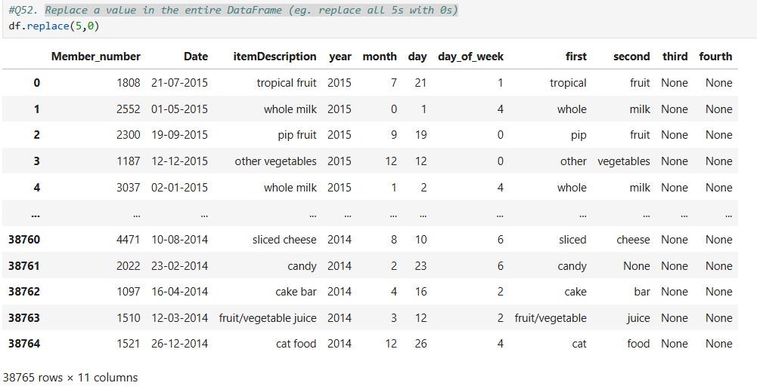

**Q61. Replace all occurrences of "2014" with "0" and "2015" with "1" in the "year" column.**

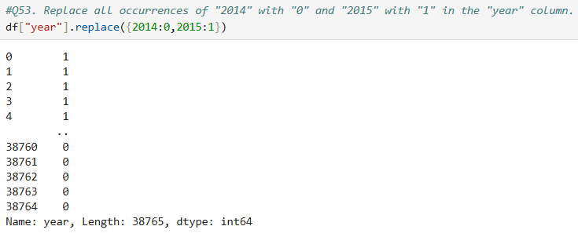

**Q62. Replace multiple values (eg. replace "12" with "end" and "1" with "start" in the "month" column)**

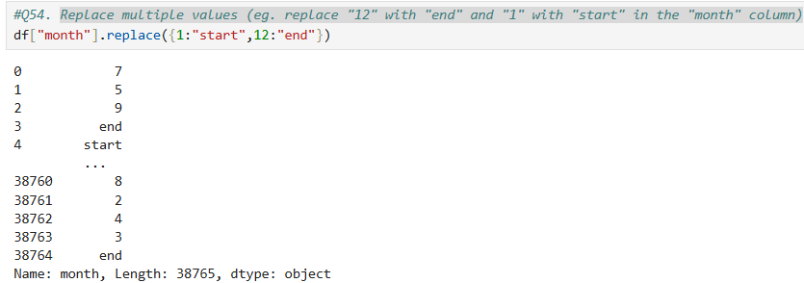

**Q63. Replace the value of "NA" in the "day" column with the mean of the column.**

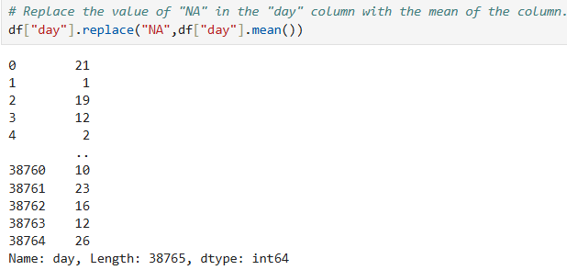

1. **Index - Indexing and resetting index**

**Q64. Set a specific column (eg. itemDescription) as the index of the DataFrame.**

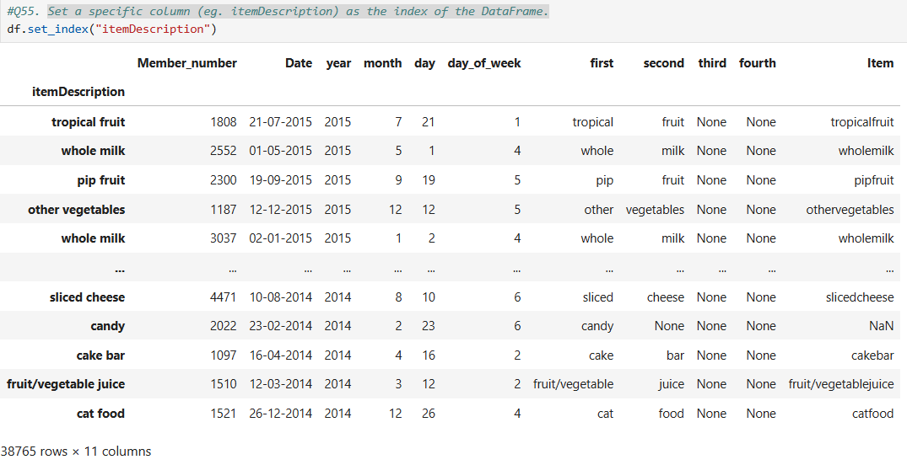

**Q65. Reset the index of the dataframe after setting a new column as the index.**

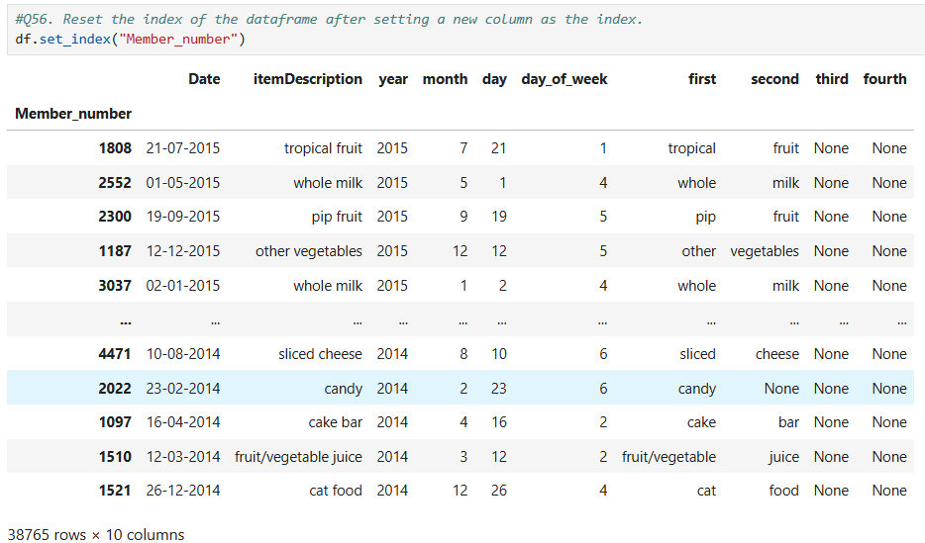

**Q66. Set a multi-level index using "itemDescription" and "day" columns.**

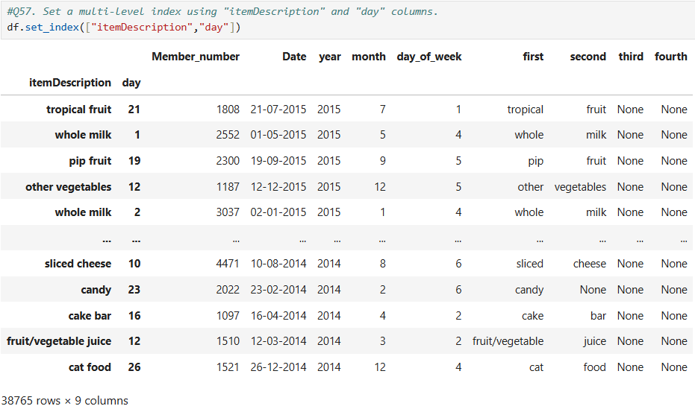

**Q67. Access a specific row by using the index after setting the index to "month"**

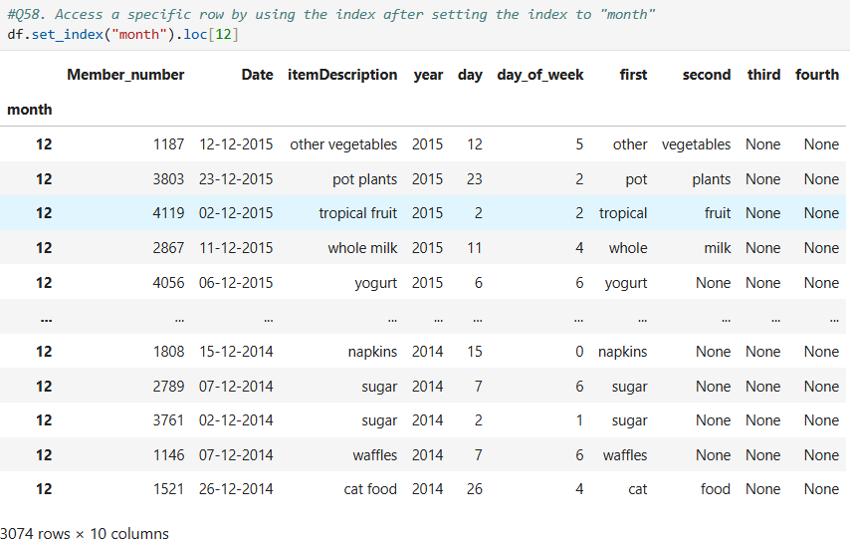

**Q68. Check the index type and whether its unique.**

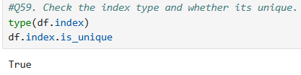

**Q69. Rename the index labels to make them more descriptive (eg. from numeric to "Row_1","Row_2").**

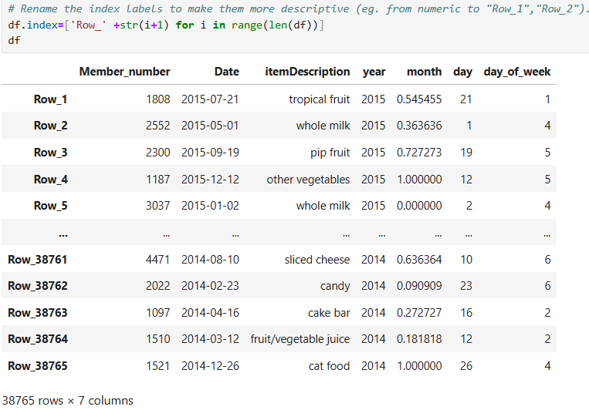

1. **groupby – grouping data**

**Q70. Group the dataset by "itemDescription" column and find the average "month" for each "itemDescription"**

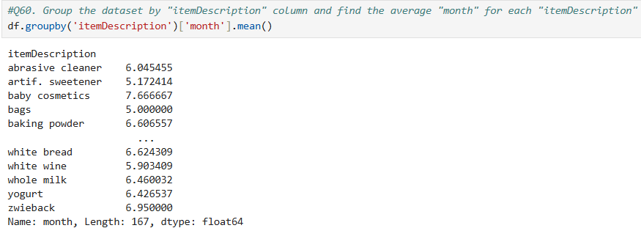

**Q71. Group by "day" and get the count of each group in the "month" column.**

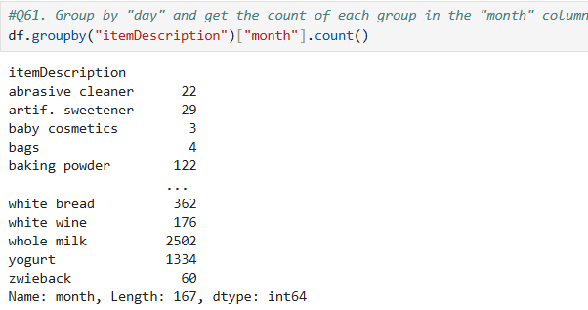

**Q72. Group the data by "itemDescription" and calculate the total "day" for each product**

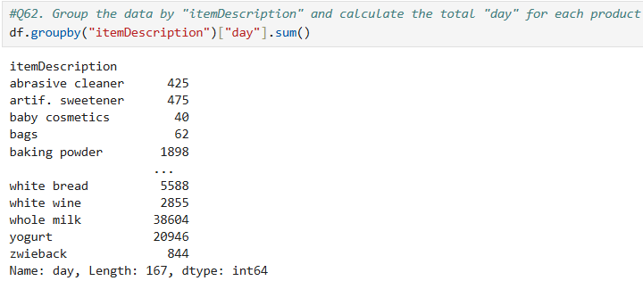

**Q73. Group by "year" and display the sum of "month" for each age group**

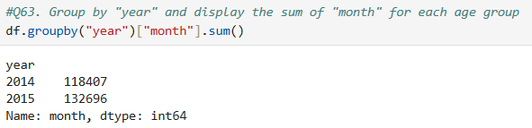

**Q74. Group by "itemDescription" and find the unique entries in the "month" column.**

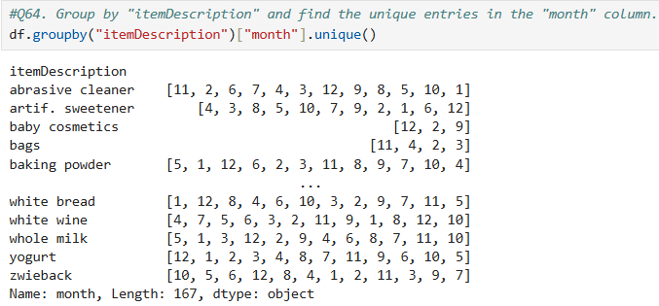

**Q75. Group the dataset by "itemDescription" and find the maximum value of "day" for each group**

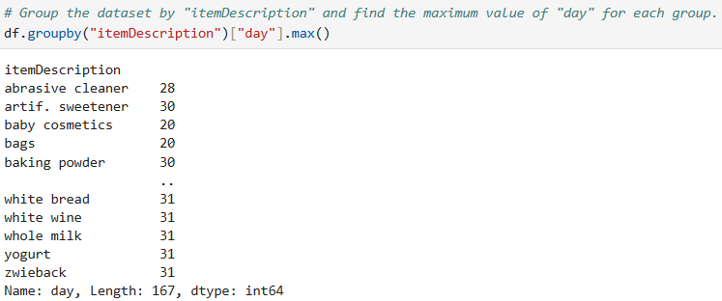

1. **Aggregation - Performing multiple aggregations**

**Q76. Group by "year" and calculate both the mean and median of the "month" column.**

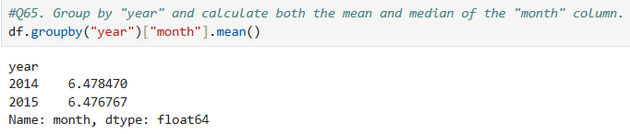

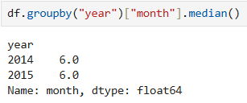

**Q77. Perform multiple aggregations: find the sum,mean,count of the "day" column,grouped by "itemDescription".**

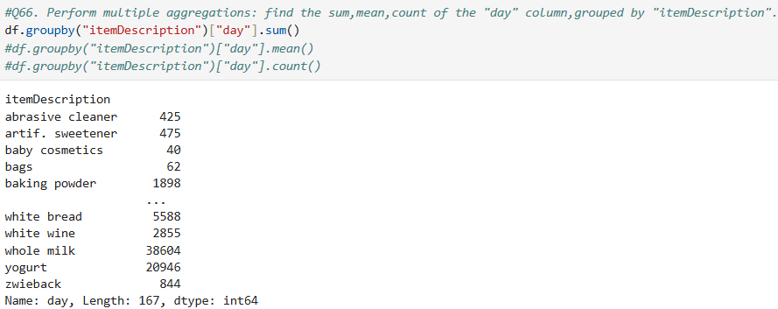

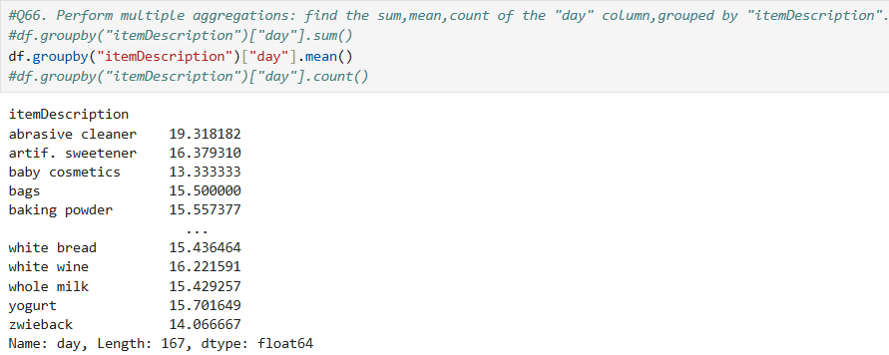

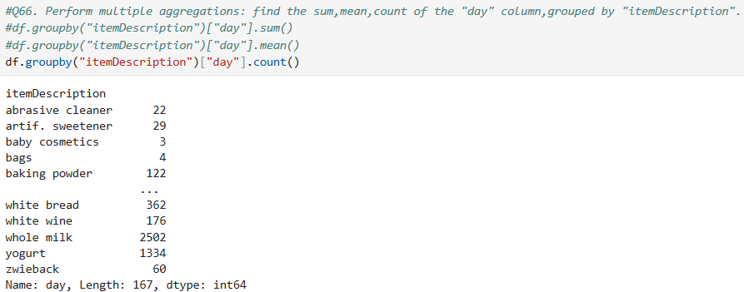

**Q78. Group by "itemDescription" and apply min() and max() functions to the "month" column.**

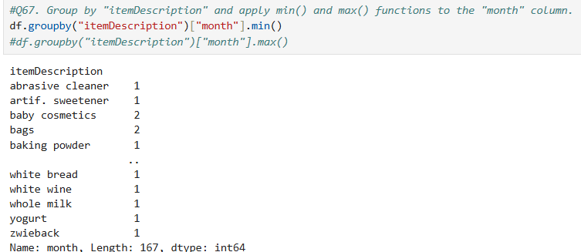

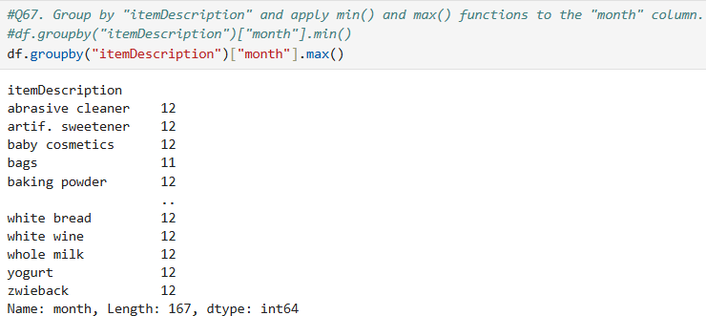

**Q79. Group by "itemDescription" column and apply a custom aggregation function(find the range of "month" within each itemDescription)**

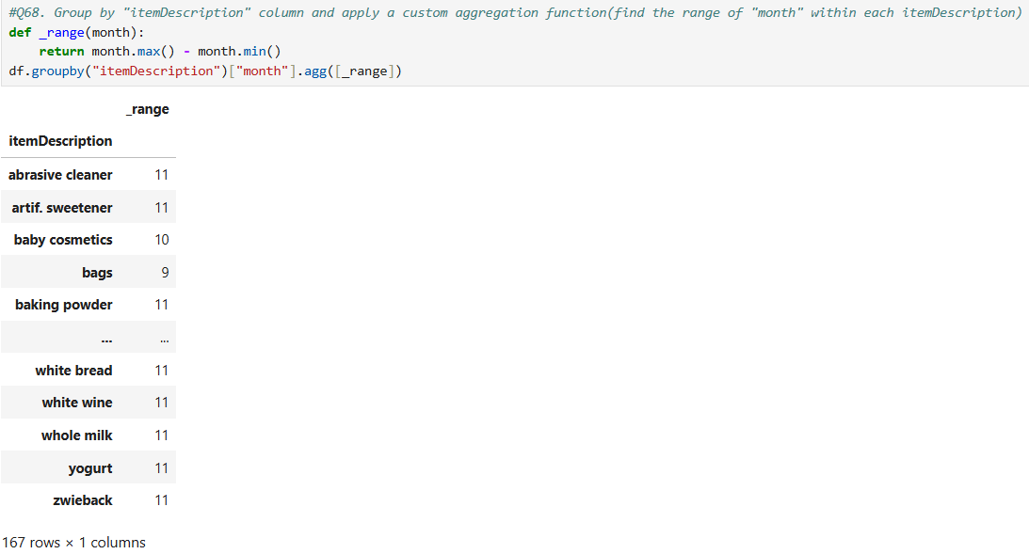

**Q80. Group by "itemDescription" and calculate the average "day", along with the total "day_of_week" for each group.**

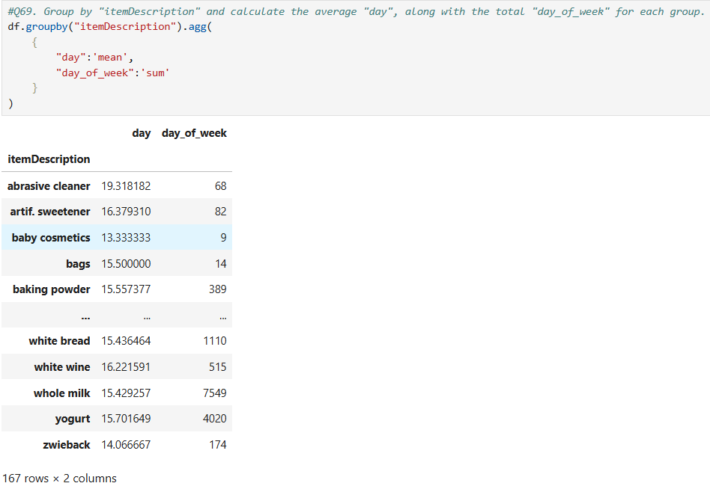

**Q81. Group the data by "month" and find both the standard deviation and the variance of the "day".**

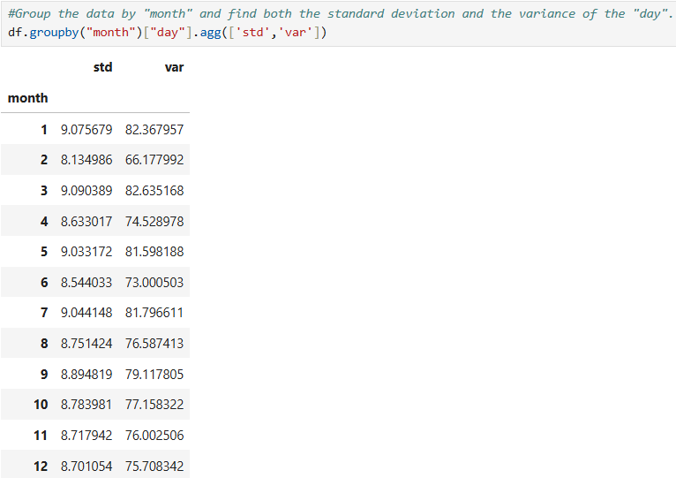

1. **Faker – Generating Fake Data for Testing**

**Q82. Generate a fake dataset with 100 rows of random names,addresses,and dates using the Faker library.**

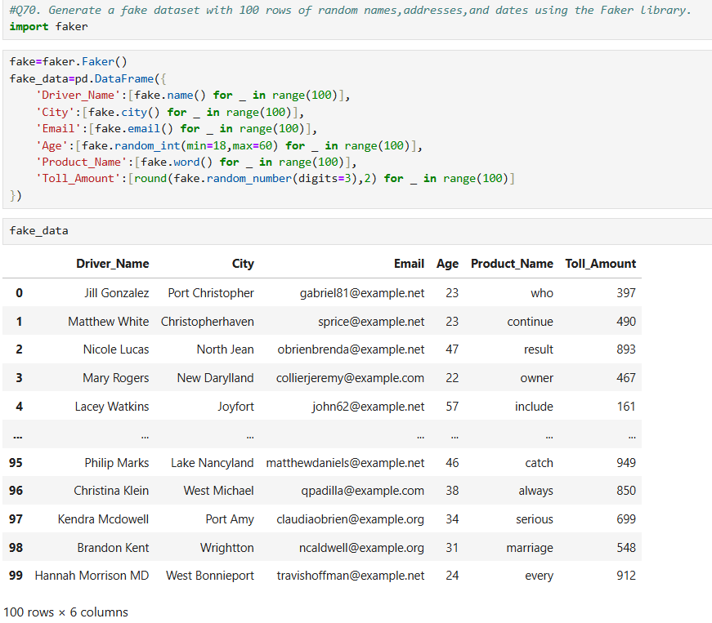

**Q83. Create a list of 20 fake names and store them in a "Name" column.**

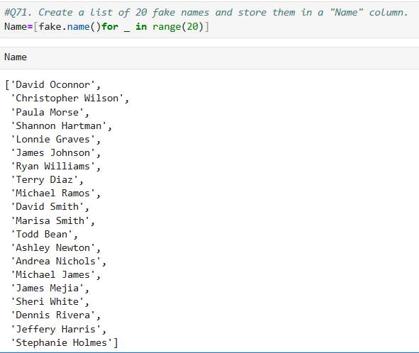

**Q84. Generate fake email addresses and store them in a column called "Email.**

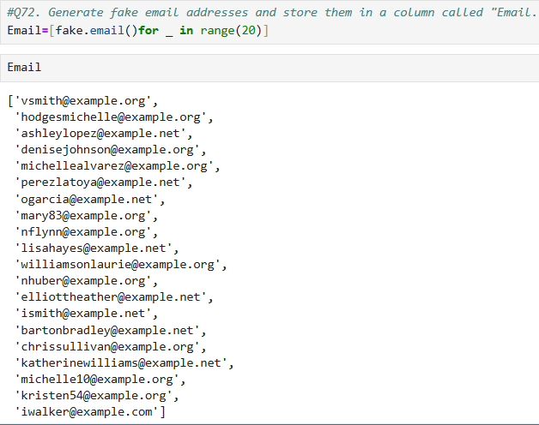

**Q85. Generate fake date of birth and convert them into an "Age" column using faker.**

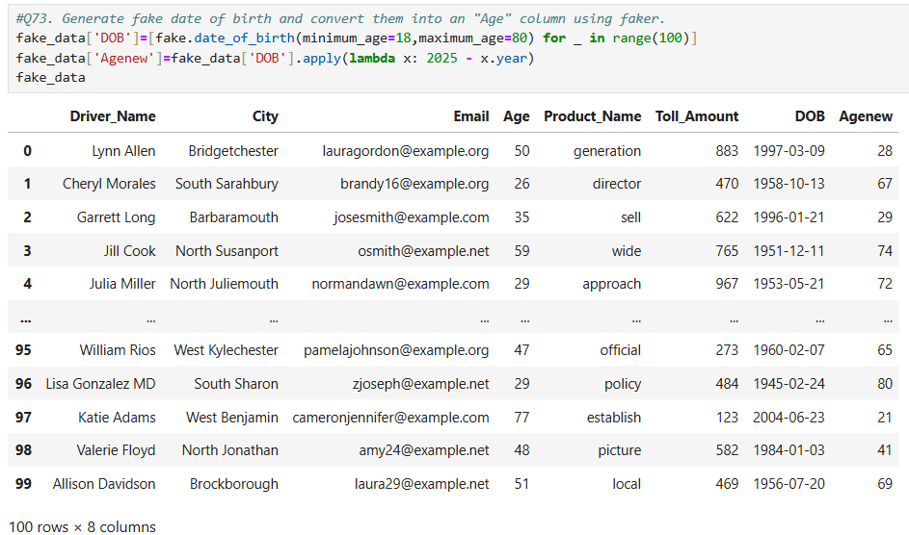

**Q86. Generate fake product names, and then create a dataframe with columns for "Product_Name" and "Price".**

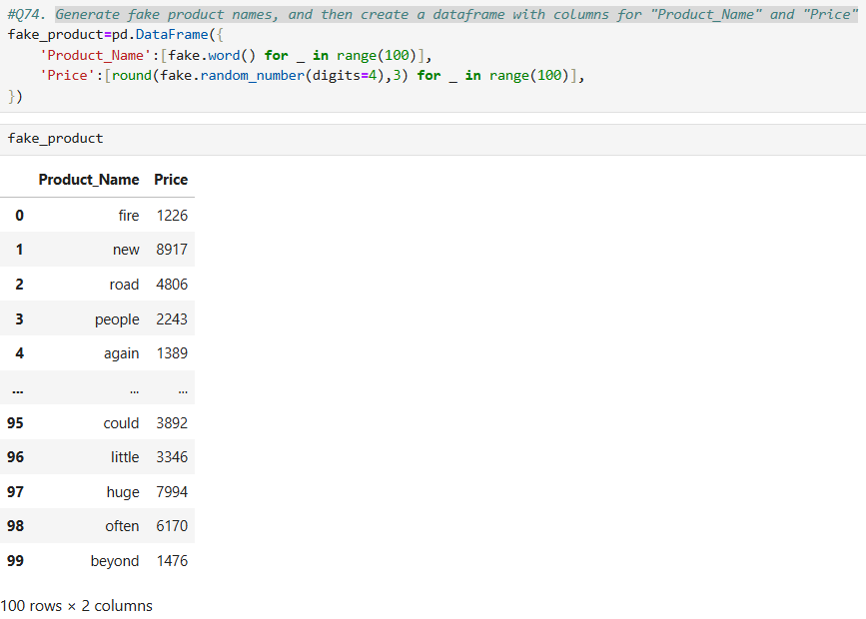

**Q87. Use the faker library to create a dataframe with fake user information, including Name, City, and Phone_Number.**

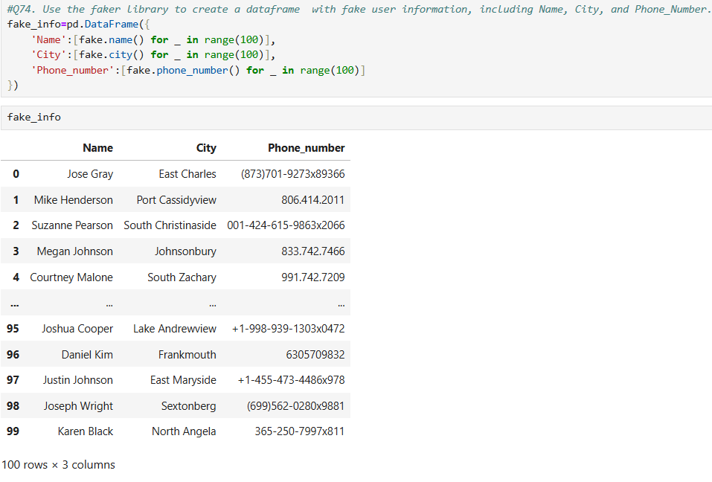

1. **merge – Merging DataFrames**

**Q88. Merge two dataframes on common column Product_ID**

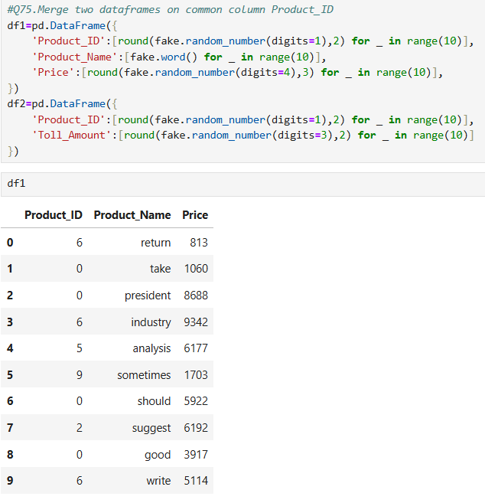

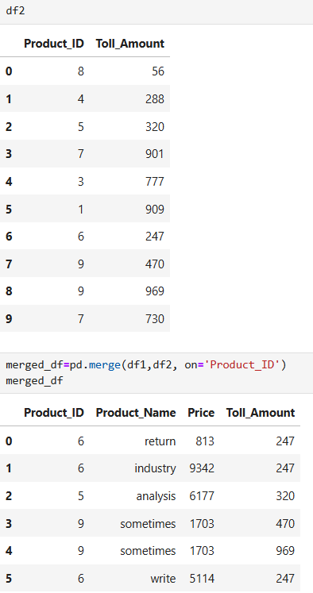

**Q89. Perform left join between dataframes based on "ProductID"**

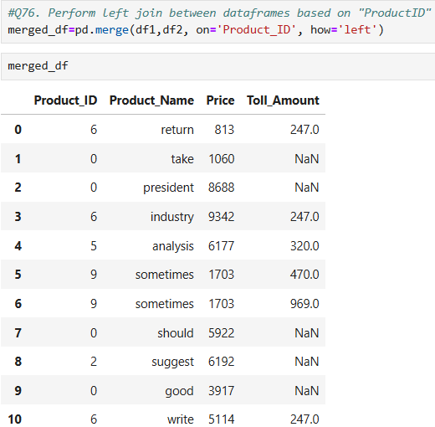

**Q90. Merge two dataframes, keeping all rows from the left dataframe and matching rows from the right.**

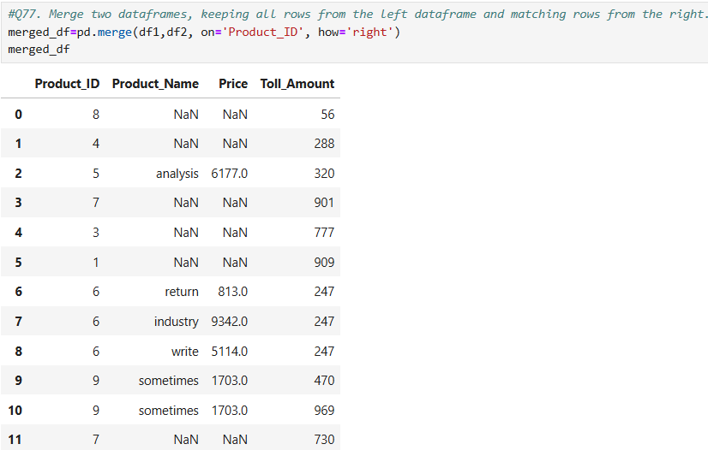

**Q91. Merge two dataframes on multiple columns(eg. city and Age)**

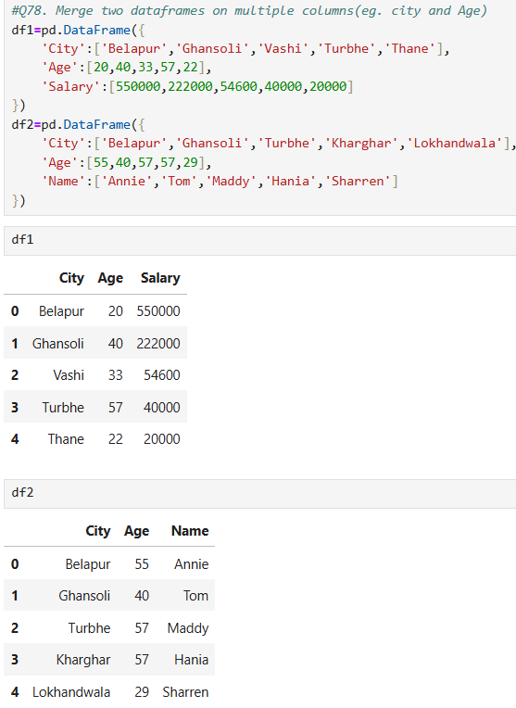

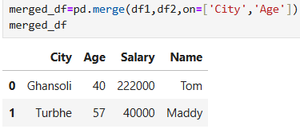

**Q92. Perform an inner join on two dataframes with a common column "Country"**

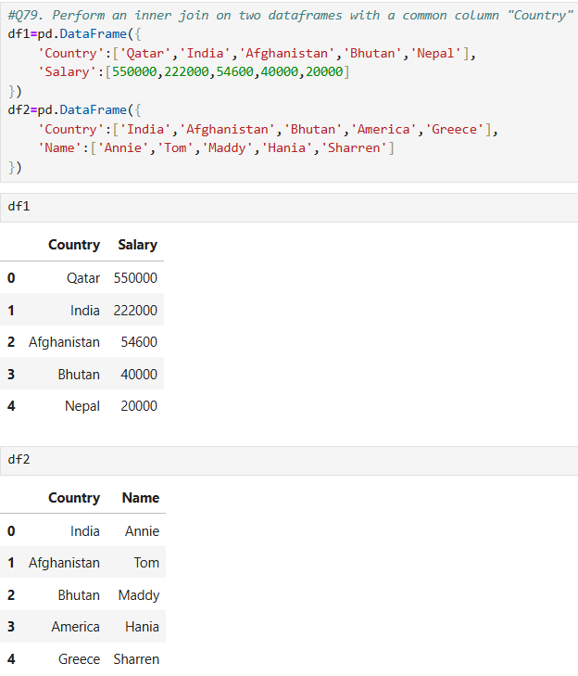

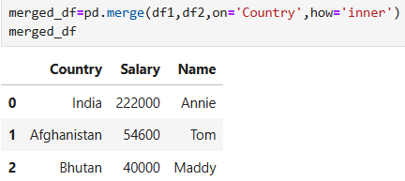

**Q93. Merge two dataframes and keep all the rows, even if there's no match in the second dataframe.**

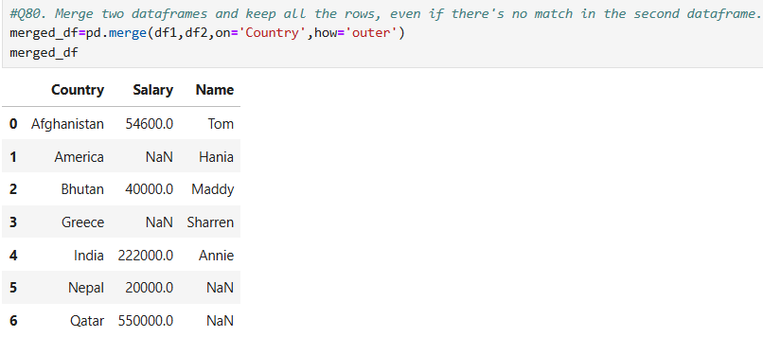

1. **Saving and Exporting Data**

**Q94. Save the dataframe to a new csv file.**



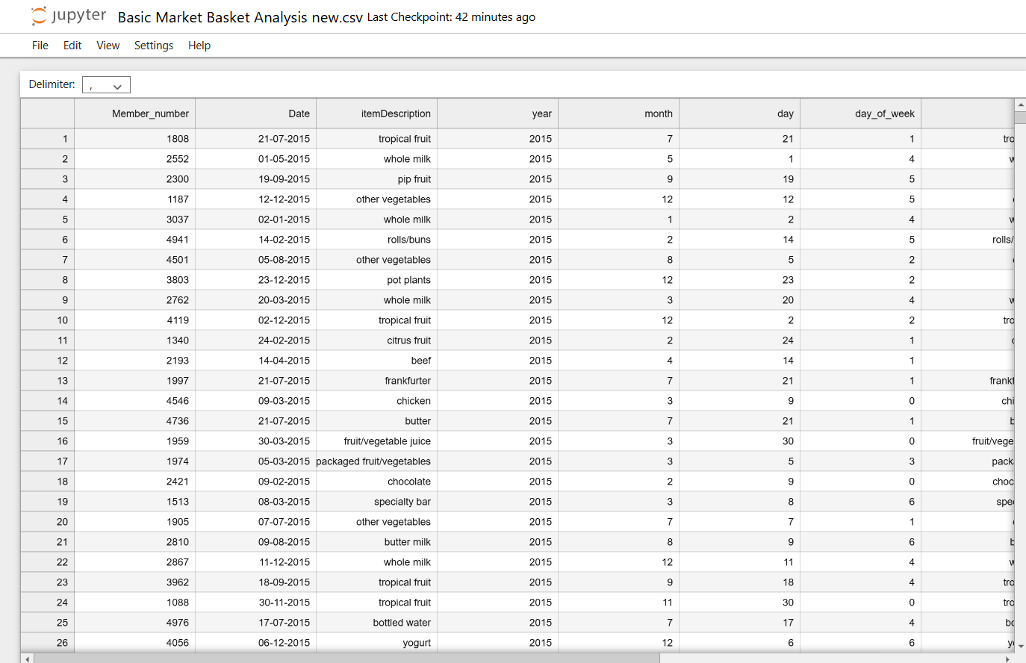

**Q95. Export the dataframe to an excel file.**



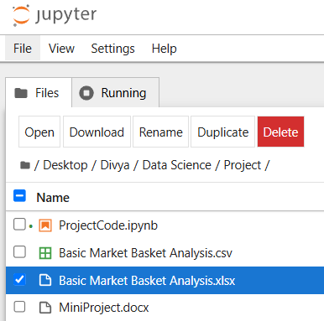

1. **Complex Filtering and Aggregation**

**Q96. Filter the dataset for all rows where the "month" is between 3 and 9 and the "itemDescription" is "whole milk"**

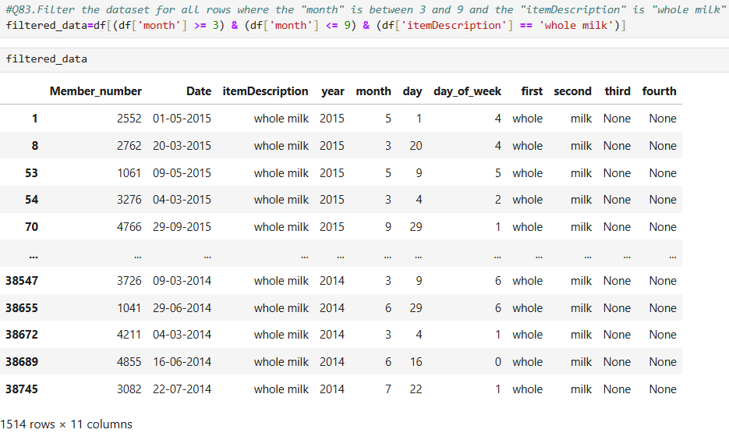

**Q97. Then group the filtered data by "year" and calculate both the mean and median of the "month" column.**

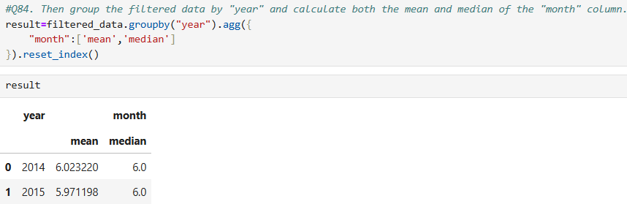

**Q98. After that, sort the result in descending order by the "month" column**

1. **Advanced String Manipulation and Grouping**

**Q99. Create a new column "Item" by concatenating the "itemDescription" and "Date" columns with a space in between.**

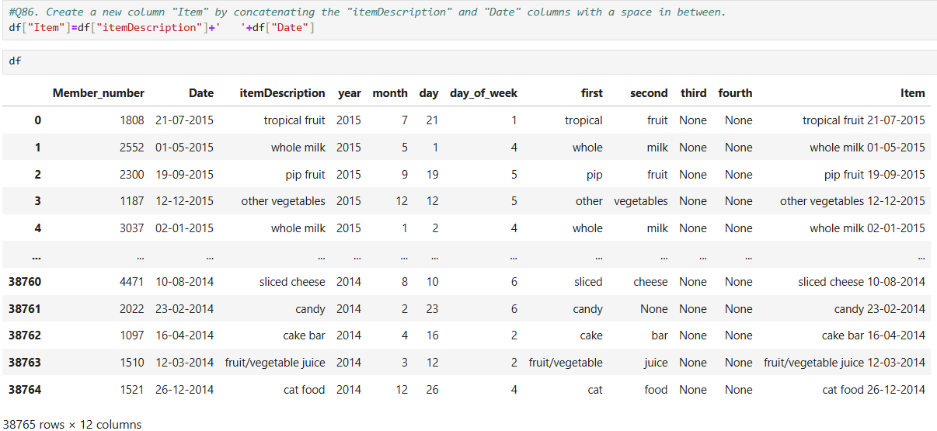

**Q100. Then, split the "Item" column into two separate columns.:"First_Half" and "Second_Half".**

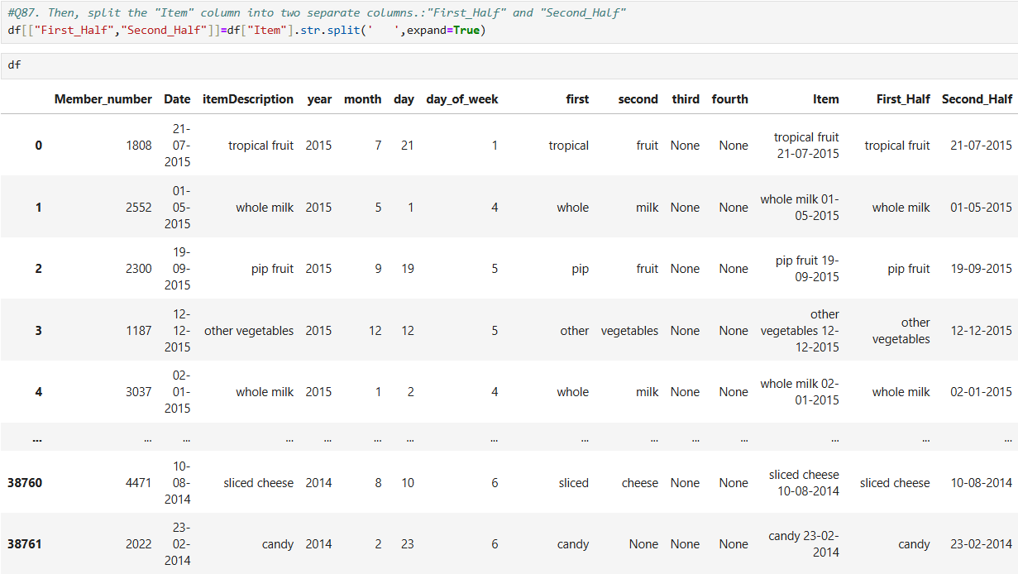

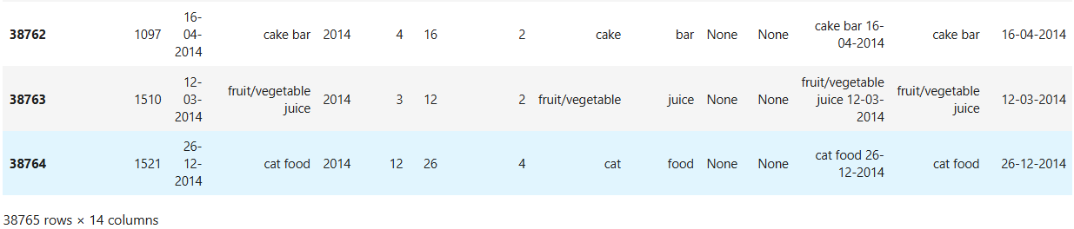

**Q101. Finally group the dataset by "itemDescription" and calculate the count of unique "Item" entries for each city.**

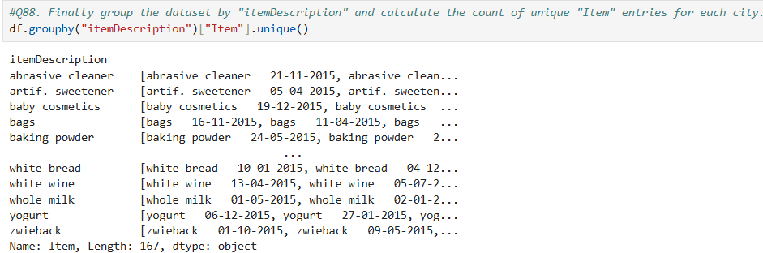

1. **Multiple Data Transformation and Merging**

**Q102. Normalize the "month" column to scale between 0 and 1.**

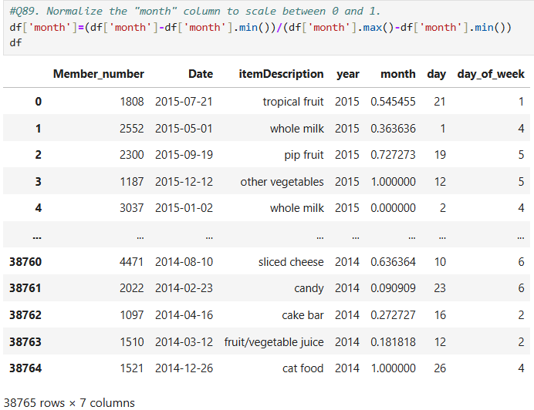

**Q103. Replace any negative values in the "day" column with the median of the column.**

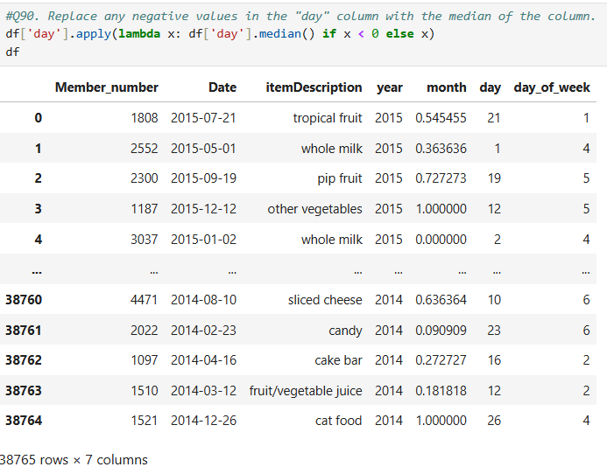

**Q104. Merge the cleaned dataset with another dataframe (say,Product_data) based on the "Product_ID" column and display the first 5 rows of the merged dataset.**

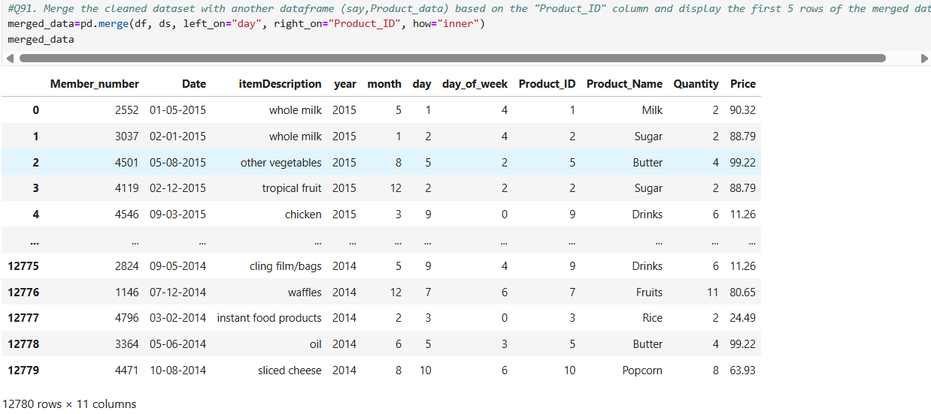

**Q105. Create a DataFrame with 'Product ID', 'Product Name', 'Quantity', and 'Price'. Add 10**

**rows of data for different products. Perform an operation to calculate the 'Total Value'**

**(Quantity * Price) and add it as a new column. Export the modified DataFrame to an**

**Excel file and compare the original and modified versions. What changes can you**

**observe in the data?**

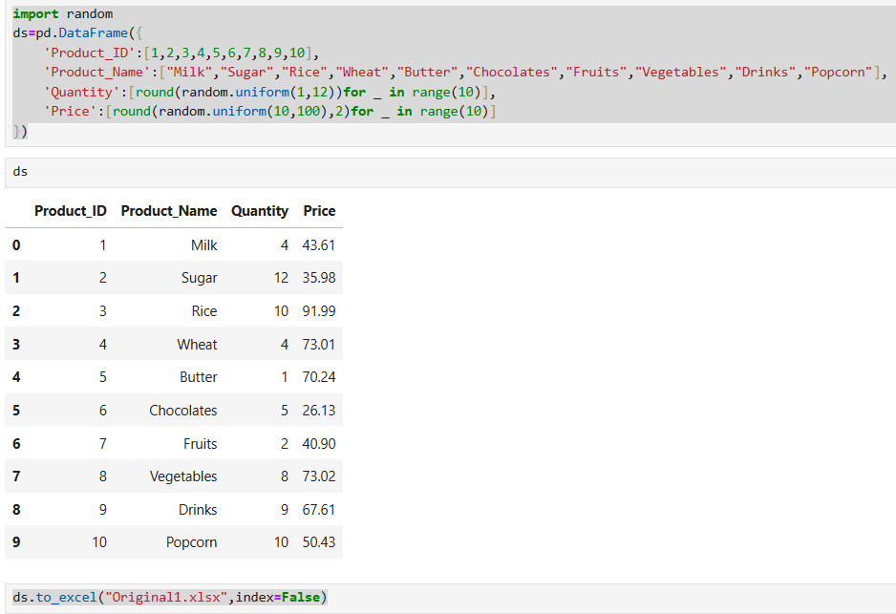

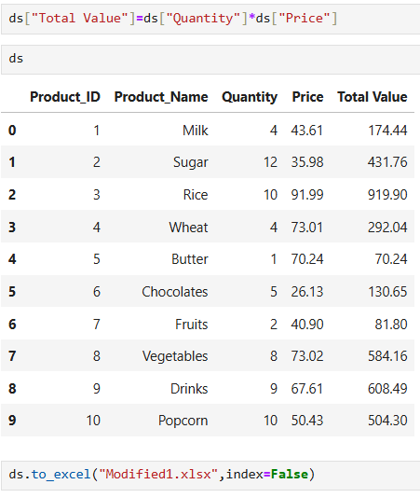

**Q106. Create a DataFrame with 'Student ID', 'Name', 'Grade', and 'Score'. Add 10 rows with**

**data. Perform an operation to assign a 'Pass/Fail' status based on whether the score is**

**above 50 (Pass) or below 50 (Fail). Export the modified DataFrame to an Excel file and**

**show the comparison between the initial file and the updated one. What new columns or**

**changes can you see?**

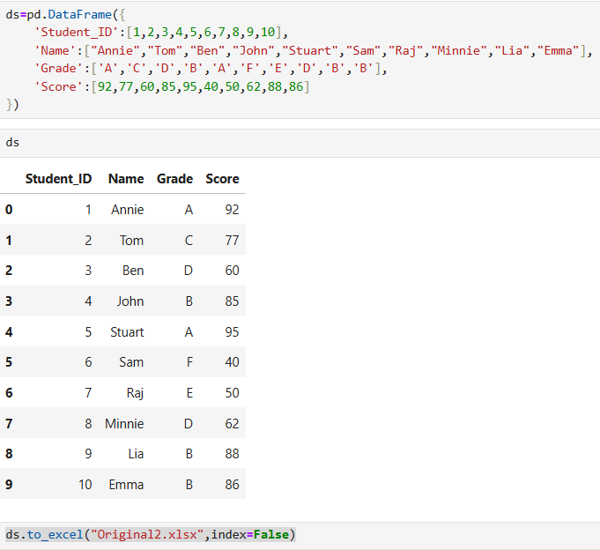

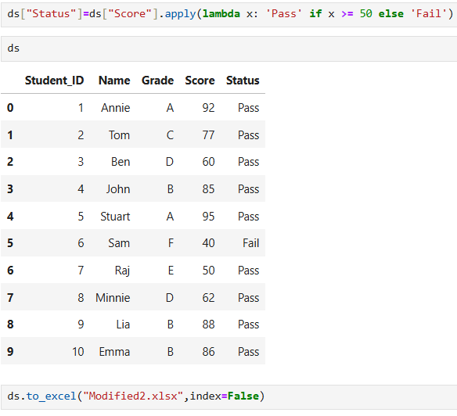

**Q107. Create a CSV file and an Excel file with columns 'Student ID', 'Name', 'Grade', and**

**'Score'. Add 5 rows of student data to each file. Upload the files to Jupyter Notebook,**

**then perform an operation to assign a 'Pass/Fail' status based on whether the score is**

**above 50. Export the modified CSV and Excel files and compare them with the originals.**

**Explain the differences and the new columns added**



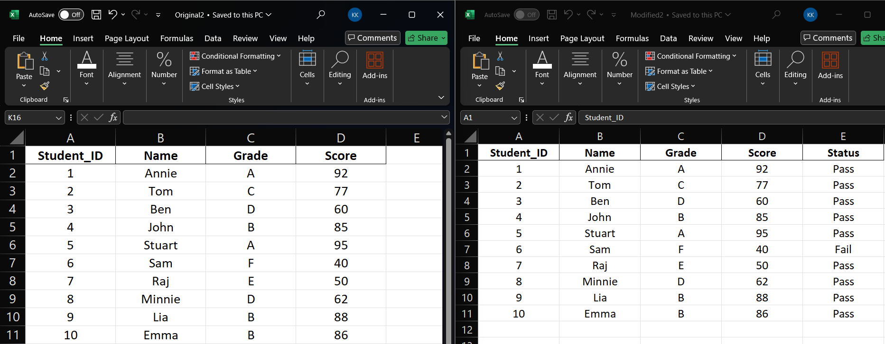

**Q108. Create a CSV file and an Excel file with 'City', 'Country', 'Population', and 'Area'. Add 5**

**rows of city data to both files. Upload the files to Jupyter Notebook, then perform an**

**operation to calculate the 'Population Density' (Population / Area) and add it as a new**

**column. Export both files after modification and compare the original and updated files.**

**What new information can you observe in the 'Population Density' column?**

