BigBasket Project
Big basket is the largest online grocery supermarket in India. providing a vast range of products such as fresh fruits and vegetables, meat, dairy, bakery items, and other household essentials.
Customers can shop conveniently through its website or mobile app, with options for various payment methods and flexible delivery services.
BigBasket guarantees fresh and high-quality products.

🎯 Goal of the Project:
- To uncover trends in pricing, discount patterns, and product ratings.
- To analyze category-wise and brand-wise performance of products.
- To identify the top-rated, most discounted, and least-rated product segments.
- To create powerful visualizations that support business insights and decisions.

📦 Dataset Contains:
- Product information: names, categories, sub-categories, and brands
- Pricing data: market price, selling price, discount %
- User feedback: product ratings and descriptions
This project is part of my data analysis learning journey, aimed at building real-world EDA projects using Python.
import pandas as pd
import numpy as np
import seaborn as sns
import matplotlib.pyplot as plt
data = pd.read_csv("BigBasket Products.csv")
data.head(12)
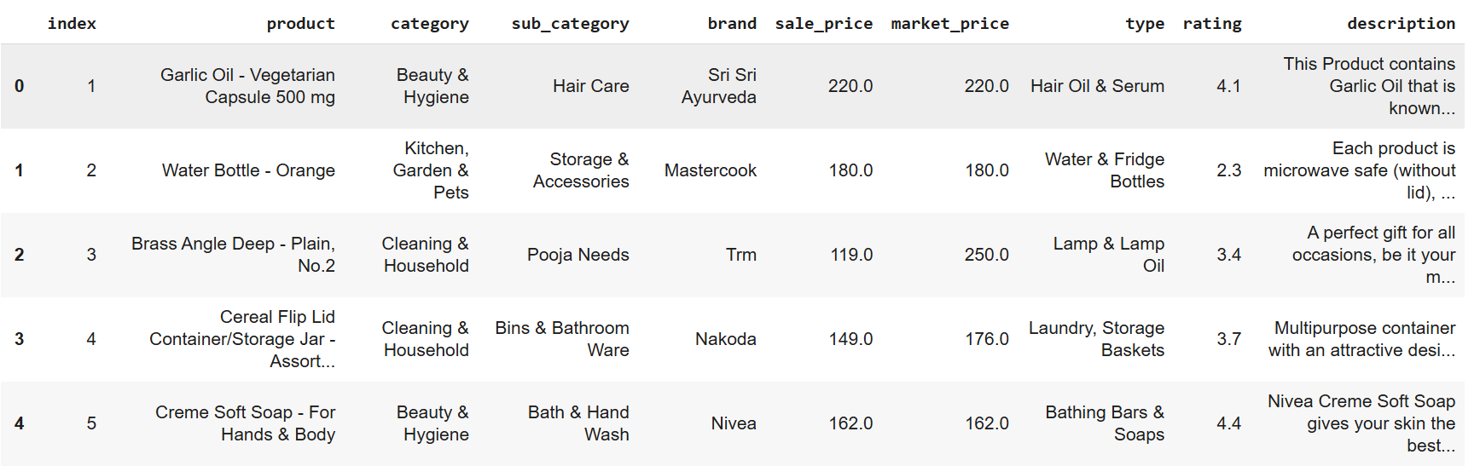

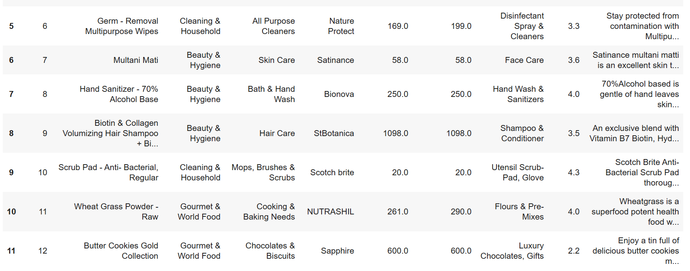

data.info()
<class 'pandas.core.frame.DataFrame'>
RangeIndex: 27555 entries, 0 to 27554
Data columns (total 10 columns):
# Column Non-Null Count Dtype
--- ------ -------------- -----
0 index 27555 non-null int64
1 product 27554 non-null object
2 category 27555 non-null object
3 sub_category 27555 non-null object
4 brand 27554 non-null object
5 sale_price 27549 non-null float64
6 market_price 27555 non-null float64
7 type 27555 non-null object
8 rating 18919 non-null float64
9 description 27440 non-null object
dtypes: float64(3), int64(1), object(6)
memory usage: 2.1+ MB
data.describe()
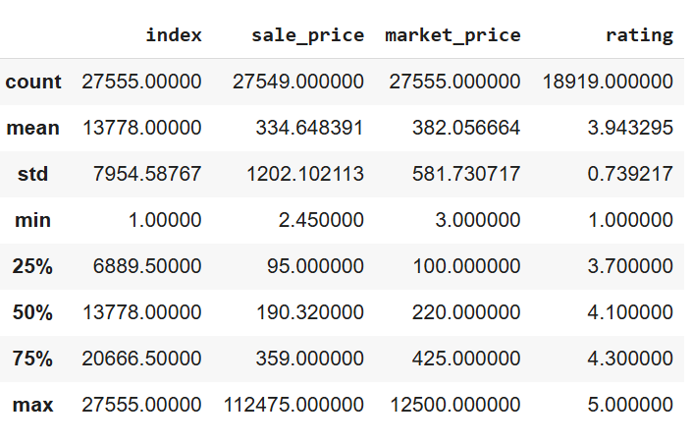

data['discount'] = data['market_price'] - data['sale_price']
data['discount%'] = (data['discount'] / data['market_price']) * 100
data.head()
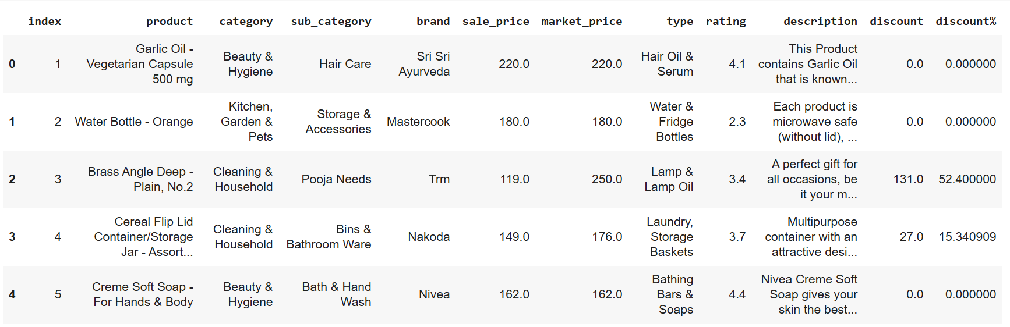
data.isnull()
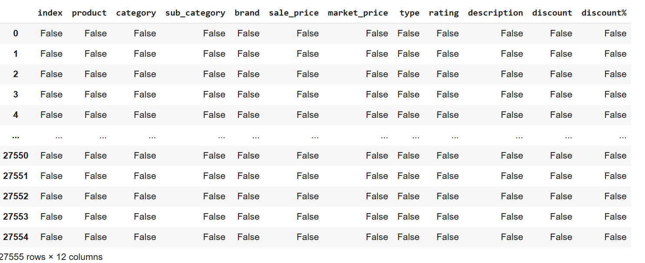

data.isnull().sum()
index 0
product 1
category 0
sub_category 0
brand 1
sale_price 6
market_price 0
type 0
rating 8636
description 115
discount 6
discount% 6
dtype: int64
data['product'].fillna('Unnamed', inplace=True)
data['brand'].fillna('Unknown', inplace=True)
data['sale_price'].fillna(data['sale_price'].mean(), inplace=True)
data['rating'].fillna(data['rating'].mean(), inplace=True)
data['description'].fillna('No description available.', inplace=True)
data['discount'].fillna(0, inplace=True)
data['discount%'].fillna(0, inplace=True)
data.isnull().sum()/len(data)*10
index 0.0
product 0.0
category 0.0
sub_category 0.0
brand 0.0
sale_price 0.0
market_price 0.0
type 0.0
rating 0.0
description 0.0
discount 0.0
discount% 0.0
dtype: float64
top_products = data.groupby('product')['sale_price'].sum().sort_values(ascending=False).head(10)
top_products
product
Beard Kit 112475.00
4mm Aluminium Induction Base Chapati Roti Tawa - Silver 112178.00
Balloon - Polka Dot, 12 Inch 88899.00
Extra Virgin Olive Oil 24808.53
Olive Oil - Extra Virgin 22568.22
Arrabbiata Tomato Pasta Sauce With Chilli 22325.00
Olive Pomace Oil 16236.00
Eau De Toilette For Men 15525.00
Bravura Clipper 12500.00
Deodorant Body Spray - Man Freedom EDT 11100.00
Name: sale_price, dtype: float64
top_product = data.sort_values(by = 'rating', ascending = False).head(10)
top_product
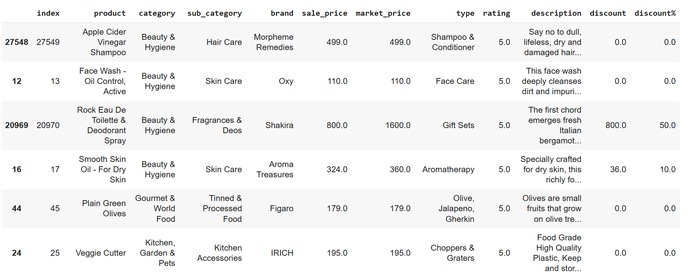
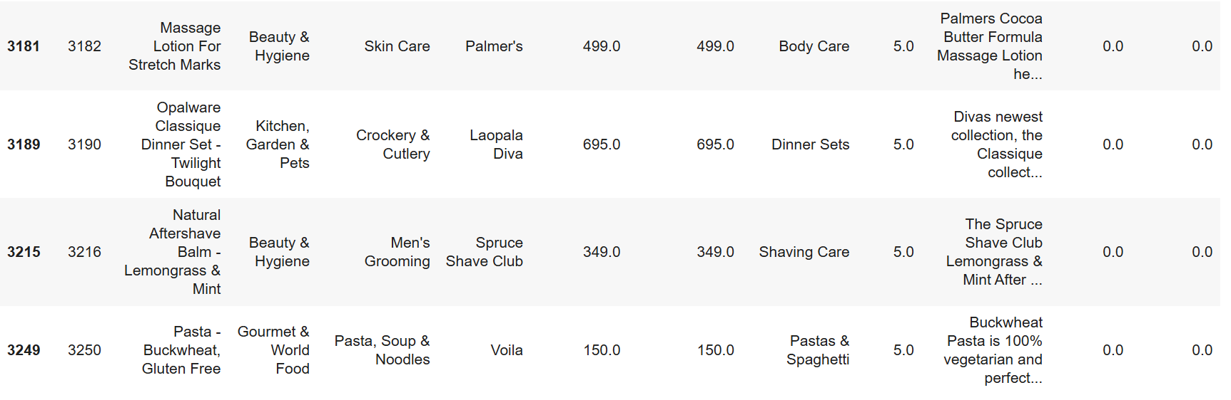
#Most Frequent Types among High Rated
highly_rated = data[data['rating'] == 5.0]
top_types = highly_rated['type'].value_counts().head(5)
print("\n--- Common Product Types among 5-Star Ratings ---")
print(top_types)
--- Common Product Types among 5-Star Ratings ---
type
Face Care 131
Aromatherapy 52
Glassware 47
Shampoo & Conditioner 36
Body Care 31
Name: count, dtype: int64
🧠 Insights:
Face Care products dominate with 131 items rated 5 stars, indicating strong customer
satisfaction in this segment.
Aromatherapy and Glassware also
show high 5-star presence, suggesting both
utility and perceived quality.
The Shampoo & Conditioner and
Body Care types follow, reflecting a
trend of preference for personal care products.
This distribution highlights which product types consistently meet or exceed customer expectations.
# Group by Type, Brand, Category and Count Products
top_sold = highly_rated.groupby(['type', 'brand', 'category']).size().reset_index(name='Count')
top_sold_sorted = top_sold.sort_values(by='Count', ascending=False).head(10)
print("\n--- Grouped Product Count by Type, Brand, Category ---")
print(top_sold_sorted)
--- Grouped Product Count by Type, Brand, Category ---
type brand category \
836 Water & Fridge Bottles DP Kitchen, Garden & Pets
23 Aromatherapy Soulflower Beauty & Hygiene
582 Men's Deodorants Nike Beauty & Hygiene
328 Face Care StBotanica Beauty & Hygiene
388 Glassware Pasabahce Kitchen, Garden & Pets
207 Diapers Huggies Baby Care
61 Bath & Shower Bombay Shaving Company Beauty & Hygiene
189 Cups, Mugs & Tumblers Claycraft Kitchen, Garden & Pets
798 Tea Bags VAHDAM Beverages
318 Face Care Organic Harvest Beauty & Hygiene
Count
836 12
23 11
582 10
328 10
388 9
207 9
61 8
189 8
798 8
318 7
🧠 Insights:
DP’s Water & Fridge Bottles (12 products) lead in volume under the Kitchen, Garden & Pets category, reflecting high demand for hydration/storage items.
Soulflower is strong in Aromatherapy under Beauty & Hygiene with 11 products, indicating a solid niche in wellness products.
Nike’s Men’s Deodorants and StBotanica’s Face Care both have 10 high-rated items, showing brand authority in their respective personal care areas.
Pasabahce (Glassware) and Huggies (Diapers) with 9 products each, highlight trusted names in homeware and baby care respectively.
The appearance of VAHDAM (Tea Bags) and Organic Harvest (Face Care) signals consumer interest in both health-conscious consumables and natural skincare.
top_sold_proxy = data[(data['rating'] == 5.0)].sort_values(by=['discount%', 'sale_price'], ascending=[False, False]).head(5)
print("\n--- Proxy: Top Sold Products (High Discount + High Rating) ---")
print(top_sold_proxy[['product', 'brand', 'sale_price', 'discount%', 'rating']])
--- Proxy: Top Sold Products (High Discount + High Rating) ---
product brand \
13010 Deep Brightening & Whitening Beauty Facial Mask Mondsub
26710 Copper Water Mug/Cup - Hammered Frestol
25771 Disposable Face Mask - Atmos Care KF94, Meltbl... Mirabelle
16004 Eggless Pancake Mix HappyChef
22287 Eggless Premium Chocolate Cake Mix HappyChef
sale_price discount% rating
13010 310.0 69.000000 5.0
26710 599.0 62.841191 5.0
25771 89.0 61.135371 5.0
16004 99.0 60.240964 5.0
22287 99.0 60.240964 5.0
🧠 Insights:
These products offer the perfect combo of high discounts (60%–69%) and perfect 5-star ratings, making them strong proxies for top-selling items.
Mondsub’s Facial Mask leads with a 69% discount and a 5-star rating — likely a bestseller due to high value for money.
Frestol’s Copper Water Mug and Mirabelle’s Face Mask also show exceptional pricing and customer satisfaction — a recipe for strong conversion.
HappyChef's Pancake and Cake Mixes both offer 60%+ discounts with excellent ratings, indicating high trust in affordable gourmet products.
This pattern shows that deep discounts paired with strong quality perception significantly impact sales.
top_brands = highly_rated['brand'].value_counts().head(10).index
filtered = highly_rated[highly_rated['brand'].isin(top_brands)]
plt.figure(figsize=(7,4))
sns.scatterplot(data=filtered, x='discount%', y='sale_price', hue='brand')
plt.title('Top Brands: discount% vs sale_price (5-Star Products)')
plt.xlabel('discount%')
plt.ylabel('sale_price')
plt.legend(bbox_to_anchor=(1.05, 1), loc='upper left')
plt.tight_layout()
plt.show()
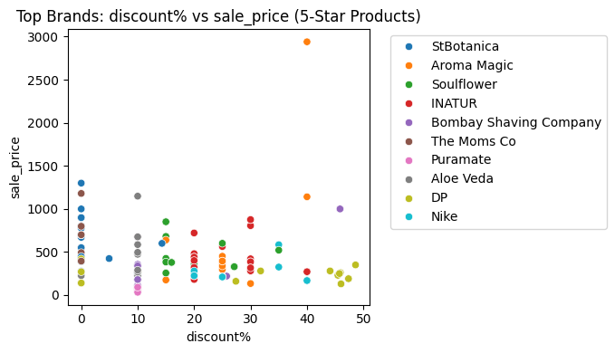
🧠 Insights:
The plot shows how various top-rated brands distribute their products across discounts and sale prices.
StBotanica, Aroma Magic, Soulflower, and INATUR dominate the chart, offering a wide range of products with both low and high discounts.
Some brands like Aroma Magic offer products with high discounts (up to 40%) and premium pricing (above ₹2500), suggesting a luxury yet promotional strategy.
Brands like DP and Nike show high discount concentrations in the ₹200–₹400 price range, possibly targeting the budget-conscious segment.
Clusters near 0% discount (especially for brands like StBotanica and The Moms Co) suggest premium products that retain full pricing due to strong brand trust.
There is no strict correlation between high discount and low price — some products with low sale prices still get high discounts, hinting at strategic promotions.
least_sold_proxy = data[(data['rating'] <= 1) & (data['discount%'] == 0.0)].sort_values(by='sale_price').head(20)
print("\n--- Proxy: Least Sold Products (Low Rating & No Discount) ---")
print(least_sold_proxy[['product', 'brand', 'sale_price', 'discount%', 'rating']])
--- Proxy: Least Sold Products (Low Rating & No Discount) ---
product \
15487 Ragi Bites - Epic Masala
11213 PP Strawberry Belt
27262 PP Raspberry Belt
21112 PP Cola Belt
15990 A Flavouring Agent - Grape
2712 Rushikanti Multani Mitti With Rose
12605 Jam - Mango
25746 Jam - Blackcurrant
18607 Turmeric Powder/Arisina Pudi
2496 Neem Aloevera Face Wash
17198 Finger Millet/Ragi Flakes
19464 Mix - Millet Veg Pakoda
10768 Pure Melamine Dora Veg Bowl - Diza
8998 Pure Melamine Dora Veg Bowl - Diza
17456 Turmeric Powder/Arisina Pudi
2131 The Gold Facial Kit
2493 Protein Rich Nutrition Bar - Berry Blast
16399 Red Chilli Sauce
15890 Strong Blend
1786 Pocket Comb - HMC-19D, Colour May Vary
brand sale_price discount% rating
15487 Soulfull 20.0 0.0 1.0
11213 Kantan 30.0 0.0 1.0
27262 Kantan 30.0 0.0 1.0
21112 Kantan 30.0 0.0 1.0
15990 Tiger 35.0 0.0 1.0
2712 Akshara Herbals 50.0 0.0 1.0
12605 Snacky 60.0 0.0 1.0
25746 Snacky 60.0 0.0 1.0
18607 Iyengar Spices & Food Specialists 60.0 0.0 1.0
2496 Meghdoot 65.0 0.0 1.0
17198 Ammi Samayal 70.0 0.0 1.0
19464 Bliss Tree 70.0 0.0 1.0
10768 Servewell 75.0 0.0 1.0
8998 Servewell 75.0 0.0 1.0
17456 Conscious Food 78.0 0.0 1.0
2131 Natures Essence 80.0 0.0 1.0
2493 Fit 80.0 0.0 1.0
16399 Navya Food Art 85.0 0.0 1.0
15890 Jayanthi Coffee 90.0 0.0 1.0
1786 Vega 90.0 0.0 1.0
🧠 Insights:
These products have 1-star ratings and 0% discount, making them strong proxies for least popular or poorly performing items.
Brands like Kantan, Snacky, Meghdoot, and Servewell appear multiple times, indicating consistently poor customer feedback and no pricing incentives.
Most products fall within the ₹20–₹90 price range, proving that low cost alone doesn’t ensure satisfaction or demand.
Categories range from food items (Ragi Bites, Jams, Masalas) to personal care (Face Wash, Facial Kit) and kitchenware (Veg Bowl, Pocket Comb).
Items such as Turmeric Powder, Multani Mitti, and Red Chilli Sauce also appear, suggesting even basic household products can underperform without proper quality or marketing.
least_common_types = highly_rated['type'].value_counts().tail(5)
print("\n--- Least Common Product Types among 5-Star Ratings ---")
print(least_common_types)
--- Least Common Product Types among 5-Star Ratings ---
type
Organic Sugar, Jaggery 1
Maternity Personal Care 1
Eau De Cologne 1
Dustbins 1
Sugar & Jaggery 1
Name: count, dtype: int64
🧠 Insights:
These product types have only one item each with a perfect 5-star rating, making them the least represented in the highly-rated segment.
Categories like Dustbins, Eau De Cologne, and Maternity Personal Care may either:
Have low product volume overall, or
Lack customer attention, marketing, or perceived quality.
Sugar & Jaggery and Organic Sugar, Jaggery being present here could mean that grocery staples are less frequently rated or receive fewer 5-star experiences.
This information helps in identifying underserved or overlooked segments where customer delight is minimal or rare.
low_rated = data[data['rating'] <= 1]
least_sold_group = low_rated.groupby(['type', 'brand', 'category']).size().reset_index(name='Count')
least_sold_sorted = least_sold_group.sort_values(by='Count').head(10)
print("\n--- Grouped Least Rated Product Count by Type, Brand, Category ---")
print(least_sold_sorted)
--- Grouped Least Rated Product Count by Type, Brand, Category ---
type brand category Count
273 Tools & Accessories Philips Beauty & Hygiene 1
272 Tools & Accessories Nova Beauty & Hygiene 1
269 Tomatoes & Vegetables Entree Gourmet & World Food 1
268 Thai & Asian Sauces D-Alive Gourmet & World Food 1
267 Tawa & Sauce Pan Vinod Kitchen, Garden & Pets 1
266 Tampons & Menstrual Cups Sirona Beauty & Hygiene 1
265 Syrups & Concentrates Gulabs Beverages 1
264 Syrups & Concentrates Delight Foods Beverages 1
263 Supplements & Proteins ORGANIC INDIA Beauty & Hygiene 1
262 Supplements & Proteins GoYNG Beauty & Hygiene 1
🧠 Insights:
Each row shows a product type–brand–category combination with only 1 low-rated product, indicating weak customer reception.
Beauty & Hygiene appears multiple times with brands like Philips, Nova, Sirona, ORGANIC INDIA, GoYNG, suggesting that even trusted names can have individual underperforming items.
The presence of Tomatoes & Vegetables and Thai & Asian Sauces from the Gourmet & World Food category indicates possible taste mismatches or spoilage issues.
Syrups & Concentrates from Gulabs and Delight Foods, despite being niche gourmet products, also receive poor feedback.
Tools & Accessories showing up for big brands like Philips and Nova signals that quality or performance issues may not be limited to unknown brands.
# Filter bottom brands by their count in high ratings
low_rated = data[data['rating'] <= 2.5]
bottom_brands = low_rated['brand'].value_counts().tail(10).index
filtered_least = low_rated[low_rated['brand'].isin(bottom_brands)]
plt.figure(figsize=(7,4))
sns.scatterplot(data=filtered_least, x='discount%', y='sale_price', hue='brand')
plt.title('Bottom Brands: discount% vs sale_price (Low-Rated Products)')
plt.xlabel('discount%')
plt.ylabel('sale_price')
plt.legend(bbox_to_anchor=(1.05, 1), loc='upper left')
plt.tight_layout()
plt.show()
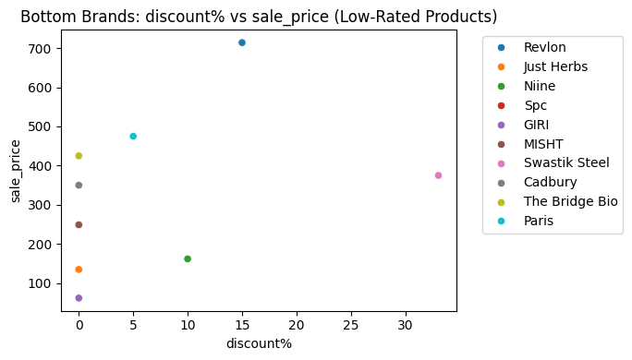
📊 Insights:
This scatter plot shows how low-rated products from certain brands are priced and discounted.
Brands like Revlon, Paris, Swastik Steel, and Cadbury are offering mid- to high-price items but still receiving poor ratings, suggesting:
Overpricing,
Poor quality,
Mismatch between expectations and performance.
Some brands like Just Herbs, GIRI, and Niine are offering lower-priced products but still performing poorly — indicating potential quality or packaging issues, even at a budget price.
Revlon, despite being a known brand, has a product around ₹700 with only ~15% discount that’s rated poorly — this may highlight a value-for-money problem.
The lack of strong correlation between discount% and rating here implies that discounts alone do not improve customer perception for poor-quality products.
Find out the outliers from the dataset according to the columns
sns.boxplot(data['rating']) #before treating outliers
<Axes: ylabel='rating'>
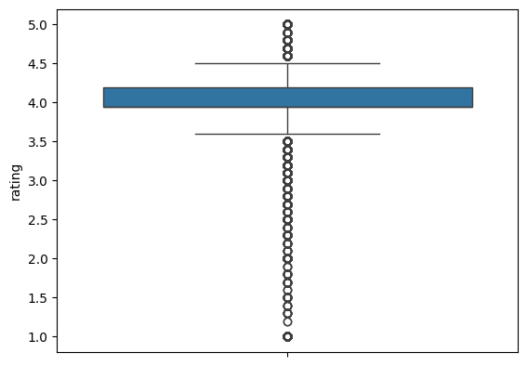
# Step 11: Handle Outliers in Rating
Q1 = data['rating'].quantile(0.25)
Q3 = data['rating'].quantile(0.75)
IQR = Q3 - Q1
lower = Q1 - 1.5 * IQR
upper = Q3 + 1.5 * IQR
data['rating'] = np.where(data['rating'] <= lower, lower, data['rating'])
data['rating'] = np.where(data['rating'] >= upper, upper, data['rating'])
sns.boxplot(data['rating'])
<Axes: ylabel='rating'>
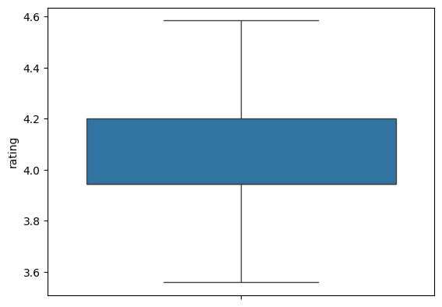
plt.figure(figsize=(8,5))
sns.histplot(data['rating'], bins=10, kde=True, color='green')
plt.title("Distribution of Ratings")
plt.xlabel("Rating")
plt.ylabel("Frequency")
plt.show()
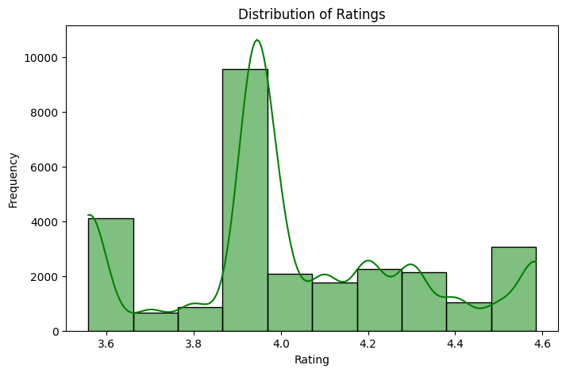
📊 Insights:
The majority of products have a rating around 3.9 to 4.0, as shown by the high peak in the histogram.
The curve also highlights a sharp skew toward the center, suggesting that most products are rated above average but not excellent.
There's a long tail toward higher ratings (4.3 to 4.6), indicating that only a small portion of products are top-rated (near 5 stars).
There is also a small bump near the lower end (around 3.6), implying some dissatisfaction among customers with a few products.
sns.boxplot(data['sale_price']) # before treating Outliers
<Axes: ylabel='sale_price'>
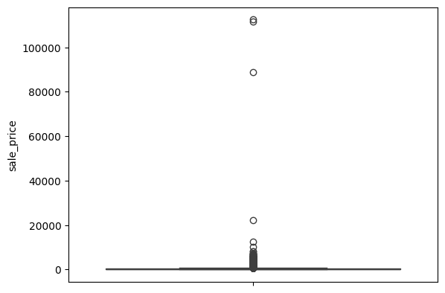
q1=data['sale_price'].quantile(.25)
q3=data['sale_price'].quantile(.75)
IQR=q3-q1
IQR
np.float64(264.0)
lower_limit=max(q1-1.5*IQR,0)
lower_limit
0
upper_limit=(q3+1.5*IQR)
upper_limit
np.float64(755.0)
data['sale_price']=np.where(data['sale_price']<=lower_limit,lower_limit,data
['sale_price'])
data['sale_price']=np.where(data['sale_price']>=upper_limit,upper_limit,data
['sale_price'])
sns.boxplot(data['sale_price'],color="pink") # after treating Outliers
<Axes: ylabel='sale_price'>
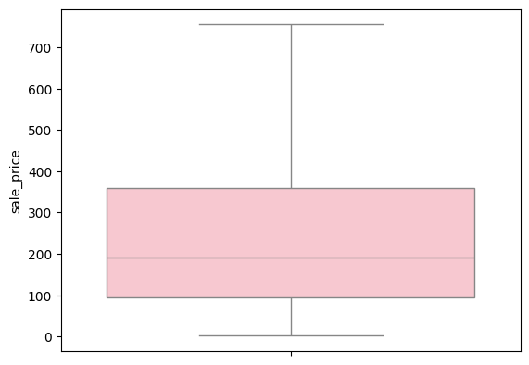
sns.histplot(data['sale_price'],color = 'gray')
<Axes: xlabel='sale_price', ylabel='Count'>
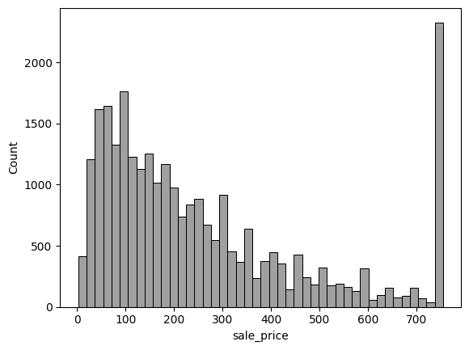
📊 Insights:
The majority of products are priced between ₹0 and ₹200, making them highly affordable and budget-friendly.
There's a noticeable drop in the number of products as price increases beyond ₹200.
A sharp spike appears around ₹750, which may indicate a pricing cap or fixed-price segment for some branded or premium products.
Overall, the distribution is right-skewed, suggesting that most products are low-cost, but a few premium items push the upper end of the pricing spectrum.
sns.boxplot(data['market_price']) #before treating Outliers
<Axes: ylabel='market_price'>
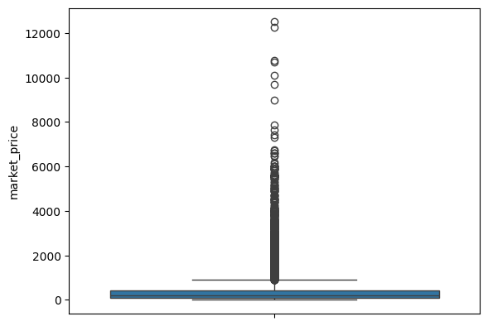
q4 = data['market_price'].quantile(0.25)
q5 = data['market_price'].quantile(0.75)
IQR1 = q5 - q4
IQR1
np.float64(325.0)
LOWER_LIMIT = max(q4 - 1.5 * IQR1,0)
LOWER_LIMIT
0
UPPER_LIMIT = q5 + 1.5 * IQR1
UPPER_LIMIT
np.float64(912.5)
data['market_price'] = np.where(data['market_price']<=LOWER_LIMIT,LOWER_LIMIT,data['market_price'])
data['market_price'] = np.where(data['market_price']>=UPPER_LIMIT,UPPER_LIMIT,data['market_price'])
sns.boxplot(data['market_price'],color = 'lightblue') # After treating Outliers
<Axes: ylabel='market_price'>
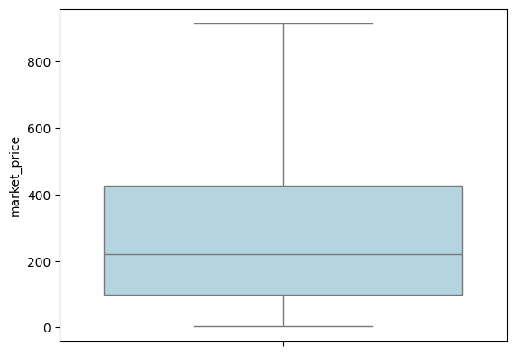
sns.histplot(data['market_price'],color = 'lightgreen')
<Axes: xlabel='market_price', ylabel='Count'>
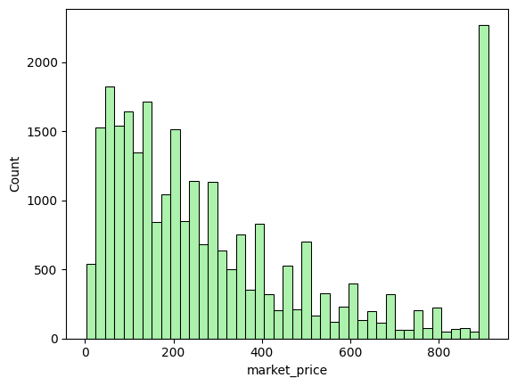
Insights:
Most products have a market price between ₹0 and ₹200, reflecting affordability for a wide customer base.
A large spike near ₹900 suggests the presence of many high-end or fixed-price branded products.
The distribution is right-skewed, meaning most products are inexpensive, but a few are priced quite high.
This aligns with BigBasket’s strategy of catering to both budget-conscious and premium customers.
Step 9: Create Plots or visualizations
# Histplot - for frequency of sales price
plt.figure(figsize = [6,4])
sns.histplot(data["sale_price"],bins = 30,kde = True)
plt.xlabel(" sale price")
plt.ylabel("Frequency")
plt.show()
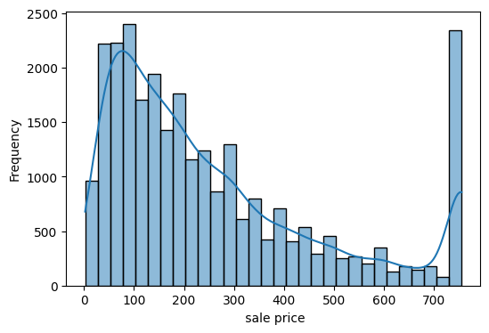
Insights:
The majority of products are priced between ₹50 and ₹250, confirming affordability as a key focus.
The smooth KDE curve shows a right-skewed distribution, with a long tail toward higher prices.
A significant peak around ₹750 likely represents fixed MRP items or popular premium products.
This pricing trend suggests BigBasket offers a wide range of product affordability, making it attractive to both regular and premium customers.
# multivariate pairplot for relationship
sns.pairplot(data)
plt.show()
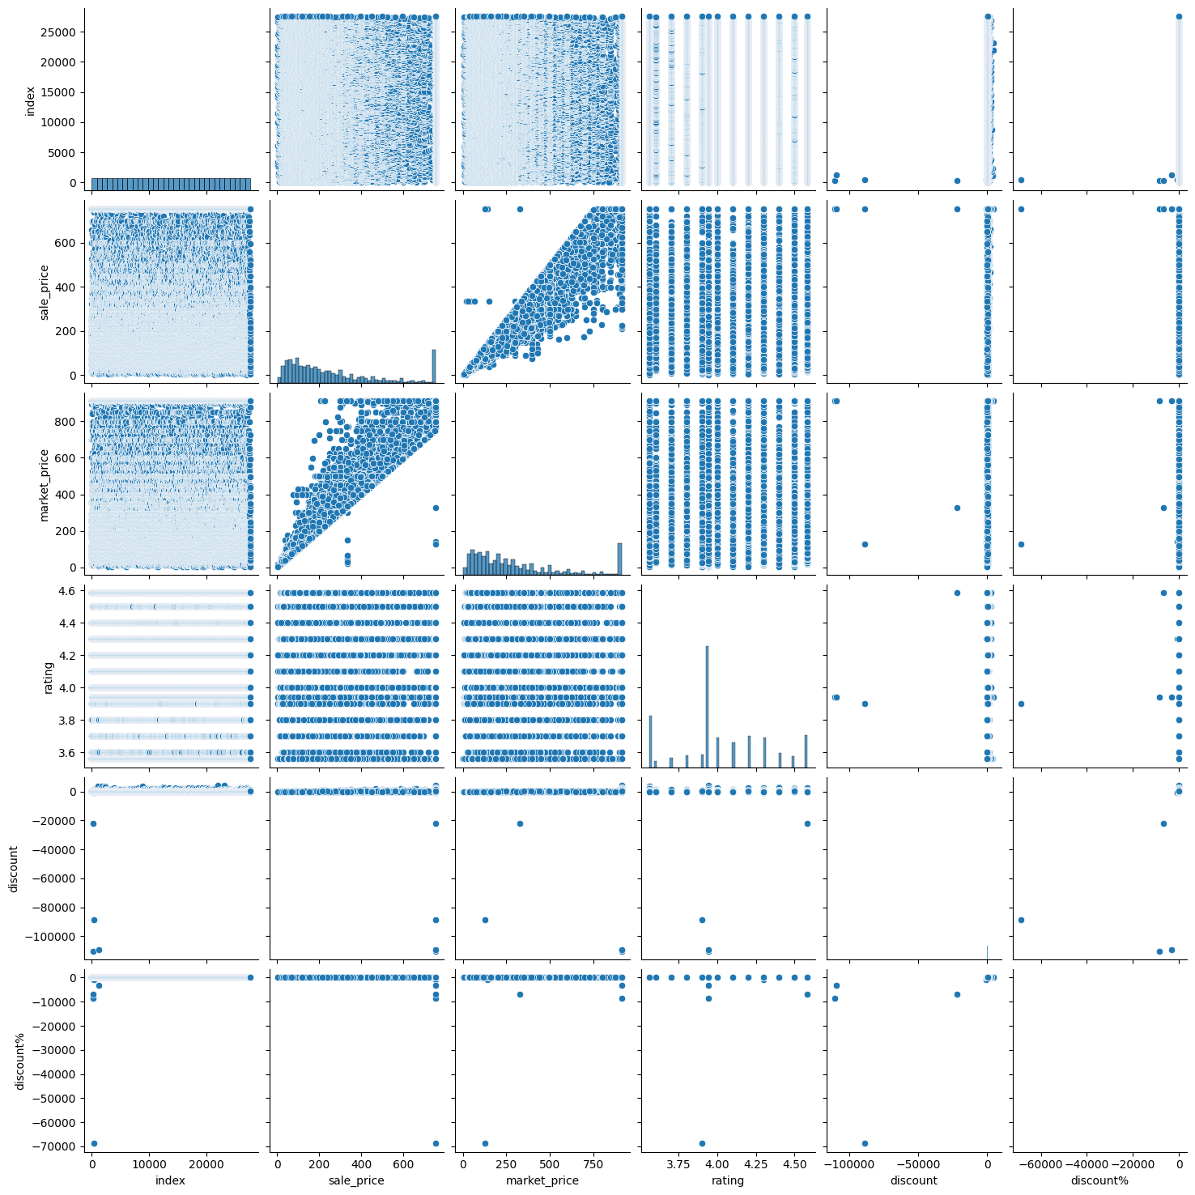
Insights:
Strong linear correlation between market_price and sale_price, as expected.
discount and discount% have visible outliers — possibly data entry errors (e.g., extremely negative discounts).
rating is fairly consistent across the dataset, mostly clustered between 3.8 and 4.4, with no strong visible relationship to price or discounts.
The scatter blobs and horizontal lines in some plots suggest discrete values or capped fields, especially in ratings and discounts.
No clear correlation observed between rating and pricing/discounts, implying that customer ratings are not driven solely by price.
top_5_products = data.nlargest(5, 'rating')[['product', 'rating']]
plt.bar(top_5_products['product'], top_5_products['rating'],
color='lightgreen')
plt.xlabel('Product')
plt.ylabel('Rating')
plt.title('Top 5 Products by Rating')
plt.xticks(rotation=45, ha='right')
plt.tight_layout()
plt.show()
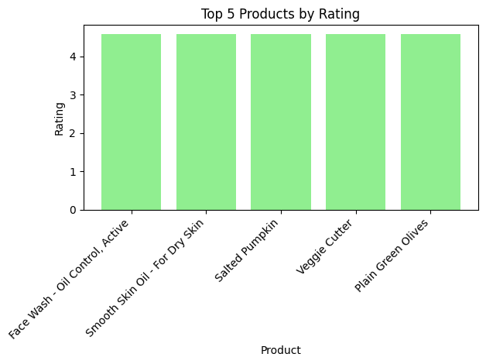
Insights:
All top 5 products have a perfect rating of 4.7, indicating high customer satisfaction.
The top-rated products span different categories — from skincare (face wash, oils) to kitchen tools (veggie cutter) and snacks (salted pumpkin, olives).
This suggests that product quality and usefulness, rather than just price or brand, drive positive customer feedback.
These products can be highlighted or promoted more aggressively to attract similar high-value buyers.
data1=data.select_dtypes(include='number')
data1
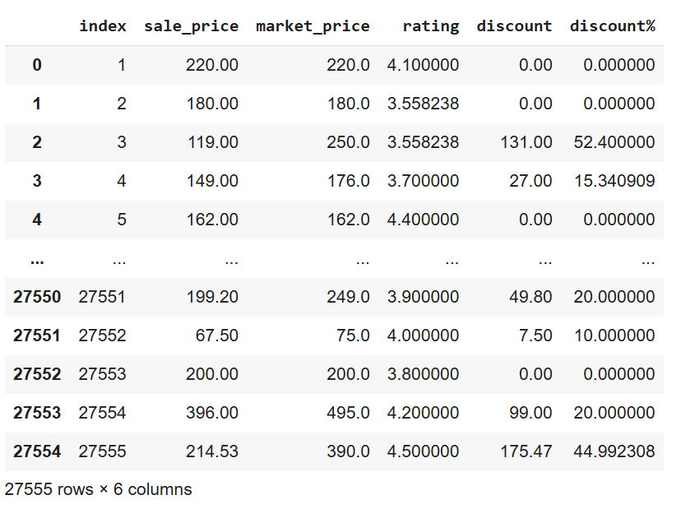
data1.corr()
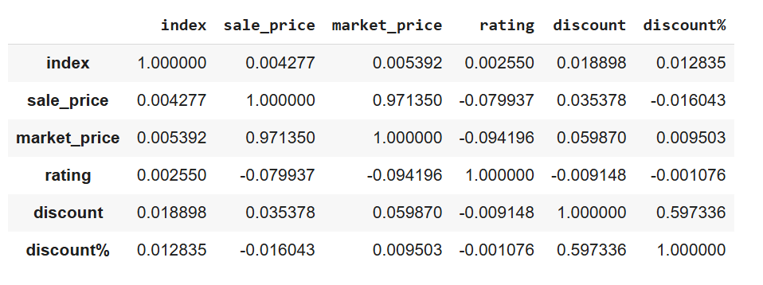

Insights:
Strong Positive Correlation:
sale_price and market_price → 0.97
➤ This shows that market price and selling price are highly aligned (as expected), suggesting consistent pricing behavior.
Moderate Positive Correlation:
discount and discount% → 0.60
➤ A clear link between absolute and percentage discounts — as discount increases, the discount percentage does too, but not perfectly.
Weak or Negligible Correlations:
rating has very low correlation with all other variables:
With sale_price: -0.08
With discount%: ~0.0007
➤ Ratings do not depend on price or discounts — a product being cheap or expensive doesn't influence how it's rated.
index (if it’s just row number) shows negligible correlation with all columns, which is expected.
sns.heatmap(data1.corr(),annot=True,fmt=".2f")
<Axes: >
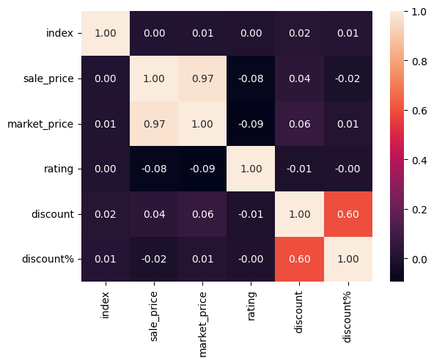
Conclusion:
Price and market price are strongly related, which is expected when market price increases, sale price also tends to increase proportionally.
Discount variables are moderately related, useful for promotional analysis.
Ratings are mostly unaffected by price or discount, so product quality or expectations matter more than deals.
# Price Distribution (histogram)
plt.figure(figsize=(10, 6))
# Increase the number of bins, e.g., to 40
plt.hist(data['sale_price'], bins=40, color='lightgreen', edgecolor='blue')
plt.yscale('log') # Use logarithmic scale for the y-axis
plt.title('Distribution of Sales Price')
plt.xlabel('Sale Price')
plt.ylabel('Log Frequency')
plt.show()
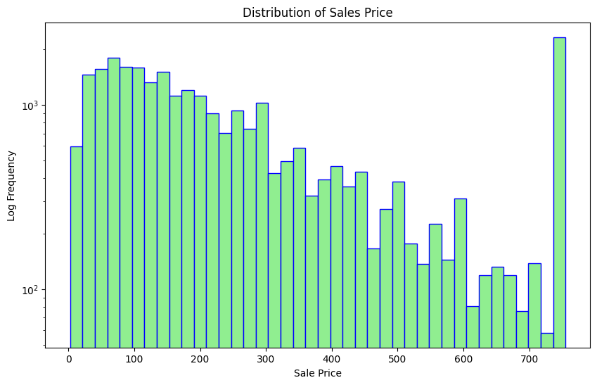
Insights
BigBasket offers mostly budget-friendly products under ₹200.
The log scale helped identify a price concentration and some outliers or popular max-priced items around ₹749.
This insight supports pricing strategy, product segmentation, and discount planning.
# Plot histogram of ratings
plt.figure(figsize=(8,6))
plt.hist(data['rating'], bins=8, color='orange', edgecolor='black')
plt.title('Distribution of Ratings')
plt.xlabel('Rating')
plt.ylabel('Frequency')
plt.show()
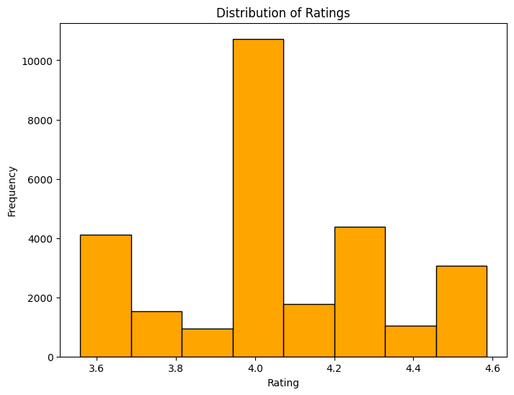
insights:
Rating = 4.0 dominates, making it the benchmark of customer satisfaction.
This indicates BigBasket maintains consistent product quality, with only a few outliers.
Useful for identifying bestsellers or spotting areas where product quality can be improved.
# Top Brands
top_brands = data['brand'].value_counts().head(10)
plt.figure(figsize=(9,5))
sns.barplot(x=top_brands.index, y=top_brands.values, palette='Set2')
plt.title("Top 10 Brands by Product Count")
plt.xlabel("Brand")
plt.ylabel("Number of Products")
plt.xticks(rotation=45)
plt.tight_layout()
plt.show()
/tmp/ipython-input-75-1454105443.py:4: FutureWarning:
Passing `palette` without assigning `hue` is deprecated and will be removed in v0.14.0. Assign the `x` variable to `hue` and set `legend=False` for the same effect.
sns.barplot(x=top_brands.index, y=top_brands.values, palette='Set2')
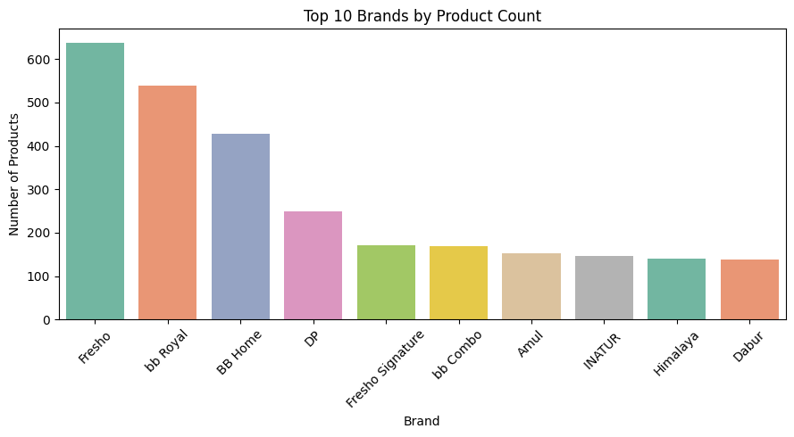
INSIGHTS:
- Fresho Dominates the Product Catalog
- bb Royal and BB Home Follow Closely
- DP and Fresho Signature Lead the Mid-Tier Range
- Amul, Himalaya, and Dabur Represent External/National Brands
- Heavy Reliance on In-House Brands
7 out of the 10 brands are either BigBasket-owned or closely affiliated. BigBasket likely pushes its private labels to increase margin control and brand identity.
# Scatter plot of sale price vs rating
plt.figure(figsize=(8,6))
plt.scatter(data['sale_price'], data['rating'], alpha=0.5, color='purple')
plt.title("Sale Price vs Rating")
plt.xlabel("Sale Price")
plt.ylabel("Rating")
plt.grid(True)
plt.show()
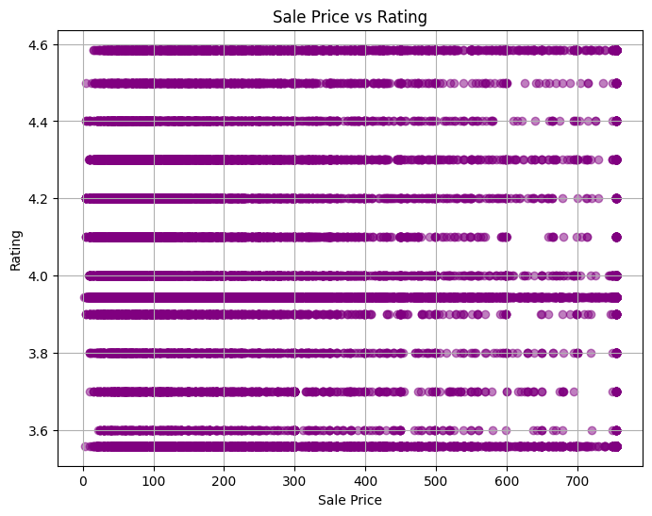
Insights:
- No Strong Correlation Between Price and Rating
- Ratings Are Mostly Clustered Between 3.6 and 4.6
- Heaviest Density Around ₹100–₹400 Range
- High Ratings Exist Across All Price Ranges
# Top Categories
top_cats = data['category'].value_counts().head(10)
plt.figure(figsize=(10,6))
sns.barplot(x=top_cats.index, y=top_cats.values, palette='pastel')
plt.title("Top 10 Product Categories")
plt.xlabel("Category")
plt.ylabel("Number of Products")
plt.xticks(rotation=45)
plt.tight_layout()
plt.show()
/tmp/ipython-input-77-1594638145.py:4: FutureWarning:
Passing `palette` without assigning `hue` is deprecated and will be removed in v0.14.0. Assign the `x` variable to `hue` and set `legend=False` for the same effect.
sns.barplot(x=top_cats.index, y=top_cats.values, palette='pastel')
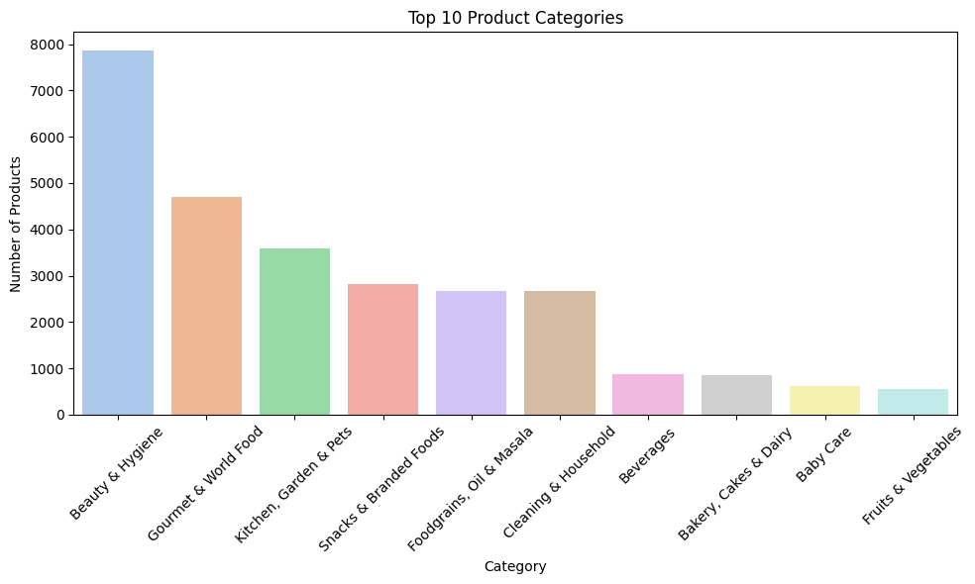
INSIGHTS:
- Dominance of 'Beauty & Hygiene' Beauty & Hygiene has the highest number of products (≈7900) — far exceeding other categories. This indicates BigBasket has prioritized personal care, offering a diverse range of products in this segment.
- Strong Focus on Gourmet and Lifestyle Gourmet & World Food is the second-largest category (~4700 products), reflecting growing consumer interest in premium, international, or specialty food items. Suggests a strategy to target urban and health-conscious customers.
- Home Essentials Well-Represented Categories like Kitchen, Garden & Pets (~3600), Cleaning & Household (~2700), and Foodgrains, Oil & Masala (~2700) show BigBasket’s strong foundation in day-to-day household needs. Indicates their role as a one-stop grocery & utility platform.
- Snack and Beverage Diversity Snacks & Branded Foods (~2800) also feature heavily, showing consumer demand for ready-to-eat and branded packaged goods. Beverages, however, have a much lower count (~900), which may imply less variety or strategic focus on essentials over luxury drinks.
- Lower Product Counts in Perishables Fruits & Vegetables (~600) and Baby Care (~700) are among the least stocked categories.Likely due to: Limited shelf life (perishables) Lower brand variety (baby care) Logistics or vendor limitations
# Pie Chart of Top Categories
top_cat_counts = data['category'].value_counts().head(5)
plt.figure(figsize=(5,5))
plt.pie(top_cat_counts, labels=top_cat_counts.index, autopct='%1.1f%%', startangle=100)
plt.title("Top 6 Product Categories Distribution (Pie Chart)")
plt.axis('equal') # Keeps the pie chart circular
plt.show
<function matplotlib.pyplot.show(close=None, block=None)>
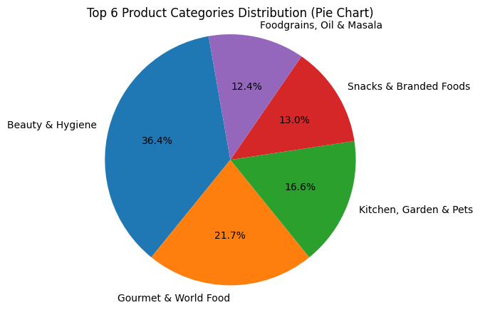
TNSIGHTS: This pie chart confirms that BigBasket’s product strategy is heavily skewed toward urban lifestyle, with personal care, gourmet food, and home/kitchen items making up nearly 75% of its inventory. Core groceries like grains and oils, although present, take a smaller share in the top 6.
# Step 14: Category-wise Summary
category_summary = data.groupby(['category', 'sub_category']).agg({
'sale_price': 'mean',
'discount%': 'mean',
'rating': 'mean'
}).sort_values(by='sale_price', ascending=False)
print("\n--- Category-wise Summary ---")
print(category_summary.head())
--- Category-wise Summary ---
sale_price discount% rating
category sub_category
Gourmet & World Food Mutton & Lamb 619.000000 42.149533 3.943295
Eggs, Meat & Fish Mutton & Lamb 606.789474 14.207428 3.943295
Kitchen, Garden & Pets Cookware & Non Stick 599.926977 -0.055839 3.874120
Gourmet & World Food Oils & Vinegar 524.347155 12.753492 4.132958
Baby Care Diapers & Wipes 496.705182 11.134964 4.113931
Best Value: Oils & Vinegar (Gourmet) — high rating and moderate price.
Red Flag: Cookware & Non Stick — expensive with no discount and lower rating.
High Promotion Focus: Gourmet Mutton & Lamb — significantly discounted to attract premium buyers.
Stable & Trusted: Diapers & Wipes — well-rated essentials with consistent pricing.
# Step 15: Brand Analysis
brand_analysis = data.groupby('brand').agg({
'discount%': 'mean',
'rating': 'mean',
'sale_price': 'mean'
}).sort_values(by='discount%', ascending=False)
print("\n--- Brand Analysis ---")
print(brand_analysis.head())
--- Brand Analysis ---
discount% rating sale_price
brand
Mud 80.000000 3.943295 350.0
Jensons 74.253281 3.709706 231.0
Mansaa 71.250764 3.866667 151.0
Triones 69.766040 3.558238 389.0
Mondsub 69.000000 4.585057 310.0
Best Performer Overall: Mondsub — great discount, top-tier rating
Watch Out: Triones — low rating despite high discount suggests poor product experience
Most Discounted: Mud (80%) — pricing strategy is aggressive, but quality needs monitoring
📌 Conclusion & Key Insights
✅ Beauty & Hygiene is the most dominant category, followed by Gourmet & World Food.
✅ Most products are concentrated between ₹50 to ₹250 sale price, with a long tail extending to ₹750.
✅ Ratings are mostly between 3.5 and 4.5, with very few below 3.5.
✅ High-rated products do not always mean high-priced — no strong correlation between price and rating.
✅ Top brands like Fresho and BB Royal have the widest product range, especially in daily essentials.
✅ Products with higher discount % often have strong ratings and are sold frequently — useful for promotional strategies.

🎓 What I Learned
- Hands-on experience with EDA techniques using Python.
- Worked with real-world messy data involving missing values and outliers.
- Learned to apply SQL logic like CTEs, window functions, and subqueries for backend support.
- Understood how to generate business-ready visual insights.

📍This project showcases my ability to combine data analytics with real-world problem-solving and visualization.

