**Neo4j server:**

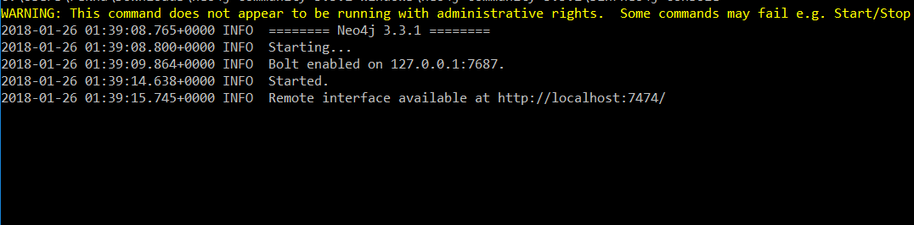

**Query:**

CREATE

(NorthAmerica:Location {name:'North America', type:'continent'}),

(UnitedStates:Location {name:'United States', type:'country' }),

(ID:Location {name:'Idaho', type:'state' }),

(Europe:Location {name:'Europe', type:'continent'}),

(UnitedKingdom:Location {name:'United Kingdom', type:'country' }),

(France:Location {name:'France', type:'country' }),

(England:Location {name:'England', type:'country' }),

(Burgdny:Location {name_fr:'Bourgogne', name:'Burgundy', type:'region' }),

(London:Location {name:'London', type:'city' }),

(CotedOr:Location {name:'Cote-dOr', type:'department' }),

(Beaune:Location {name:'Beaune', type:'city' }),

(Lucy:Person {name:'Lucy' }),

(Alain:Person {name:'Alain' }),

/* Add relationship */

(ID) -[:WITHIN]-> (UnitedStates) -[:WITHIN]-> (NorthAmerica),

(London) -[:WITHIN]-> (England) -[:WITHIN]-> (UnitedKingdom) -[:WITHIN]-> (Europe),

(Beaune) -[:WITHIN]-> (CotedOr) -[:WITHIN]-> (Burgdny) -[:WITHIN]-> (France) -[:WITHIN]-> (Europe),

(Alain) -[:BORN_IN]-> (Beaune),

(Lucy) -[:BORN_IN]-> (ID),

(Alain) -[:LIVES_IN]-> (London),

(Lucy) -[:LIVES_IN]-> (London),

(Lucy) -[:Married]-> (Alain),

(Alain) -[:Married]-> (Lucy)

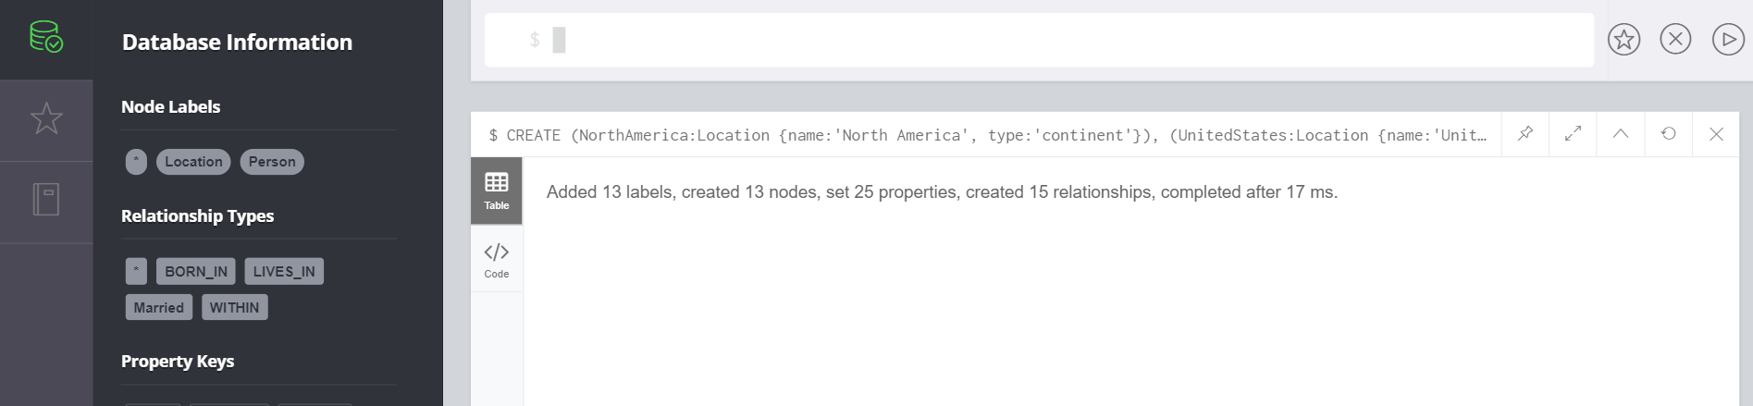

**Match Query:**

/* Cypher query to find people who emigrated from the US to Europe*/

MATCH

(person) -[:BORN_IN]-> () -[:WITHIN*0..]-> (USA:Location {name:'United States'}),

(person) -[:LIVES_IN]-> () -[:WITHIN*0..]-> (Europe:Location {name:'Europe'})

RETURN person.name

