**DBT-Assignment 5**

**Divya Mereddy -M12482385**

Start MongoDb server

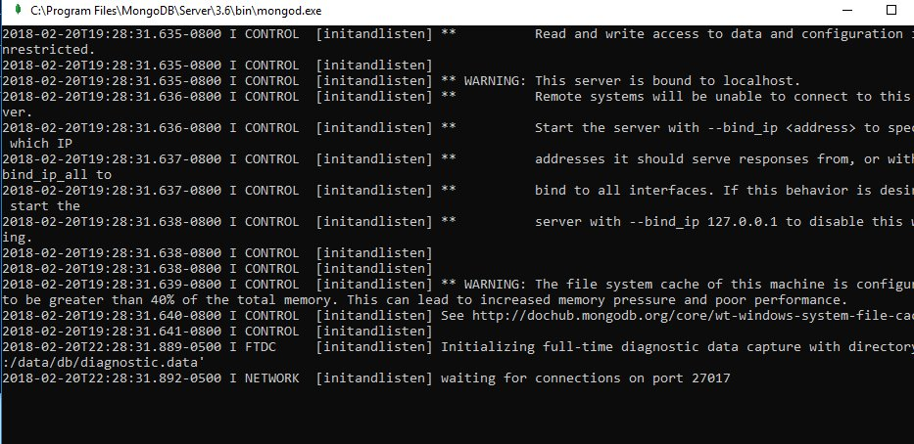

Starting mongo shell that is not connected to any mongod

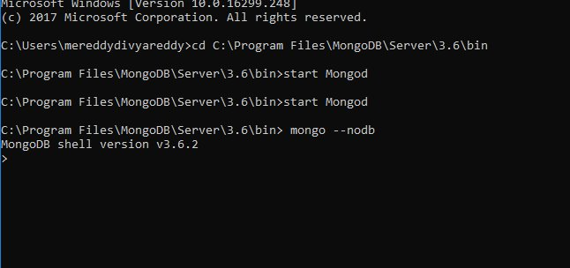

Create replica set by

replicaSet = new ReplSetTest({"nodes" : 3})

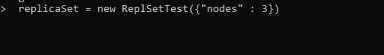

Start the replication processes :

WhatsApp%20Image%202018-02-20%20at%2011.27.06%20PM-9.jpeg

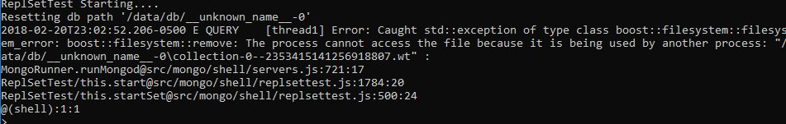

replicaSet.initiate()

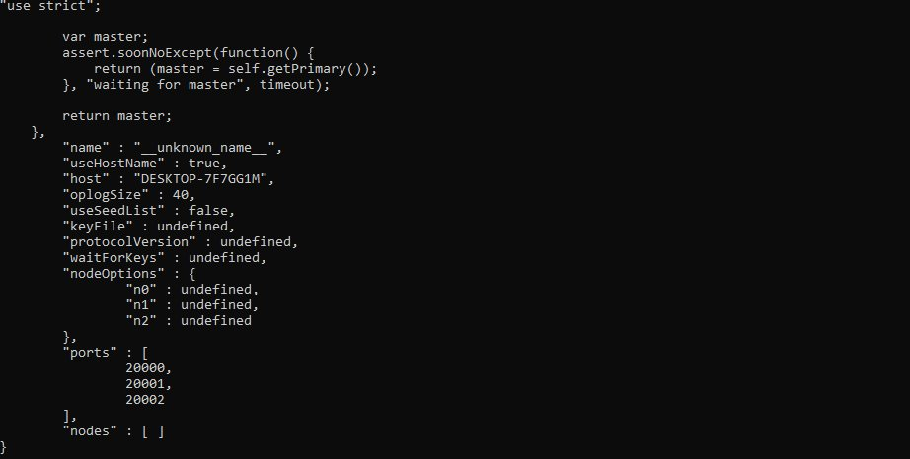

port Numbers are :

20000

20001

20002



WhatsApp%20Image%202018-02-20%20at%2011.27.06%20PM.jpeg



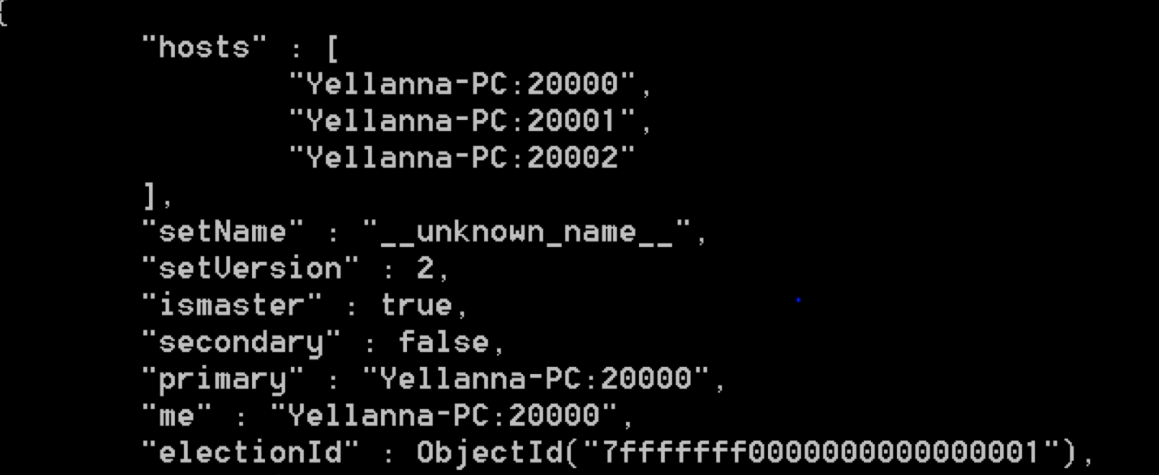

Insertion:

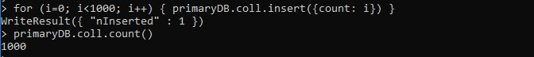

Connecting to DB-port 2:



Test:



Find:

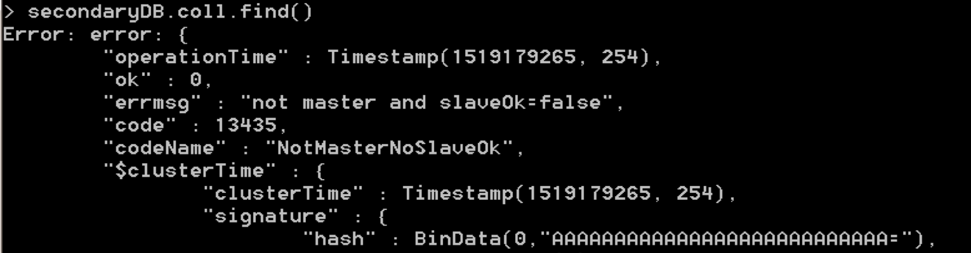



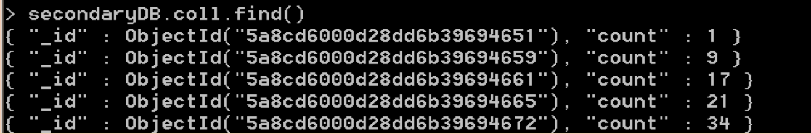

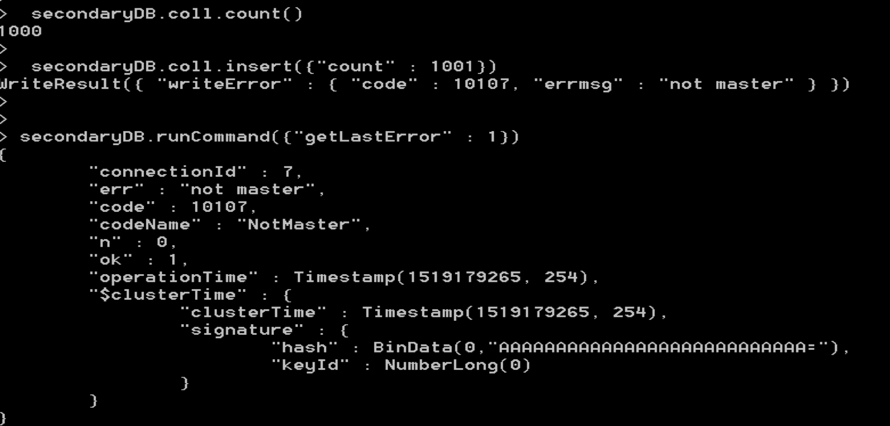

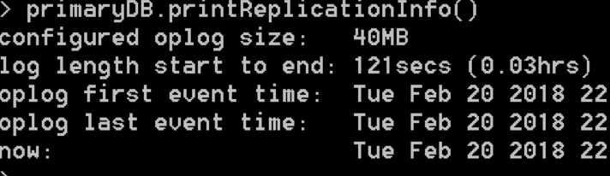

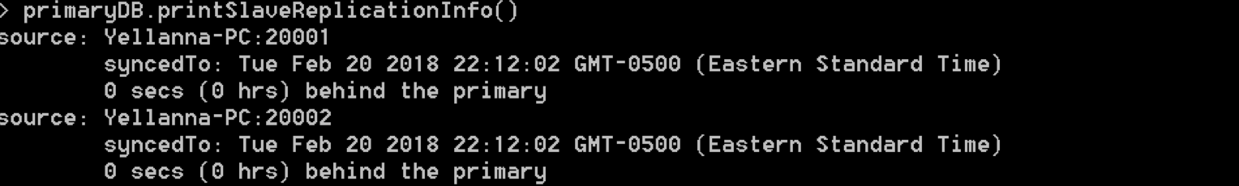

primary Shutdown and secondary becomes master:

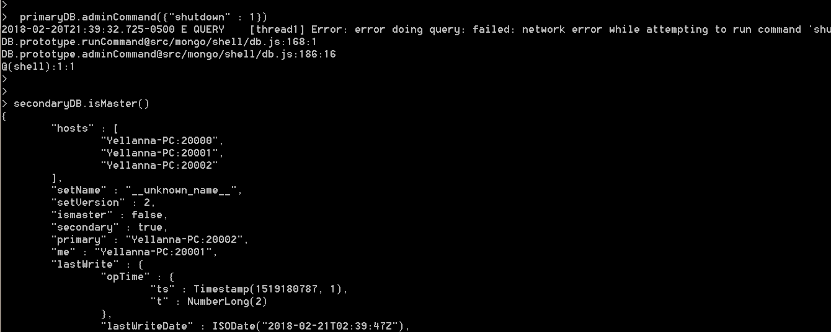

replication information:

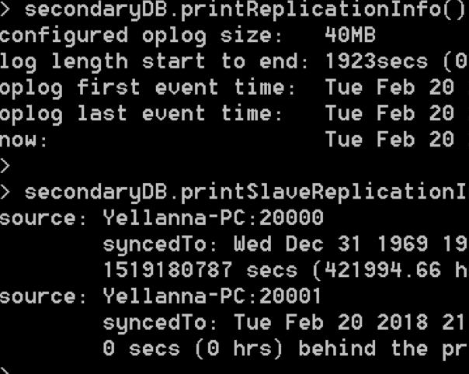

Stopping:

