Remove about tab
Remove Notices
Remove Results
Add a direct botton of login/register 
Give dropdown in Careers and Registration for apply edit and find (find inside print or download option)
Menu Item | Behaviour / Sub-items
Home | Returns user to the home page
Registration | Dropdown with three options: Apply (new OTR), Edit (modify existing), Find (retrieve registration number)
Online Application | Dropdown with three options: Apply (submit application), Edit (modify draft), Print (print submitted application)
Fee | Opens the fee payment page
Call Letter | Allows eligible candidates to download call letters
Help | Opens the Help / Query page with contact info and FAQ
Login / Register | Opens the authentication modal (Login or New Registration)

Add
- Scrolling ticker bar 1: Toll-free helpline contact number
- Scrolling ticker bar 2: Just show the headline of newest post

Merge
Latest News & Notices
Latest Releases & New Opportunities
Merge both the sections as one and manage the UI

Change the UI of Quick Links to bold but simple buttons and quick links should have this options
- How to Register
- How to Apply
- Apply (direct link to application)
- Admit Card / Call Letter
- Results
- Help / Query

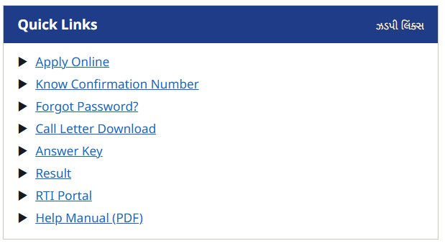
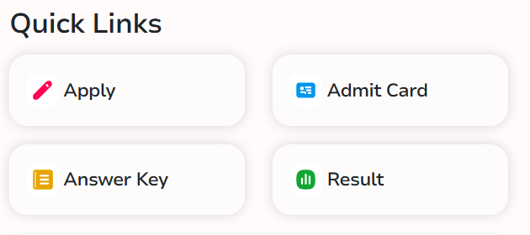

Remove this filter

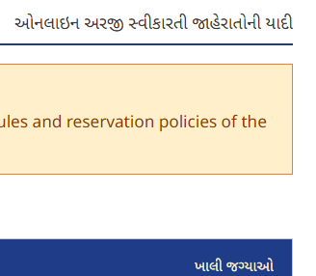increase font size of gujurati words of like change the font or something to make it more visible

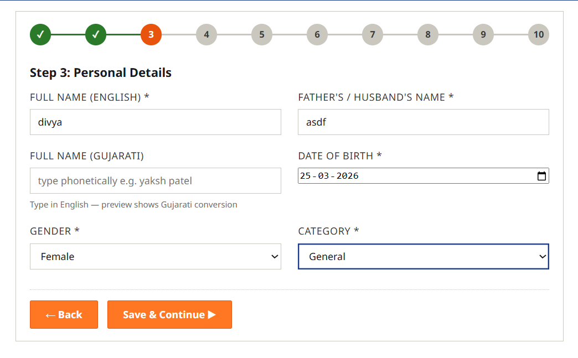
Gujurati name not required
Every field heading should complusary have heading in both English and gujurati separated by /
Add fields to take the caste certificate if obc , sc st , Ews
Also add fields to take UDID certi
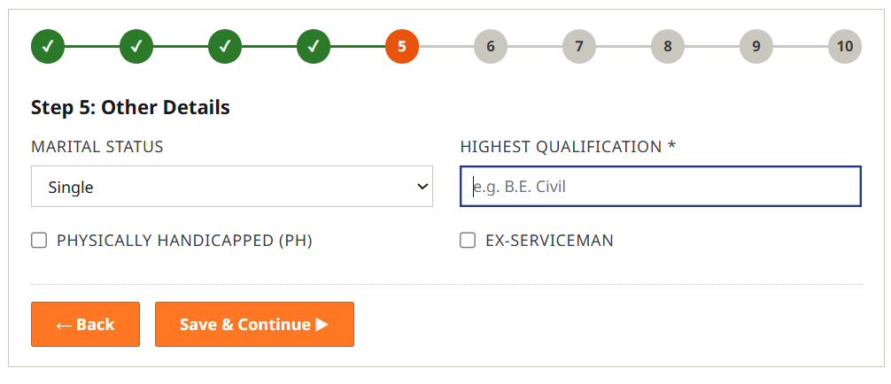
Add dropdown in highest qualification for basic 6 to 8 qualification like
10 , 12th , diploma , BE graduate , Btech Graduate , bba/bcom graduate , post graduate and others

