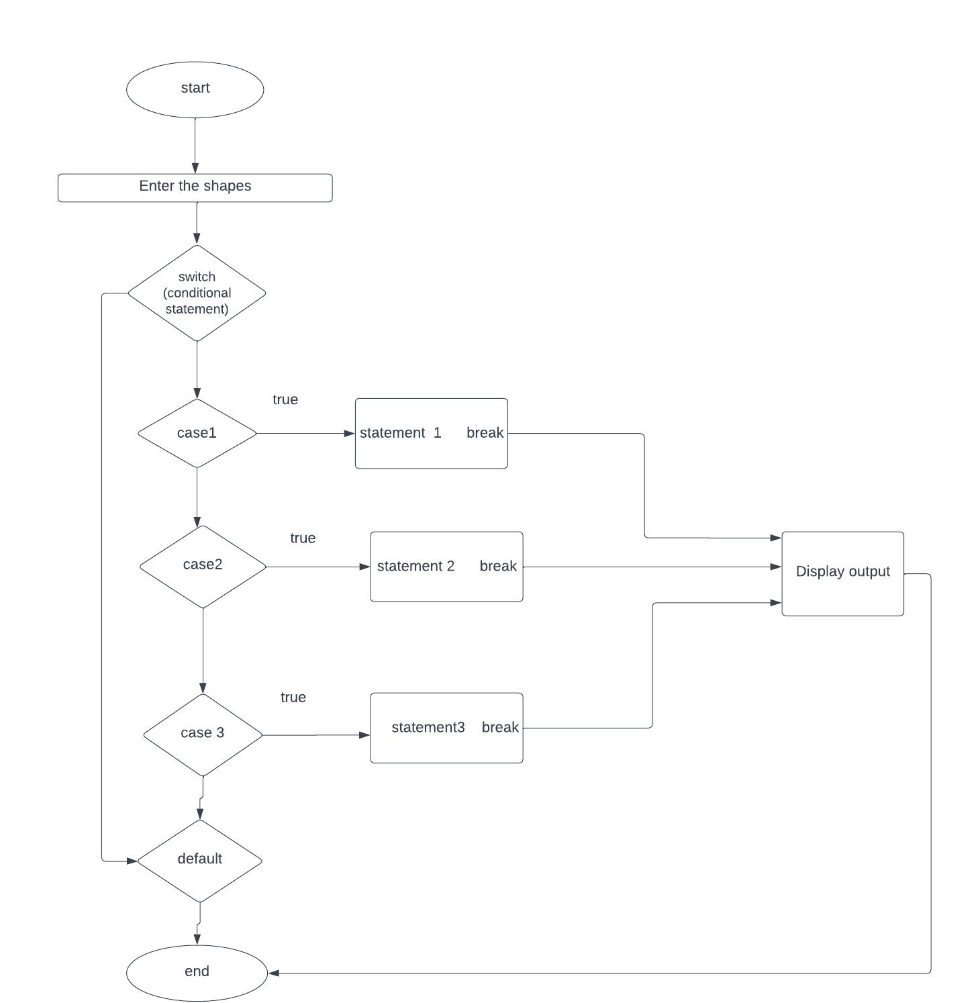

Java features

1.Enum(ShapesTypes)

2.Exceception Handing(try and catch)

3.FileWriterand reader.

4.Interface(VolumeCalculator)

Scenarios

Calculator App is a Java program that allows users to calculate the volume of different shapes such as sphere, cube, cylinder, and cone. The app keeps track of the calculation history, which can be viewed by the user at any time.

When the program starts, it displays a welcome message and the menu with different options to choose from. The user can select an option by entering a number from the keyboard. If the user enters an invalid option, the program displays an error message and prompts the user to enter a valid option.

1. If the user selects option 1, the program prompts the user to enter the radius of the sphere. After the user enters the radius, the program creates a new instance of the Sphere class and calculates its volume.

2. If the user selects option 2, the program prompts the user to enter the side length of the cube. After the user enters the side length, the program creates a new instance of the Cube class and calculates its volume.

3. If the user selects option 3, the program prompts the user to enter the radius and height of the cylinder. After the user enters the radius and height, the program creates a new instance of the Cylinder class and calculates its volume.

4. If the user selects option 4, the program prompts the user to enter the radius and height of the cone. After the user enters the radius and height, the program creates a new instance of the Cone class and calculates its volume.

5. If the user selects option 5, the program displays the calculation history, which includes all the previous calculations that were stored in the history list..

6. If the user selects option 6, the program resets all the values by clearing the history list and deleting the contents of the history file.

7.If the user selects option 0, the program exits and terminates.

Overall, the Volume Calculator App provides a simple and efficient way to calculate the volume of different shapes and keeps track of the calculation history. It can be useful for students, teachers, engineers, and anyone who needs to calculate the volume of shapes in their work or daily life.

Classes

1.cube

2.Sphere

3.Cylinder

4.Cone

5.Viewhistory

6.VolumecCalculatorApp

7.VolumeMain

8.Enum(ShapeType)

9.Interface(created one method volumecalculator).