Creating Microservices for account and loan

In this hands on exercises, we will create two microservices for a bank. One

microservice for handing accounts and one for handling loans.

Each microservice will be a specific independent Spring RESTful Webservice

maven project having it's own pom.xml. The only difference is that, instead of

having both account and loan as a single application, it is split into two

different applications. These webservices will be a simple service without any

backend connectivity.

Follow steps below to implement the two microservices:

Account Microservice

• Create folder with employee id in D: drive

• Create folder named 'microservices' in the new folder created in

previous step. This folder will contain all the sample projects that we will

create for learning microservices.

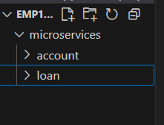

• Open https://start.spring.io/ in browser

• Enter form field values as specified below:

o Group: com.cognizant

o Artifact: account

• Select the following modules

o Developer Tools > Spring Boot DevTools

o Web > Spring Web

• Click generate and download the zip file

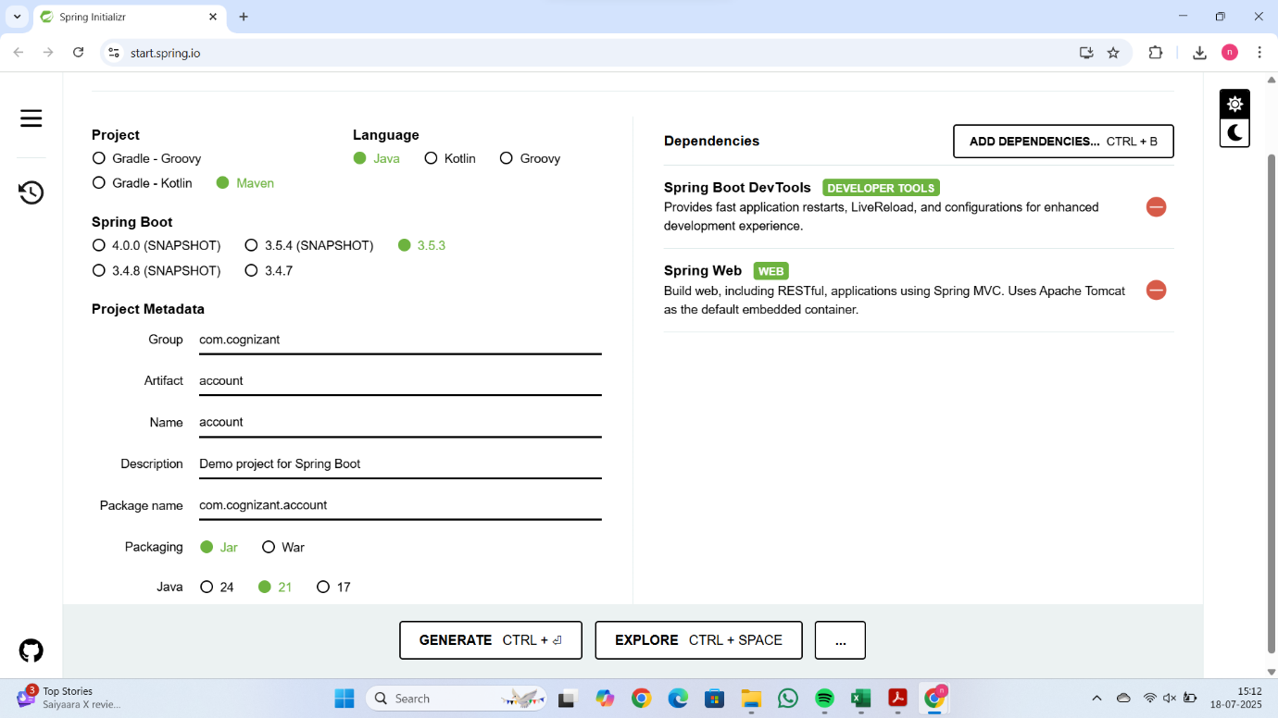

• Extract 'account' folder from the zip and place this folder in the

'microservices' folder created earlier

• Open command prompt in account folder and build using mvn clean

package command

• Import this project in Eclipse and implement a controller method for

getting account details based on account number. Refer specification

below:

package com.cognizant.account.controller;

import org.springframework.web.bind.annotation.\*;

import java.util.\*;

@RestController

@RequestMapping("/accounts")

public class AccountController {

    @GetMapping("/{number}")

    public Map<String, Object> getAccount(@PathVariable String number) {

        Map<String, Object> account = new HashMap<>();

        account.put("number", number);

        account.put("type", "savings");

        account.put("balance", 234343);

        return account;

    }

}

o Method: GET

o Endpoint: /accounts/{number}

o Sample Response. Just a dummy response without any backend

connectivity.

{ number: "00987987973432", type: "savings", balance: 234343 }

• Launch by running the application class and test the service in browser

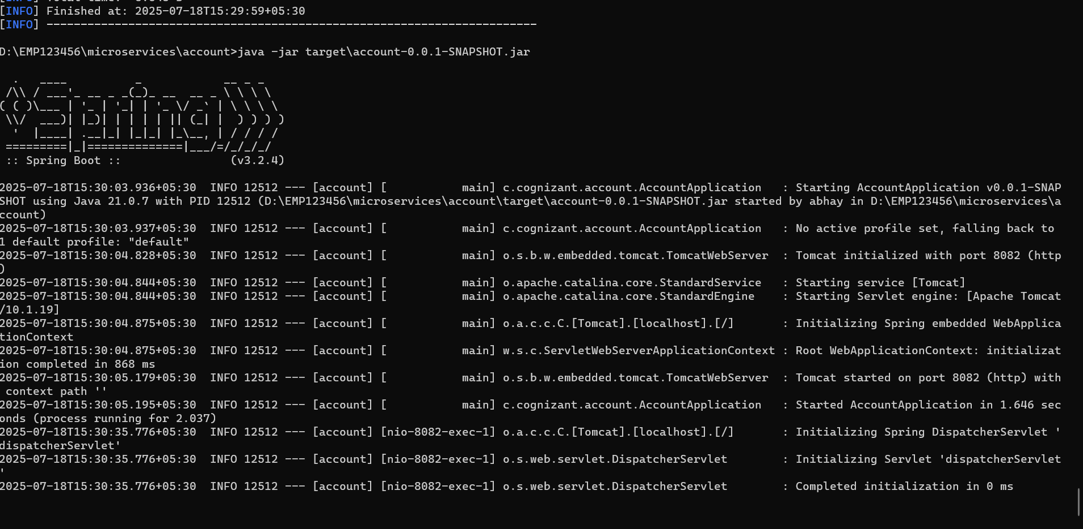

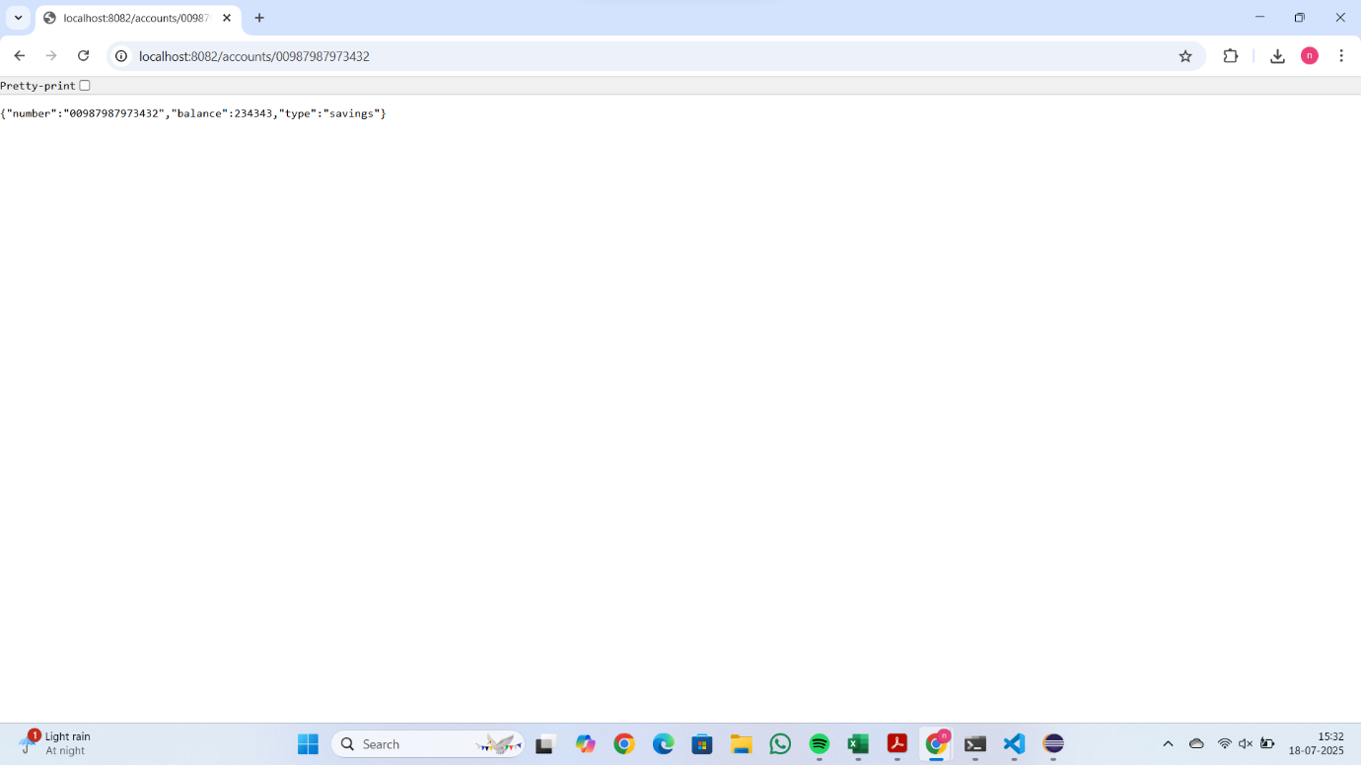

Loan Microservice

• Follow similar steps specified for Account Microservice and implement a

service API to get loan account details

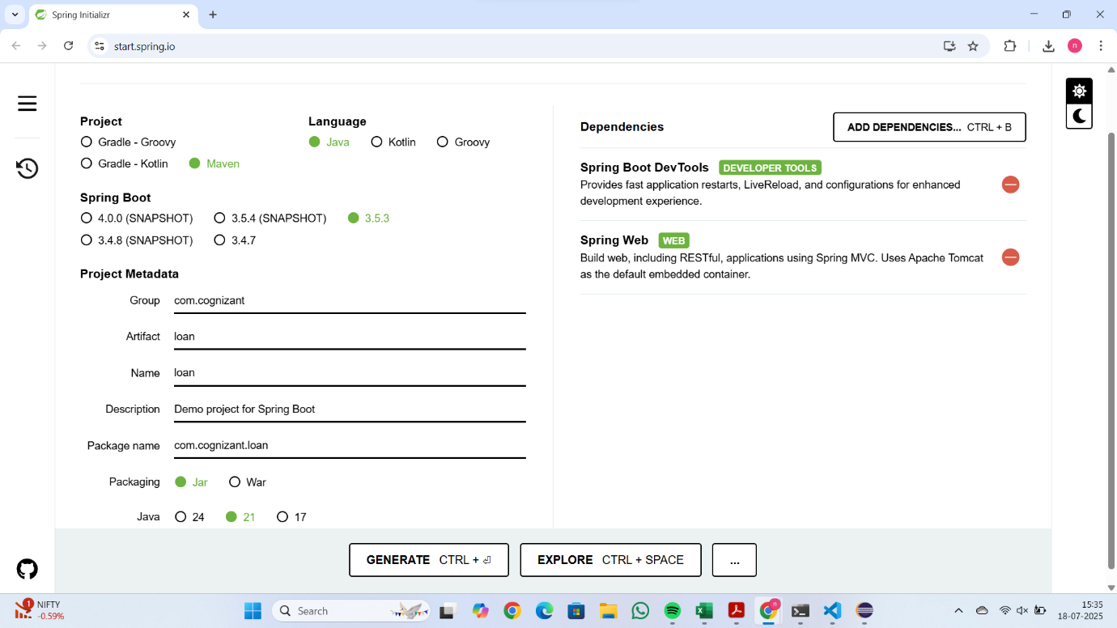

o Method: GET

o Endpoint: /loans/{number}

o Sample Response. Just a dummy response without any backend

connectivity.

{ number: "H00987987972342", type: "car", loan: 400000, emi: 3258, tenure:

18 }

• Launching this application by having account service already running

• This launch will fail with error that the bind address is already in use

• The reason is that each one of the service is launched with default port

number as 8080. Account service is already using this port and it is not

available for loan service.

• Include "server.port" property with value 8081 and try launching the

application

• Test the service with 8081 port

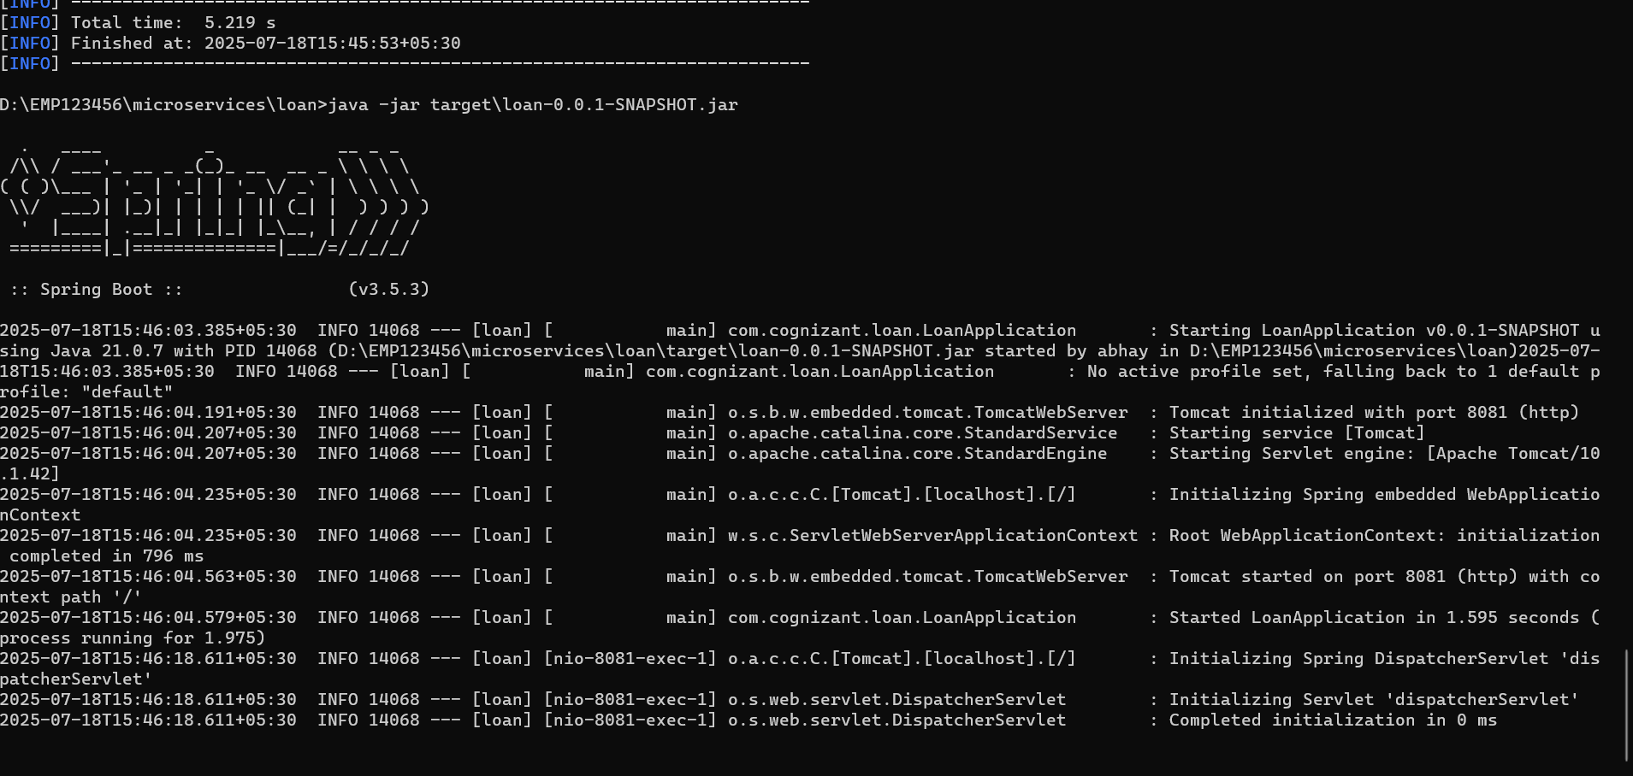

Now we have two microservices running on different ports.

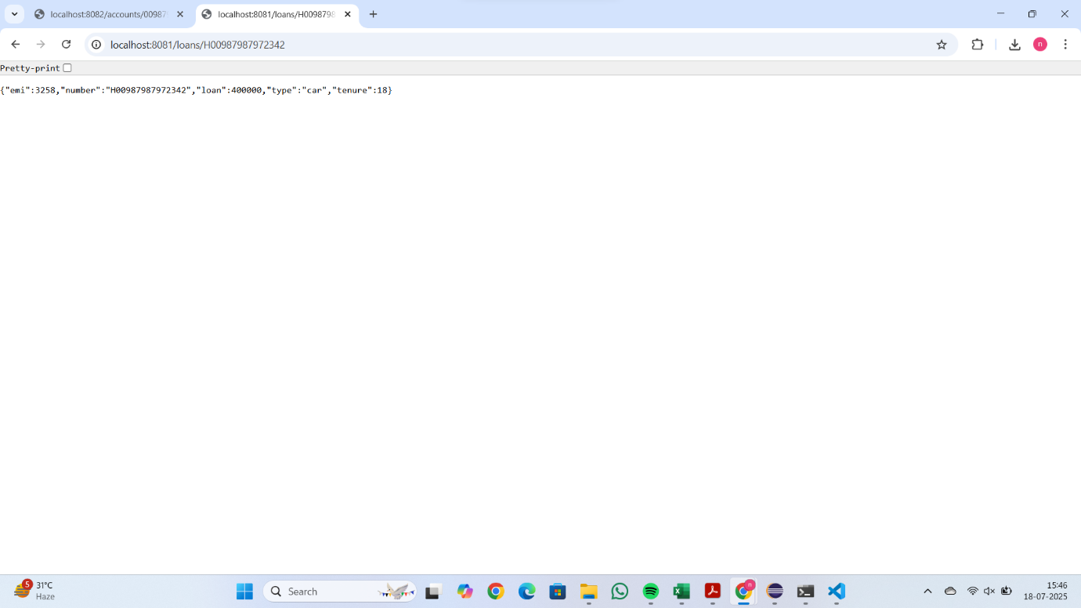

Create Eureka Discovery Server and register

Microservices(Mandatory)

Eureka Discovery Server holds a registry of all the services that are available

for immediate consumption. Anybody whom wants to consume a RESTful

Web Service can come to the discovery server and find out what is available

and ready for consumption. Eureka Discovery Server is part of spring cloud

module.

Follow steps below to implement:

Create and Launch Eureka Discovery Server

• Using https://start.spring.io generate a project with following

configuration:

o Group: com.cognizant

o Artifact: eureka-discovery-server

o Module: Spring Cloud Discovery > Eureka Server

• Download the project, build it using maven in command line

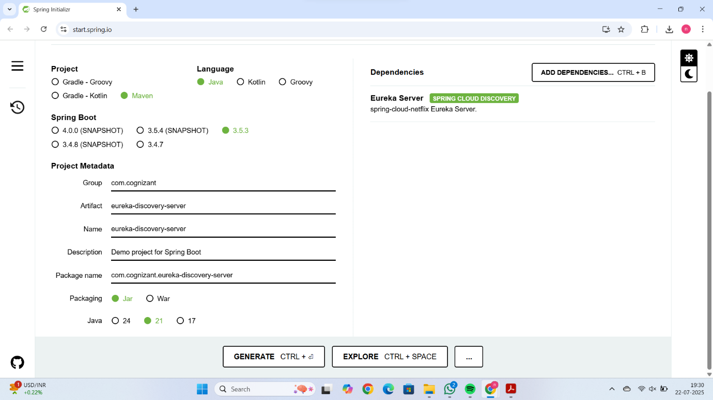

• Import the project in Eclipse

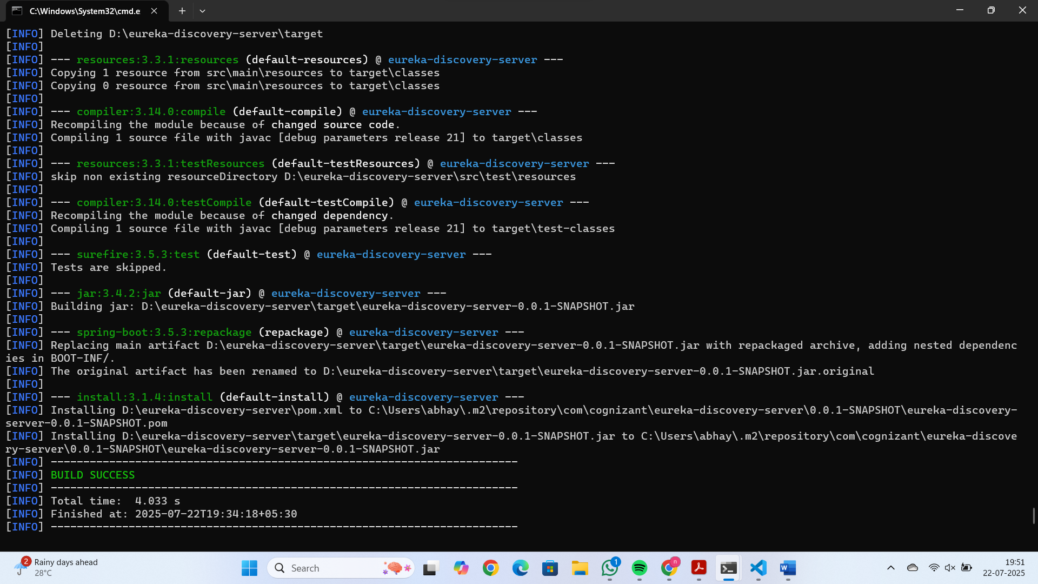

• Include @EnableEurekaServer in

class EurekaDiscoveryServerApplication

package com.cognizant.eurekadiscoveryserver;

import org.springframework.boot.SpringApplication;

import org.springframework.boot.autoconfigure.SpringBootApplication;

import org.springframework.cloud.netflix.eureka.server.EnableEurekaServer;

@SpringBootApplication

@EnableEurekaServer

public class EurekaDiscoveryServerApplication {

    public static void main(String[] args) {

        SpringApplication.run(EurekaDiscoveryServerApplication.class, args);

    }

}

• Include the following configurations in application.properties:

server.port=8761

eureka.client.register-with-eureka=false

eureka.client.fetch-registry=false

logging.level.com.netflix.eureka=OFF

logging.level.com.netflix.discovery=OFF

• The above configuration runs the discovery service in port 8761

• The eureka properties prohibits direct registration of services, instead

discovery server will find available services and register them.

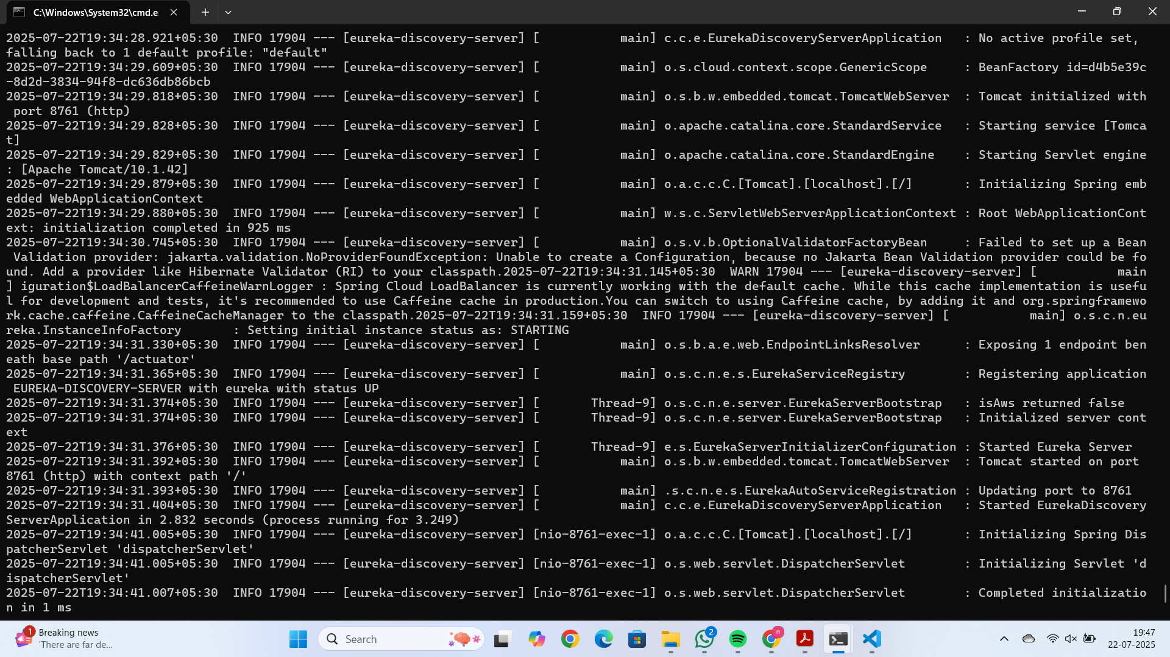

• Launch the service by running the application class

• The discovery service can be view by launching http://locahost:8761 in

the browser.

• This will display the discover server details

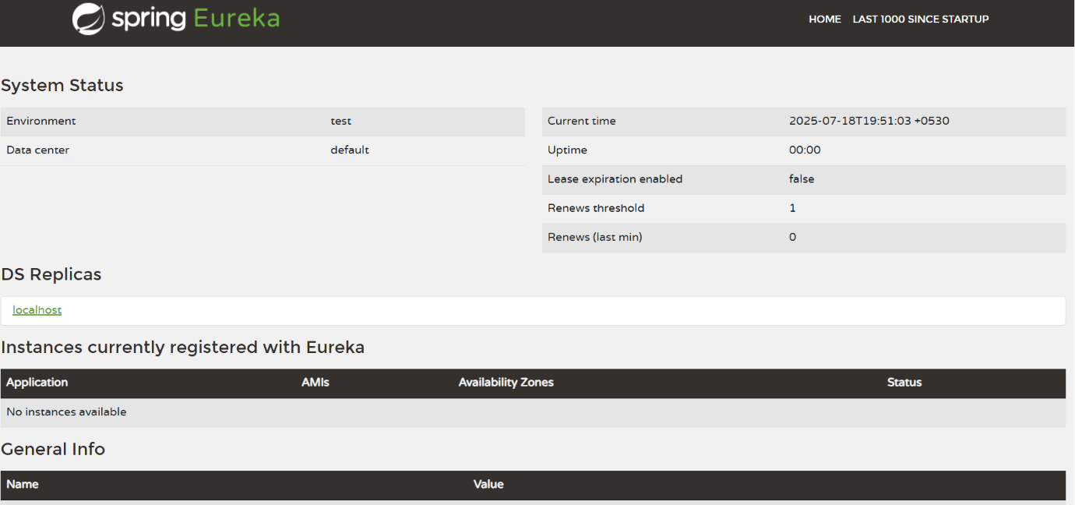

• Look into the section "Instances currently registered with Eureka", which

will have an empty list

• Follow steps below to add account and loan service to this discovery

server.

Register Account REST API to eureka discovery

• Go to https://start.spring.io and provide the following configuration:

o Group: com.cognizant

o Artifact: account

o Modules:

▪ Spring Boot DevTools

▪ Eureka Discovery Client

▪ Spring Web

• Click "Explore", which will open pom.xml

• Use copy option in the opened window to copy the pom.xml and

overwrite the pom.xml in account project

• Build the project using maven in console

• Include @EnableDiscoveryClient annotation to application class of

account project

• Include application name for account application as specified below in

application.properties. This is the name that will be displayed in the

eureka discovery registry.

spring.application.name=account-service

• Stop all services (account, loan, eureka-discovery-server) using the

console window of Eclipse. Use the monitor icon in console view to

switch between applications and use the Terminate button to stop the

server.

• First start eureka-discovery-server and wait till the application starts

completely. Then open http://locahost:8761 in browser. The service list

should be empty.

• Then start account application and wait till the application starts.

• Refresh the eureka-discovery-server web page in browser, the accountservice

will be listed in the registry

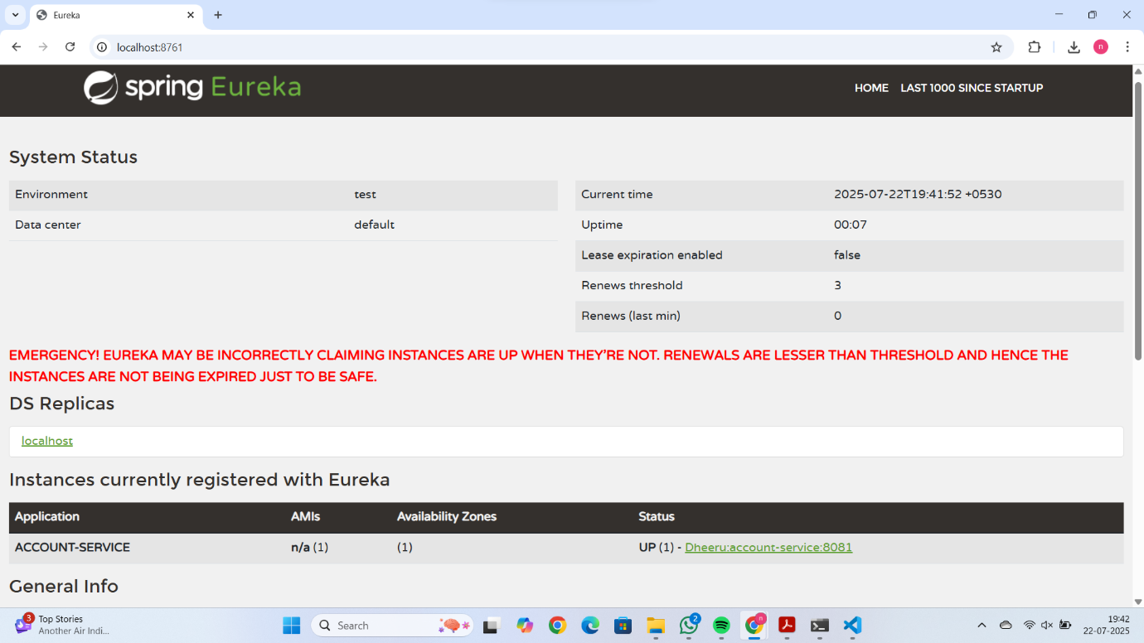

• Perform similar steps for loan application and have it registered with

eureka-discovery-server.

