**Spring Data JPA - Quick Example** (Mandatory)  
  
**Software Pre-requisites**

* MySQL Server 8.0
* MySQL Workbench 8
* Eclipse IDE for Enterprise Java Developers 2019-03 R
* Maven 3.6.2

**Create a Eclipse Project using Spring Initializr**

* Go to <https://start.spring.io/>
* Change Group as “com.cognizant”
* Change Artifact Id as “orm-learn”
* In Options > Description enter "Demo project for Spring Data JPA and Hibernate"
* Click on menu and select "Spring Boot DevTools", "Spring Data JPA" and "MySQL Driver"
* Click Generate and download the project as zip
* Extract the zip in root folder to Eclipse Workspace
* Import the project in Eclipse "File > Import > Maven > Existing Maven Projects > Click Browse and select extracted folder > Finish"
* Create a new schema "ormlearn" in MySQL database. Execute the following commands to open MySQL client and create schema.

> mysql -u root -p

mysql> create schema ormlearn;

* In orm-learn Eclipse project, open src/main/resources/application.properties and include the below database and log configuration.

# Spring Framework and application log

logging.level.org.springframework=info

logging.level.com.cognizant=debug

# Hibernate logs for displaying executed SQL, input and output

logging.level.org.hibernate.SQL=trace

logging.level.org.hibernate.type.descriptor.sql=trace

# Log pattern

logging.pattern.console=%d{dd-MM-yy} %d{HH:mm:ss.SSS} %-20.20thread %5p %-25.25logger{25} %25M %4L %m%n

# Database configuration

spring.datasource.driver-class-name=com.mysql.cj.jdbc.Driver

spring.datasource.url=jdbc:mysql://localhost:3306/ormlearn

spring.datasource.username=root

spring.datasource.password=root

# Hibernate configuration

spring.jpa.hibernate.ddl-auto=validate

spring.jpa.properties.hibernate.dialect=org.hibernate.dialect.MySQL5Dialect

* Build the project using ‘mvn clean package -Dhttp.proxyHost=proxy.cognizant.com -Dhttp.proxyPort=6050 -Dhttps.proxyHost=proxy.cognizant.com -Dhttps.proxyPort=6050 -Dhttp.proxyUser=123456’ command in command line
* Include logs for verifying if main() method is called.

import org.slf4j.Logger;

import org.slf4j.LoggerFactory;

private static final Logger LOGGER = LoggerFactory.getLogger(OrmLearnApplication.class);

public static void main(String[] args) {

SpringApplication.run(OrmLearnApplication.class, args);

  LOGGER.info("Inside main");

}

* Execute the OrmLearnApplication and check in log if main method is called.

SME to walk through the following aspects related to the project created:

1. src/main/java - Folder with application code
2. src/main/resources - Folder for application configuration
3. src/test/java - Folder with code for testing the application
4. OrmLearnApplication.java - Walkthrough the main() method.
5. Purpose of @SpringBootApplication annotation
6. pom.xml
   1. Walkthrough all the configuration defined in XML file
   2. Open 'Dependency Hierarchy' and show the dependency tree.

**Country table creation**

* Create a new table country with columns for code and name. For sample, let us insert one country with values 'IN' and 'India' in this table.

create table country(co_code varchar(2) primary key, co_name varchar(50));

* Insert couple of records into the table

insert into country values ('IN', 'India');

insert into country values ('US', 'United States of America');

CREATE SCHEMA ormlearn;

USE ormlearn;

CREATE TABLE country (

co_code VARCHAR(2) PRIMARY KEY,

co_name VARCHAR(50)

);

INSERT INTO country VALUES ('IN', 'India');

INSERT INTO country VALUES ('US', 'United States of America');

Output:

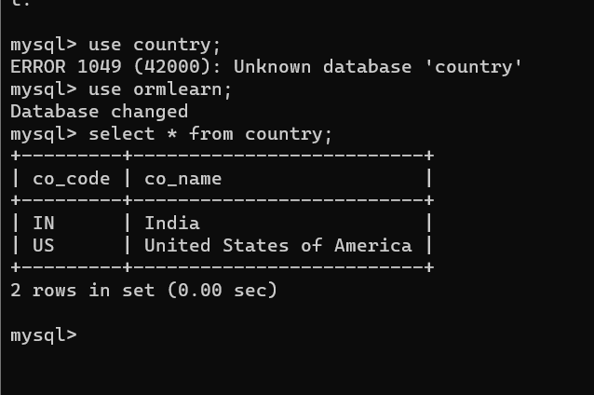

**Persistence Class - com.cognizant.orm-learn.model.Country**

* Open Eclipse with orm-learn project
* Create new package com.cognizant.orm-learn.model
* Create Country.java, then generate getters, setters and toString() methods.

package com.cognizant.ormlearn.model;

import jakarta.persistence.Entity;

import jakarta.persistence.Table;

import jakarta.persistence.Id;

import jakarta.persistence.Column;

@Entity

@Table(name = "country")

public class Country {

    @Id

    @Column(name = "co_code")

    private String code;

    @Column(name = "co_name")

    private String name;

    // Getters & Setters

    public String getCode() { return code; }

    public void setCode(String code) { this.code = code; }

    public String getName() { return name; }

    public void setName(String name) { this.name = name; }

    @Override

    public String toString() {

        return "Country [code=" + code + ", name=" + name + "]";

    }

}

* Include @Entity and @Table at class level
* Include @Column annotations in each getter method specifying the column name.

*Notes:*

* @Entity is an indicator to Spring Data JPA that it is an entity class for the application
* @Table helps in defining the mapping database table
* @Id helps is defining the primary key
* @Column helps in defining the mapping table column

**Repository Class - com.cognizant.orm-learn.CountryRepository**

* Create new package com.cognizant.orm-learn.repository
* Create new interface named CountryRepository that extends JpaRepository<Country, String>
* Define @Repository annotation at class level

import org.springframework.data.jpa.repository.JpaRepository;

import org.springframework.stereotype.Repository;

import com.cognizant.ormlearn.model.Country;

@Repository

public interface CountryRepository extends JpaRepository<Country, String> {

}

**Service Class - com.cognizant.orm-learn.service.CountryService**

* Create new package com.cognizant.orm-learn.service
* Create new class CountryService
* Include @Service annotation at class level
* Autowire CountryRepository in CountryService
* Include new method getAllCountries() method that returns a list of countries.
* Include @Transactional annotation for this method
* In getAllCountries() method invoke countryRepository.findAll() method and return the result

package com.cognizant.ormlearn.service;

import java.util.List;

import jakarta.transaction.Transactional;

import org.springframework.beans.factory.annotation.Autowired;

import org.springframework.stereotype.Service;

import com.cognizant.ormlearn.model.Country;

import com.cognizant.ormlearn.repository.CountryRepository;

@Service

public class CountryService {

    @Autowired

    private CountryRepository countryRepository;

    @Transactional

    public List<Country> getAllCountries() {

        return countryRepository.findAll();

    }

}

**Testing in OrmLearnApplication.java**

* Include a static reference to CountryService in OrmLearnApplication class

private static CountryService countryService;

* Define a test method to get all countries from service.

    private static void testGetAllCountries() {

        LOGGER.info("Start");

        List<Country> countries = countryService.getAllCountries();

        LOGGER.debug("countries={}", countries);

        LOGGER.info("End");

    }

* Modify SpringApplication.run() invocation to set the application context and the CountryService reference from the application context.

        ApplicationContext context = SpringApplication.run(OrmLearnApplication.class, args);

        countryService = context.getBean(CountryService.class);

package com.cognizant.ormlearn;

import java.util.List;

import org.slf4j.Logger;

import org.slf4j.LoggerFactory;

import org.springframework.boot.SpringApplication;

import org.springframework.boot.autoconfigure.SpringBootApplication;

import org.springframework.context.ApplicationContext;

import com.cognizant.ormlearn.model.Country;

import com.cognizant.ormlearn.service.CountryService;

@SpringBootApplication

public class OrmLearnApplication {

    private static final Logger LOGGER = LoggerFactory.getLogger(OrmLearnApplication.class);

    private static CountryService countryService;

    public static void main(String[] args) {

        ApplicationContext context = SpringApplication.run(OrmLearnApplication.class, args);

        LOGGER.info("Inside main");

        countryService = context.getBean(CountryService.class);

        testGetAllCountries();

    }

    private static void testGetAllCountries() {

        LOGGER.info("Start");

        List<Country> countries = countryService.getAllCountries();

        LOGGER.debug("countries={}", countries);

        LOGGER.info("End");

    }

}

testGetAllCountries();

* Execute main method to check if data from ormlearn database is retrieved.

Output:

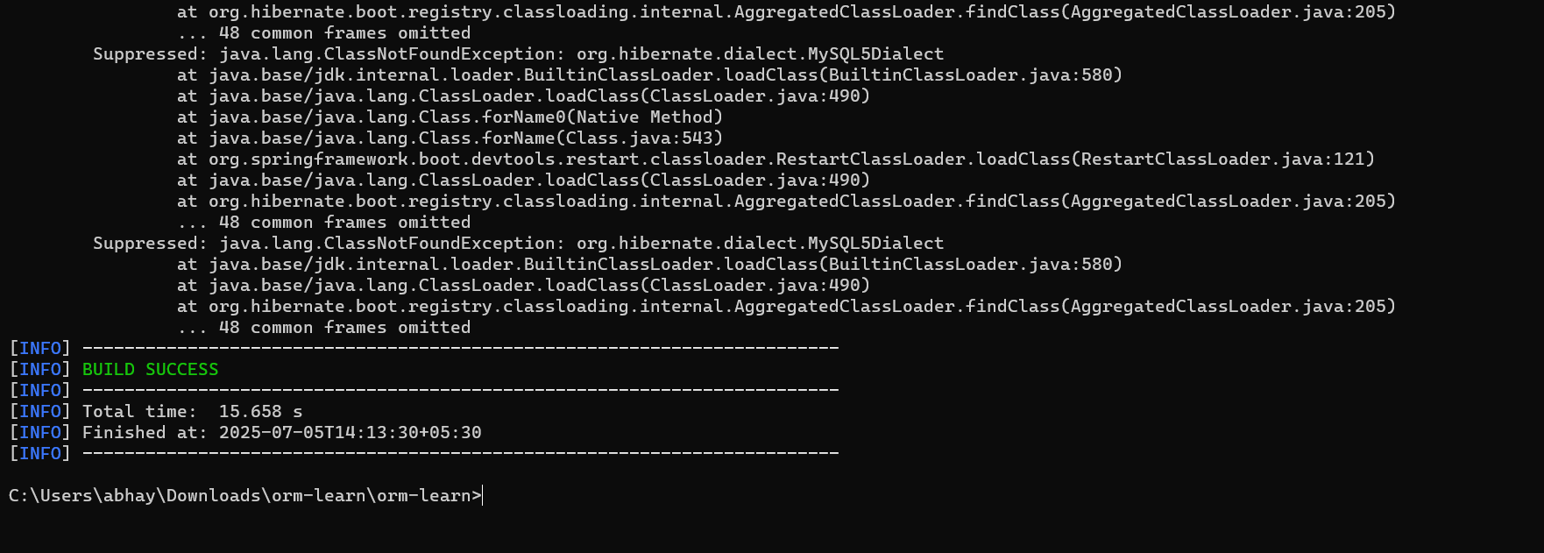

**Hands on 4(Mandatory)**

**Difference between JPA, Hibernate and Spring Data JPA**   
  
Java Persistence API (JPA)

* JSR 338 Specification for persisting, reading and managing data from Java objects
* Does not contain concrete implementation of the specification
* Hibernate is one of the implementation of JPA

Hibernate

* ORM Tool that implements JPA

Spring Data JPA

* Does not have JPA implementation, but reduces boiler plate code
* This is another level of abstraction over JPA implementation provider like Hibernate
* Manages transactions

**Refer code snippets below on how the code compares between Hibernate and Spring Data JPA  
Hibernate**

   /* Method to CREATE an employee in the database */

   public Integer addEmployee(Employee employee){

      Session session = factory.openSession();

      Transaction tx = null;

      Integer employeeID = null;

      try {

         tx = session.beginTransaction();

         employeeID = (Integer) session.save(employee);

         tx.commit();

      } catch (HibernateException e) {

         if (tx != null) tx.rollback();

         e.printStackTrace();

      } finally {

         session.close();

      }

      return employeeID;

   }

**Spring Data JPA**  
EmployeeRespository.java

public interface EmployeeRepository extends JpaRepository<Employee, Integer> {

}

EmployeeService.java

@Autowire

  private EmployeeRepository employeeRepository;

@Transactional

public void addEmployee(Employee employee) {

  employeeRepository.save(employee);

  }

​​​​​​​ My understandings:

**Introduction**

In Java-based enterprise applications, interacting with relational databases is a critical part. To simplify this, frameworks like JPA, Hibernate, and Spring Data JPA are used. This document explains the key differences between them.

**Java Persistence API (JPA)**

• JPA is a specification defined in JSR 338 for managing relational data in Java applications.  
• It is only a set of rules; it doesn't provide any actual implementation.  
• Developers need an implementation like Hibernate to use JPA.

**Hibernate**

• Hibernate is an ORM (Object Relational Mapping) tool.  
• It is the most popular implementation of JPA.  
• Hibernate connects Java objects to database tables and handles SQL, transactions, etc.

**Spring Data JPA**

• Spring Data JPA is a part of the Spring Framework that abstracts JPA and Hibernate.  
• It reduces boilerplate code using interfaces like JpaRepository.  
• Spring Data JPA manages transactions and provides powerful features like derived queries, pagination, etc.

Code Snippets

Hibernate Example:

public Integer addEmployee(Employee employee){

Session session = factory.openSession();

Transaction tx = null;

Integer employeeID = null;

try {

tx = session.beginTransaction();

employeeID = (Integer) session.save(employee);

tx.commit();

} catch (HibernateException e) {

if (tx != null) tx.rollback();

e.printStackTrace();

} finally {

session.close();

}

return employeeID;

}

Spring Data JPA Example:

public interface EmployeeRepository extends JpaRepository<Employee, Integer> {

}

@Service

public class EmployeeService {

@Autowired

private EmployeeRepository employeeRepository;

@Transactional

public void addEmployee(Employee employee) {

employeeRepository.save(employee);

}

}

Summary

• JPA defines the rules for persisting Java objects.

• Hibernate implements these rules.

• Spring Data JPA simplifies the process even further by reducing the need for boilerplate code.