**Create a Spring Web Project using Maven** (mandatory)  
  
Follow steps below to create a project: 

1. Go to <https://start.spring.io/>
2. Change Group as “com.cognizant”
3. Change Artifact Id as “spring-learn”
4. Select Spring Boot DevTools and Spring Web
5. Create and download the project as zip

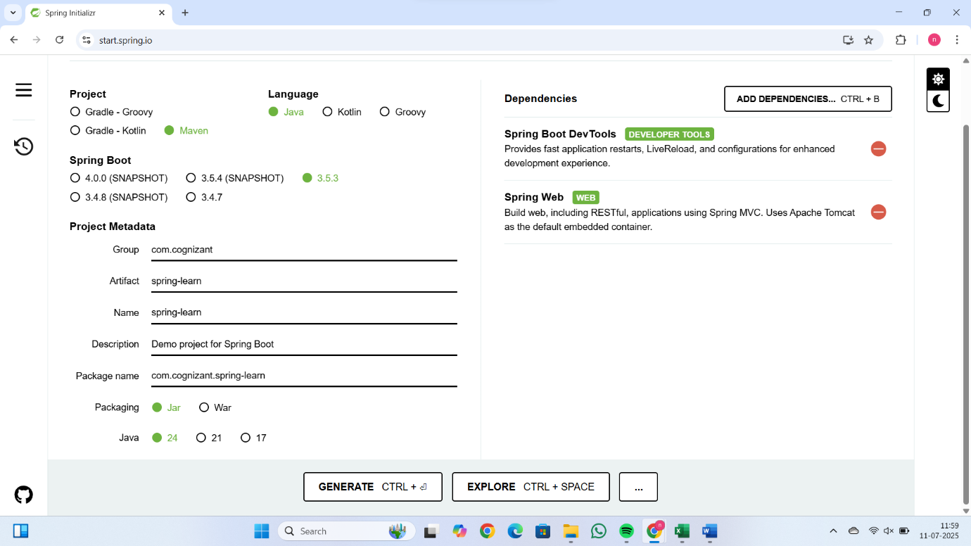

1. Extract the zip in root folder to Eclipse Workspace
2. Build the project using ‘mvn clean package -Dhttp.proxyHost=proxy.cognizant.com -Dhttp.proxyPort=6050 -Dhttps.proxyHost=proxy.cognizant.com -Dhttps.proxyPort=6050 -Dhttp.proxyUser=123456’ command in command line
3. Import the project in Eclipse "File > Import > Maven > Existing Maven Projects > Click Browse and select extracted folder > Finish"

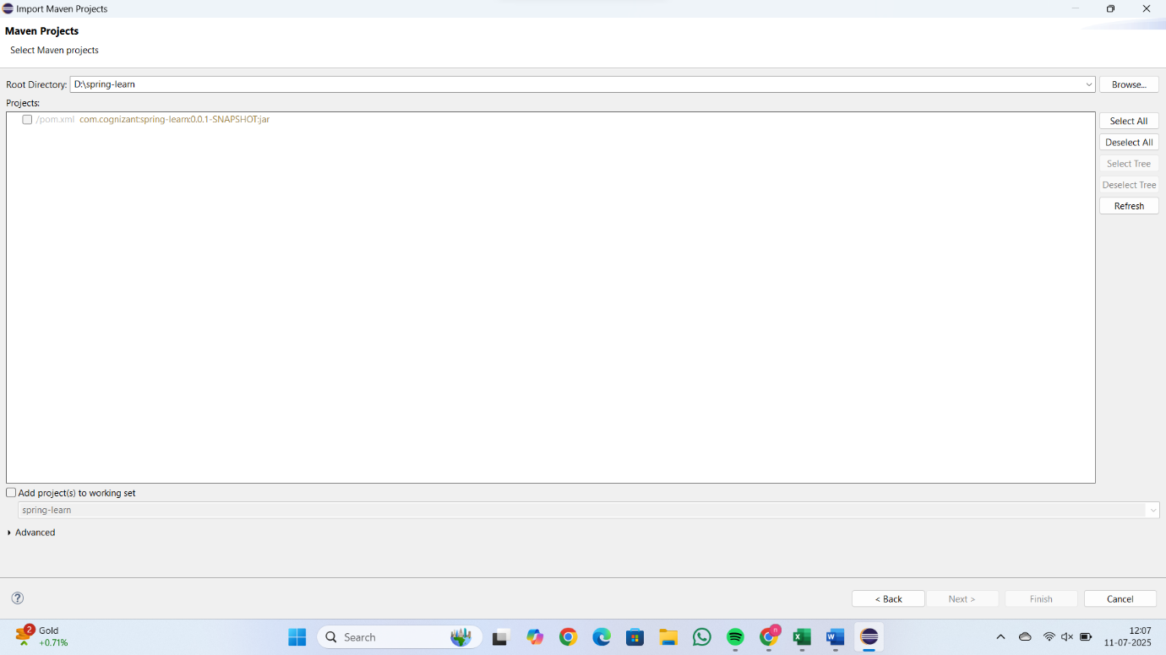

1. Include logs to verify if main() method of SpringLearnApplication.

package com.cognizant.springlearn;

import org.springframework.web.bind.annotation.GetMapping;

import org.springframework.web.bind.annotation.RestController;

@RestController

public class HelloController {

    @GetMapping("/hello")

    public String sayHello() {

        return "Hello, Spring Boot!";

    }

}

1. Run the SpringLearnApplication class.

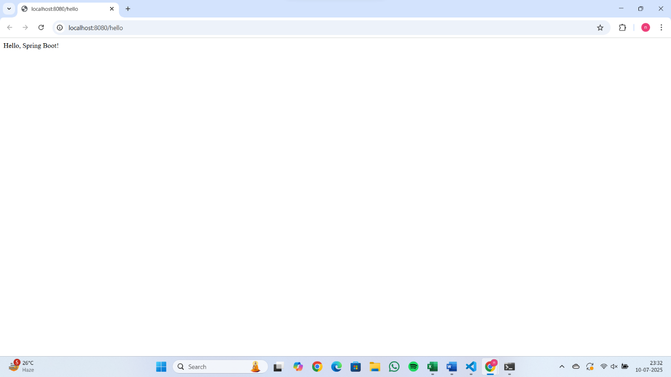

SME to walk through the following aspects related to the project created:

1. src/main/java - Folder with application code
2. src/main/resources - Folder for application configuration
3. src/test/java - Folder with code for testing the application
4. SpringLearnApplication.java - Walkthrough the main() method.
5. Purpose of @SpringBootApplication annotation
6. pom.xml
   1. Walkthrough all the configuration defined in XML file

<?xml version="1.0" encoding="UTF-8"?>

<project xmlns="http://maven.apache.org/POM/4.0.0" xmlns:xsi="http://www.w3.org/2001/XMLSchema-instance"

    xsi:schemaLocation="http://maven.apache.org/POM/4.0.0 https://maven.apache.org/xsd/maven-4.0.0.xsd">

    <modelVersion>4.0.0</modelVersion>

    <parent>

        <groupId>org.springframework.boot</groupId>

        <artifactId>spring-boot-starter-parent</artifactId>

        <version>3.5.3</version>

        <relativePath/> <!-- lookup parent from repository -->

    </parent>

    <groupId>com.cognizant</groupId>

    <artifactId>spring-learn</artifactId>

    <version>0.0.1-SNAPSHOT</version>

    <name>spring-learn</name>

    <description>Demo project for Spring Boot</description>

    <url/>

    <licenses>

        <license/>

    </licenses>

    <developers>

        <developer/>

    </developers>

    <scm>

        <connection/>

        <developerConnection/>

        <tag/>

        <url/>

    </scm>

    <properties>

        <java.version>24</java.version>

    </properties>

    <dependencies>

        <dependency>

            <groupId>org.springframework.boot</groupId>

            <artifactId>spring-boot-starter-web</artifactId>

        </dependency>

        <dependency>

            <groupId>org.springframework.boot</groupId>

            <artifactId>spring-boot-devtools</artifactId>

            <scope>runtime</scope>

            <optional>true</optional>

        </dependency>

        <dependency>

            <groupId>org.springframework.boot</groupId>

            <artifactId>spring-boot-starter-test</artifactId>

            <scope>test</scope>

        </dependency>

    </dependencies>

    <build>

        <plugins>

            <plugin>

                <groupId>org.springframework.boot</groupId>

                <artifactId>spring-boot-maven-plugin</artifactId>

            </plugin>

        </plugins>

    </build>

</project>

* 1. Open 'Dependency Hierarchy' and show the dependency tree.

<dependencies>

        <dependency>

            <groupId>org.springframework.boot</groupId>

            <artifactId>spring-boot-starter-web</artifactId>

        </dependency>

        <dependency>

            <groupId>org.springframework.boot</groupId>

            <artifactId>spring-boot-devtools</artifactId>

            <scope>runtime</scope>

            <optional>true</optional>

        </dependency>

        <dependency>

            <groupId>org.springframework.boot</groupId>

            <artifactId>spring-boot-starter-test</artifactId>

            <scope>test</scope>

        </dependency>

    </dependencies>

**Spring Core – Load SimpleDateFormat from Spring Configuration XML** (Mandatory)  
  
SimpleDateFormat with the pattern ‘dd/MM/yyyy’ is created in multiple places of an application. To avoid creation of SimpleDateFormat in multiple places, define a bean in Spring XML Configuration file and retrieve the date.  
  
Follow steps below to implement:

* Create spring configuration file date-format.xml in src/main/resources folder of 'spring-learn' project
* Open https://docs.spring.io/spring-framework/docs/current/spring-framework-reference/core.html#beans-factory-metadata
* Copy the XML defined in the section of previous step URL and paste it into date-format.xml
* Define bean tag in the XML with for date format. Refer code below.

<?xml version="1.0" encoding="UTF-8"?>

<beans xmlns="http://www.springframework.org/schema/beans"

       xmlns:xsi="http://www.w3.org/2001/XMLSchema-instance"

       xsi:schemaLocation="http://www.springframework.org/schema/beans

       https://www.springframework.org/schema/beans/spring-beans.xsd">

    <!-- SimpleDateFormat bean -->

    <bean id="dateFormat" class="java.text.SimpleDateFormat">

        <constructor-arg value="dd/MM/yyyy" />

    </bean>

</beans>

* Create new method displayDate() in SpringLearnApplication.java
* In displayDate() method create the ApplicationContext. Refer code below:

ApplicationContext context = new ClassPathXmlApplicationContext("date-format.xml");

* Get the dateFormat using getBean() method. Refer code below.

SimpleDateFormat format = context.getBean("dateFormat", SimpleDateFormat.class);

* Using the format variable try to parse string '31/12/2018' to Date class and display the result using System.out.println.

package com.cognizant.springlearn;

import org.springframework.boot.SpringApplication;

import org.springframework.boot.autoconfigure.SpringBootApplication;

import org.springframework.context.ApplicationContext;

import org.springframework.context.support.ClassPathXmlApplicationContext;

import java.text.SimpleDateFormat;

import java.util.Date;

@SpringBootApplication

public class SpringLearnApplication {

    public static void main(String[] args) {

        SpringApplication.run(SpringLearnApplication.class, args);

        System.out.println("Application Started Successfully");

        displayDate(); // Call the new method

    }

    public static void displayDate() {

        ApplicationContext context = new ClassPathXmlApplicationContext("date-format.xml");

        SimpleDateFormat format = context.getBean("dateFormat", SimpleDateFormat.class);

        try {

            Date parsedDate = format.parse("31/12/2018");

            System.out.println("Parsed Date: " + parsedDate);

        } catch (Exception e) {

            System.out.println("Error parsing date: " + e.getMessage());

        }

    }

}

* Run the application as 'Java Application' and check the result in console log output.

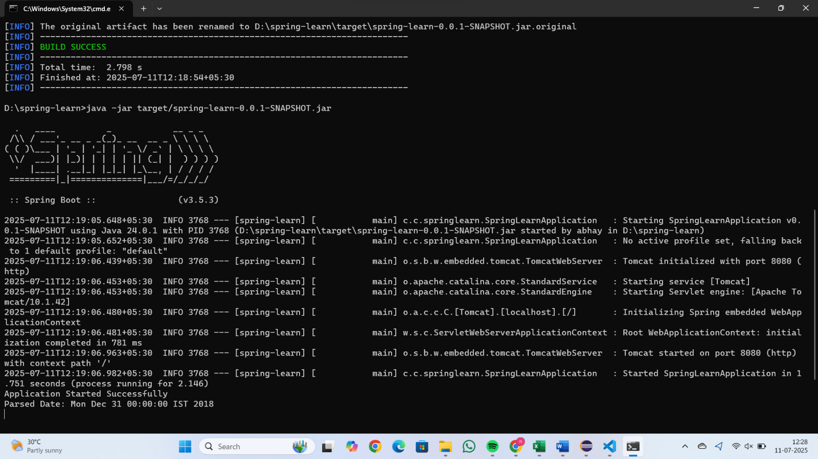

**Hands on 3**

**Spring Core - Incorporate Logging**   
  
Incorporate logging in the Spring Boot project created in previous hands on. Refer steps below:

* Create application.properties if not yet created in src/main/resources folder
* Add below lines in application.properties

logging.level.org.springframework=info

logging.level.com.cognizant.springlearn=debug

logging.pattern.console=%d{yyMMdd}|%d{HH:mm:ss.SSS}|%-20.20thread|%5p|%-25.25logger{25}|%25M|%m%n

In SpringLearnApplication.java include the following imports:

package com.cognizant.springlearn;

import org.springframework.boot.SpringApplication;

import org.springframework.boot.autoconfigure.SpringBootApplication;

import org.springframework.context.ApplicationContext;

import org.springframework.context.support.ClassPathXmlApplicationContext;

import java.text.SimpleDateFormat;

import java.util.Date;

import org.slf4j.Logger;

import org.slf4j.LoggerFactory;

@SpringBootApplication

public class SpringLearnApplication {

    private static final Logger LOGGER = LoggerFactory.getLogger(SpringLearnApplication.class);

    public static void main(String[] args) {

        SpringApplication.run(SpringLearnApplication.class, args);

        LOGGER.info("Application Started Successfully");

        displayDate();

    }

    public static void displayDate() {

        LOGGER.info("START");

        ApplicationContext context = new ClassPathXmlApplicationContext("date-format.xml");

        SimpleDateFormat format = context.getBean("dateFormat", SimpleDateFormat.class);

        try {

            Date parsedDate = format.parse("31/12/2018");

            LOGGER.debug("Parsed Date: {}", parsedDate);

        } catch (Exception e) {

            LOGGER.error("Date parsing error: {}", e.getMessage());

        }

        LOGGER.info("END");

    }

}

