**Hello World RESTful Web Service(Mandatory)**   
  
Write a REST service in the spring learn application created earlier, that returns the text "Hello World!!" using Spring Web Framework. Refer details below:

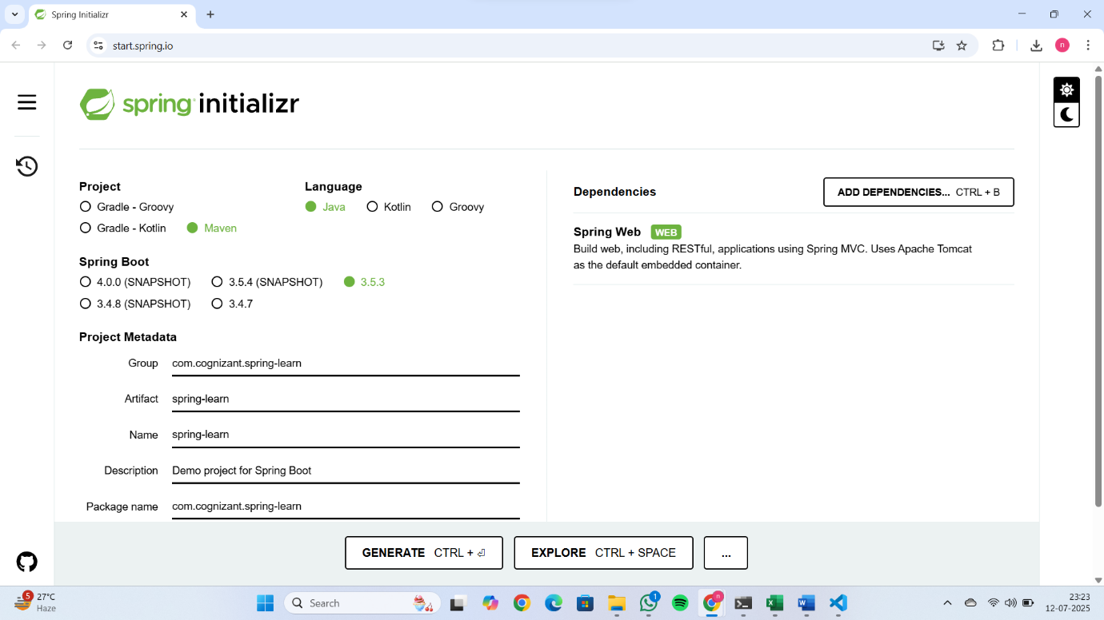  
  
**Method:** GET  
**URL:** /hello  
**Controller:** com.cognizant.spring-learn.controller.HelloController  
**Method Signature:** public String sayHello()  
**Method Implementation:** return hard coded string "Hello World!!"  
**Sample Request**: http://localhost:8083/hello  
**Sample Response:** Hello World!!

package com.cognizant.springlearn.controller;

import org.slf4j.Logger;

import org.slf4j.LoggerFactory;

import org.springframework.web.bind.annotation.GetMapping;

import org.springframework.web.bind.annotation.RestController;

@RestController

public class HelloController {

    private static final Logger LOGGER = LoggerFactory.getLogger(HelloController.class);

    @GetMapping("/hello")

    public String sayHello() {

        LOGGER.info("START sayHello");

        String message = "Hello World!!";

        LOGGER.info("END sayHello");

        return message;

    }

}

**IMPORTANT NOTE**: Don't forget to include start and end log in the sayHello() method.  
  
Try the URL http://localhost:8083/hello in both chrome browser and postman.  
  
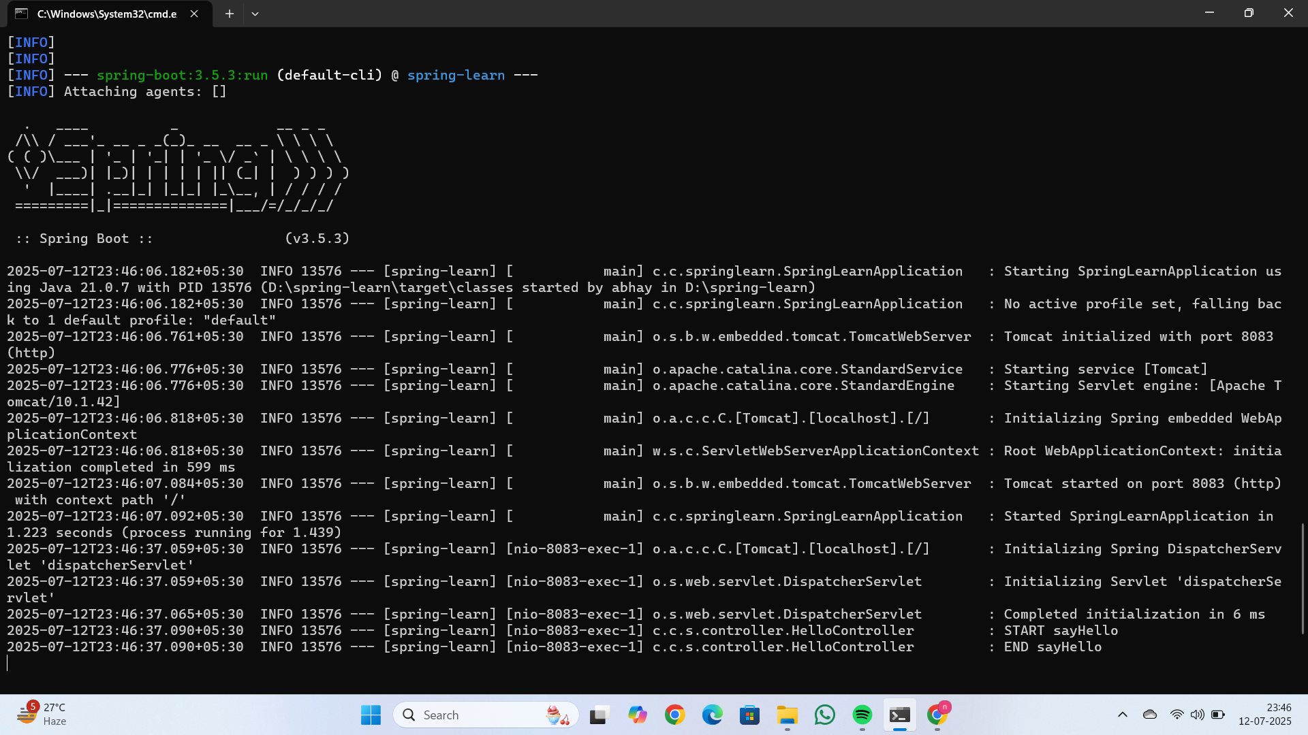

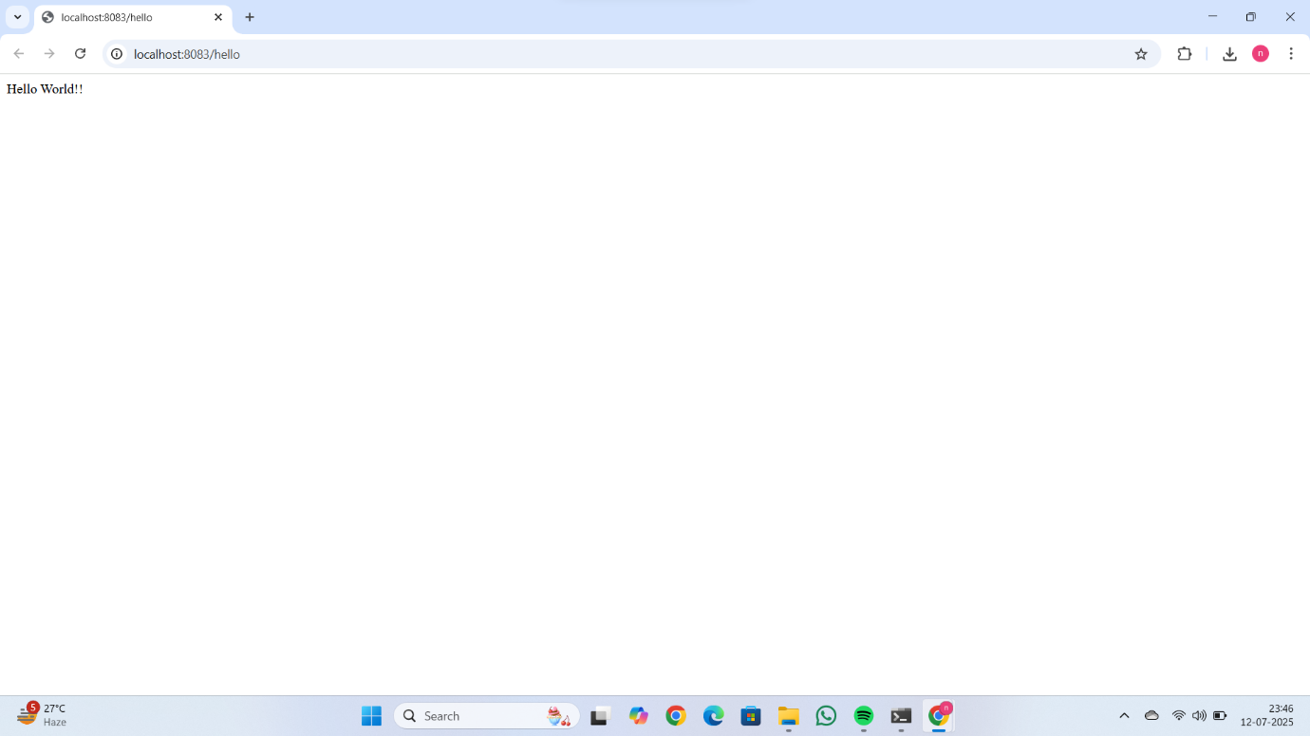

**REST - Country Web Service(Mandatory)**  
  
Write a REST service that returns India country details in the earlier created spring learn application.  
  
**URL**: /country  
**Controller**: com.cognizant.spring-learn.controller.CountryController  
**Method Annotation**: @RequestMapping  
**Method Name**: getCountryIndia()  
**Method Implementation**: Load India bean from spring xml configuration and return  
**Sample Request**: http://localhost:8083/country  
**Sample Response**:

{

  "code": "IN",

  "name": "India"

}

package com.cognizant.springlearn.controller;

import com.cognizant.springlearn.model.Country;

import org.slf4j.Logger;

import org.slf4j.LoggerFactory;

import org.springframework.context.ApplicationContext;

import org.springframework.context.support.ClassPathXmlApplicationContext;

import org.springframework.web.bind.annotation.RequestMapping;

import org.springframework.web.bind.annotation.RestController;

@RestController

public class CountryController {

    private static final Logger LOGGER = LoggerFactory.getLogger(CountryController.class);

    @RequestMapping("/country")

    public Country getCountryIndia() {

        LOGGER.info("START getCountryIndia");

        ApplicationContext context = new ClassPathXmlApplicationContext("country.xml");

        Country country = (Country) context.getBean("in");

        LOGGER.info("END getCountryIndia");

        return country;

    }

}

Country.xml

<?xml version="1.0" encoding="UTF-8"?>

<beans xmlns="http://www.springframework.org/schema/beans"

       xmlns:xsi="http://www.w3.org/2001/XMLSchema-instance"

       xsi:schemaLocation="http://www.springframework.org/schema/beans

       http://www.springframework.org/schema/beans/spring-beans.xsd">

    <bean id="in" class="com.cognizant.springlearn.model.Country">

        <property name="code" value="IN"/>

        <property name="name" value="India"/>

    </bean>

</beans>

Output:

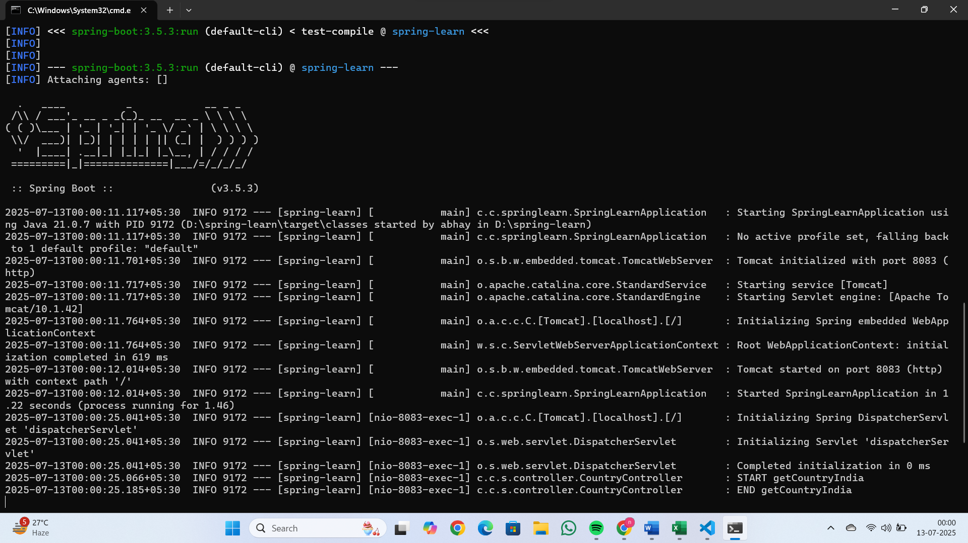

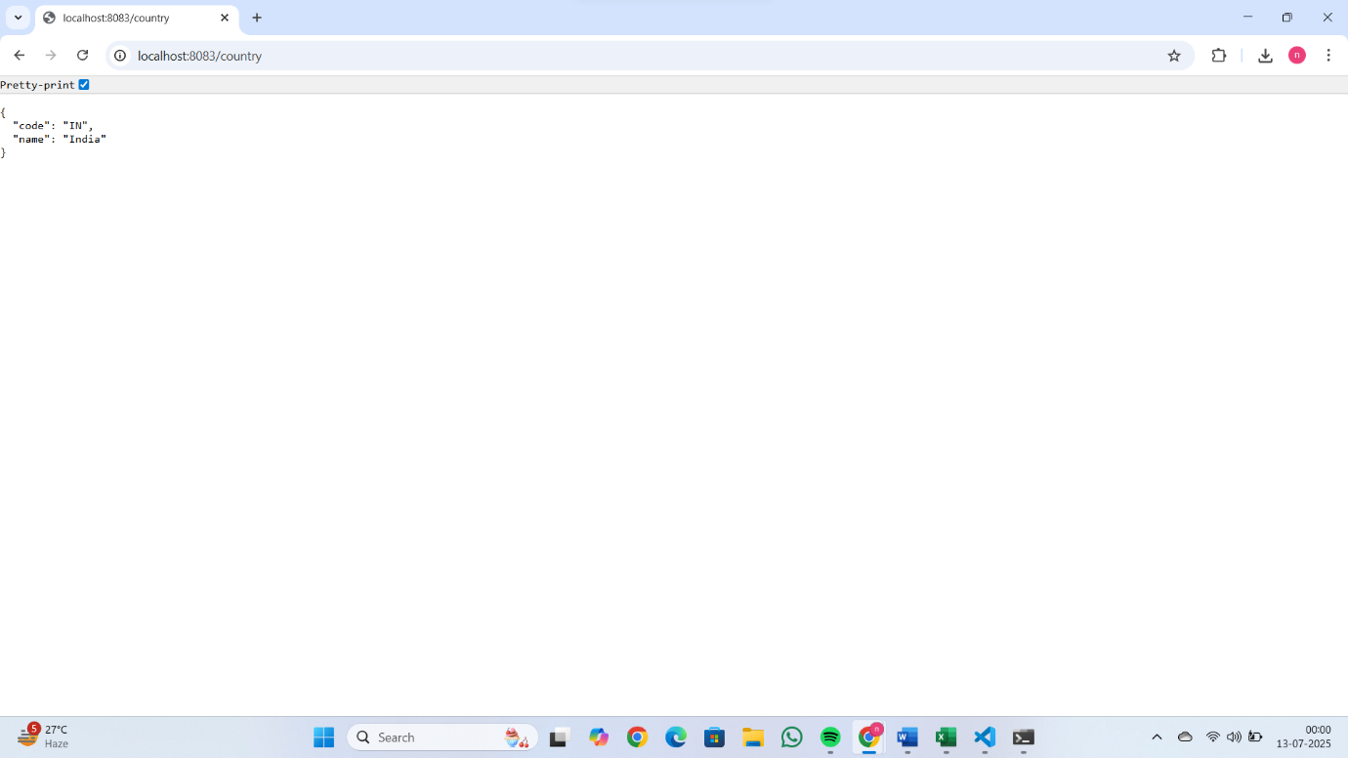

**REST - Get country based on country code**   
  
Write a REST service that returns a specific country based on country code. The country code should be case insensitive.  
  
**Controller**: com.cognizant.spring-learn.controller.CountryController  
**Method Annotation:** @GetMapping("/countries/{code}")  
**Method Name**: getCountry(String code)  
**Method Implemetation**: Invoke countryService.getCountry(code)   
**Service Method:**com.cognizant.spring-learn.service.CountryService.getCountry(String code)

package com.cognizant.springlearn.service;

import com.cognizant.springlearn.model.Country;

import org.springframework.context.ApplicationContext;

import org.springframework.context.support.ClassPathXmlApplicationContext;

import org.springframework.stereotype.Service;

import java.util.List;

@Service

public class CountryService {

    public Country getCountry(String code) {

        ApplicationContext context = new ClassPathXmlApplicationContext("country.xml");

        List<Country> countryList = context.getBean("countryList", List.class);

        return countryList.stream()

                .filter(c -> c.getCode().equalsIgnoreCase(code))

                .findFirst()

                .orElse(null); // or throw an exception if preferred

    }

}

**Service Method Implementation**:

* Get the country code using @PathVariable
* Get country list from country.xml
* Iterate through the country list
* Make a case insensitive matching of country code and return the country.
* Lambda expression can also be used instead of iterating the country list

<?xml version="1.0" encoding="UTF-8"?>

<beans xmlns="http://www.springframework.org/schema/beans"

       xmlns:xsi="http://www.w3.org/2001/XMLSchema-instance"

       xsi:schemaLocation="http://www.springframework.org/schema/beans

       http://www.springframework.org/schema/beans/spring-beans.xsd">

    <bean id="countryList" class="java.util.ArrayList">

        <constructor-arg>

            <list>

                <bean class="com.cognizant.springlearn.model.Country">

                    <property name="code" value="IN"/>

                    <property name="name" value="India"/>

                </bean>

                <bean class="com.cognizant.springlearn.model.Country">

                    <property name="code" value="US"/>

                    <property name="name" value="United States"/>

                </bean>

                <bean class="com.cognizant.springlearn.model.Country">

                    <property name="code" value="JP"/>

                    <property name="name" value="Japan"/>

                </bean>

            </list>

        </constructor-arg>

    </bean>

</beans>

**Sample Request**: http://localhost:8083/country/in  
  
**Sample Response**:

{

  "code": "IN",

  "name": "India"

}

Output:

