Facebooker::Session::PermissionError in UsersController#home
The user hasn't authorized the application to perform this action

http://wiki.developers.facebook.com/index.php/Authorization_and_Authentication_for_Desktop_Applications#Prompting_for_Permissions ---------- It has how to give permission to the user from our rails application

in your controller : To post a message on my wall

def home
@users = facebook_session.user.friends
@login_user = facebook_session.user

#~ render :text => @login_user and return
@user = 1412752930 # ratnakar

#~ @user = 1712994316 #which is ratnam raju id and he is my friend
facebook_session = Facebooker::Session.create
facebook_session.permission_url('publish_stream')
facebook_session.post 'facebook.stream.publish', :uid => @user, :message => 'Hi, Raju, how r u?'

To send notification to your friends and to you

@login_user = facebook_session.user
@user = 1712994316 ### he is my friend in facebook (ratnam raju)

facebook_session.send_notification([@user], "Hi, Raju Sir... this is notification message from rails app")

# need to work on this
To see this limit you can use the following call: Facebooker::Session.create.post('facebook.admin.getAllocation', :integration_point_name => 'announcement_notifications_per_week')

How to pass images to notification in facebook?

http://forums.pragprog.com/forums/59/topics/2477

http://apps.facebook.com/facebooker_tutorial/messaging/news_feed ----- important

http://www.thoughtintomotion.com/2009/06/publish-feed-stories-with-facebooker-rails.html

By using this below link I posted my msg successfully

http://www.facebook.com/connect/prompt_permissions.php?api_key=YOURAPIKEY&v=1.0&next=http://www.facebook.com/connect/login_success.html?xxRESULTTOKENxx&display=popup&ext_perm=read_stream,publish_stream&enable_profile_selector=1&profile_selector_ids=1234%2C5454

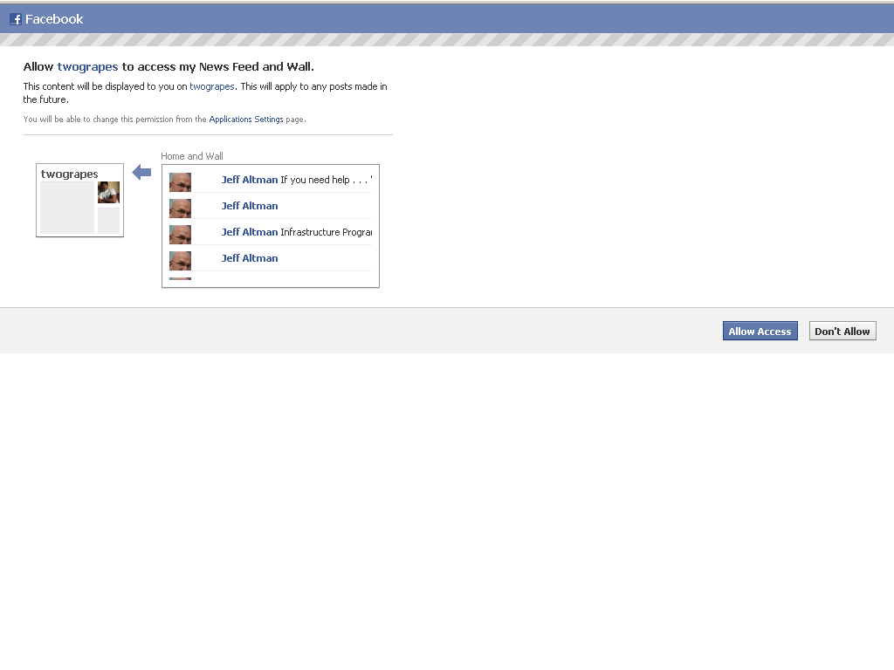
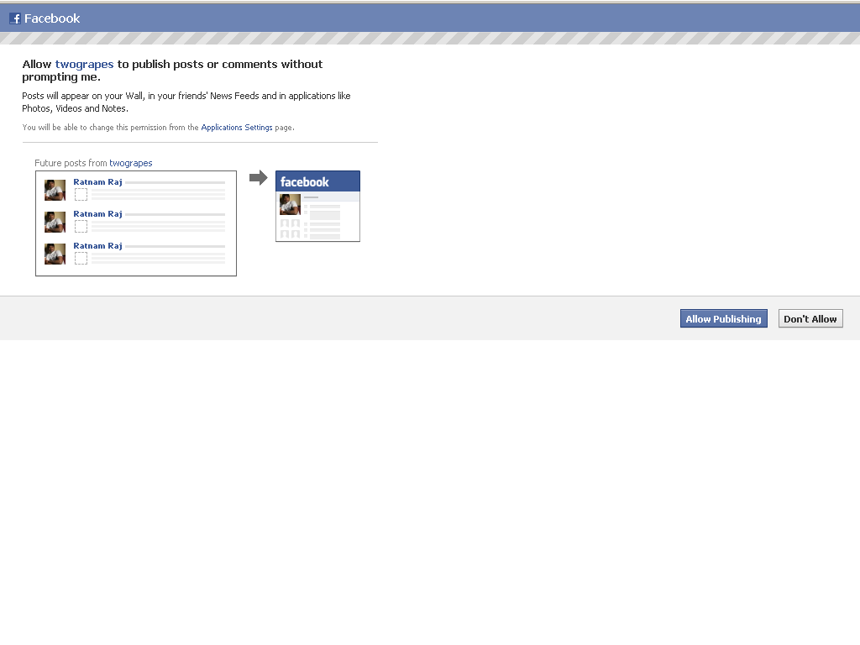
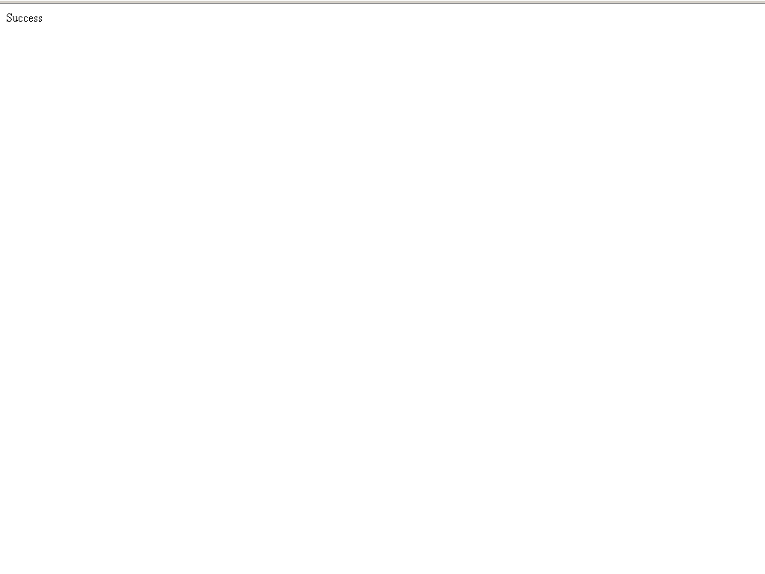
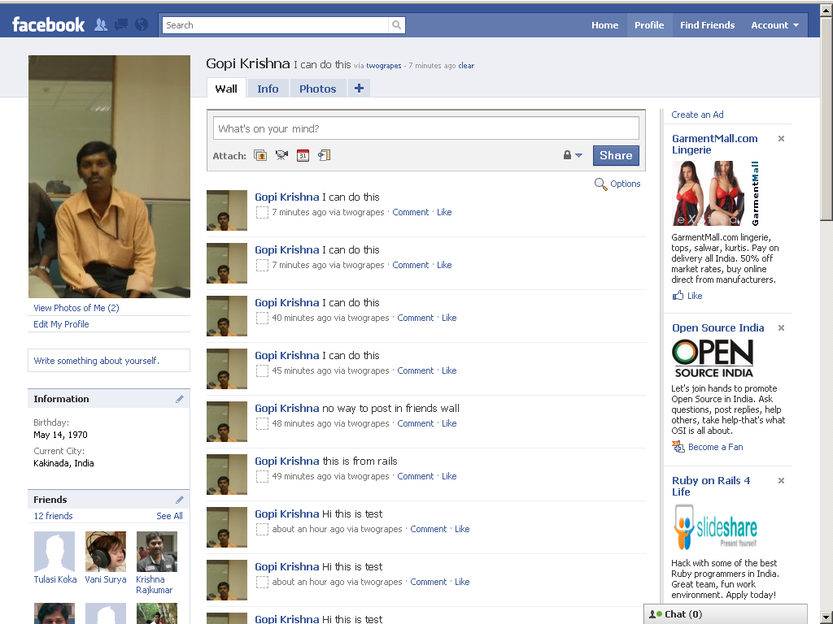

http://www.facebook.com/connect/login_success.html?read_stream%2Cpublish_stream

it gives a message “success”

http://wiki.developers.facebook.com/index.php/Extended_permissions

Hello,

Last few days back, I worked on facbook integration using rails application. While working with this, i have same problem.

For this, I followed the below link

http://www.facebook.com/connect/prompt_permissions.php?api_key=YOURAPIKEY&v=1.0&next=http://www.facebook.com/connect/login_success.html?xxRESULTTOKENxx&display=popup&ext_perm=read_stream,publish_stream&enable_profile_selector=1&profile_selector_ids=1234%2C5454

1) copy the above URL and paste it in your browser address bar. And replace "YOURAPIKEY" with your api key provided.

2) It shows a window, with two buttons "Allow Access" ,"Don't accept"

3) It means you need to provide access to allow the comments which are posted from outside of the facebook.

4) By selecting "Allow Access" button, your comments will successfully added to your facebook wall.

I hope this can helps you...

