**APPLIED DATA SCIENCE – PHASE 5**

**ELECTRICITY PRICE PREDICTION**

**PROBLEM STATEMENT :**

The energy market is characterized by significant volatility, driven by various factors such as changes in energy supply, demand patterns, weather conditions, economic indicators, and policy shifts. Accurate and timely predictions of electricity prices are essential for utility companies, consumers, and renewable energy producers to make informed decisions, optimize resource allocation, and manage costs efficiently.

The problem at hand revolves around the development of reliable and precise electricity price prediction models. These models must take into account a wide range of variables, including historical price data, energy production from various sources, weather-related variables, market sentiment, and economic indicators. Furthermore, the models need to address the challenges posed by the non-linear and dynamic nature of electricity price fluctuations, making it difficult to capture the underlying patterns accurately.

The objective of this problem statement is to create robust and adaptable prediction models that enhance the accuracy of electricity price forecasts.The solution to this problem will significantly benefit a wide range of stakeholders, including utility companies, energy traders, renewable energy providers, policymakers, and consumers.

**DESIGN THINKING :**

Design thinking is a problem-solving and innovation approach that focuses on understanding and addressing user needs, often involving iterative processes and multidisciplinary collaboration. It can be effectively applied to the task of electricity price prediction. Here's how you can use the design thinking process for electricity price prediction

1. Empathize:

* User Research: Begin by understanding the needs and pain points of various stakeholders in the electricity market, including utility companies, consumers, regulators, and renewable energy producers. Conduct interviews, surveys, and workshops to gain insights.
* Data Exploration: Analyze historical electricity price data to understand patterns, trends, and anomalies. This step helps in empathizing with the behavior of the dataset.

1. Define:

* Problem Statement: Based on your research and data exploration, clearly define the problem you aim to address in electricity price prediction. Specify the objectives and constraints.
* User Personas: Create user personas to represent the different stakeholders. Understand their unique requirements and expectations.

1. Ideate:

* Brainstorming: Collaborate with a multidisciplinary team, including data scientists, domain experts, and software developers, to generate a wide range of ideas for improving electricity price prediction.
* Feature Engineering: Generate ideas for new features that can be derived from the available data. Consider lag features, weather data integration, time-related features, and external factors.

1. Prototype:

* Model Prototyping: Build prototype prediction models using various algorithms (e.g., linear regression, random forests, time series forecasting) to test the feasibility of different approaches.
* Visualization: Create visualizations that help stakeholders understand the data and potential model outputs.

1. Test:

* Model Evaluation: Assess the performance of the prototype models using appropriate evaluation metrics (e.g., RMSE, MAE). Compare models' results with user requirements.
* User Testing: Involve potential users in testing the prototype models and gather feedback on usability and relevance.

1. Feedback and Iterate:

* Based on user feedback and model performance, iterate on the design and functionality of the electricity price prediction system. Make improvements, refine features, and adjust model parameters.

1. Implement:

* Develop the production-ready electricity price prediction system. This involves implementing the selected model, creating a user-friendly interface, and integrating it into the existing infrastructure.
* Ensure that the system can handle real-time data and provide predictions and insights to the relevant stakeholders.

1. Test and Validate:

* Thoroughly test the system in a real-world environment, using historical data and real-time data streams. Verify that it meets performance and reliability standards.

1. Launch and Monitor:

* Launch the electricity price prediction system. Continuously monitor its performance and gather user feedback. Implement a feedback loop for ongoing improvement and adaptation to changing market conditions.

1. Scale and Iterate:

* As the system gains traction and usage, consider scalability and expandability. Continuously iterate on the model, data sources, and features to adapt to evolving market dynamics.

**PHASES OF DEVELOPMENT :**

The development of a machine learning-based electricity price prediction system involves several phases.

Here are the key phases

**Project Initiation :**

Problem Definition : Clearly define the problem of electricity price prediction and identify the objectives and desired outcomes.

Data Collection : Gather historical data on electricity prices, demand, supply, weather conditions, and other relevant variables.

**Data Preprocessing :**

Data Cleaning : Clean the dataset by handling missing values, removing duplicates, and addressing outliers.

Feature Engineering : Create new features and transform existing ones to improve model performance.

Data Splitting : Divide the data into training, validation, and test sets.

**Model Development :**

Model Selection : Choose an appropriate machine learning algorithm for regression tasks, considering the specific characteristics of electricity price prediction.

Feature Selection : Decide on the relevant features (input variables) for the model.

Hyperparameter Tuning : Optimize the model's hyperparameters to achieve the best performance.

Model Training : Train the selected model on the training dataset using historical data.

Model Evaluation : Assess the model's performance using appropriate regression metrics and cross-validation.

**Model Optimization and Model Validation :**

Fine-tune the model based on the evaluation results, making adjustments to improve accuracy and robustness.

Validate the model's performance on the test dataset to ensure it generalizes well to unseen data.

**Visualization and Interpretation :**

Create visualizations and interpretations of the model's output to understand the predictions and insights.

**Deployment :**

Deploy the model in a production environment where it can make real-time or batch predictions for electricity prices.

**Monitoring and Maintenance :**

Continuously monitor the model's performance in the production environment. Implement a feedback loop for ongoing improvements

**DATASET :**

A dataset is a structured collection of data that is typically organized for a specific purpose, such as analysis, research, or reference. It can consist of various types of information, including numbers, text, images, or any other relevant data. Datasets are commonly used in fields like data science, machine learning, and statistics for training models, conducting research, and gaining insights from the information they contain.

This dataset has been taken from Kaggle.com

Link: [**https://www.kaggle.com/datasets/chakradharmattapalli/electricity-price-prediction**](https://www.kaggle.com/datasets/chakradharmattapalli/electricity-price-prediction)

**DETAILS OF COLUMN USED :**

DateTime: String, defines date and time of sample.

Holiday: String, gives name of holiday if day is a bank holiday.

HolidayFlag: Integer, 1 if day is a bank holiday, zero otherwise.

DayOfWeek: Integer (0-6), 0 monday, day of week.

WeekOfYear: Integer, running week within year of this date.

Day Integer: Day of the date.

Month Integer: Month of the date.

Year Integer: Year of the date.

PeriodOfDay integer: Denotes half hour period of day (0-47).

ForecastWindProduction: The forecasted wind production for this period.

SystemLoadEA: The national load forecast for this period.

SMPEA: The price forecast for this period.

ORKTemperature: The actual temperature measured at Cork airport.

ORKWindspeed: The actual windspeed measured at Cork airport.

CO2Intensity: The actual CO2 intensity in (g/kWh) for the electricity produced.

ActualWindProduction: The actual wind energy production for this period.

SystemLoadEP2: The actual national system load for this period.

**DATA PREPROCESSING STEPS :**

Data preprocessing is a crucial step in electricity price prediction. Here are specific data preprocessing steps tailored to the context of electricity price prediction.

Data Collection : Gather historical data related to electricity prices, including features such as time stamps, demand, supply, weather conditions, and other relevant variables.

Data Cleaning : Handle Missing Values: Identify and address missing values in your dataset. Depending on the nature of the missing data, you can use techniques like imputation (e.g., filling missing values with the mean or median) or remove rows or columns with excessive missing data.

Duplicate Removal : Check for and remove duplicate records, if any, to avoid bias in the analysis.

Outlier Detection and Handling : Identify outliers in electricity price data that could distort predictions. Decide whether to remove, transform, or cap these outliers based on domain knowledge.

Feature Engineering : Create Lag Features: For time series data, generate lag features by shifting historical electricity prices backward in time. These lag features can capture autocorrelation patterns.

Rolling Statistics : Compute rolling statistics (e.g., rolling means, rolling standard deviations) to capture short-term trends and seasonality.

Weather Data Integration : If weather data is relevant to your prediction, integrate weather variables (e.g., temperature, wind speed) into your dataset. These features can significantly impact electricity prices.

Categorical Variable Encoding :If your dataset includes categorical variables (e.g., day of the week, season), convert them into a numerical format using techniques like one-hot encoding or label encoding.

Normalization or Standardization :Standardize or normalize numerical features to ensure they have a similar scale. This is important for many machine learning algorithms. Common methods include z-score standardization and min-max scaling.

Time Series Handling :Sort your data by timestamp to maintain temporal order.

Extract Time-Based Features : Extract relevant time-based features such as day of the week, hour of the day, and holidays.

Data Splitting :Divide your dataset into training, validation, and test sets. The choice of split ratios depends on your dataset size and the nature of the problem.

Dealing with Imbalanced Data :If your dataset has imbalanced classes (e.g., extreme price events), consider techniques like oversampling, undersampling, or adjusting evaluation metrics to address the imbalance.

Data Exploration and Visualization :Explore your data through summary statistics, visualizations, and correlation matrices to understand relationships between features and target variables.

Final Data Inspection :Double-check the data for inconsistencies or anomalies introduced during preprocessing.

Data Saving : Save the cleaned and preprocessed data to a suitable format for analysis and model training.

Handling Time Series Forecasting : Consider using time series forecasting models (e.g., ARIMA, Prophet) in addition to traditional regression models for capturing seasonality and trends.

**MODEL TRAINING :**

Model training in machine language is the process of feeding an ML algorithm with data to help identify and learn good values for all attributes involved.There are several types of machine learning models, of which the most common ones are supervised and unsupervised learning.

**Data Preparation :** Ensure that your dataset is cleaned, preprocessed, and split into training, validation, and test sets. Make sure the data is in a format that can be fed into the model.

**Select a Model :** Choose an appropriate machine learning algorithm for your regression task. Common choices for electricity price prediction include Linear Regression, Random Forest, Decision Trees, Support Vector Machines, and neural networks.

**Feature Selection :** Decide on the set of features (independent variables) that the model will use for making predictions. Features may include historical electricity prices, demand, supply, weather conditions, and other relevant variables.

**Hyperparameter Tuning :** Optimize the hyperparameters of your chosen model. Hyperparameters are settings that affect the model's behavior but are not learned from the data. Use techniques like grid search, random search, or Bayesian optimization to find the best hyperparameter settings.

**Model Training :** Train the selected machine learning model using the training dataset. Fit the model to the historical data to learn the underlying patterns and relationships.

from sklearn.linear_model import LinearRegression

model = LinearRegression()

model.fit(x_train, y_train)

**Model Evaluation :** Evaluate the model's performance using the validation dataset. Use appropriate regression evaluation metrics such as Mean Absolute Error (MAE), Mean Squared Error (MSE), Root Mean Squared Error (RMSE), and R-squared (R^2).

from sklearn.metrics import mean_squared_error

y_pred = model.predict(x_validation)

rmse = np.sqrt(mean_squared_error(y_validation, y_pred))

**Cross-Validation :** Perform k-fold cross-validation to assess the model's robustness. Cross-validation involves splitting the data into multiple subsets, training and testing the model multiple times, and aggregating the results to evaluate overall performance.

from sklearn.model_selection import cross_val_score

scores = cross_val_score(model, x_train, y_train, cv=5, scoring='neg_mean_squared_error')

rmse_scores = np.sqrt(-scores)

**Model Comparison :** If you have tried multiple algorithms and hyperparameters, compare the performance of different models and select the best-performing model based on the evaluation results.

**Final Model Training :** Train the final selected model on the entire training dataset to maximize its learning from all available historical data.

**Testing and Validation :** Validate the final model using the test dataset to ensure that it performs well on unseen data.

**Save the Model :** Once satisfied with the model's performance, save it to a file for later use in making predictions.

**MODEL USED :**

**Linear Regression:**

* Model Type : Linear Regression is a simple and interpretable regression model that assumes a linear relationship between the input features and the target variable.
* Application : Linear regression can be applied when there is a linear relationship between electricity price and predictors. It's a good starting point for modeling.

**Random Forest:**

* Model Type : Random Forest is an ensemble method that combines multiple decision trees to make predictions. It's known for its robustness and ability to capture complex relationships in the data.
* Application : Random Forest is a versatile model suitable for various data types. It's effective when electricity prices are influenced by multiple variables, including weather conditions and historical data.

**Decision Trees:**

* Model Type : Decision Trees are simple tree-like models that make decisions by recursively splitting the data into subsets based on the most significant features.
* Application : Decision Trees can be used when there are clear decision points and different branches in the factors influencing electricity prices. They are interpretable and easy to visualize.

**Support Vector Machines (SVM):**

* Model Type : Support Vector Machines are used for classification and regression tasks. In regression, SVM aims to find a hyperplane that best fits the data.
* Application : SVM can be useful for electricity price prediction when you expect non-linear relationships between the variables. It's effective when dealing with small to medium-sized datasets.

**Neural Networks:**

* Model Type : Neural Networks are a type of deep learning model inspired by the structure of the human brain. They consist of interconnected layers of artificial neurons.
* Application : Neural Networks, particularly deep learning models like recurrent neural networks (RNNs) or Long Short-Term Memory (LSTM) networks, can capture complex, non-linear relationships in the data. They are suitable for tasks where historical sequences and patterns are crucial for prediction, as in time series forecasting.

**Algorithm Choice :**

For time series forecasting, you have several algorithm options, including:

ARIMA (AutoRegressive Integrated Moving Average) : Suitable for univariate time series data with trends and seasonality. ARIMA is interpretable and widely used for forecasting.

Prophet : Developed by Facebook, Prophet is designed for forecasting with daily observations that display patterns on different time scales. It can handle missing data and outliers effectively.

LSTM (Long Short-Term Memory) : Deep learning model, particularly effective when there are complex, non-linear relationships and long-term dependencies in the data. It can capture intricate patterns.

**Evaluation Metrics:**

Two common evaluation metrics for regression tasks like time series forecasting are MAE and RMSE:

Mean Absolute Error (MAE) : Measures the average absolute difference between predicted and actual values. It provides a sense of the magnitude of errors.

from sklearn.metrics import mean_absolute_error

y_true = # Actual values

y_pred = # Predicted values

mae = mean_absolute_error(y_true, y_pred)

print(f"MAE: {mae}")

Root Mean Squared Error (RMSE) : Similar to MAE but gives more weight to large errors. It's the square root of the average of squared differences between predicted and actual values.

from sklearn.metrics import mean_squared_error

y_true = # Actual values

y_pred = # Predicted values

rmse = np.sqrt(mean_squared_error(y_true, y_pred))

print(f"RMSE: {rmse}")

**LSTM (Long Short-Term Memory) :**

**CODE :**

import numpy as np

import pandas as pd

from sklearn.preprocessing import MinMaxScaler

from tensorflow.keras.models import Sequential

from tensorflow.keras.layers import LSTM, Dense

from sklearn.metrics import mean_squared_error

import matplotlib.pyplot as plt

data = pd.read_csv("Electricity.csv")

# Extract the relevant column for prediction

price_data = data["Price"].values

# Normalize the data to a range between 0 and 1

scaler = MinMaxScaler(feature_range=(0, 1))

price_data = scaler.fit_transform(price_data.reshape(-1, 1))

# Define parameters for creating sequences

sequence_length = 10 # Length of input sequences

look_back = 1 # Number of time steps to look back

# Prepare the data by creating sequences

dataX, dataY = [], []

for i in range(len(price_data) - sequence_length - look_back):

a = price_data[i:(i + sequence_length + look_back)]

dataX.append(a[:sequence_length])

dataY.append(a[sequence_length:])

dataX = np.array(dataX)

dataY = np.array(dataY)

# Split the data into training and testing sets

train_size = int(len(dataX) * 0.67)

x_train, x_test = dataX[0:train_size], dataX[train_size:len(dataX)]

y_train, y_test = dataY[0:train_size], dataY[train_size:len(dataX)]

# Build the LSTM model

model = Sequential()

model.add(LSTM(50, input_shape=(sequence_length, 1)))

model.add(Dense(1))

model.compile(loss='mean_squared_error', optimizer='adam')

# Train the model

model.fit(x_train, y_train, epochs=100, batch_size=64)

# Make predictions

train_predict = model.predict(x_train)

test_predict = model.predict(x_test)

# Inverse transform the predictions to the original scale

train_predict = scaler.inverse_transform(train_predict)

y_train = scaler.inverse_transform(y_train)

test_predict = scaler.inverse_transform(test_predict)

y_test = scaler.inverse_transform(y_test)

# Calculate RMSE for the test set

rmse = np.sqrt(mean_squared_error(y_test, test_predict))

print(f"Test RMSE: {rmse}")

# Plot the predictions and actual values

plt.figure(figsize=(12, 6))

plt.plot(y_test, label="Actual Prices")

plt.plot(test_predict, label="Predicted Prices")

plt.legend()

plt.show()

**ARIMA (AutoRegressive Integrated Moving Average) :**

import pandas as pd

import numpy as np

import matplotlib.pyplot as plt

from statsmodels.tsa.arima_model import ARIMA

from statsmodels.tsa.stattools import adfuller

from sklearn.metrics import mean_squared_error

data = pd.read_csv("Electricity.csv")

# Visualize your time series

plt.figure(figsize=(12, 6))

plt.plot(data['Date'], data['Value'])

plt.title("Time Series Data")

plt.xlabel("Date")

plt.ylabel("Value")

plt.show()

# Check stationarity with Augmented Dickey-Fuller test

result = adfuller(data['Value'])

print(f'ADF Statistic: {result[0]}')

print(f'p-value: {result[1]}')

print('Critical Values:')

for key, value in result[4].items():

print(f'{key}: {value}')

data['Differenced'] = data['Value'].diff().dropna()

# Visualize the differenced time series

plt.figure(figsize=(12, 6))

plt.plot(data['Date'][1:], data['Differenced'][1:])

plt.title("Differenced Time Series")

plt.xlabel("Date")

plt.ylabel("Differenced Value")

plt.show()

# Fit an ARIMA model to the differenced data

model = ARIMA(data['Differenced'][1:], order=(1, 1, 1)) # Replace the order with appropriate values

model_fit = model.fit(disp=0)

# Make predictions

forecast, stderr, conf_int = model_fit.forecast(steps=12) # Adjust the number of forecasted time steps

# Inverse the differencing to get back to the original scale

forecast = np.cumsum(forecast)

forecast = np.insert(forecast, 0, data['Value'].iloc[-1])

# Visualize the original data and the forecast

plt.figure(figsize=(12, 6))

plt.plot(data['Date'], data['Value'], label="Original Data")

plt.plot(data['Date'].iloc[-1:] + pd.to_timedelta(data['Date'].diff().mean()), forecast, label="Forecast", linestyle='--')

plt.title("ARIMA Forecast")

plt.xlabel("Date")

plt.ylabel("Value")

plt.legend()

plt.show()

# Calculate RMSE for the forecast

test_data = data['Value'].tail(12) # Use the last 12 data points for testing

rmse = np.sqrt(mean_squared_error(test_data, forecast))

print(f"Root Mean Squared Error (RMSE): {rmse}")

**FEATURE ENGINEERING :**

Feature engineering is the process of creating new features or transforming existing ones to improve the performance of machine learning models. In the context of electricity price prediction, feature engineering can be critical for capturing relevant patterns and improving prediction accuracy.

Here are some feature engineering techniques you can apply to your dataset:

* **Lag Features :** Create lag features for the target variable (electricity price) to incorporate past values. For example, you can add lagged prices from previous hours or days.
* **Rolling Statistics :** Calculate rolling statistics, such as rolling mean or rolling standard deviation, for features like electricity demand or temperature. This can help capture short-term trends.
* **Time-Related Features :** Extract time-related information from timestamps, such as day of the week, hour of the day, or holidays. These features can help model daily or weekly patterns.
* **Seasonal Features :** Identify and create features that capture seasonal patterns in electricity prices, like summer/winter indicators or seasonal dummies.
* **Weather Data Integration :** Integrate weather data into your dataset. Features like temperature, wind speed, or precipitation can significantly impact electricity prices.
* **Time Series Decomposition :** Use time series decomposition methods (e.g., seasonal decomposition of time series - STL) to separate your data into trend, seasonality, and residual components.
* **Moving Averages :** Compute moving averages to capture trends and reduce noise in the data.
* **Feature Scaling and Normalization : Scale and normalize numerical features to ensure all features have a similar impact on the model.**
* **Interaction Terms :** Create interaction terms between relevant features to capture complex relationships.
* **Domain-Specific Features :** Leverage domain knowledge to engineer features specific to the electricity market, like energy source availability or market sentiment indicators.
* **Cross-Correlations :** Calculate cross-correlations between electricity prices and external factors like gas prices, which can reveal interesting relationships.
* **Outlier Handling :** Identify and handle outliers in your dataset, which can distort predictions.
* **Aggregated Features :** Create aggregated features based on historical data, like rolling averages over the past week or month.
* **Sentiment Analysis :** If you have access to news data, perform sentiment analysis to incorporate the market sentiment's effect on prices.
* **Principal Component Analysis (PCA) :** Use PCA for dimensionality reduction if your dataset has many correlated features.

**CODE :**

#importing required libraries

import numpy as np

import pandas as pd

import matplotlib.pyplot as plt

import seaborn as sns

from sklearn.model_selection import train_test_split

from sklearn.metrics import mean_squared_error

from sklearn.ensemble import RandomForestRegressor

from sklearn.tree import DecisionTreeRegressor

from sklearn.linear_model import LinearRegression

from sklearn.neighbors import KNeighborsRegressor

# Load the dataset

df=pd.read_csv("Electricity.csv", low_memory=False)

df.head()

df.info()

data.isnull().sum()

# Remove rows with missing values denoted by "?"

data=df[['ForecastWindProduction',

       'SystemLoadEA', 'SMPEA', 'ORKTemperature', 'ORKWindspeed',

       'CO2Intensity', 'ActualWindProduction', 'SystemLoadEP2', 'SMPEP2']]

data.isin(['?']).any()

for col in data.columns:

    data.drop(data.index[data[col] == '?'], inplace=True)

data=data.apply(pd.to_numeric)

data=data.reset_index()

data.drop('index', axis=1, inplace=True)

data.info()

# Convert data to numeric

data = data.apply(pd.to_numeric)

data.corrwith(data['SMPEP2']).abs().sort_values(ascending=False)

X=data.drop('SMPEP2', axis=1)

y=data['SMPEP2']

#Now let’s have a look at the correlation between all the columns in the dataset:

correlations = data.corr(method='pearson')

plt.figure(figsize=(16, 12))

sns.heatmap(correlations, cmap="coolwarm", annot=True)

plt.show()

# Feature Engineering

# Add lag features (e.g., lag of SMPEP2 for 24 hours)

data['SMPEP2_lag_24'] = data['SMPEP2'].shift(24)

#To Machine Learning

# Data Splitting

x_train, x_test, y_train, y_test=train_test_split(X,y, test_size=0.2, random_state=42)

# Model Training and Evaluation

#LinearRegression

linear_model=LinearRegression()

linear_model.fit(x_train, y_train)

linear_predict=linear_model.predict(x_test)

np.sqrt(mean_squared_error(y_test, linear_predict))

#RandomForestRegressor

# Model Training and Evaluation

forest_model=RandomForestRegressor()

forest_model.fit(x_train, y_train)

forest_predict=forest_model.predict(x_test)

print(np.sqrt(mean_squared_error(y_test, forest_predict)))

model = RandomForestRegressor()

model.fit(xtrain, ytrain)

#features = [["Day", "Month", "ForecastWindProduction", "SystemLoadEA", "SMPEA", "ORKTemperature", "ORKWindspeed", "CO2Intensity", "ActualWindProduction", "SystemLoadEP2"]]

features = np.array([[10, 12, 54.10, 4241.05, 49.56, 9.0, 14.8, 491.32, 54.0, 4426.84]])

model.predict(features)

#DecisionTreeRegressor

# Model Training and Evaluation

tree_model=DecisionTreeRegressor(max_depth=50)

tree_model.fit(x_train, y_train)

tree_predict=tree_model.predict(x_test)

print(np.sqrt(mean_squared_error(y_test, tree_predict)))

#KNeighborsRegressor

# Model Training and Evaluation

knn_model=KNeighborsRegressor()

knn_model.fit(x_train, y_train)

knn_predict=knn_model.predict(x_test)

print(np.sqrt(mean_squared_error(y_test, knn_predict)))

#Let's see some sample prediction and difference between label and prediction

some_data=x_test.iloc[50:60]

some_data_label=y_test.iloc[50:60]

some_predict=forest_model.predict(some_data)

pd.DataFrame({'Predict':some_predict,'Label':some_data_label})

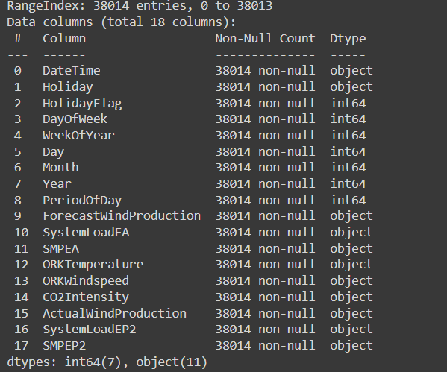

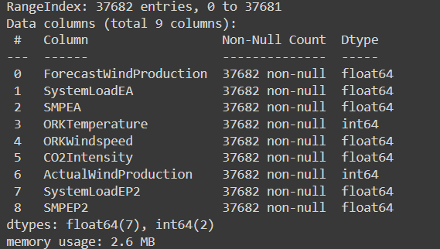

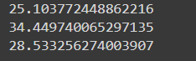

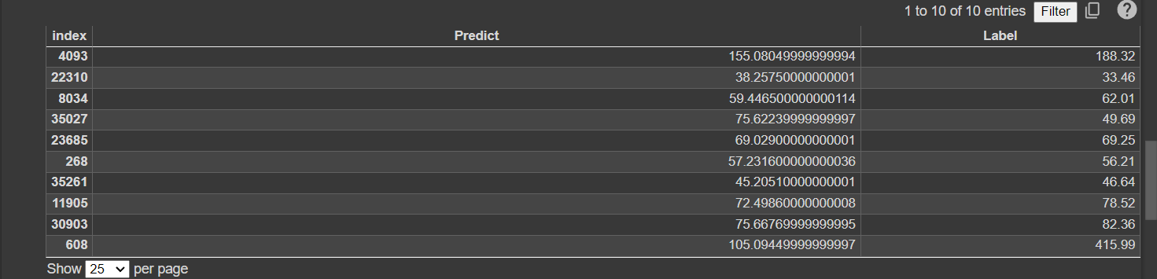

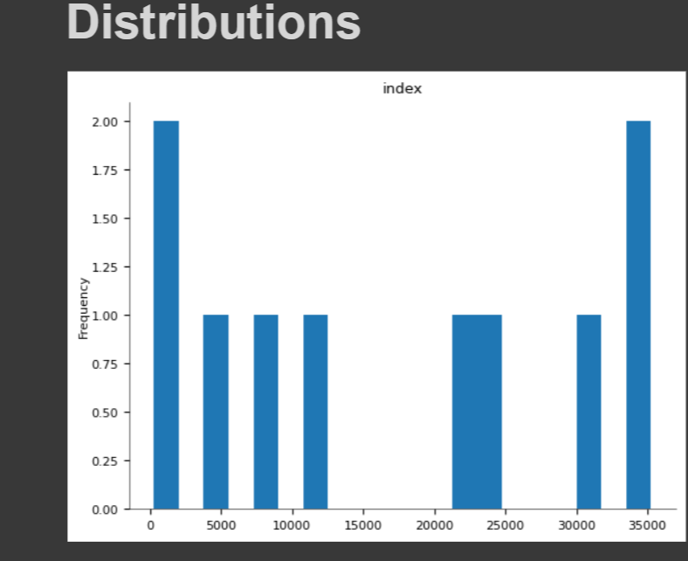

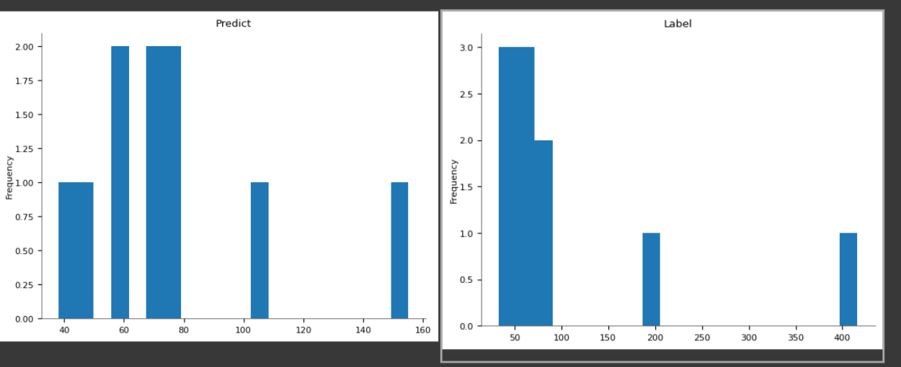

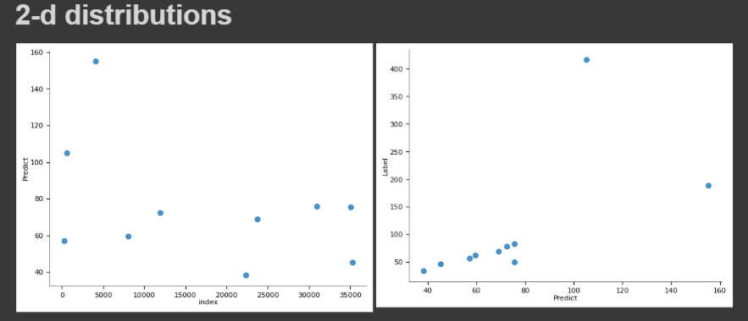

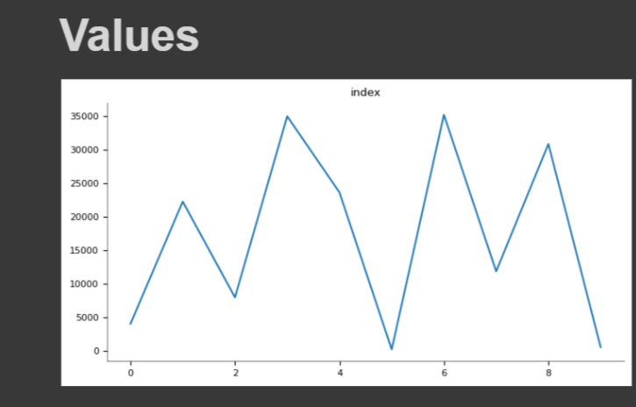

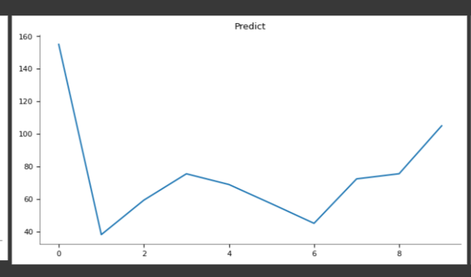

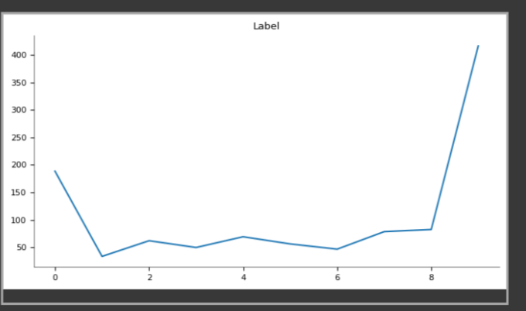



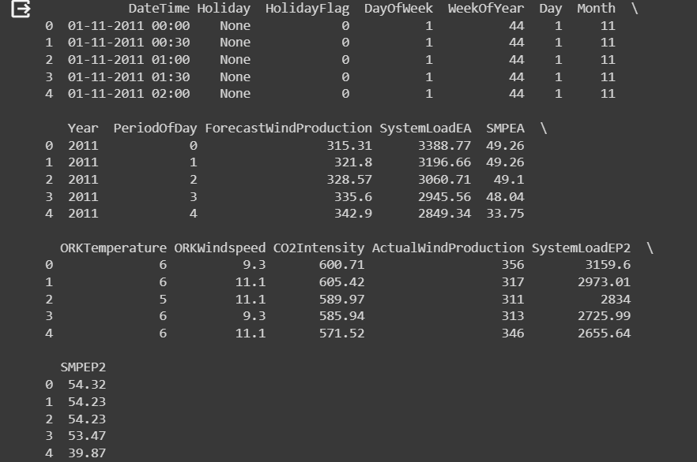

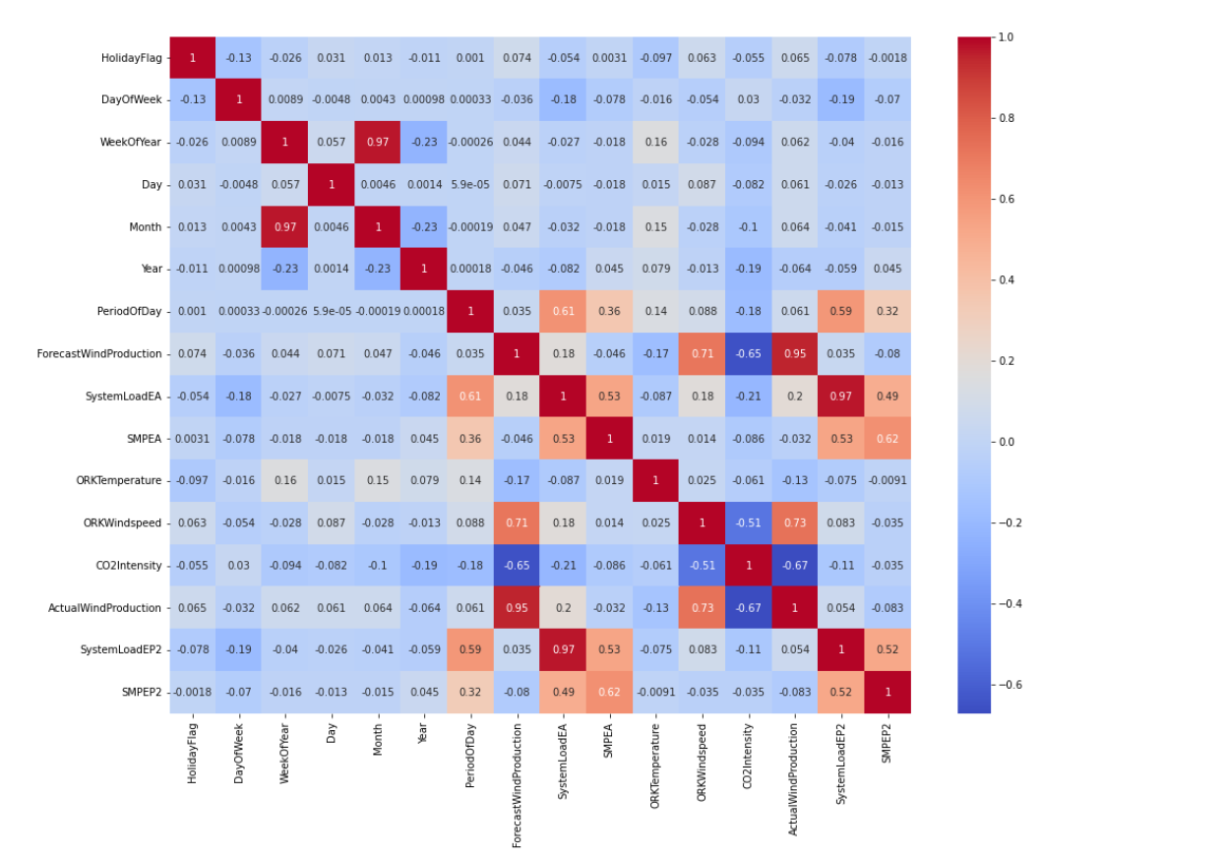

**SUMMARY :**

* Objective : Develop a model to predict electricity prices, a critical task in energy markets, with a focus on pre-processing data, model selection, and evaluation.
* **Data Preprocessing :**
* Load the dataset, ensuring it contains relevant features and a timestamp.
* Address missing values and outliers.
* Perform feature engineering to create meaningful predictors.
* Normalize or scale the data if necessary.
* Consider time-based splitting to separate training and testing data.
* **Model Selection:**
* Choose a suitable machine learning or deep learning model based on the data characteristics and complexity.
* Consider options like Linear Regression, Random Forest, Decision Trees, Support Vector Machines, and neural networks like LSTM or ARIMA for time series forecasting.
* Evaluate the model's assumptions, strengths, and weaknesses for the task.
* **Evaluation Metrics:**
* Select appropriate evaluation metrics for assessing the model's performance, such as Mean Absolute Error (MAE) or Root Mean Squared Error (RMSE).
* Utilize cross-validation techniques to ensure the model's robustness.
* **Hyperparameter Tuning:**
* Optimize the model's hyperparameters using techniques like grid search, random search, or Bayesian optimization.
* Fine-tune the model to achieve the best possible results.
* **Training and Testing:**
* Split the dataset into training and testing sets, ensuring that temporal order is preserved in time series data.
* Train the model on the training data and evaluate it on the testing data to measure its predictive accuracy.
* **LSTM for Time Series :**
* For time series data with complex temporal patterns and dependencies, consider Long Short-Term Memory (LSTM) neural networks.
* Apply differencing if needed to make the time series stationary.
* **ARIMA for Time Series :**
* Use ARIMA models for time series forecasting, particularly when data exhibits patterns, seasonality, or trends.
* Difference the time series to achieve stationarity if necessary.
* **Iterative Process:**
* Building an effective prediction model often involves an iterative process.
* Experiment with different algorithms, features, and hyperparameters to achieve the best performance.
* Regularly assess and adapt the model based on new data and changing patterns.
* **Monitoring and Maintenance:**
* Once deployed, monitor the model's performance in a real-world setting.
* Implement a feedback loop for ongoing improvements and maintenance.
* **Conclusion:**
* Building a reliable electricity price prediction model is a comprehensive process that encompasses data preparation, model selection, evaluation, and fine-tuning.
* The choice of model and approach should align with the specific characteristics of the electricity price dataset and the objectives of the prediction task.
* Continuous monitoring and adaptation are key to maintaining model performance over time.