**PART 1**

1. Docker File creation using nginx as base image:

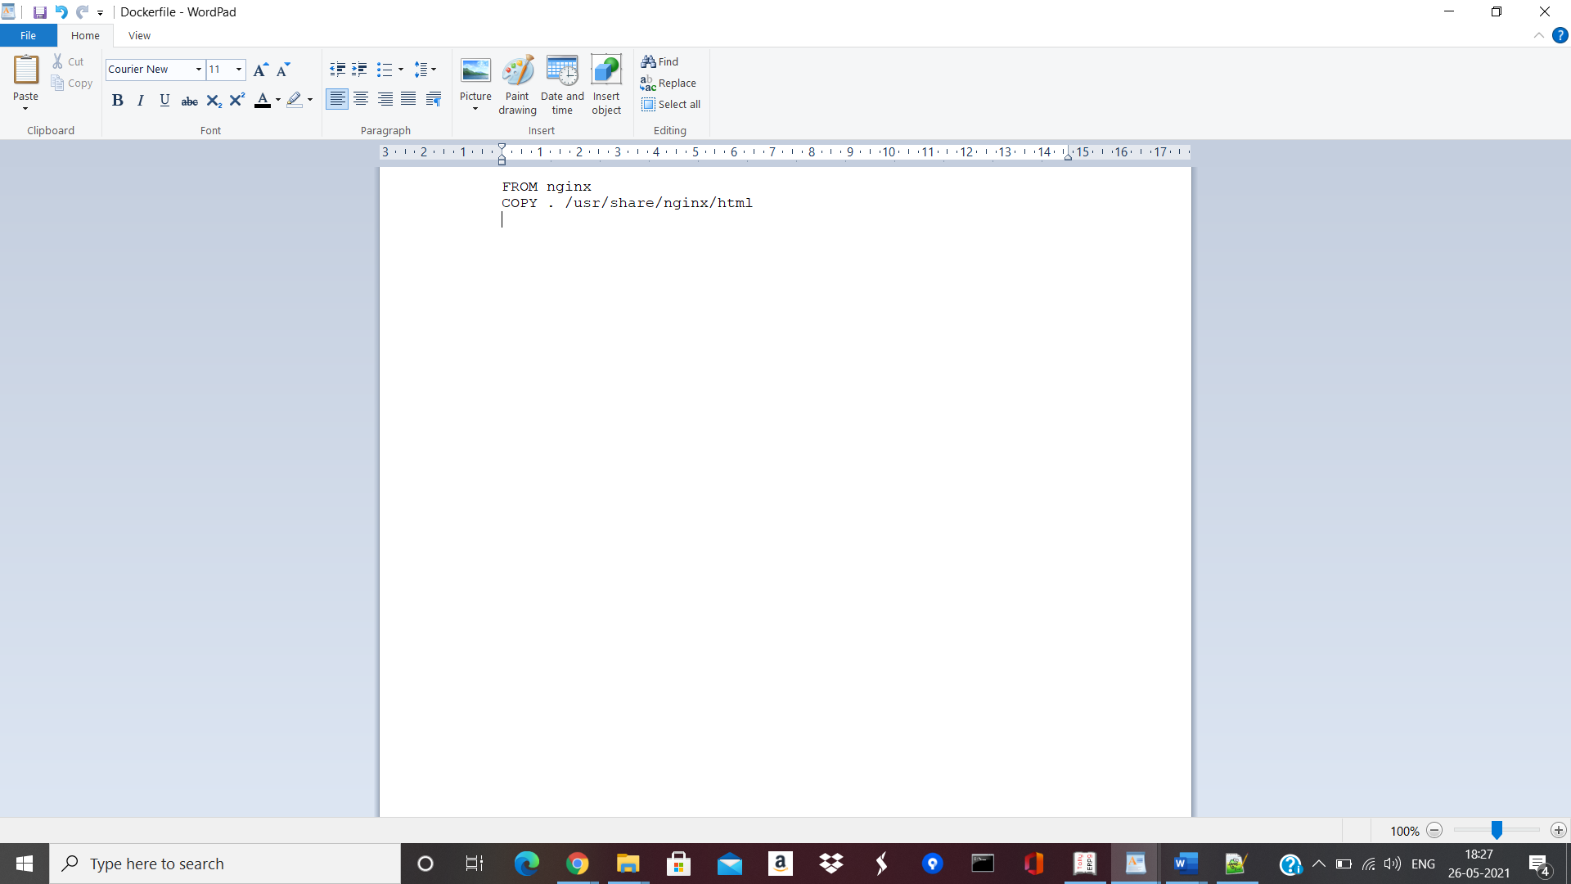

1. Docker image has been built:

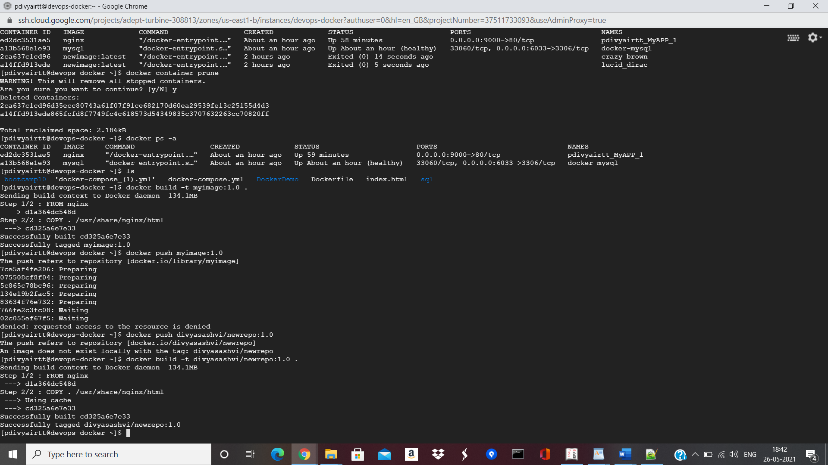

1. Pushed the image into Dockerhub:

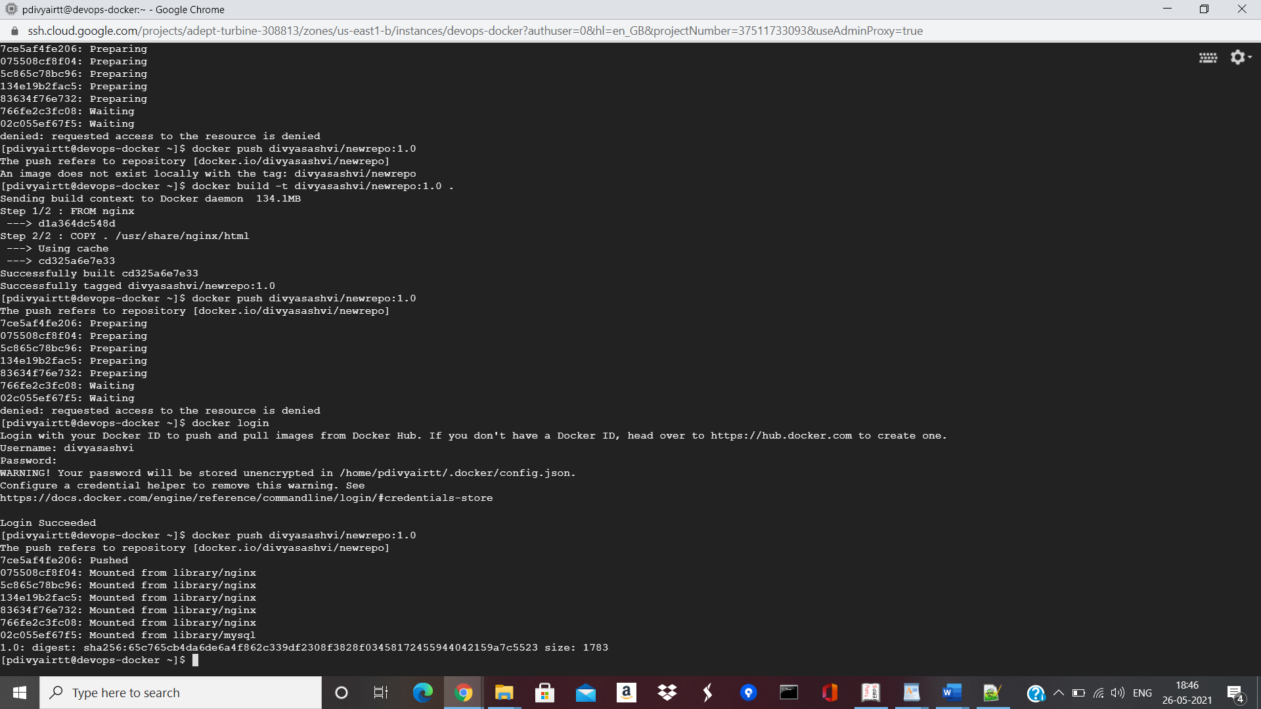

1. Pulled the image and ran the container.

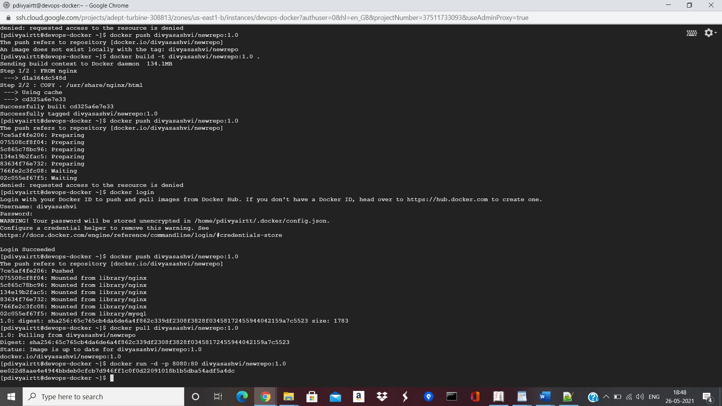

1. Accessed the application via URL.

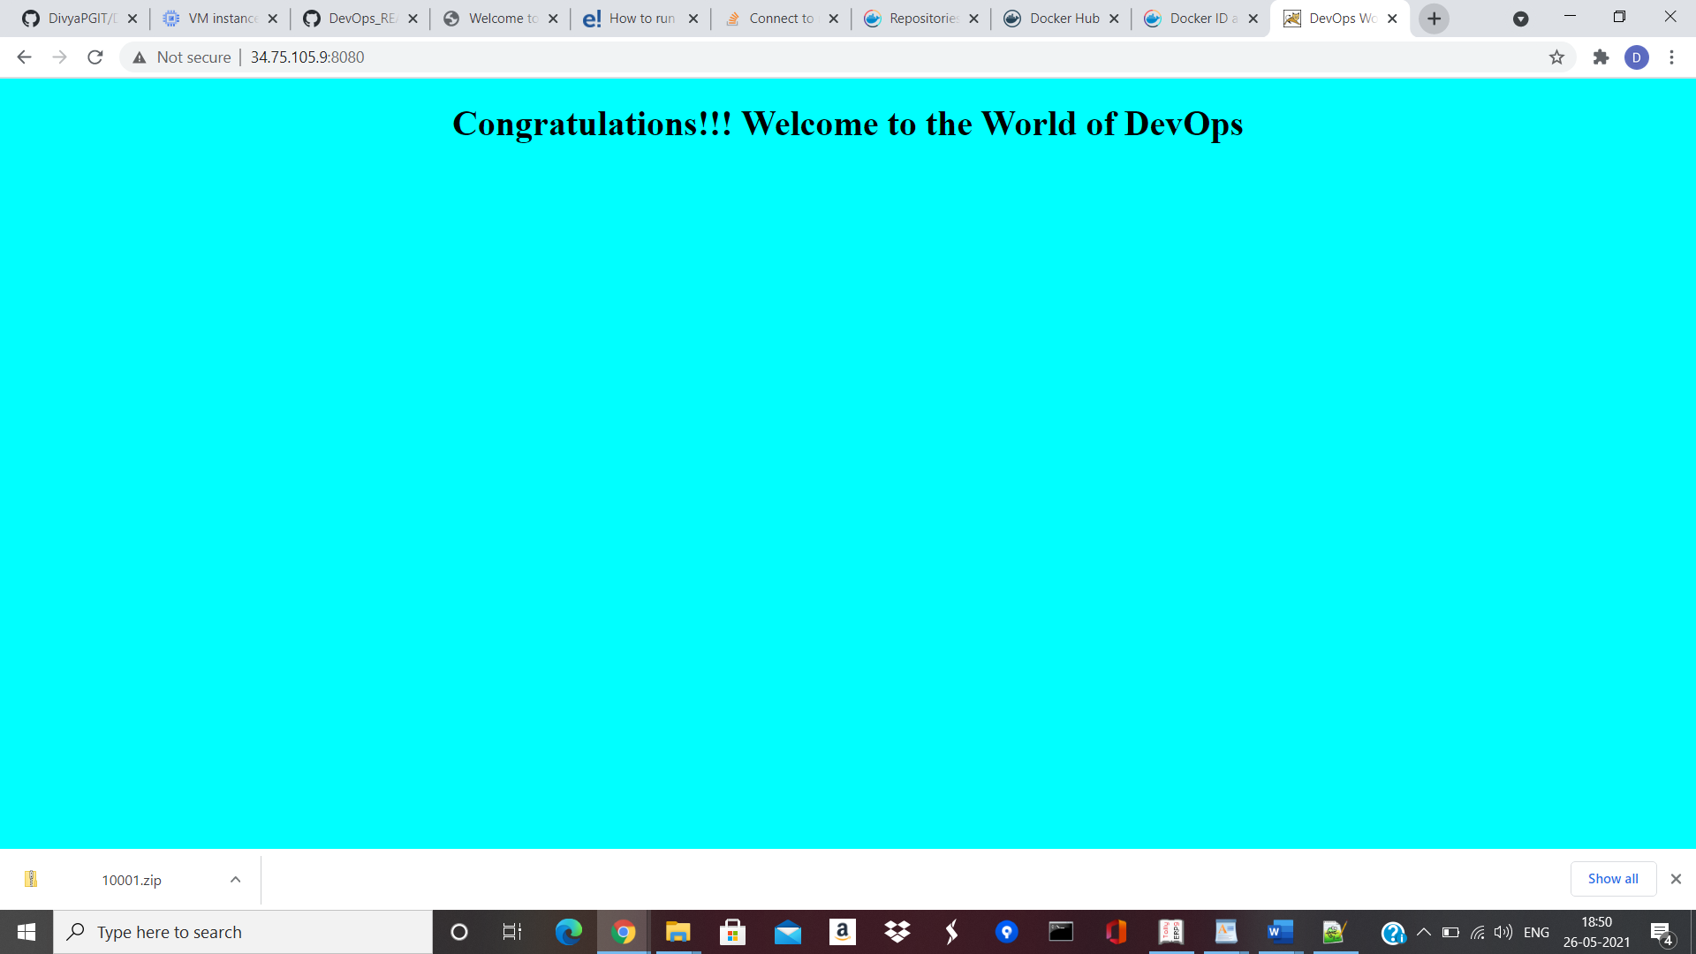

**PART 2**

1. Installed Docker-compose:

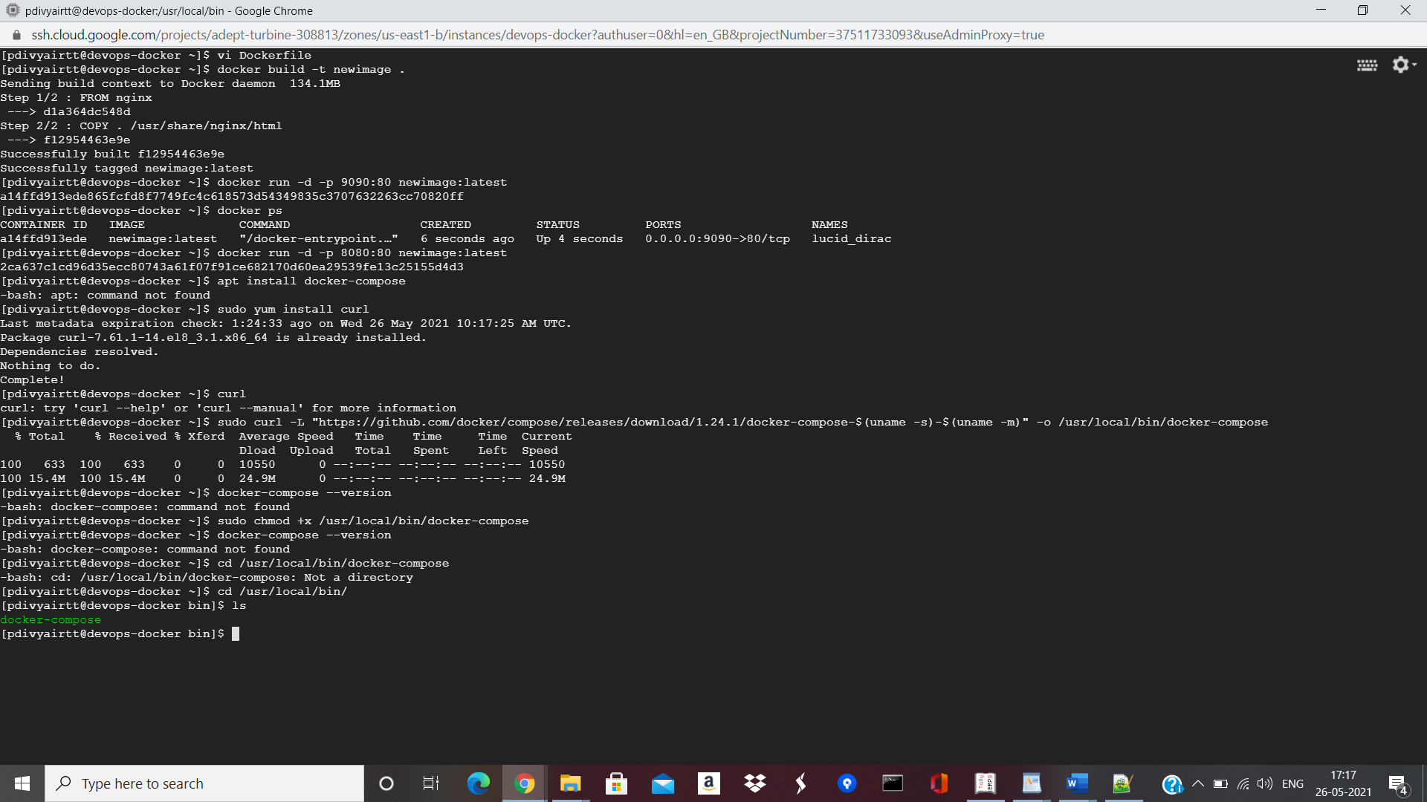

1. Created Docker-compose.yml file as below:

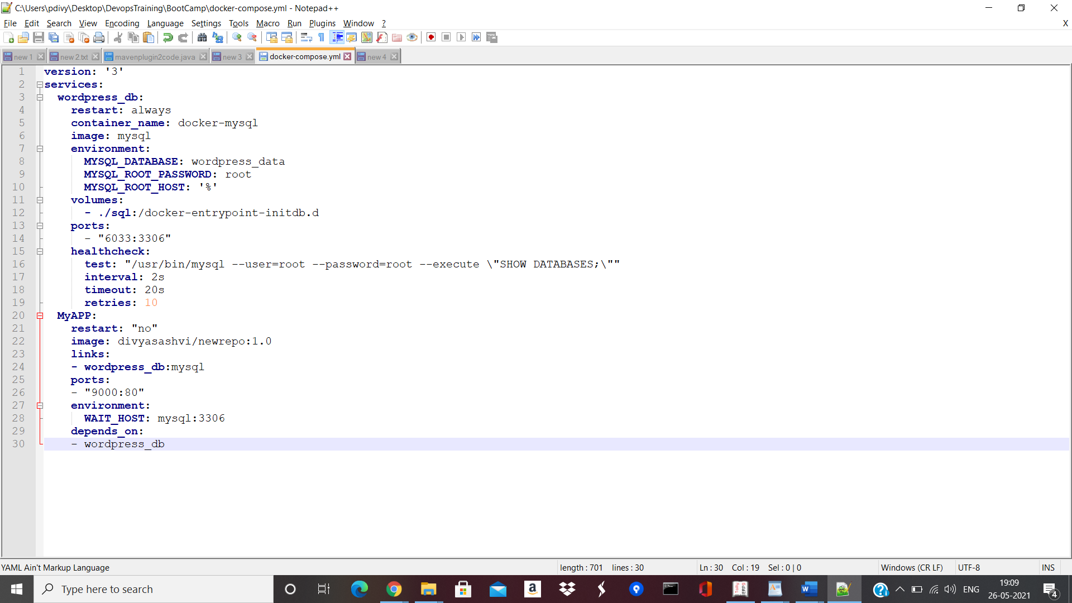

1. Ran docker-compose up

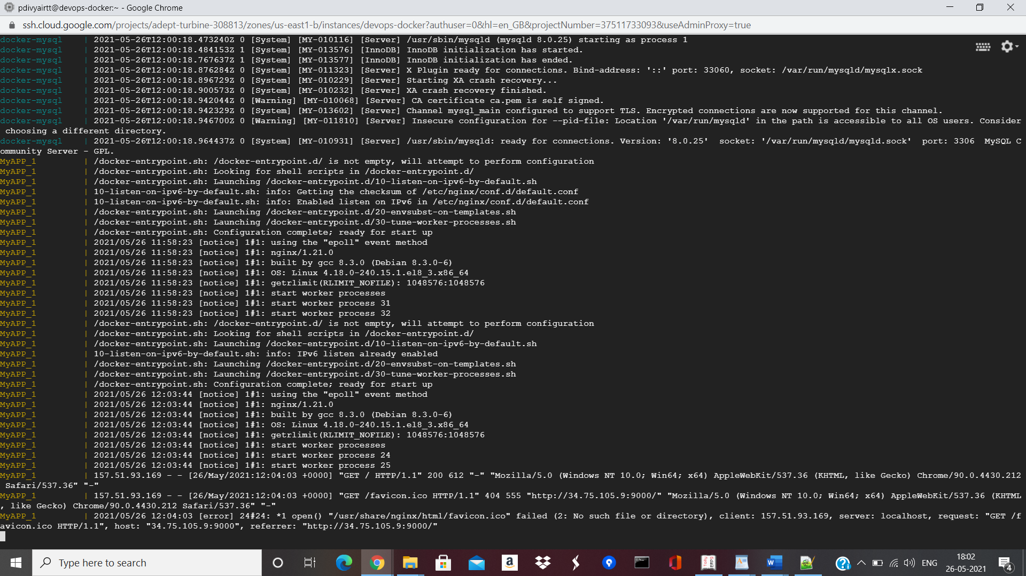

1. Connected the APP:

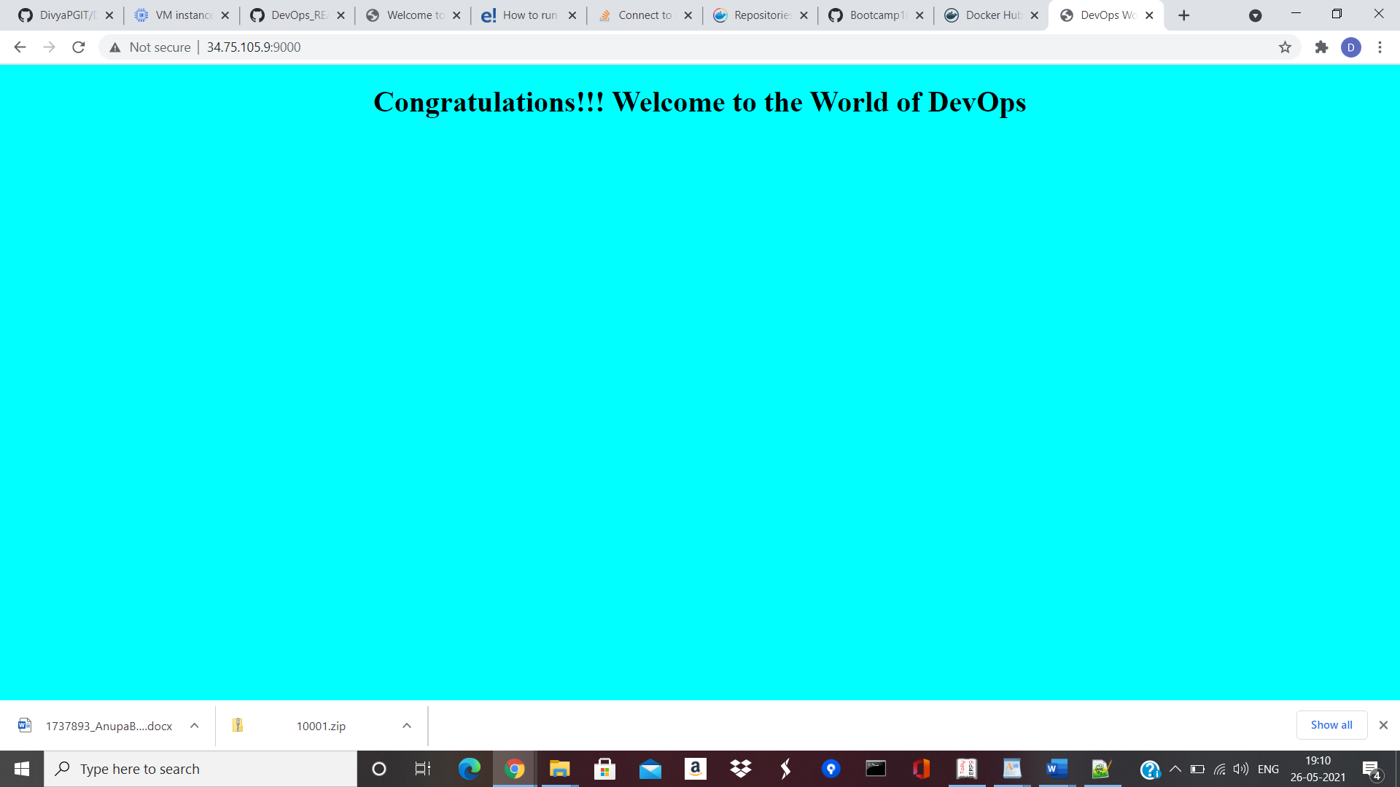

1. Connected MySQL DB using mysql -u root -p and gave pwd as root.

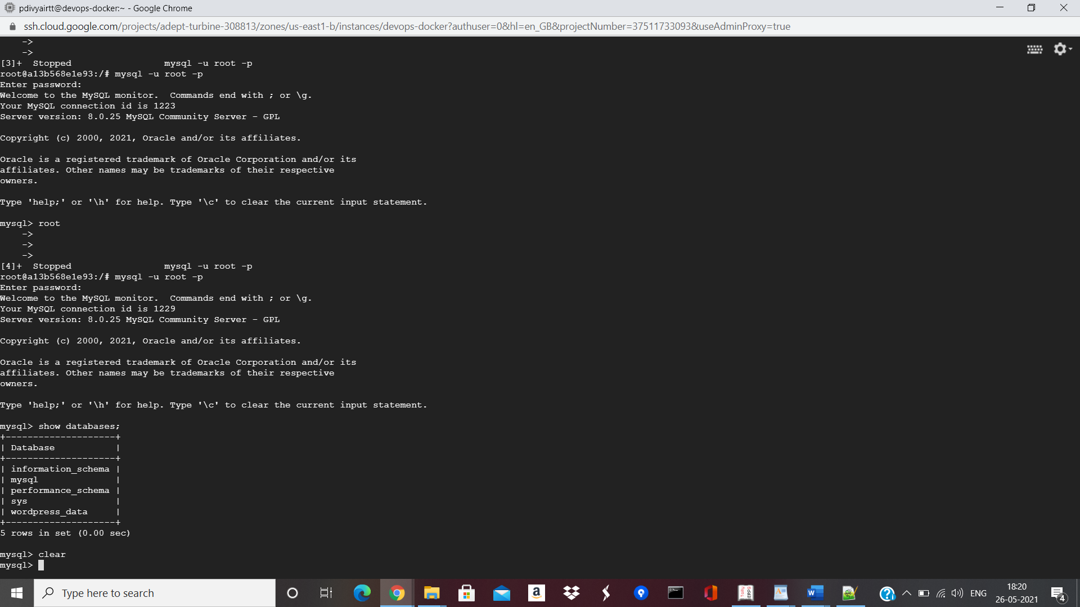

1. Created test table as below:

