Ansible Assignment

1. Created 2 nodes, one is master and another is slave node in AWS.

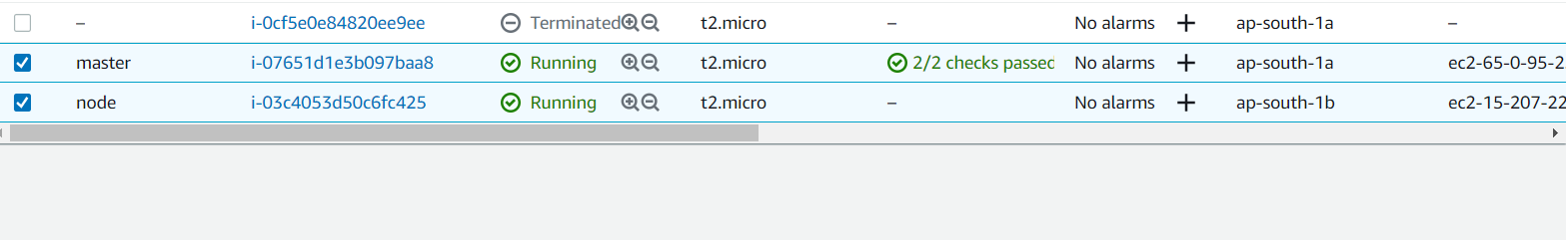

1. Configured Master node to enable password less Authentication.

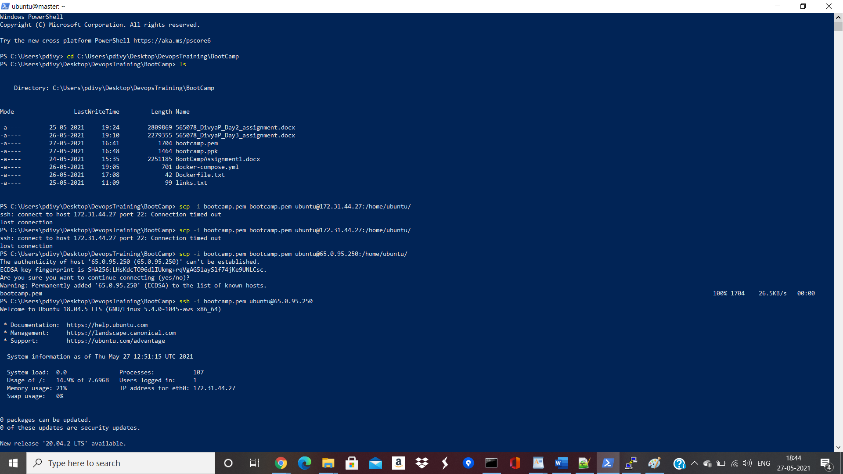

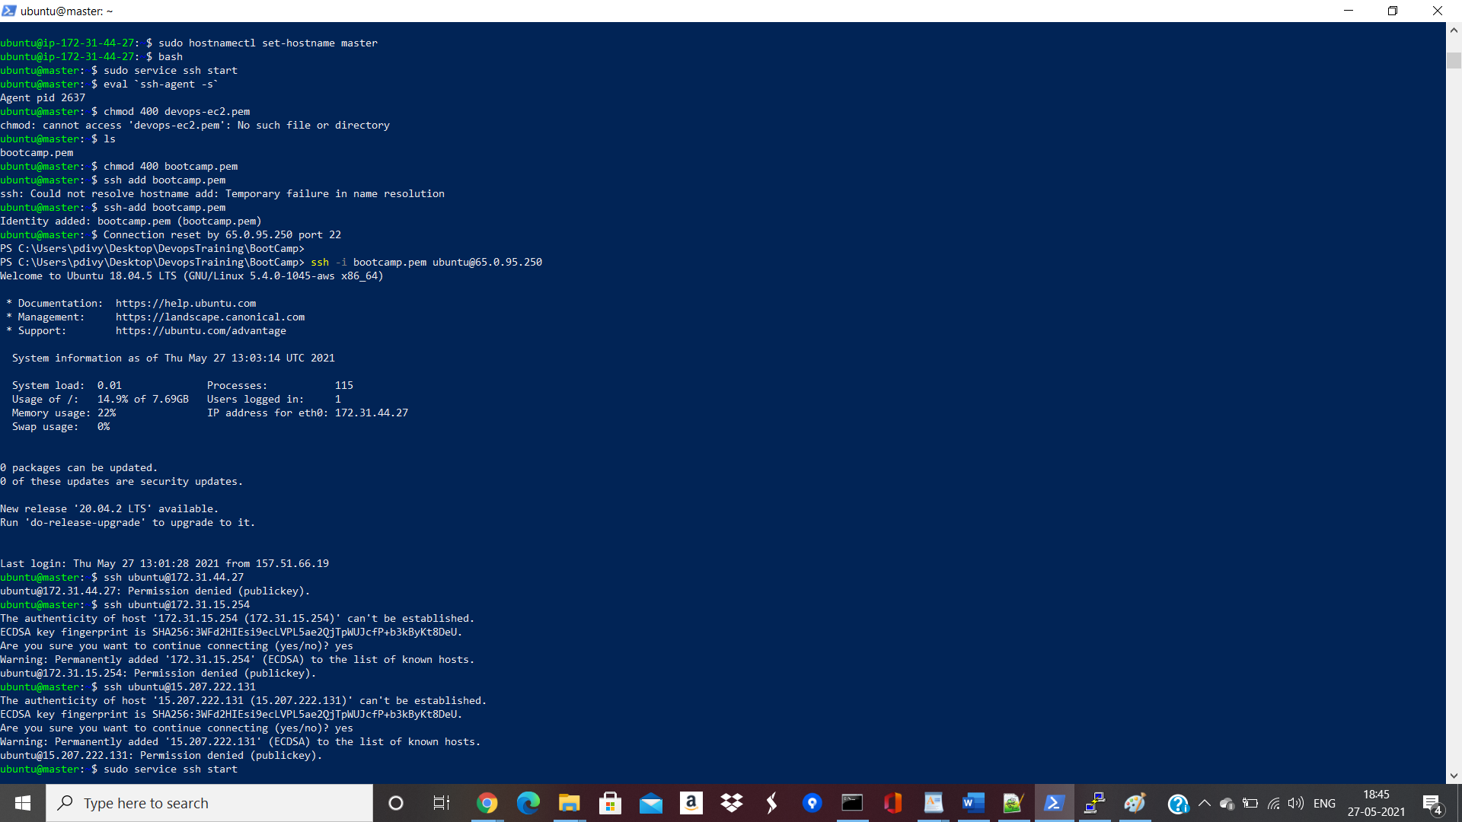

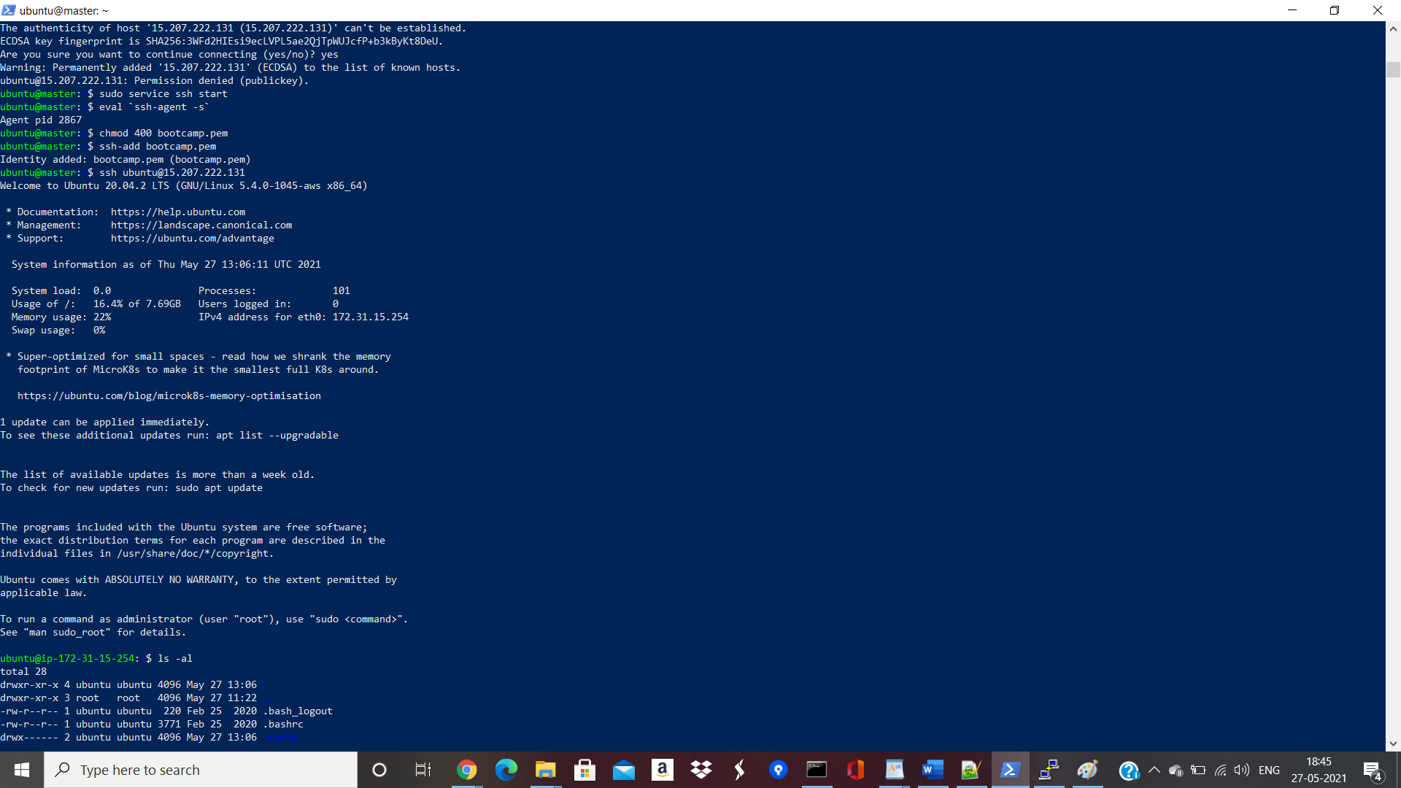

1. Installed Ansible on Master node:

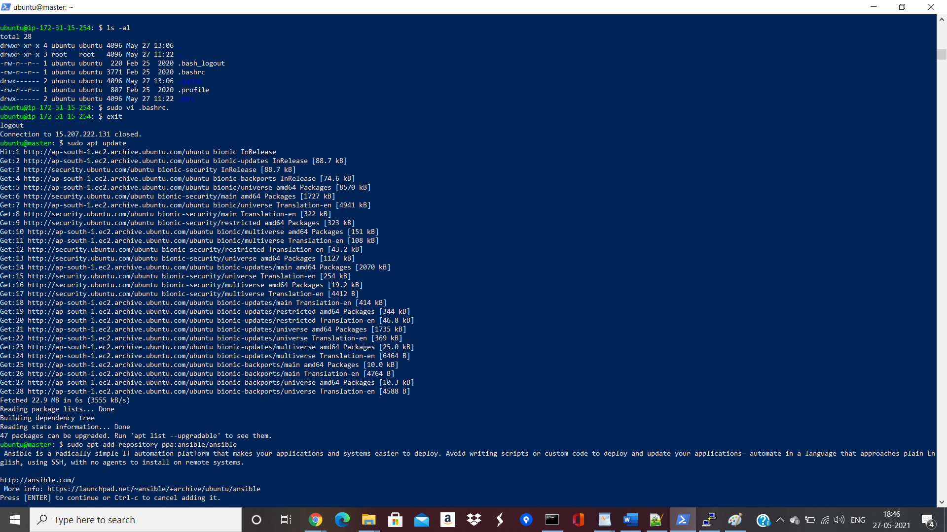

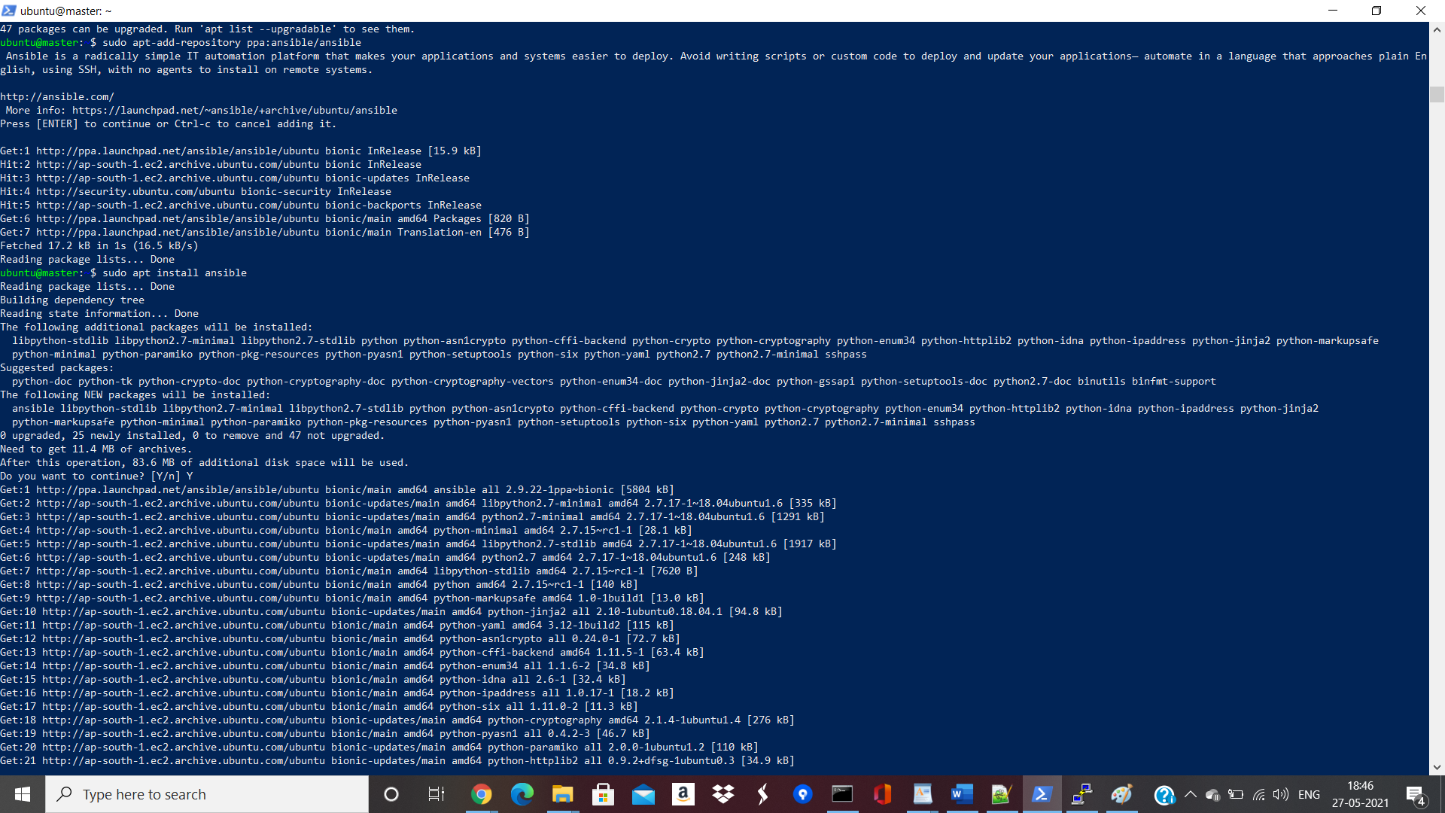

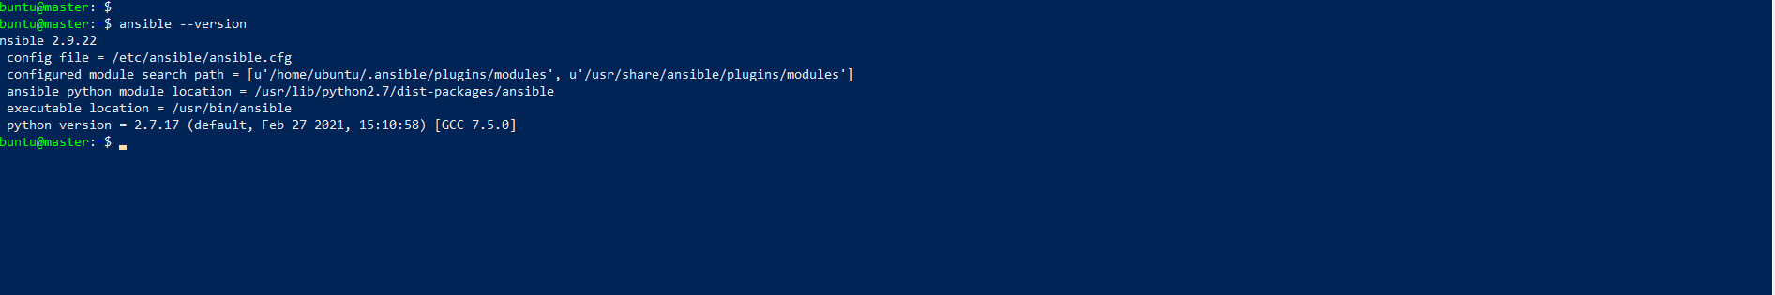

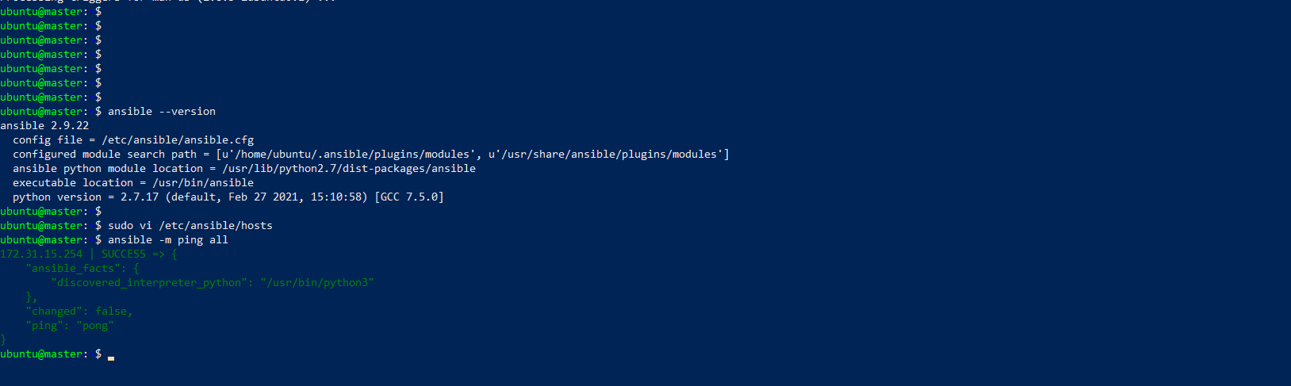

1. Installed Maven,Nginx,Docker via Playbook in Slave Machine:

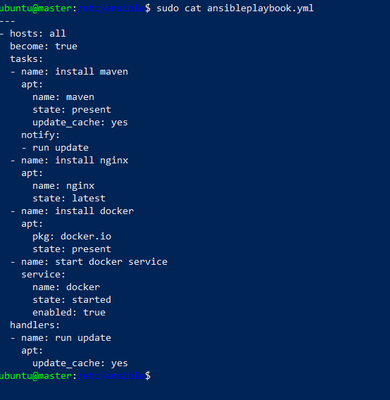

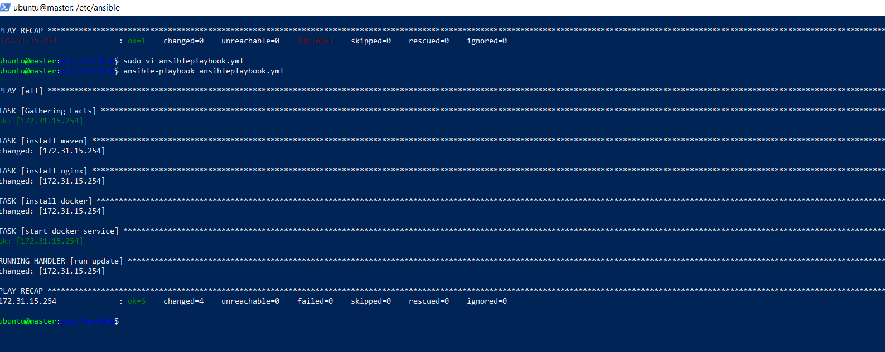

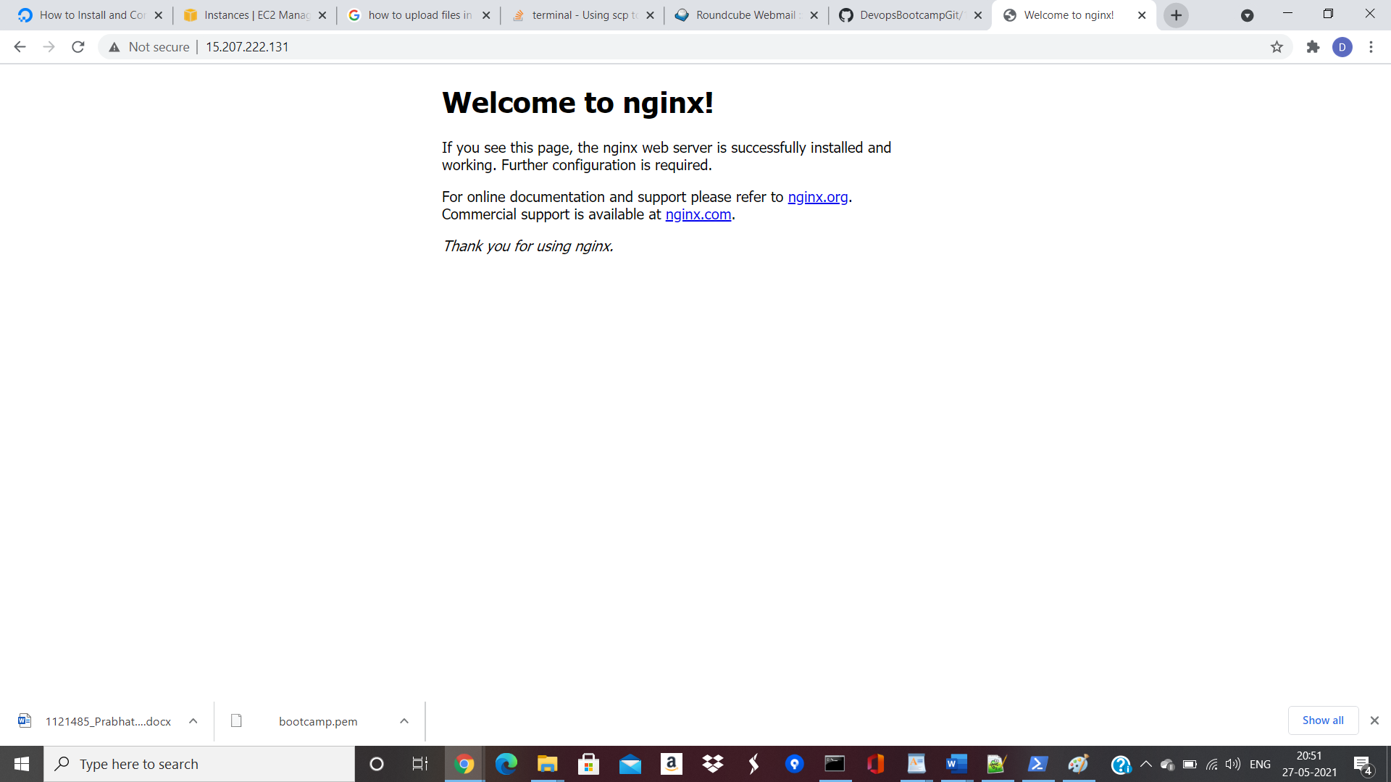

1. Created new image to deploy war-test.war file which is created after cloning this repo-https://github.com/shubhamkushwah123/war-test/tree/master/target and did mvn clean package to create a war file in target folder and then created Dockerfile as below,

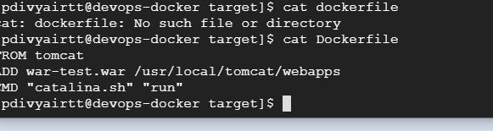

Created and image and pushed in dockerhub.

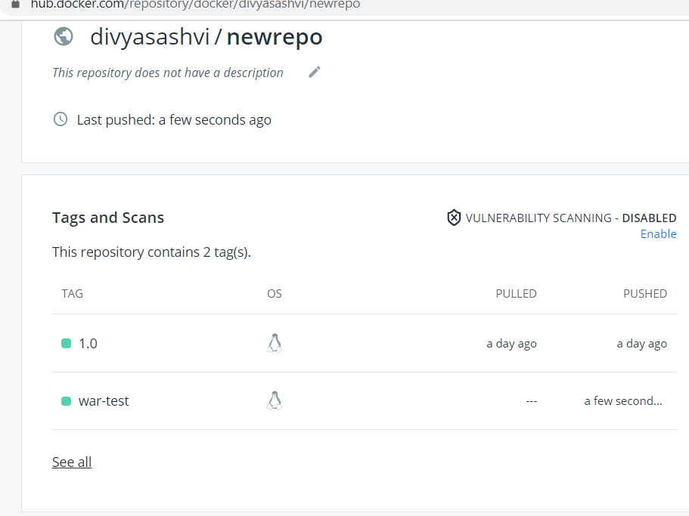

Updated current playbook to run the docker application using the last pushed image (war-test).

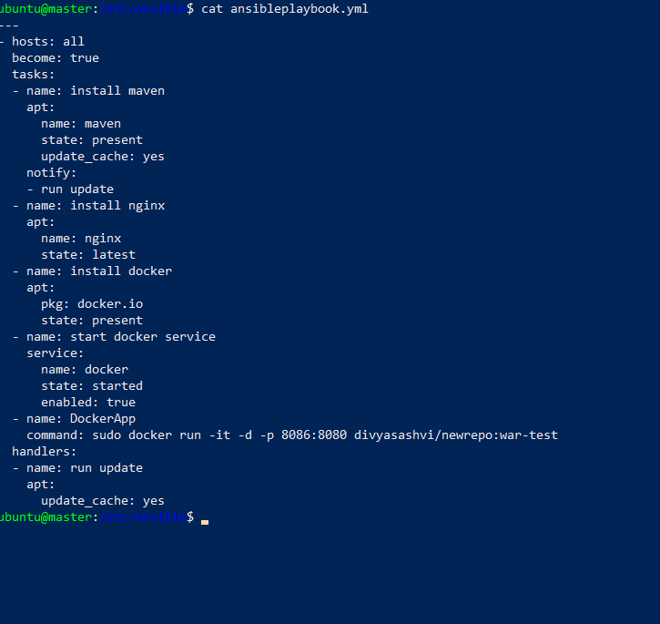

And Ran the playbook.Below are the outputs:

