EduGrade AI Agent: How It Works
A simple guide to the homework workflow, module rubric, Azure AI call, API-key boundary, and teacher control
EduGrade AI helps teachers evaluate assigned homework consistently while keeping the educator in control. It uses trusted learning modules, editable rubrics, responsible AI rules, confidence gating, and final teacher approval.
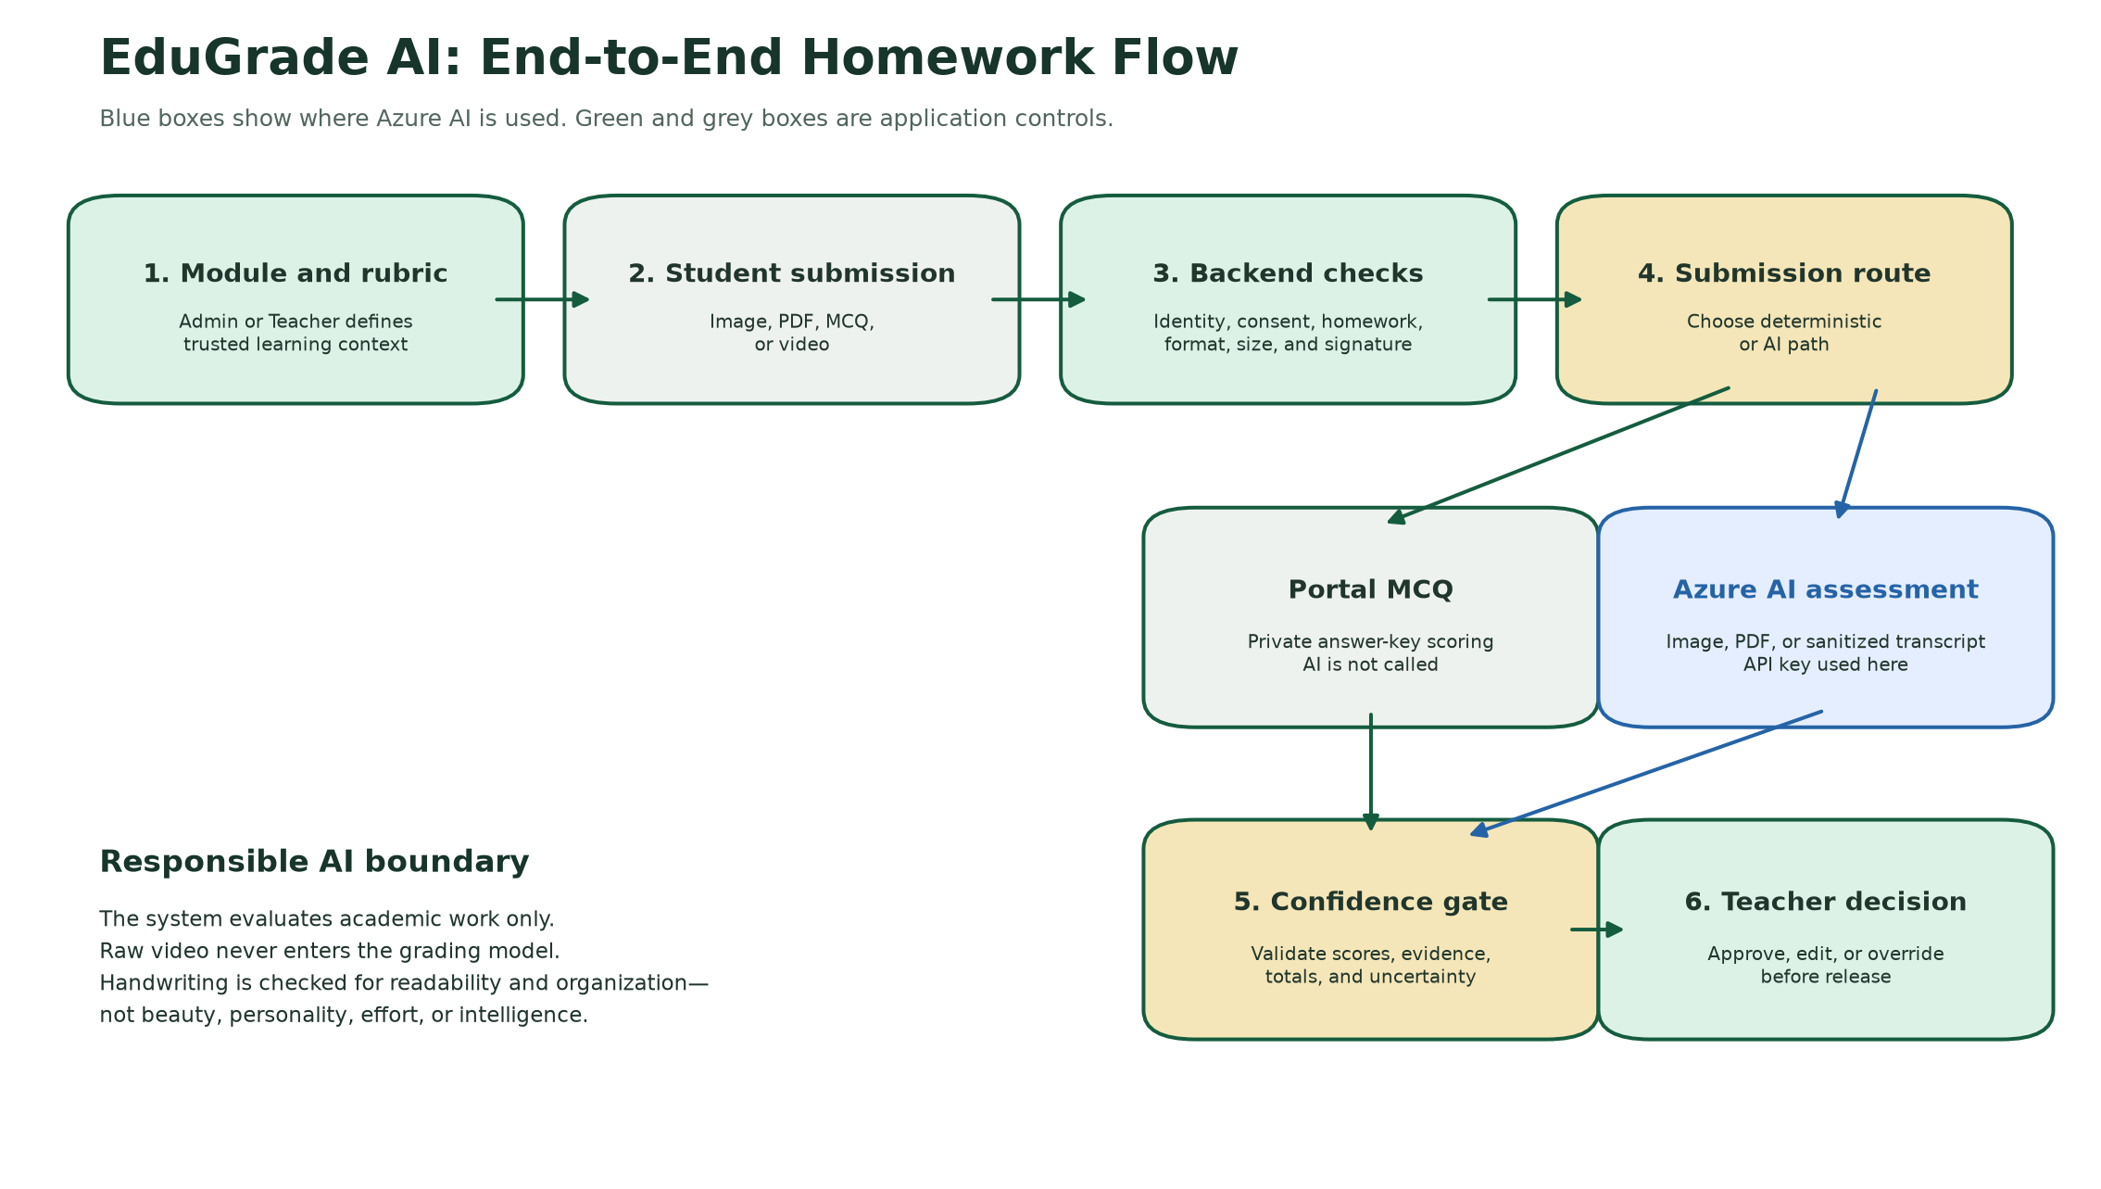

1. What the agent does
- Uses the teacher-approved module as the academic source of truth.
- Uses a class- and subject-specific 100-point rubric.
- Accepts handwritten images, handwritten PDFs, portal MCQs, and externally transcribed video.
- Produces criterion scores, evidence, bilingual feedback, and confidence.
- Routes the result to a Teacher for approval, editing, or override.
Responsible AI rule: The system evaluates academic work only. It does not judge intelligence, personality, appearance, voice, character, motor ability, handwriting beauty, perceived effort, or future potential.

2. End-to-end workflow
Step | Stage | What happens
1 | Module setup | Admin uploads or selects a module. EduGrade creates an age- and subject-aware starting rubric.
2 | Rubric review | Admin or Teacher edits the evaluation parameters and point weights. The total must equal 100.
3 | Student submission | The student submits an allowed homework format. There is no typed-answer option.
4 | Backend controls | The server verifies registration, consent, homework, file type, size, signature, and submission policy.
5 | Assessment route | MCQs use the private answer key. Images, PDFs, and sanitized transcripts use Azure AI.
6 | Validation and confidence | The backend checks scores, evidence, totals, and uncertainty.
7 | Teacher decision | The Teacher approves, edits, or overrides before feedback is released.

3. Where AI and the API key are used
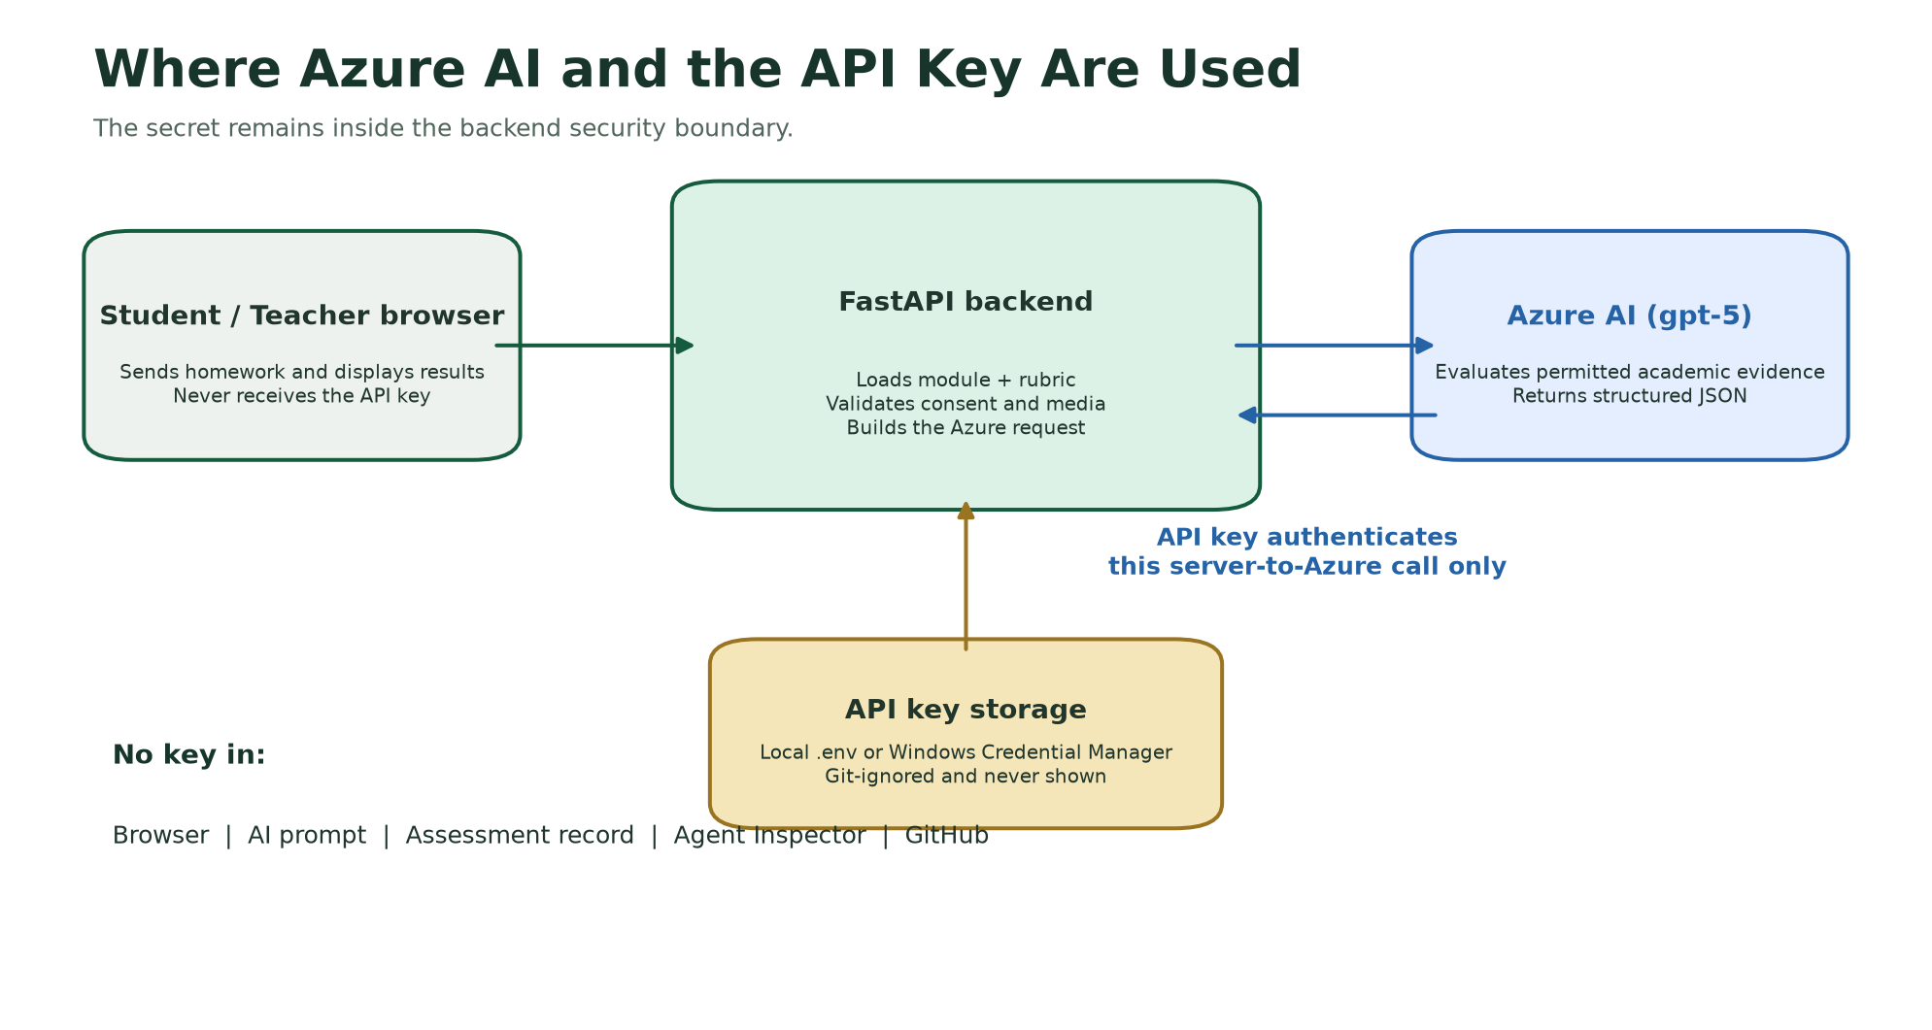
Azure AI is called only by the FastAPI backend. The backend loads the trusted module, homework instructions, saved rubric, and permitted academic submission, then sends them to the Azure OpenAI-compatible Responses API.
The API key is used only to authenticate the backend-to-Azure request. It is loaded from the local .env file or Windows Credential Manager. It is never sent to the browser, included in the AI prompt, stored in an assessment, shown in the Agent Inspector, or committed to GitHub.
Activity | AI used? | Method
Email OTP and parent consent | No | Server verification and stored consent
Homework and module lookup | No | Trusted application catalog
File and media validation | No | Backend rules
Portal MCQ scoring | No | Private answer-key comparison
Raw video | No grading AI | Separate external media boundary
Handwritten image or PDF | Yes | Azure AI evaluates academic evidence
Sanitized video transcript | Yes | Azure AI evaluates transcript text only
Final approval | No | Teacher decision

4. How the module rubric was designed
Every module receives its own rubric because expectations should change by class, subject, and learning objective. The initial weights are EduGrade defaults and are not presented as official CBSE-mandated percentages.
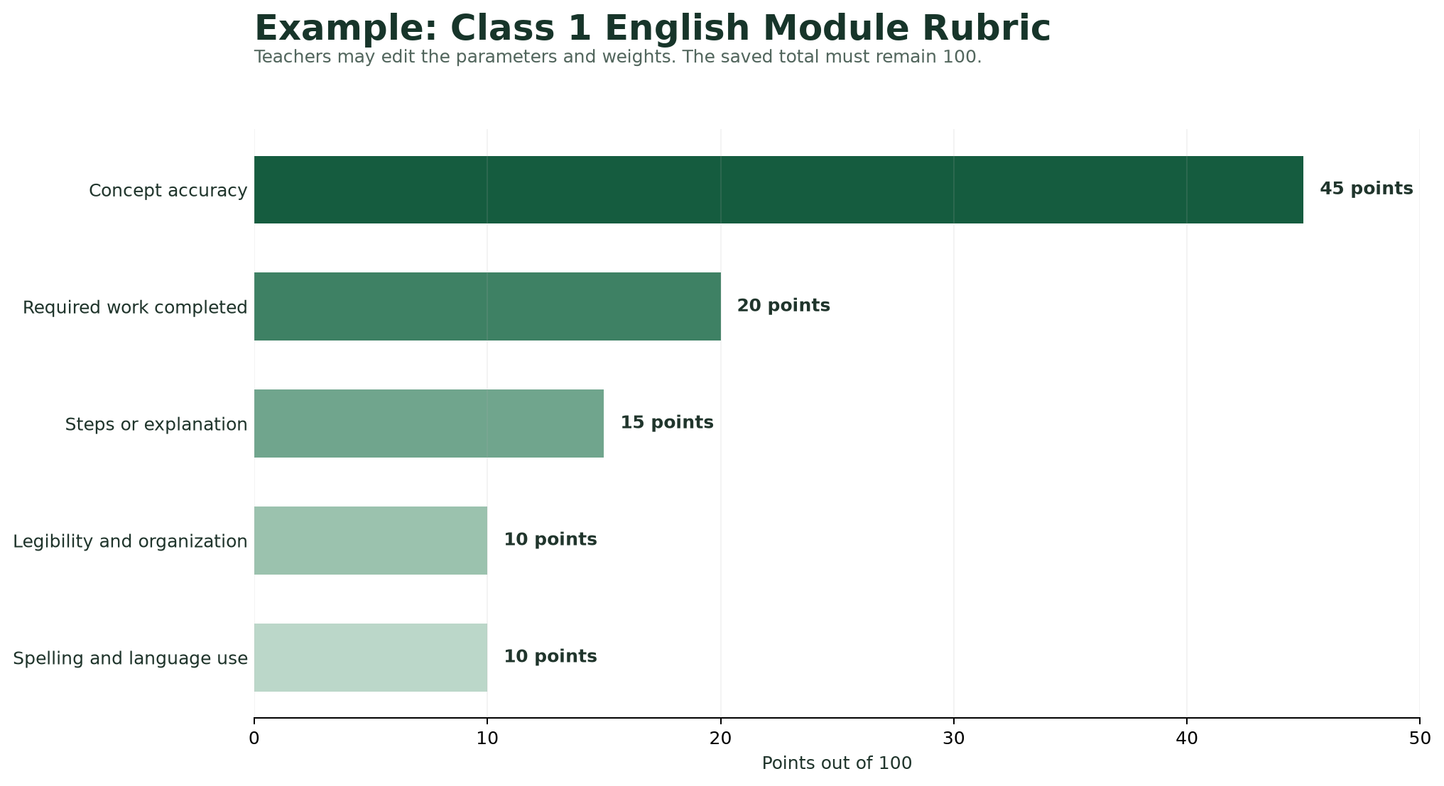
Parameter | Points | What it checks
Concept accuracy | 45 | Does the work reflect what was taught?
Required work completed | 20 | Was every requested activity visibly attempted?
Steps or explanation | 15 | Are simple, age-appropriate examples or steps shown?
Legibility and organization | 10 | Is the work readable, spaced, and organized?
Spelling and language use | 10 | Is the language appropriate for Class 1?

Pre-Primary focuses more on concept recognition, activity completion, readable letter or number formation, and early-learning variation. Classes 3-4 add reasoning and method. Classes 5-6 add deeper reasoning, application, structure, and precise subject terminology.

5. How AI scores homework
- The AI receives the module, homework instructions, saved rubric, and permitted student work.
- It evaluates every rubric parameter separately.
- For each parameter it returns a score, maximum points, rationale, and observed evidence.
- The backend verifies that every criterion matches the rubric and that totals are mathematically correct.
- Confidence is reduced for unclear images, missing pages, weak evidence, or ambiguous answers.
- Low-confidence work is automatically routed to mandatory Teacher review.
For handwriting, AI may consider readability, spacing, alignment, and organization only. It must not reward or penalize handwriting beauty, decoration, personality, effort, intelligence, or motor development.

6. Human control and safe release
The Teacher remains the final decision-maker. The Teacher can accept or discard AI feedback, edit English and Hindi feedback, change the score within the maximum, approve the result, or override the AI assessment. The Agent Inspector and audit trail record the responsible AI controls used during the workflow.

Hackathon summary
EduGrade AI is an educator-assistance system, not an autonomous grading authority. AI is used only for permitted academic evidence. Deterministic checks, protected key handling, responsible AI boundaries, confidence gating, and Teacher approval surround the model call.

