**Introduction:**

**Customer Analysis Dashboard.**  
The customer analysis dashboard is created to give overview of revenue on the basis of multiple key factors like Age of customer, gender of customer, region, state, year/month of sales and the quantity discount corelation.

**Methodology**  
1) The data for customer analysis dashboard was taken from kaggle.

2) Basic data cleaning and transformation such as checking for null values in key columns like customer name, order ID, order date, Item ID etc was done. The datatypes for all the columns were checked to keep the data uniform across each column.

3) The data was loaded into tableau dashboard and further data manipulations were done from tableau to help create desired visualizations.

**Requirement analysis**

1) The columns in the dataset were analysed which helped in finding data relations for better understanding the data.  
2) There were few non generic column headers for which the meanings/descriptions were sought from internet.

**Visualizations:**

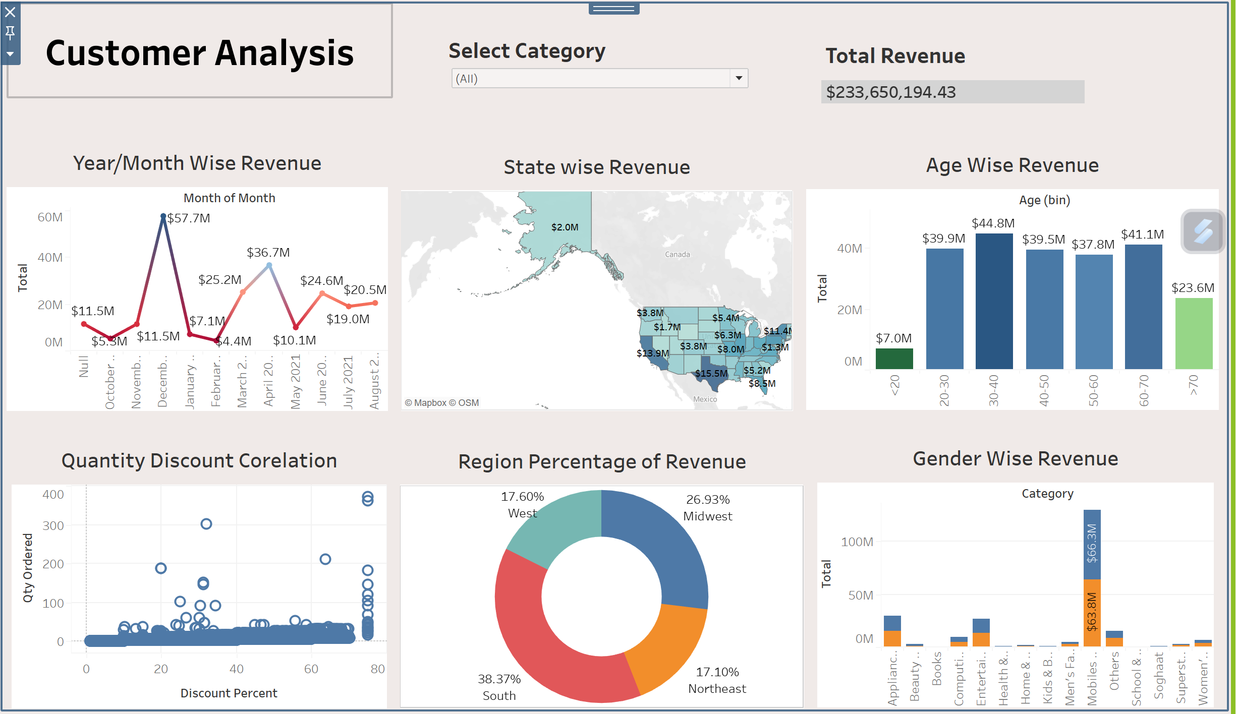

This dashboard was created with multiple visualizations as given below.

1. The Line chart: To display the year/month wise revenue.
2. The Map chart: To display the state wise revenue.
3. The bar chart: To display age wise revenue.
4. Scatter plot: To show the corelation between quantity ordered and discount given.
5. The donut chart: To display region wise revenue percentage.
6. The stacked bar chart: To display gender wise revenue.
7. A KPI shows the total revenue generated.
8. Filter: The charts can be filtered on the basis of product categories

**Insights**

The key insights which we can infer from this dashboard are:

1. The total revenue generated in the financial year is $ 233,650,194.43
2. The Month of December, 2020 recorded the highest sales amount and February 2021 recorded the lowest.
3. Texas and California were the highest revenue generating states.
4. The highest purchases were done by the customers in the age group of 30-40 followed by the age group of 60-70 and the lowest purchases were from the age group 10-20.
5. The maximum sales were done in the south region and least in the west region.
6. The maximum sales was in mobiles and tablets category In which $66.3M revenue was generated from female customers and $ 63.8M revenue was generated from male customers.

**Conclusion**  
Looking at the dashboard we can conclude that the sales in the months of Oct 2020, Jan 2021 and Feb 2021 were the lowest sales months recorded. The company can work on strategizing discounts to target sales boost in these months.  
The company has lowest sales of product categories like books, health and sports, home and living, kids and baby, school and education, soghaat.  
The sales pattern for the customers in the age 20-70 is almost similar.  
WY, NV, ID are the states with lowest revenue. Company can increase marketing to boost sales to bring the numbers at par with other states. The region wise parity might be fixed if the low performing states’ revenue improves.