**Introduction:**

**Emergency Room Dashboard.**  
  
The emergency room dashboard is created to give overview on the key factors like no. of patients visiting the hospital and the same is further analyzed based on other key patient details such as age , race, gender etc and the satisfaction of the patients based on wait time and other services provided by the hospital.

**Methodology**  
1) The dataset for emergency room dashboard was taken from below link <https://data.world/markbradbourne/rwfd-real-world-fake-data>

2) Basic data cleaning and transformation such as checking for null values in key columns like patient name, date of visit, time taken to attend the patient etc was done. The datatypes for all the columns were checked to keep the data uniform across each column.

3) The data was loaded into tableau dashboard and further data manipulations were done from tableau to help create desired visualizations.

**Requirement analysis**

1) The columns in the dataset were analysed which helped in finding data relations for better understanding the data.  
2) There were few non generic column headers for which the meanings/descriptions were sought from internet.

**Visualizations:**

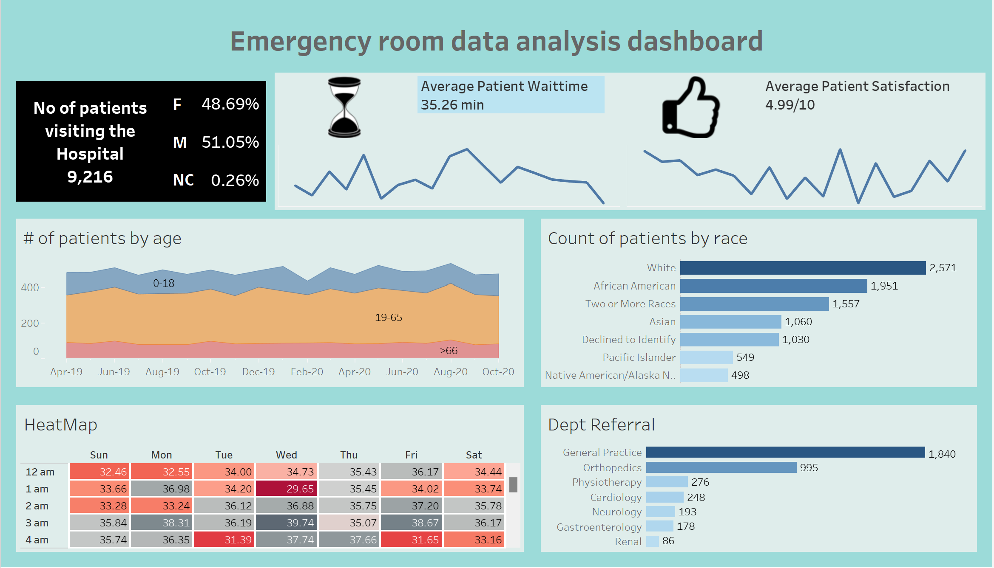

This dashboard was created with multiple visualizations as given below.

1. The Line chart: To display the average patient wait time and average patient satisfaction.
2. The bar chart: To display the Count of patients by race and department referral
3. The stacked area chart: To display age wise average count of customers in each month.
4. The heat Map: To display the day wise average patient wait time for each hour.

**Insights**

The key insights which we can infer from this dashboard are:

1. There was almost similar number of male and female patients visiting the hospital where the count of male patients is slightly higher.
2. The average Wait time for the patients is 35.26 minutes.
3. The overall patient satisfaction comes up to 5 out of 10 which is bit on the lower side. The hospital has a scope of improvement in providing the services and reducing the wait time of the patients.
4. The No. of patients in age group 19-65 is the highest.
5. Maximum no. of patients visiting the hospital were from White and African American backgrounds.
6. Most of the patients are referred to take treatments under general practice and orthopedics departments.
7. The heat map shows each days’ highest wait time in dark grey shade and lowest wait time in dark red shade. The other wait times in the map are shown in the colour gradient scheme between lowest to highest.

**Conclusion  
_**   
The major issue which was observed is that the patient satisfaction score is very low and the average wait time is in the higher end. The reason for the low satisfaction score might be a combination of mediocre hospital services and the long wait time the patient needs to endure before being attended by the doctor.