**NAME: Divya Jaywant Pondkule**

**1. What is the difference between truncate, delete, drop?**

**Solution:**

**Truncate:**

1.DDL Command

2.It deletes all the rows as well as the structure of the table

3.It is faster than delete command

4.It cannot be rolled back

**Delete**

1.DML Command

2.It deletes a particular row using where condition or even the entire table

3.It is slower than truncate command

4.It can be rolled back

**Drop:**

1.It is a DDL command.

2.It drops the entire table i-e all the rows as well as the structure of the table gets deleted

3.It also cannot be rolled back as it auto commits

**2. What are alias in MySQL?**

**Solution:**

-They are temporary names given to a column or table in sql to make them more readable

-They only exist for the duration of that query.

-They created with the AS keyword.

**3. How do you display even rows of the any table?**

**Solution:**

**1.Using mod(id,2)=0**

select * from employees where mod(empid,2)=0;

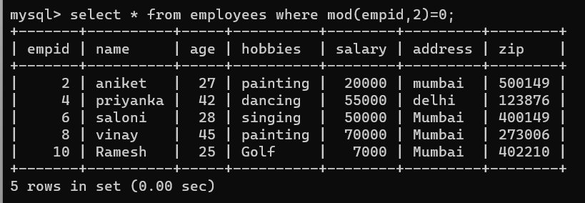

**2.Using row_number() function:**

select * from (select *,row_number() over(order by empid) row_no from employees) abc where row_no %2=0;

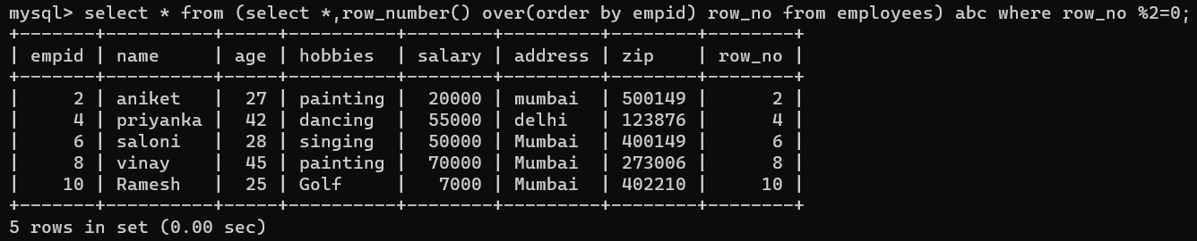

**4. How can you remove duplicates from a table(distinct and other way)**

**Solution:**

**1. Using distinct:**

select distinct name,hobbies from employees;

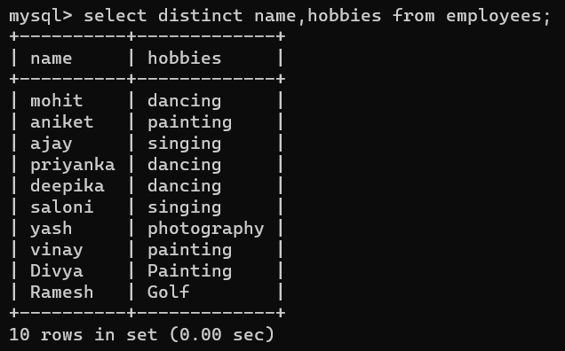

**2. Using group by:**

select name,hobbies from employees group by name,hobbies;

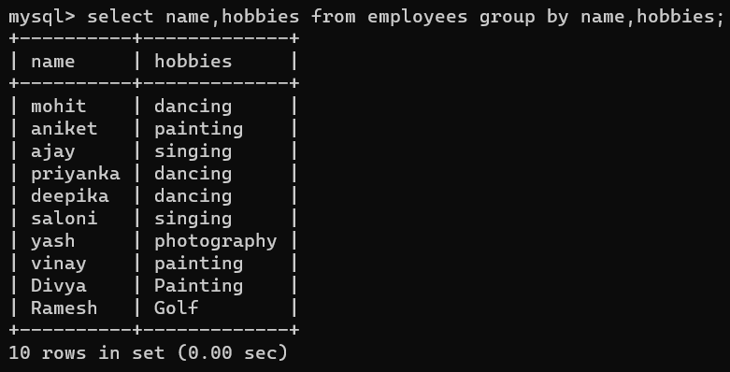

**5. How you can find 5th max salary?(Do it by all 3 ways)**

**Solution:**

**1. Using limit and offset:**

select * from employees order by salary desc limit 1 offset 4;

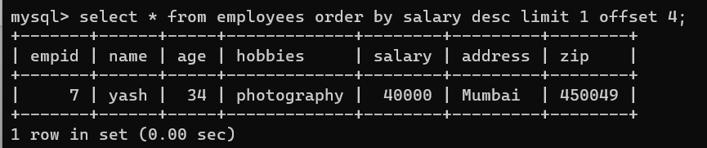

**2. Using rank() function**

select * from (select *, rank() over(order by salary desc) rank_sal from employees) abc where rank_sal=5;

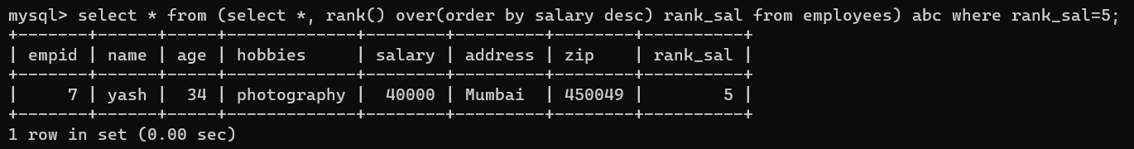

**3. Using dense_rank() function**

select * from (select *, dense_rank() over(order by salary desc) rank_sal from employees) abc where rank_sal=5;

