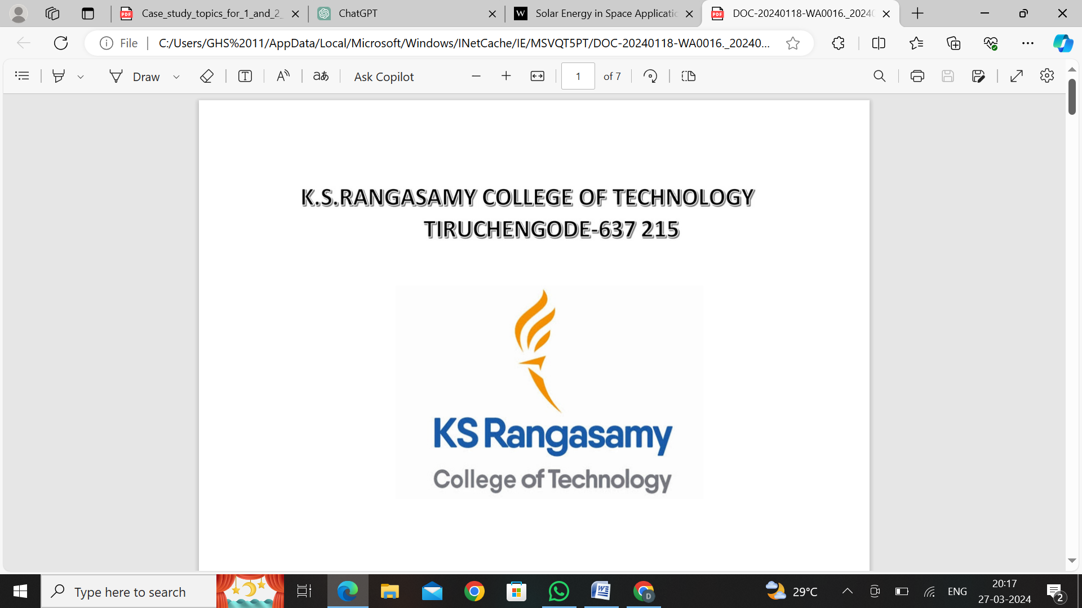

NAME :

REGISTER NO. : 23037377148210

DEPARTMENT : BE. CSE(AIML)

YEAR/SEM : I-YEAR/II-SEM

SUBJECT : ENGINEERING PHYSICS

SUBJECT CODE : 60CP0P2

SIGNATURE :

**Case Study: Electrical and Optical Properties of Semiconductors in Photovoltaic Cells**

**Introduction:** Photovoltaic (PV) cells, also known as solar cells, are semiconductor devices that convert sunlight into electricity. Understanding the electrical and optical properties of semiconductors is crucial for optimizing the performance of PV cells. This case study explores the electrical and optical properties of semiconductors in the context of PV cell design and performance.

**Scenario:** SolarTech, a leading solar energy company, is developing next-generation PV cells for increased efficiency and cost-effectiveness. The research and development team at SolarTech is focusing on optimizing the electrical and optical properties of semiconductor materials to enhance the performance of their PV cells.

**Electrical Properties:**

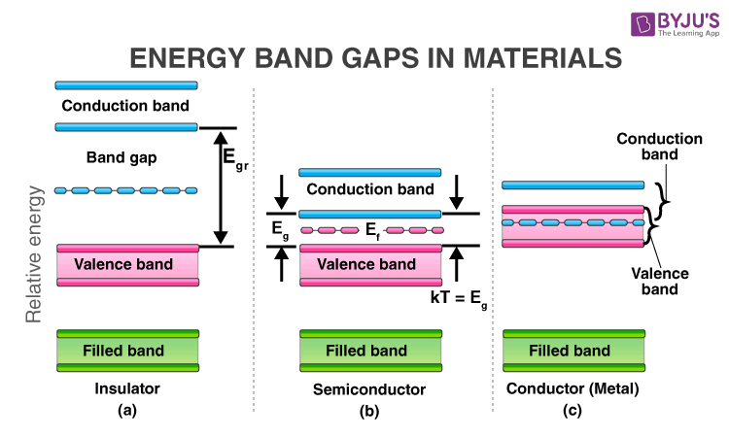

1. **Band Gap Engineering**: SolarTech engineers are experimenting with different semiconductor materials and band gap configurations to maximize the absorption of sunlight across the solar spectrum. By carefully selecting the band gap of the semiconductor material, they aim to achieve a balance between photon absorption and carrier collection efficiency.
2. **Carrier Mobility and Lifetime**: The mobility and lifetime of charge carriers (electrons and holes) within the semiconductor material significantly impact the PV cell's electrical conductivity and efficiency. SolarTech researchers are studying doping techniques and material processing methods to enhance carrier mobility and increase carrier lifetime, reducing recombination losses.
3. **Contact Resistance**: Optimizing the electrical contacts between the semiconductor material and the metal electrodes is essential for minimizing contact resistance and maximizing charge carrier extraction efficiency. SolarTech is investigating novel contact materials and interface engineering techniques to improve electrical conductivity and reduce losses at the contacts.

**Optical Properties:**

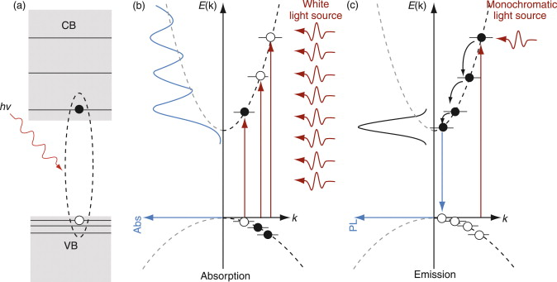

1. **Absorption Coefficient**: The absorption coefficient of the semiconductor material determines its ability to absorb photons from sunlight. SolarTech researchers are studying the optical properties of various semiconductor materials to identify materials with high absorption coefficients across the solar spectrum, particularly in the visible and near-infrared regions.
2. **Anti-Reflection Coating**: To minimize optical losses due to reflection at the surface of the PV cell, SolarTech is developing anti-reflection coatings that reduce surface reflectance and increase light absorption. These coatings are designed to match the refractive index of the semiconductor material, effectively minimizing reflection losses over a broad range of wavelengths.
3. **Light Trapping Structures**: SolarTech is exploring the use of light trapping structures, such as textured surfaces and photonic crystal structures, to enhance light absorption within the semiconductor material. These structures are designed to increase the optical path length of photons within the PV cell, improving absorption and ultimately increasing the conversion efficiency.

**Conclusion:** By optimizing the electrical and optical properties of semiconductor materials in PV cells, SolarTech aims to develop highly efficient and cost-effective solar energy solutions. Through continuous research and development efforts focused on band gap engineering, carrier mobility, contact resistance, absorption coefficient, anti-reflection coatings, and light trapping structures, SolarTech aims to push the boundaries of PV cell performance and contribute to the widespread adoption of solar energy as a clean and renewable energy source.