1. Difference Between Frontend, Backend, and Full-Stack Development
- Frontend Development: Focuses on the visual and interactive parts of a website that users see and interact with.
Example: Designing a login form using HTML, CSS, and JavaScript.
- Backend Development: Handles the server-side logic, database interactions, and authentication.
Example: Validating login credentials and fetching user data from a database using Node.js and MongoDB.
- Full-Stack Development: Combines both frontend and backend skills.
Example: Building an entire e-commerce site including product pages (frontend) and order processing system (backend).

2.Create a simple diagram showing how the client-server model works in web architecture.
[Client (Browser)]
|
| HTTP Request
v
[Web Server]
|
| Processes Request
v
[Database] <--> [Backend Logic]
|
| HTTP Response
v
[Client (Browser)]

3. Describe how a browser requests and displays a web page from a web server.
- User enters a URL in the browser.
- Browser sends an HTTP request to the web server.
- Server processes the request and sends back HTML, CSS, and JS files.
- Browser receives the response and uses its rendering engine to display the page.
- Additional resources (images, scripts) are fetched as needed.

4. Identify and list the tools required to set up a web development environment. Explain the
purpose of each.
- VS Code: Code editor for writing HTML, CSS, JS.
- Browser (e.g., Chrome): To preview and test websites.
- Node.js: For backend development and running JavaScript outside the browser.
- Git: Version control system.
- Terminal/Command Prompt: To run commands and scripts.
- Live Server Extension: Auto-refresh browser on file changes.

5. What is a Web Server? Examples
A web server is software that handles HTTP requests and serves web pages to clients.
- Examples:
- Apache
- Nginx
- Microsoft IIS
- LiteSpeed

6.Define the roles of a frontend developer, backend developer, and database administrator
in a project.
Roles in a Web Project
- Frontend Developer: Designs and builds the user interface.
- Backend Developer: Manages server-side logic, APIs, and databases.
- Database Administrator (DBA): Maintains database performance, security, and backups.

7. VS Code Setup for HTML, CSS, JS
Steps:
- Install VS Code from https://code.visualstudio.com.
- Install extensions:
- Live Server
- Prettier
- HTML CSS Support
- Create a folder and add index.html, style.css, and script.js.
- Open folder in VS Code and right-click index.html → "Open with Live Server".

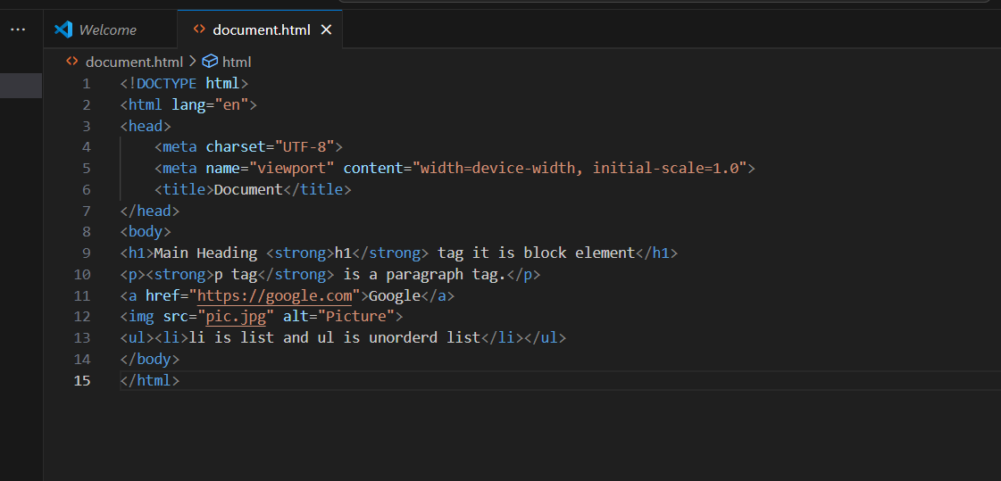
8. Static vs Dynamic Websites
- Static Website: Fixed content, no server-side processing.
Example: Portfolio site built with only HTML and CSS.
- Dynamic Website: Content changes based on user interaction or data.
Example: Facebook, where content updates based on user activity.

9. Five Web Browsers and Their Rendering Engines
Browser | Rendaring Engine
Google chrome | Blink
Mozilla firefox | Gecko
Safari | Web kit
Microsoft edge | Blink
opera | Blink

10. Basic Web Architecture Flow Diagram
[Client (Browser)]
|
| HTTP Request
v
[Web Server]
|
| Calls APIs
v
[Backend Logic]
|
| Queries
v
[Database]
|
| Response
v
[Client (Browser)]

