BIG DATA PROJECT

INDEX

BIG DATA

Big data is a term used to refer to the study and applications of data sets that are too complex for traditional data-processing application software to adequately deal with. Big data challenges include capturing data, data storage, data analysis, search, sharing, transfer, visualization, querying, updating, information privacy and data source. Big data was originally associated with three key concepts: volume, variety, and velocity.[2] Other concepts later attributed with big data are veracity (i.e., how much noise is in the data) [3] and value.[4]
Modern usage of the term "big data" tends to refer to the use of predictive analytics, user behavior analytics, or certain other advanced data analytics methods that extract value from data, and seldom to a particular size of data set. Analysis of data sets can find new correlations to "spot business trends, prevent diseases, combat crime and so on."[6] Scientists, business executives, practitioners of medicine, advertising and governments alike regularly meet difficulties with large data-sets in areas including Internet search, fintech, urban informatics, and business informatics.
Big data usually includes data sets with sizes beyond the ability of commonly used software tools to capture, curate, manage, and process data within a tolerable elapsed time.[21] Big data philosophy encompasses unstructured, semi-structured and structured data, however the main focus is on unstructured data.[22] Big data "size" is a constantly moving target, as of 2012 ranging from a few dozen terabytes to many exabytes of data.[23] Big data requires a set of techniques and technologies with new forms of integration to reveal insights from datasets that are diverse, complex, and of a massive scale

Characteristics
Volume
The quantity of generated and stored data. The size of the data determines the value and potential insight, and whether it can be considered big data or not.
Variety
The type and nature of the data. This helps people who analyze it to effectively use the resulting insight. Big data draws from text, images, audio, video; plus it completes missing pieces through data fusion.
Velocity
In this context, the speed at which the data is generated and processed to meet the demands and challenges that lie in the path of growth and development. Big data is often available in real-time.
Veracity
The data quality of captured data can vary greatly, affecting the accurate analysis.[37]
Value
Data has intrinsic value. Today, big data has become capital. Think of some of the world’s biggest tech companies. A large part of the value comes from their data, which they’re constantly analyzing to produce more efficiency and develop new products.

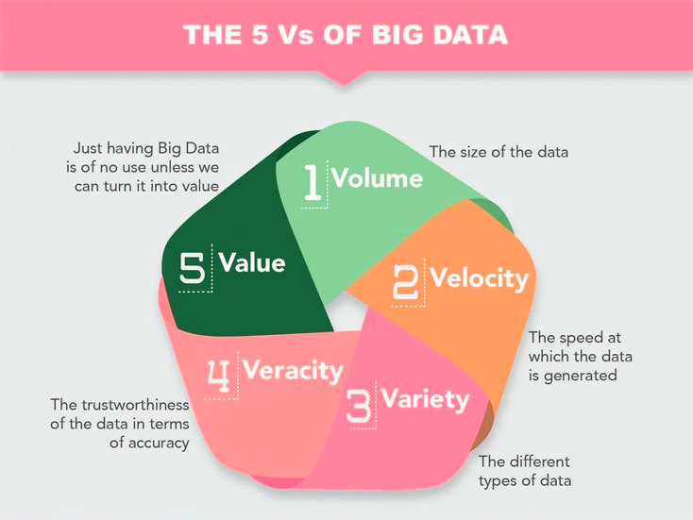

ADVANTAGES OF BIGDATA

Cost Savings : Some tools of Big Data like Hadoop and Cloud-Based Analytics can bring cost advantages to business when large amounts of data are to be stored and these tools also help in identifying more efficient ways of doing business.
- Time Reductions :The high speed of tools like Hadoop and in-memory analytics can easily identify new sources of data which helps businesses analyzing data immediately and make quick decisions based on the learnings.
- New Product Development : By knowing the trends of customer needs and satisfaction through analytics you can create products according to the wants of customers.
- Understand the market conditions : By analyzing big data you can get a better understanding of current market conditions. For example, by analyzing customers’ purchasing behaviors, a company can find out the products that are sold the most and produce products according to this trend. By this, it can get ahead of its competitors.
- Control online reputation: Big data tools can do sentiment analysis. Therefore, you can get feedback about who is saying what about your company. If you want to monitor and improve the online presence of your business, then, big data tools can help in all this.

HADOOP

The Apache Hadoop software library is a framework that allows for the distributed processing of large data sets across clusters of computers using simple programming models. It is designed to scale up from single servers to thousands of machines, each offering local computation and storage. Rather than rely on hardware to deliver high-availability, the library itself is designed to detect and handle failures at the application layer, so delivering a highly-available service on top of a cluster of computers, each of which may be prone to failures.

Apache Hadoop ( /həˈduːp/) is a collection of open-source software utilities that facilitate using a network of many computers to solve problems involving massive amounts of data and computation. It provides a software framework for distributed storage and processing of big data using the MapReduce programming model. Originally designed for computer clusters built from commodity hardware[3]—still the common use—it has also found use on clusters of higher-end hardware.[4][5] All the modules in Hadoop are designed with a fundamental assumption that hardware failures are common occurrences and should be automatically handled by the framework.[2]
The core of Apache Hadoop consists of a storage part, known as Hadoop Distributed File System (HDFS), and a processing part which is a MapReduce programming model. Hadoop splits files into large blocks and distributes them across nodes in a cluster. It then transfers packaged code into nodes to process the data in parallel. This approach takes advantage of data locality,[6] where nodes manipulate the data they have access to. This allows the dataset to be processed faster and more efficiently than it would be in a more conventional supercomputer architecture that relies on a parallel file system where computation and data are distributed via high-speed networking.[7][8]
The base Apache Hadoop framework is composed of the following modules:
- Hadoop Common – contains libraries and utilities needed by other Hadoop modules;
- Hadoop Distributed File System (HDFS) – a distributed file-system that stores data on commodity machines, providing very high aggregate bandwidth across the cluster;
- Hadoop YARN – introduced in 2012 is a platform responsible for managing computing resources in clusters and using them for scheduling users' applications;[9][10]
- Hadoop MapReduce – an implementation of the MapReduce programming model for large-scale data processing.
The term Hadoop has come to refer not just to the aforementioned base modules and sub-modules, but also to the ecosystem,[11] or collection of additional software packages that can be installed on top of or alongside Hadoop, such as Apache Pig, Apache Hive, Apache HBase, Apache Phoenix, Apache Spark, Apache ZooKeeper, Cloudera Impala, Apache Flume, Apache Sqoop, Apache Oozie, and Apache Storm.[12]
Apache Hadoop's MapReduce and HDFS components were inspired by Google papers on their MapReduce and Google File System.
The Hadoop framework itself is mostly written in the Java programming language, with some native code in C and command line utilities written as shell scripts. Though MapReduce Java code is common, any programming language can be used with "Hadoop Streaming" to implement the "map" and "reduce" parts of the user's program.[14] Other projects in the Hadoop ecosystem expose richer user interfaces.

Hadoop Architecture
Hadoop framework includes following four modules:
- Hadoop Common: These are Java libraries and utilities required by other Hadoop modules. These libraries provides filesystem and OS level abstractions and contains the necessary Java files and scripts required to start Hadoop.
- Hadoop YARN: This is a framework for job scheduling and cluster resource management.
- Hadoop Distributed File System (HDFS™): A distributed file system that provides high-throughput access to application data.
- Hadoop MapReduce: This is YARN-based system for parallel processing of large data sets.

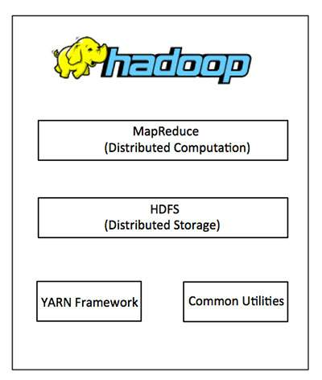

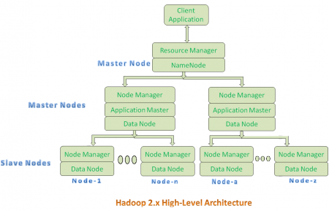

Hadoop 2.x components follow this architecture to interact each other and to work parallel in a reliable, highly available and fault-tolerant manner.
All Master Nodes and Slave Nodes contains both MapReduce and HDFS Components.
- One Master Node has two components:
- Resource Manager(YARN or MapReduce v2)
- HDFS
It’s HDFS component is also knows as NameNode. It’s NameNode is used to store Meta Data.
In Hadoop 2.x, some more Nodes acts as Master Nodes as shown in the above diagram. Each this 2nd level Master Node has 3 components:
- Node Manager
- Application Master
- Data Node
- Each this 2nd level Master Node again contains one or more Slave Nodes as shown in the above diagram.
- These Slave Nodes have two components:
- Node Manager
- HDFS
It’s HDFS component is also knows as Data Node. It’s Data Node component is used to store actual our application Big Data. These nodes does not contain Application Master component.
Hadoop 2.x Architecture Description
Resource Manager:
- Resource Manager is a Per-Cluster Level Component.
- Resource Manager is again divided into two components:
  - Scheduler
  - Application Manager
- Resource Manager’s Scheduler is :
  - Responsible to schedule required resources to Applications (that is Per-Application Master).
  - It does only scheduling.
  - It does care about monitoring or tracking of those Applications.
Application Master:
- Application Master is a per-application level component. It is responsible for:
  - Managing assigned Application Life cycle.
  - It interacts with both Resource Manager’s Scheduler and Node Manager
  - It interacts with Scheduler to acquire required resources.
  - It interacts with Node Manager to execute assigned tasks and monitor those task’s status.
Node Manager:
- Node Manager is a Per-Node Level component.
- It is responsible for:
  - Managing the life-cycle of the Container.
  - Monitoring each Container’s Resources utilization.
Container:
- Each Master Node or Slave Node contains set of Containers. In this diagram, Main Node’s Name Node is not showing the Containers. However, it also contains a set of Containers.
- Container is a portion of Memory in HDFS (Either Name Node or Data Node).
- In Hadoop 2.x, Container is similar to Data Slots in Hadoop 1.x. We will see the major differences between these two Components: Slots Vs Containers in my coming posts.

MAPREDUCE

MapReduce is the heart of Apache Hadoop. It is a programming paradigm that enables massive scalability across hundreds or thousands of servers in a Hadoop cluster. The MapReduce concept is fairly simple to understand for those who are familiar with clustered scale-out data processing solutions. MapReduce is a Distributed Data Processing Algorithm, introduced by Google in it’s MapReduce Tech Paper.
MapReduce Algorithm is mainly inspired by Functional Programming model. MapReduce algorithm is mainly useful to process huge amount of data in parallel, reliable and efficient way in cluster environments. It uses Divide and Conquer technique to process large amount of data. It divides input task into smaller and manageable sub-tasks . They should be executable independently to execute them in-parallel.

MapReduce Algorithm Steps
==The term "MapReduce" actually refers to two separate and distinct tasks that Hadoop programs perform. The first is the map job, which takes a set of data and converts it into another set of data, where individual elements are broken down into tuples (key/value pairs).
The reduce job takes the output from a map as input and combines those data tuples into a smaller set of tuples. As the sequence of the name MapReduce implies, the reduce job is always performed after the map job.==
MapReduce Algorithm uses the following three main steps:
- Map Function
- Shuffle Function
- Reduce Function

Map Function
Map Function is the first step in MapReduce Algorithm. It takes input tasks (say DataSets. I have given only one DataSet in below diagram.) and divides them into smaller sub-tasks. Then perform required computation on each sub-task in parallel.
This step performs the following two sub-steps:
- Splitting
- Mapping
- Splitting step takes input DataSet from Source and divide into smaller Sub-DataSets.
- Mapping step takes those smaller Sub-DataSets and perform required action or computation on each Sub-DataSet.
The output of this Map Function is a set of key and value pairs as <Key, Value>
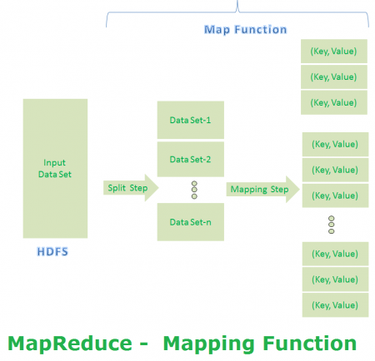

Shuffle Function
It is the second step in MapReduce Algorithm. Shuffle Function is also know as “Combine Function”.
It performs the following two sub-steps:
- Merging
- Sorting
It takes a list of outputs coming from “Map Function” and perform these two sub-steps on each and every key-value pair.
- Merging step combines all key-value pairs which have same keys (that is grouping key-value pairs by comparing “Key”). This step returns <Key, List<Value>>.
- Sorting step takes input from Merging step and sort all key-value pairs by using Keys. This step also returns <Key, List<Value>> output but with sorted key-value pairs.
Finally, Shuffle Function returns a list of <Key, List<Value>> sorted pairs to next step.
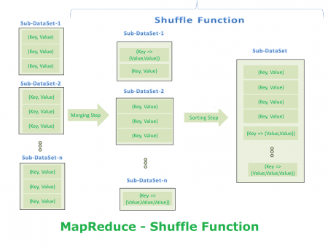

Reduce Function
It is the final step in MapReduce Algorithm. It performs only one step : Reduce step.
It takes list of <Key, List<Value>> sorted pairs from Shuffle Function and perform reduce operation.
Final step output looks like first step output. However final step <Key, Value> pairs are different than first step <Key, Value> pairs. Final step <Key, Value> pairs are computed and sorted pairs.

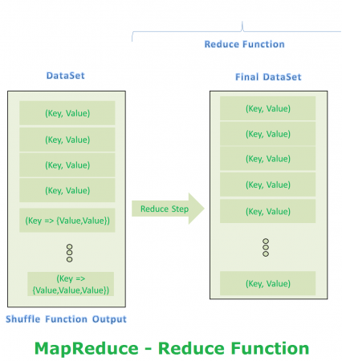

HIVE

Apache Hive is a data warehouse software project built on top of Apache Hadoop for providing data query and analysis.[2] Hive gives an SQL-like interface to query data stored in various databases and file systems that integrate with Hadoop. Traditional SQL queries must be implemented in the MapReduce Java API to execute SQL applications and queries over distributed data. Hive provides the necessary SQL abstraction to integrate SQL-like queries (HiveQL) into the underlying Java without the need to implement queries in the low-level Java API. Since most data warehousing applications work with SQL-based querying languages, Hive aids portability of SQL-based applications to Hadoop.[3] While initially developed by Facebook, Apache Hive is used and developed by other companies such as Netflix and the Financial Industry Regulatory Authority (FINRA).[4][5] Amazon maintains a software fork of Apache Hive included in Amazon Elastic MapReduce on Amazon Web Services.[6]

Hive is not
- A relational database
- A design for OnLine Transaction Processing (OLTP)
- A language for real-time queries and row-level updates

Features of Hive
- It stores schema in a database and processed data into HDFS.
- It is designed for OLAP.
- It provides SQL type language for querying called HiveQL or HQL.
- It is familiar, fast, scalable, and extensible.

Architecture of Hive

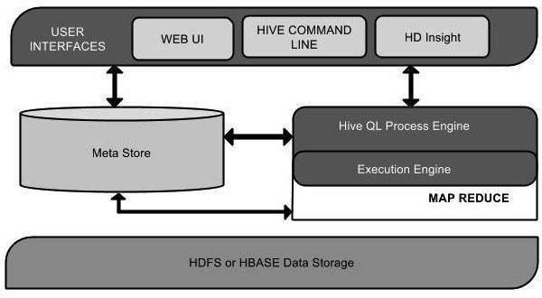
Major components of the Hive architecture are:
- Metastore: Stores metadata for each of the tables such as their schema and location. It also includes the partition metadata which helps the driver to track the progress of various data sets distributed over the cluster.[19] The data is stored in a traditional RDBMS format. The metadata helps the driver to keep track of the data and it is crucial. Hence, a backup server regularly replicates the data which can be retrieved in case of data loss.
- Driver: Acts like a controller which receives the HiveQL statements. It starts the execution of the statement by creating sessions, and monitors the life cycle and progress of the execution. It stores the necessary metadata generated during the execution of a HiveQL statement. The driver also acts as a collection point of data or query results obtained after the Reduce operation.[14]
- Compiler: Performs compilation of the HiveQL query, which converts the query to an execution plan. This plan contains the tasks and steps needed to be performed by the Hadoop MapReduce to get the output as translated by the query. The compiler converts the query to an abstract syntax tree (AST). After checking for compatibility and compile time errors, it converts the AST to a directed acyclic graph (DAG).[20] The DAG divides operators to MapReduce stages and tasks based on the input query and data.[19]
- Optimizer: Performs various transformations on the execution plan to get an optimized DAG. Transformations can be aggregated together, such as converting a pipeline of joins to a single join, for better performance.[21] It can also split the tasks, such as applying a transformation on data before a reduce operation, to provide better performance and scalability. However, the logic of transformation used for optimization used can be modified or pipelined using another optimizer.[14]
- Executor: After compilation and optimization, the executor executes the tasks. It interacts with the job tracker of Hadoop to schedule tasks to be run. It takes care of pipelining the tasks by making sure that a task with dependency gets executed only if all other prerequisites are run.[21]
- CLI, UI, and Thrift Server: A command-line interface (CLI) provides a user interface for an external user to interact with Hive by submitting queries, instructions and monitoring the process status. Thrift server allows external clients to interact with Hive over a network, similar to the JDBC or ODBC protocols.[22]

APACHE PIG

Apache Pig[1] is a high-level platform for creating programs that run on Apache Hadoop. The language for this platform is called Pig Latin.[1] Pig can execute its Hadoop jobs in MapReduce, Apache Tez, or Apache Spark[citation needed]. Pig Latin abstracts the programming from the Java MapReduce idiom into a notation which makes MapReduce programming high level, similar to that of SQL for relational database management systems. Pig Latin can be extended using user-defined functions (UDFs) which the user can write in Java, Python, JavaScript, Ruby or Groovy[2] and then call directly from the language.

Apache Pig is an abstraction over MapReduce. It is a tool/platform which is used to analyze larger sets of data representing them as data flows. Pig is generally used with Hadoop; we can perform all the data manipulation operations in Hadoop using Pig.

Pig architecture

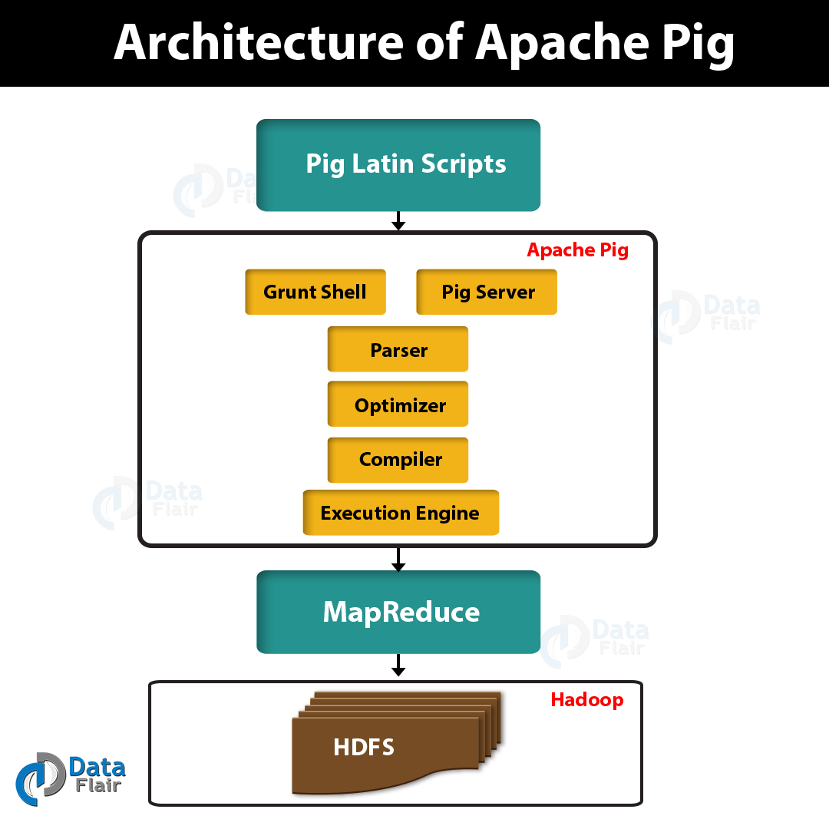

Parser
Initially the Pig Scripts are handled by the Parser. It checks the syntax of the script, does type checking, and other miscellaneous checks. The output of the parser will be a DAG (directed acyclic graph), which represents the Pig Latin statements and logical operators.
In the DAG, the logical operators of the script are represented as the nodes and the data flows are represented as edges.

Optimizer
The logical plan (DAG) is passed to the logical optimizer, which carries out the logical optimizations such as projection and pushdown.

Compiler
The compiler compiles the optimized logical plan into a series of MapReduce jobs.

Execution engine
Finally the MapReduce jobs are submitted to Hadoop in a sorted order. Finally, these MapReduce jobs are executed on Hadoop producing the desired results.
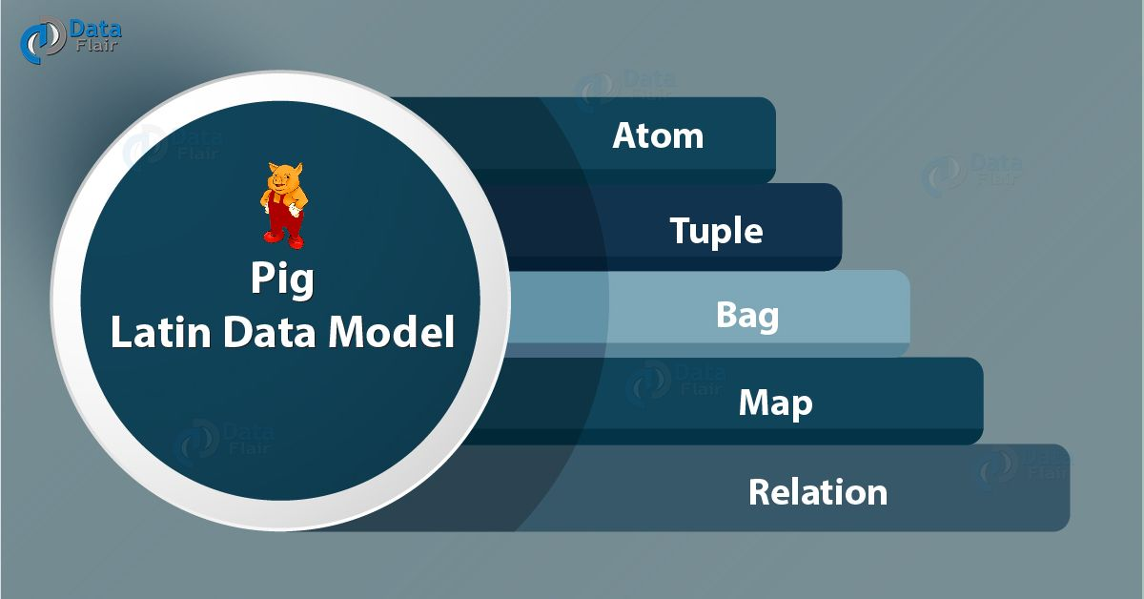

i. Atom
Atom is defined as any single value in Pig Latin, irrespective of their data. Basically, we can use it as string and number and store it as the string. Atomic values of Pig are int, long, float, double, char array, and byte array. Moreover, a field is a piece of data or a simple atomic value in Pig.
For Example − ‘Shubham’ or ‘25’

ii. Tuple
Tuple is a record that is formed by an ordered set of fields. However, the fields can be of any type. In addition, a tuple is similar to a row in a table of RDBMS.
For Example − (Shubham, 25)

iii. Bag
An unordered set of tuples is what we call Bag. To be more specific, a Bag is a collection of tuples (non-unique). Moreover, each tuple can have any number of fields (flexible schema). Generally, we represent a bag by ‘{}’.
For Example − {(Shubham, 25), (Pulkit, 35)}
In addition, when a bag is a field in a relation, in that way it is known as the inner bag.
Example − {Shubham, 25, {9826022258, Shubham@gmail.com,}}

iv. Map
A set of key-value pairs is what we call a map (or data map). Basically, the key needs to be of type char array and should be unique. Also, the value might be of any type. And, we represent it by ‘[]’
For Example − [name#Shubham, age#25]

v. Relation
A bag of tuples is what we call Relation. In Pig Latin, the relations are unordered. Also, there is no guarantee that tuples are processed in any particular order.

Advantages of pig:
Ease of programming. It is trivial to achieve parallel execution of simple, "embarrassingly parallel" data analysis tasks. Complex tasks comprised of multiple interrelated data transformations are explicitly encoded as data flow sequences, making them easy to write, understand, and maintain.
- Optimization opportunities. The way in which tasks are encoded permits the system to optimize their execution automatically, allowing the user to focus on semantics rather than efficiency.
- Extensibility. Users can create their own functions to do special-purpose processing.

SQOOP

Sqoop is a tool designed to transfer data between Hadoop and relational database servers. It is used to import data from relational databases such as MySQL, Oracle to Hadoop HDFS, and export from Hadoop file system to relational databases.

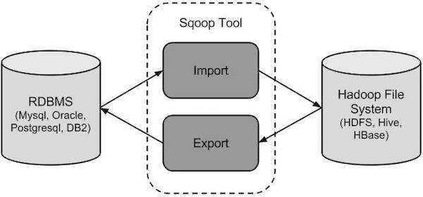

Sqoop Import
The import tool imports individual tables from RDBMS to HDFS. Each row in a table is treated as a record in HDFS. All records are stored as text data in text files or as binary data in Avro and Sequence files.

Sqoop Export
The export tool exports a set of files from HDFS back to an RDBMS. The files given as input to Sqoop contain records, which are called as rows in table. Those are read and parsed into a set of records and delimited with user-specified delimiter.

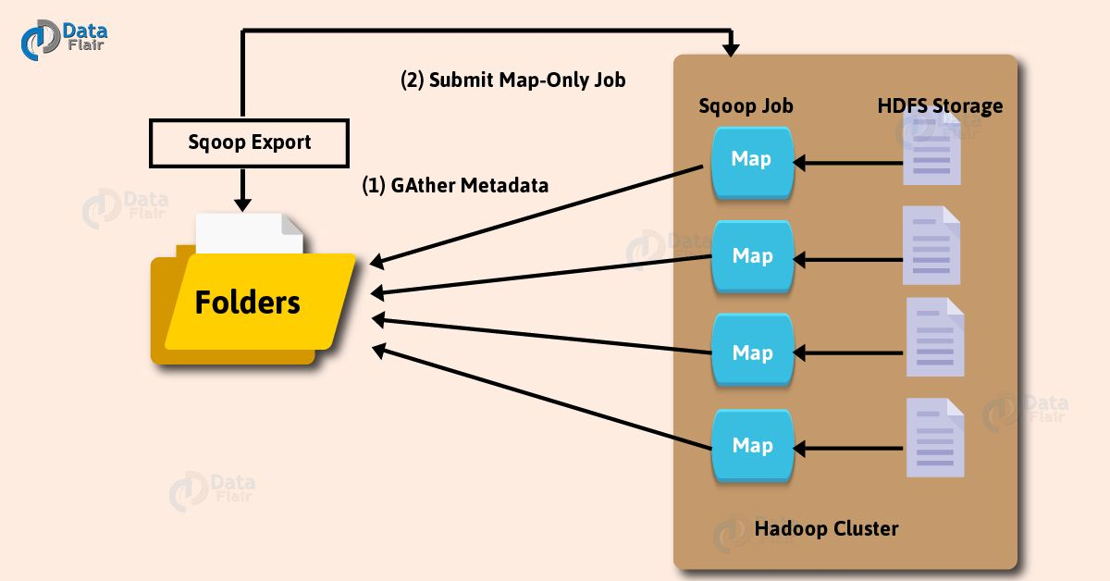
Basically, a tool which imports individual tables from RDBMS to HDFS is what we call Sqoop import tool. However, in HDFS we treat each row in a table as a record.
Moreover, our main task gets divided into subtasks, while we submit Sqoop command. However, map task individually handles it internally. On defining map task, it is the subtask that imports part of data to the Hadoop Ecosystem. Likewise, we can say all map tasks import the whole data collectively.
A tool which exports a set of files from HDFS back to an RDBMS is a Sqoop Export tool. Moreover, there are files which behave as input to Sqoop which also contain records. Those files what we call as rows in the table.
Moreover, the job is mapped into map tasks, while we submit our job, that brings the chunk of data from HDFS. Then we export these chunks to a structured data destination. Likewise, we receive the whole data at the destination by combining all these exported chunks of data. However, in most of the cases, it is an RDBMS (MYSQL/Oracle/SQL Server).
In addition, in case of aggregations, we require reducing phase. However, Sqoop does not perform any aggregations it just imports and exports the data.

FLUME

Flume is a distributed, reliable, and available service for efficiently collecting, aggregating, and moving large amounts of log data. It has a simple and flexible architecture based on streaming data flows. It is robust and fault tolerant with tunable reliability mechanisms and many fail-over and recovery mechanisms. It uses a simple extensible data model that allows for online analytic application.

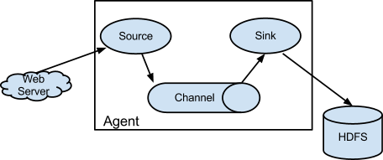

Apache Flume is a distributed, reliable, and available service for efficiently collecting, aggregating, and moving large amounts of streaming data into the Hadoop Distributed File System (HDFS). It has a simple and flexible architecture based on streaming data flows; and is robust and fault tolerant with tunable reliability mechanisms for failover and recovery. It is a service for streaming logs into Hadoop
YARN coordinates data ingest from Apache Flume and other services that deliver raw data into an Enterprise Hadoop cluster.

FLUME ARCHITECTURE

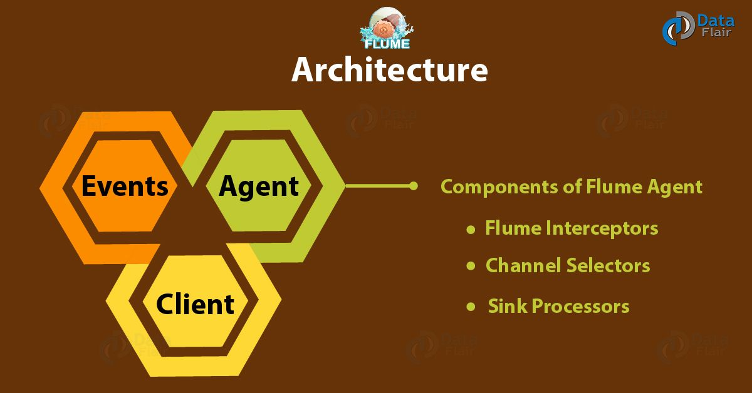
Component of Flume Architecture: Flume Event, Flume Agent, and Flume Client. Furthermore, we will discuss components of Flume agent: Flume Source, Flume Channel Selector, and Flume Sink Processors.

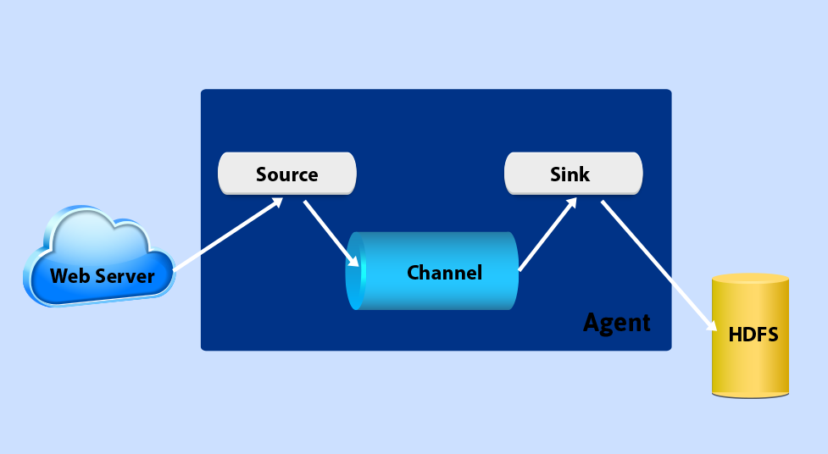

Data generators (like Facebook, Twitter) generates data which gets collected by individual Flume agents running on them. Afterward, another agent is data collector which collects all the data from the agents which are aggregated. Then pushed it into a centralized store. Like HDFS or Hbase.

a. Flume Events
The basic unit of the data which is transported inside Flume is what we call an Event. Generally, it contains a payload of the byte array. Basically, that can be transported from the source to the destination accompanied by optional headers. Moreover, refer the below image to understand the typical Flume event structure.

b. Flume Agent
However, in Apache Flume, an independent daemon process (JVM) is what we call an agent. At first, it receives events from clients or other agents. Afterward, it forwards it to its next destination that is sink or agent. Note that, it is possible that Flume can have more than one agent. Also, refer the below image to understand the Flume Agent.

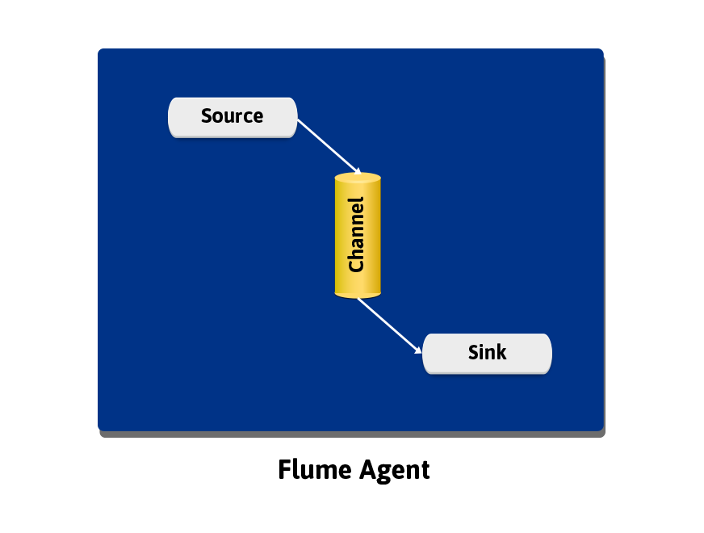
Apache Flume Architecture – Flume Agent
According to the image, it contains three main components. Such as source, channel, and sink.

i. Flume Source
Basically, Flume source receives data from the data generators. Then it transfers it to one or more channels as Flume events.
There are various types of sources Apache Flume supports. Moreover, each source receives events from a specified data generator.
Like− Avro source, Thrift source, twitter 1% source etc.

ii. Flume Channel
A transient store that receives the events from the source also buffers them till they are consumed by sinks is what we call a Flume channel. To be very specific it acts as a bridge between the sources and the sinks in Flume.
Basically, these channels can work with any number of sources and sinks are they are fully transactional.
Like − JDBC channel, File system channel, Memory channel, etc.

iii. Flume Sink
Generally, to store data into centralized stores like HBase and HDFS we use Flume sink component. Basically, it consumes events from the channels and then delivers it to the destination. Also, we can say that sink’s destination is might be another agent or the central stores.
Like − HDFS sink
In addition, it is very important to note that a flume agent can have many numbers of sources, sinks, and channels.

c. Flume Client
Those which generates events and then sent it to one or more agents is what we call Flume Clients.

FLUME FEATURES

Feature | Description
Stream data | Ingest streaming data from multiple sources into Hadoop for storage and analysis
Insulate systems | Buffer storage platform from transient spikes, when the rate of incoming data exceeds the rate at which data can be written to the destination
Guarantee data delivery | Flume NG uses channel-based transactions to guarantee reliable message delivery. When a message moves from one agent to another, two transactions are started, one on the agent that delivers the event and the other on the agent that receives the event. This ensures guaranteed delivery semantics
Scale horizontally | To ingest new data streams and additional volume as needed

OOZIE

Oozie is a workflow scheduler system to manage Apache Hadoop jobs.Oozie Workflow jobs are Directed Acyclical Graphs (DAGs) of actions. Oozie Coordinator jobs are recurrent Oozie Workflow jobs triggered by time (frequency) and data availability.
Oozie is integrated with the rest of the Hadoop stack supporting several types of Hadoop jobs out of the box (such as Java map-reduce, Streaming map-reduce, Pig, Hive, Sqoop and Distcp) as well as system specific jobs (such as Java programs and shell scripts). Oozie is a scalable, reliable and extensible system.

Oozie Architecture
An Oozie Server is deployed as Java Web Application hosted in a Tomcat server, and all of the stageful information such as workflow definitions, jobs, etc, are stored in a database. This database can be either Apache Derby, HSQL, Oracle, MySQL, or PostgreSQL.
There is an Oozie Client, which is the client that submits work, either via a CLI, and API, or a web service / REST.
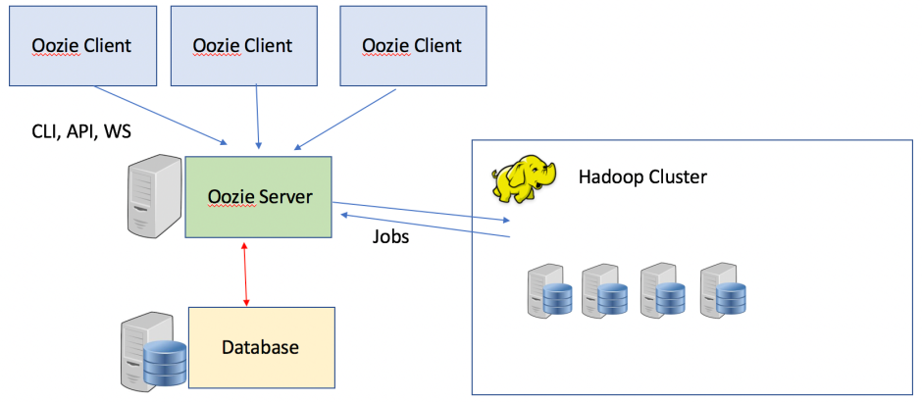

ZOOKEEPER

Apache ZooKeeper is a software project of the Apache Software Foundation. It is essentially a centralized service for distributed systems to a hierarchical key-value store, which is used to provide a distributed configuration service, synchronization service, and naming registry for large distributed systems.[2] ZooKeeper was a sub-project of Hadoop but is now a top-level Apache project in its own right.
ZooKeeper's architecture supports high availability through redundant services. The clients can thus ask another ZooKeeper leader if the first fails to answer. ZooKeeper nodes store their data in a hierarchical name space, much like a file system or a tree data structure. Clients can read from and write to the nodes and in this way have a shared configuration service. ZooKeeper can be viewed as an atomic broadcast system, through which updates are totally ordered. The ZooKeeper Atomic Broadcast (ZAB) protocol is the core of the system.[3]
ZooKeeper is used by companies including Rackspace, Yahoo!,[4] Odnoklassniki, Reddit,[5] NetApp SolidFire[6], Facebook[7] and eBay as well as open source enterprise search systems like Solr.[8]
ZooKeeper was originally developed at Yahoo for streamlining the processes running on Big Data cluster by storing the status in local log files on the ZooKeeper servers. These servers communicate with the client machines to provide them the information. ZooKeeper was developed in order to fix the bugs that occurred while deploying distributed big data applications.

ZOOKEEPER ARCHITECTURE
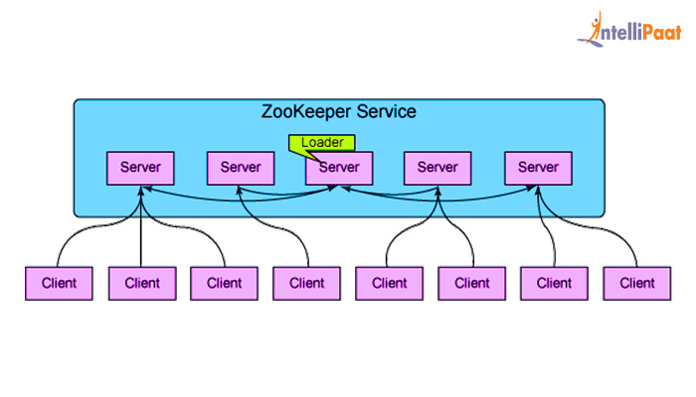
ZooKeeper is a distributed application on its own while being a coordination service for distributed systems. Basically, it has a simple client-server model in which clients are nodes (i.e. machines) and servers are nodes. As a function, ZooKeper Clients make use of the services and servers provides the services. Applications make calls to ZooKeeper through a client library. However, the client library handles the interaction with ZooKeeper servers here. Now, the following figure shows the relationship between clients and servers. Here you can see each client imports the client library then further communicate with any ZooKeeper node.

Hadoop ZooKeeper’s architecture allows the Zookeeper services to be replicated over a set of machines where each one of them maintains an image of in-memory data tree and transaction logs. The client applications contact to a single server. The clients establish a TCP link through which they send requests, receive responses, watch the events, etc.

Apache ZooKeeper basics | Tasks Performed
Server Applications | Facilitate interaction with client applications through a common interface.
Client Applications | Consist of tools that interact with distributed applications.
Zookeeper Nodes | Systems on which a cluster runs.
znode | Can be updated and/or modified by any node in the cluster.

ZOOKEEPER FEATURES:
- Reliable System: This system is very reliable as it keeps working even if a node fails.
- Simple Architecture: The architecture of ZooKeeper is quite simple as there is a shared hierarchical namespace which helps coordinating the processes.
- Fast Processing: ZooKeeper is especially fast in "read-dominant" workloads (i.e. workloads in which reads are much more common than writes).
- Scalable: The performance of ZooKeeper can be improved by adding nodes.

HBASE

Hbase is an open source and sorted map data built on Hadoop. It is column oriented and horizontally scalable.
Features:
- Horizontally scalable
- Often referred as a key value store or column family-oriented database, or storing versioned maps of maps.
- it's a platform for storing and retrieving data with random access

PROJECT ANALYSIS

H1-B Case Study

The H1B is an employment-based, non-immigrant visa category for temporary foreign workers in the United States. For a foreign national to apply for H1B visa, an US employer must offer a job and petition for H1B visa with the US immigration department. This is the most common visa status applied for and held by international students once they complete college/ higher education (Masters, Ph.D.) and work in a full-time position.

We will be performing analysis on the H1B visa applicants between the years 2011-2015. After analyzing the data, we can derive the following facts.

(We used tools such as hive, pig, mapreduce java to analyse 4 questions each.)

MAPREDUCE

3)Which industry has the most number of Data Scientist positions?

import java.io.IOException;
import java.util.TreeMap;
import org.apache.hadoop.conf.Configuration;
import org.apache.hadoop.fs.Path;
//import org.apache.hadoop.io.IntWritable;
import org.apache.hadoop.io.LongWritable;
import org.apache.hadoop.io.NullWritable;
import org.apache.hadoop.io.Text;
import org.apache.hadoop.mapreduce.Job;
import org.apache.hadoop.mapreduce.Mapper;
import org.apache.hadoop.mapreduce.Reducer;
import org.apache.hadoop.mapreduce.lib.input.FileInputFormat;
import org.apache.hadoop.mapreduce.lib.output.FileOutputFormat;

public class proj3op {
public static class Top5Mapper extends
Mapper<LongWritable, Text,Text,Text> {
public void map(LongWritable key, Text value, Context context
) throws IOException, InterruptedException {
try {
String[] str = value.toString().split(",");
String compname= str[2];
String jobtitle= str[5];

if(str[5].equals("DATA SCIENTIST"))
context.write(new Text(compname),new Text(jobtitle));

}
catch(Exception e)
{
System.out.println(e.getMessage());
}
}
}

public static class Top5Reducer extends
Reducer<Text, Text, NullWritable, Text>
{
private TreeMap<Long,Text> repToRecordMap = new TreeMap<Long,Text>();

public void reduce(Text key, Iterable<Text> values,
Context context) throws IOException, InterruptedException
{

long count=0;

for(Text v :values)
{
count++;

}

// LongWritable t=new LongWritable(count);
// context.write(key, t);
// top 1
String cn="";
String cnct="";
String tt="";
cn = key.toString();
tt= String.format("%d", count);
cnct= cn + ',' + tt;

repToRecordMap.put(new Long(count), new Text(cnct));

if (repToRecordMap.size() > 1)
{
repToRecordMap.remove(repToRecordMap.firstKey());
}

}
protected void cleanup(Context context) throws IOException,
InterruptedException
{
for (Text t : repToRecordMap.values())
{
// Output our five records to the file system with a null key
context.write(NullWritable.get(), t);

}
}

}

public static void main(String[] args) throws Exception {

Configuration conf = new Configuration();
Job job = Job.getInstance(conf, "Top record for largest amount spent");
job.setJarByClass(proj3op.class);
job.setMapperClass(Top5Mapper.class);
job.setReducerClass(Top5Reducer.class);
job.setMapOutputKeyClass(Text.class);
job.setMapOutputValueClass(Text.class);
job.setOutputKeyClass(NullWritable.class);
job.setOutputValueClass(Text.class);
job.setNumReduceTasks(1);
FileInputFormat.addInputPath(job, new Path(args[0]));
FileOutputFormat.setOutputPath(job, new Path(args[1]));
System.exit(job.waitForCompletion(true) ? 0 : 1);
}
}
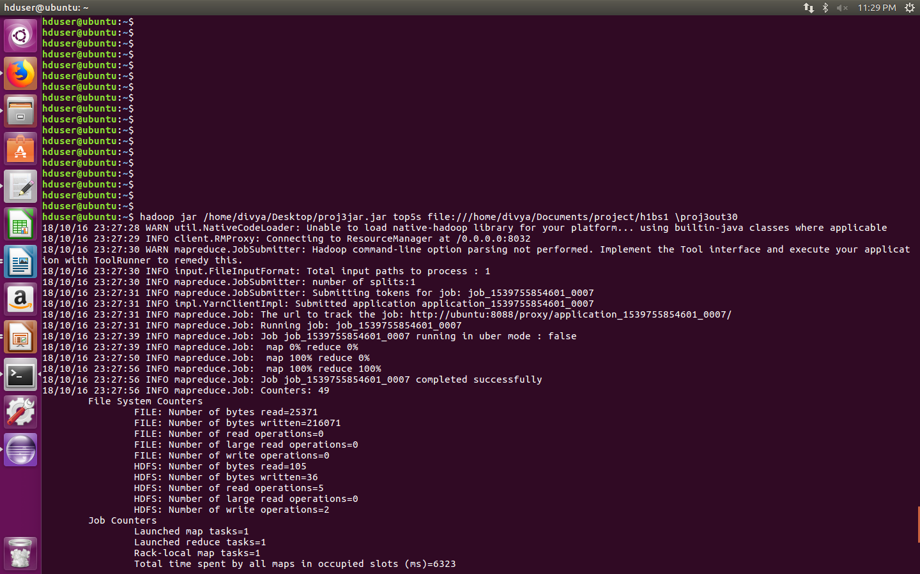

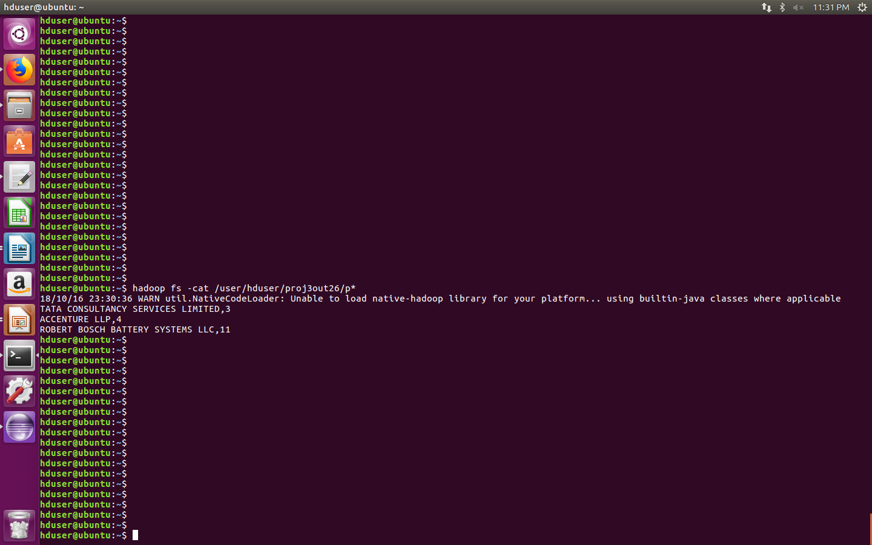
4)Which top 5 employers file the most petitions each year?
//jar empjar

import java.io.*;
import java.util.TreeMap;

import org.apache.hadoop.io.*;
//import org.apache.hadoop.mapred.MRCaching.ReduceClass;
import org.apache.hadoop.mapreduce.*;
import org.apache.hadoop.conf.*;

import org.apache.hadoop.fs.*;

import org.apache.hadoop.mapreduce.Reducer.Context;
import org.apache.hadoop.mapreduce.lib.input.*;
import org.apache.hadoop.mapreduce.lib.output.*;

import org.apache.hadoop.util.*;
//import proj4.CaderPartitioner;

public class proj4 extends Configured implements Tool
{
//Map class

public static class MapClass extends Mapper<LongWritable,Text,Text,Text>
{
public void map(LongWritable key, Text value, Context context)
{
try{
String[] str = value.toString().split(",");
String emp= str[2];
String ecs= str[1];
String eyear= str[8];

String ss=ecs+','+eyear;
context.write(new Text(emp),new Text(ss));

}
catch(Exception e)
{
System.out.println(e.getMessage());
}
}
}

//Reducer class

public static class ReduceClass extends Reducer<Text,Text,NullWritable,Text>
{

private TreeMap<Long,Text> repToRecordMap = new TreeMap<Long,Text>();

public void reduce(Text key, Iterable <Text> values, Context context) throws IOException, InterruptedException
{
long count=0;
String val="";
String cnt="";
String rec="";

String cn="";
cn=key.toString();

/* String[] str = values.toString().split(",");
String t="";
String y= str[1]; // year
*/

for(Text v:values)
{
count++;
rec=v.toString();
}

cnt= String.format("%d", count);
val = cn + ','+ rec + ',' + cnt;

//String z="";
//z= t + ',' + y;
//LongWritable t=new LongWritable(count);
//context.write(key, new Text(z));

repToRecordMap.put(new Long(count), new Text(val));

if (repToRecordMap.size() > 5)
{
repToRecordMap.remove(repToRecordMap.firstKey());
}

}
protected void cleanup(Context context) throws IOException,
InterruptedException
{
for (Text t : repToRecordMap.values())
{
// Output our five records to the file system with a null key
context.write(NullWritable.get(), t);

}
}

}

//Partitioner class

public static class CaderPartitioner extends
Partitioner < Text, Text >
{
@Override
public int getPartition(Text key, Text value, int numReduceTasks)
{
String[] str = value.toString().split(",");
String eyear=str[1];
if(eyear.equals("2011"))
{
return 0;
}
if(eyear.equals("2012"))
{
return 1 ;
}
if(eyear.equals("2013"))
{
return 2 ;
}
if(eyear.equals("2014"))
{
return 3 ;
}
else
{
return 4 ;
}

}

}

public int run(String[] arg) throws Exception
{

Configuration conf = new Configuration();
Job job = Job.getInstance(conf);
job.setJarByClass(proj4.class);
job.setJobName("State Wise Item Qty sales");
FileInputFormat.setInputPaths(job, new Path(arg[0]));
FileOutputFormat.setOutputPath(job,new Path(arg[1]));

job.setMapperClass(MapClass.class);

job.setMapOutputKeyClass(Text.class);
job.setMapOutputValueClass(Text.class);

//set partitioner statement

job.setPartitionerClass(CaderPartitioner.class);
job.setReducerClass(ReduceClass.class);
job.setNumReduceTasks(2);
job.setInputFormatClass(TextInputFormat.class);

job.setOutputFormatClass(TextOutputFormat.class);

job.setOutputKeyClass(NullWritable.class);
job.setOutputValueClass(Text.class);

System.exit(job.waitForCompletion(true)? 0 : 1);
return 0;
}

public static void main(String ar[]) throws Exception
{
ToolRunner.run(new Configuration(), new proj4(),ar);
System.exit(0);
}
}

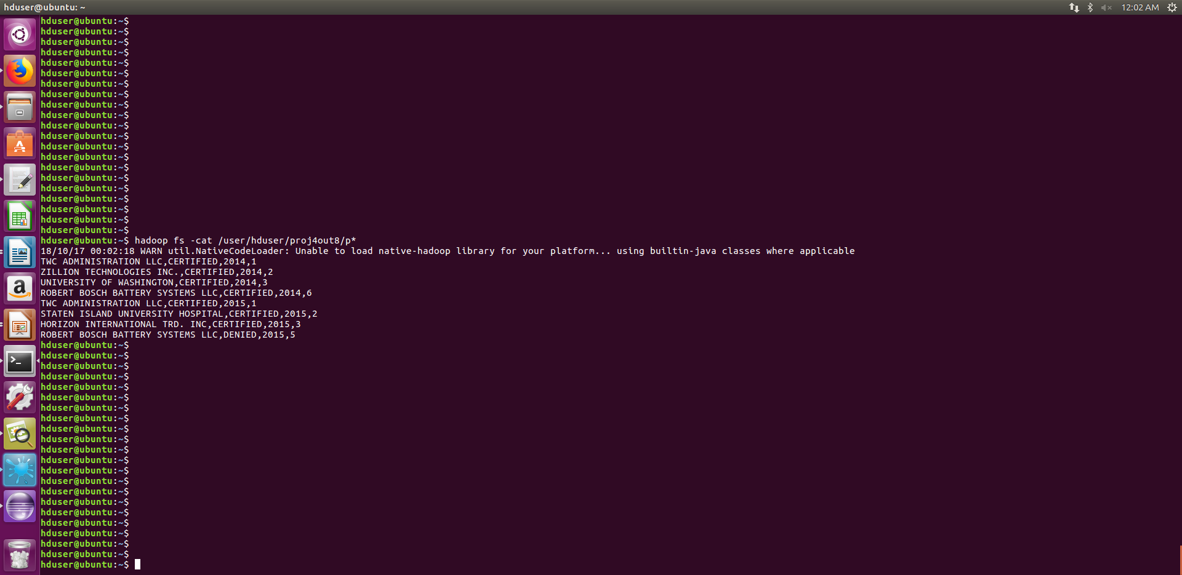

5) Find the most popular top 10 job positions for H1B visa applications for each year?

import java.io.*;
import java.util.TreeMap;

import org.apache.hadoop.io.*;
//import org.apache.hadoop.mapred.MRCaching.ReduceClass;
import org.apache.hadoop.mapreduce.*;
import org.apache.hadoop.conf.*;

import org.apache.hadoop.fs.*;

import org.apache.hadoop.mapreduce.Reducer.Context;
import org.apache.hadoop.mapreduce.lib.input.*;
import org.apache.hadoop.mapreduce.lib.output.*;

import org.apache.hadoop.util.*;
//import proj4.CaderPartitioner;

public class proj5 extends Configured implements Tool
{
//Map class

public static class MapClass extends Mapper<LongWritable,Text,Text,Text>
{
public void map(LongWritable key, Text value, Context context)
{
try{
String[] str = value.toString().split(",");
String jobtitle= str[5];

String year= str[8];
String c="";
c= jobtitle + ',' + year;
context.write(new Text(jobtitle),new Text(c));

}
catch(Exception e)
{
System.out.println(e.getMessage());
}
}
}

//Reducer class

public static class ReduceClass extends Reducer<Text,Text,NullWritable,Text>
{

private TreeMap<Long,Text> repToRecordMap = new TreeMap<Long,Text>();

public void reduce(Text key, Iterable <Text> values, Context context) throws IOException, InterruptedException
{
long count=0;

String val="";
String cnt="";
String rec="";

String jobtitle="";
jobtitle=key.toString();

/* String[] str = values.toString().split(",");
String t="";
String y= str[1]; // year
*/

for(Text v:values)
{
count++;
rec=v.toString(); // rec contains jobtitle and year
}

cnt= String.format("%d", count);
val = rec + ',' + cnt;

//String z="";
//z= t + ',' + y;
//LongWritable t=new LongWritable(count);
//context.write(key, new Text(z));

repToRecordMap.put(new Long(count), new Text(val));

if (repToRecordMap.size() > 10)
{
repToRecordMap.remove(repToRecordMap.firstKey());
}

}
protected void cleanup(Context context) throws IOException,
InterruptedException
{
for (Text t : repToRecordMap.values())
{
// Output our five records to the file system with a null key
context.write(NullWritable.get(), t);

}
}

}

//Partitioner class

public static class CaderPartitioner extends
Partitioner < Text, Text >
{
@Override
public int getPartition(Text key, Text value, int numReduceTasks)
{
String[] str = value.toString().split(",");
String eyear=str[1];
if(eyear.equals("2011"))
{
return 0;
}
if(eyear.equals("2012"))
{
return 1 ;
}
if(eyear.equals("2013"))
{
return 2 ;
}
if(eyear.equals("2014"))
{
return 3 ;
}
else
{
return 4 ;
}

}

}

public int run(String[] arg) throws Exception
{

Configuration conf = new Configuration();
Job job = Job.getInstance(conf);
job.setJarByClass(proj5.class);
job.setJobName("State Wise Item Qty sales");
FileInputFormat.setInputPaths(job, new Path(arg[0]));
FileOutputFormat.setOutputPath(job,new Path(arg[1]));

job.setMapperClass(MapClass.class);

job.setMapOutputKeyClass(Text.class);
job.setMapOutputValueClass(Text.class);

//set partitioner statement

job.setPartitionerClass(CaderPartitioner.class);
job.setReducerClass(ReduceClass.class);
job.setNumReduceTasks(2);
job.setInputFormatClass(TextInputFormat.class);

job.setOutputFormatClass(TextOutputFormat.class);

job.setOutputKeyClass(NullWritable.class);
job.setOutputValueClass(Text.class);

System.exit(job.waitForCompletion(true)? 0 : 1);
return 0;
}

public static void main(String ar[]) throws Exception
{
ToolRunner.run(new Configuration(), new proj5(),ar);
System.exit(0);
}
}

public class proj5 {

/**
* @param args
*/
public static void main(String[] args) {
// TODO Auto-generated method stub

}

}
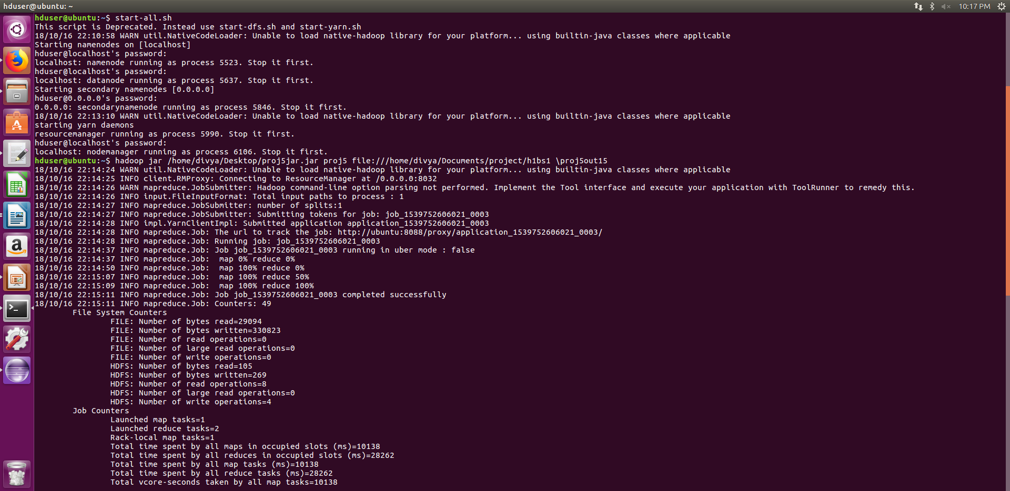
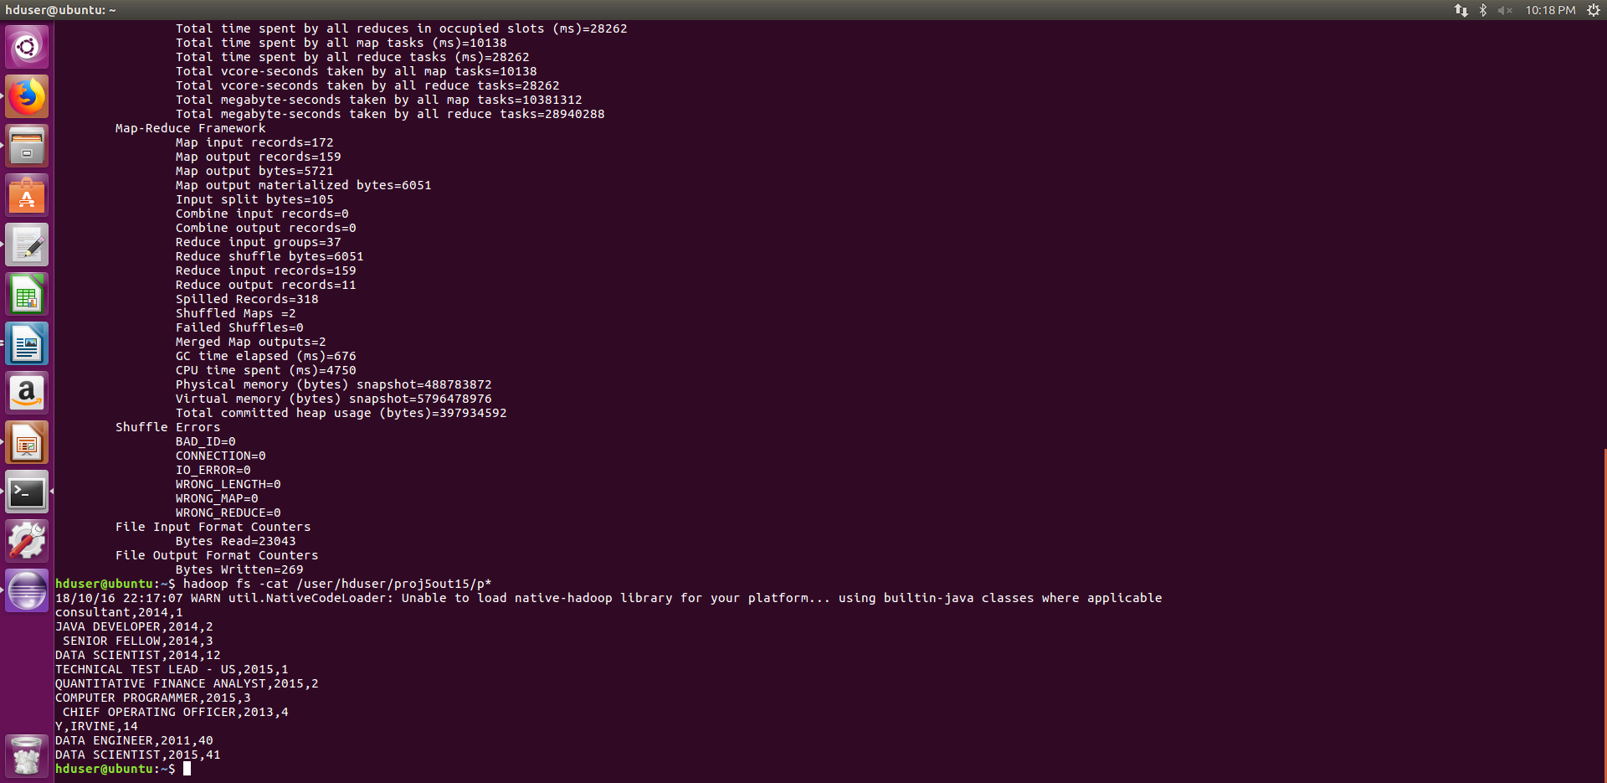

6) Find the percentage and the count of each case status on total applications for each year.

import java.io.*;
import java.util.TreeMap;

import org.apache.hadoop.io.*;
//import org.apache.hadoop.mapred.MRCaching.ReduceClass;
import org.apache.hadoop.mapreduce.*;
import org.apache.hadoop.conf.*;

import org.apache.hadoop.fs.*;

import org.apache.hadoop.mapreduce.Reducer.Context;
import org.apache.hadoop.mapreduce.lib.input.*;
import org.apache.hadoop.mapreduce.lib.output.*;

import org.apache.hadoop.util.*;

public class proj6 extends Configured implements Tool
{
//Map class

public static class MapClass extends Mapper<LongWritable,Text,Text,Text>
{
public void map(LongWritable key, Text value, Context context)
{
try
{
String[] str = value.toString().split(",");

String ecs= str[1];
String eyear= str[8];

String ss=ecs+','+eyear;

context.write(new Text(ecs),new Text(ss));

}
catch(Exception e)
{
System.out.println(e.getMessage());
}
}
}

//Reducer class

public static class ReduceClass extends Reducer<Text,Text,NullWritable,Text>
{

//private TreeMap<Long,Text> repToRecordMap = new TreeMap<Long,Text>();

public void reduce(Text key, Iterable <Text> values, Context context) throws IOException, InterruptedException
{
long count=0;
String val="";
String cnt="";
String percent="";
String rec="";

String cs=key.toString();

double totalcount=3000;
double per=0;

for(Text v:values)
{
count++;
rec=v.toString(); // rec contains case status and year
}

cnt= String.format("%d", count);

per = ( count * 100 )/totalcount;
percent= String.format("%f", per);

val = rec + ',' + cnt + ',' + percent;

context.write(NullWritable.get(),new Text(val));

}
}

//Partitioner class

public static class CaderPartitioner extends
Partitioner < Text, Text >
{
@Override
public int getPartition(Text key, Text value, int numReduceTasks)
{
String[] str = value.toString().split(",");
String eyear=str[1];
if(eyear.equals("2011"))
{
return 0;
}
if(eyear.equals("2012"))
{
return 1 ;
}
if(eyear.equals("2013"))
{
return 2 ;
}
if(eyear.equals("2014"))
{
return 3 ;
}
if(eyear.equals("2015"))
{
return 4 ;
}

}

}

public int run(String[] arg) throws Exception
{

Configuration conf = new Configuration();
Job job = Job.getInstance(conf);
job.setJarByClass(proj6.class);
job.setJobName("State Wise Item Qty sales");
FileInputFormat.setInputPaths(job, new Path(arg[0]));
FileOutputFormat.setOutputPath(job,new Path(arg[1]));

job.setMapperClass(MapClass.class);

job.setMapOutputKeyClass(Text.class);
job.setMapOutputValueClass(Text.class);

//set partitioner statement

job.setPartitionerClass(CaderPartitioner.class);
job.setReducerClass(ReduceClass.class);
job.setNumReduceTasks(2);
job.setInputFormatClass(TextInputFormat.class);

job.setOutputFormatClass(TextOutputFormat.class);

job.setOutputKeyClass(NullWritable.class);
job.setOutputValueClass(Text.class);

System.exit(job.waitForCompletion(true)? 0 : 1);
return 0;
}

public static void main(String ar[]) throws Exception
{
ToolRunner.run(new Configuration(), new proj6(),ar);
System.exit(0);
}
}

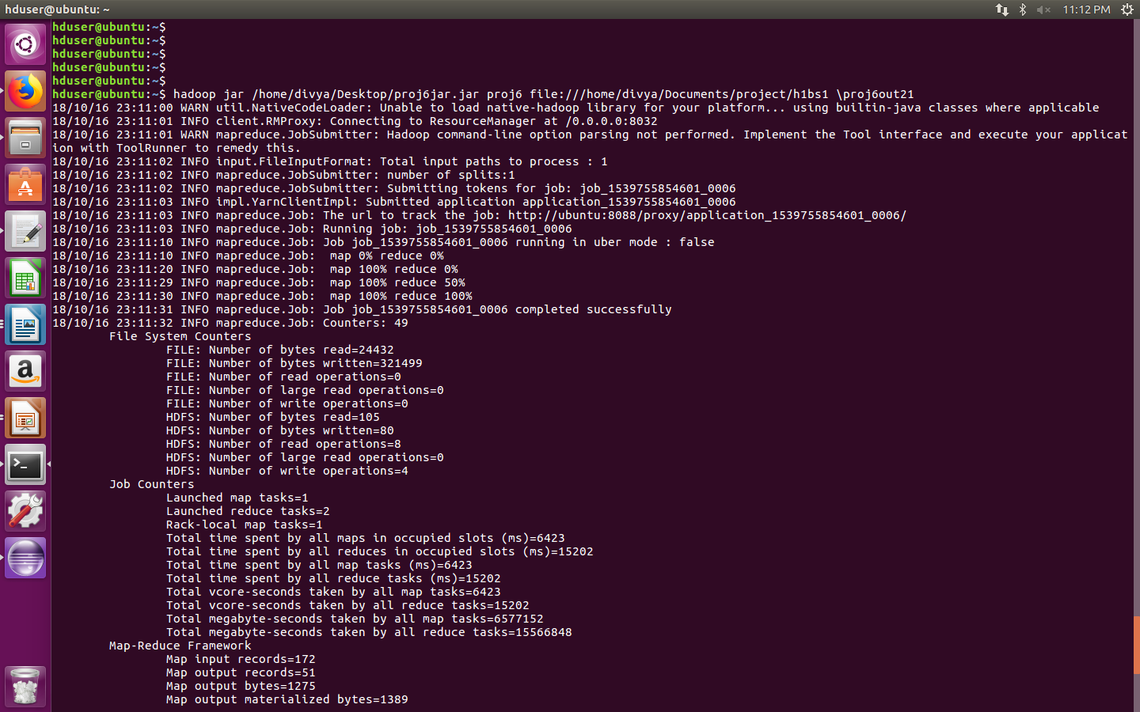

HIVE

We created a table h1b_applications with the schema as given below:

CREATE TABLE h1b_applications(s_no int,case_status string, employer_name string, soc_name string, job_title string, full_time_position string,prevailing_wage int,year string, worksite string, longitute double, latitute double )

ROW FORMAT SERDE 'org.apache.hadoop.hive.serde2.OpenCSVSerde'

WITH SERDEPROPERTIES (

"separatorChar" = ",",

"quoteChar" = "\""

) STORED AS TEXTFILE;

1 a) Is the number of petitions with Data Engineer job title increasing over time?

select job_title,year,count(case_status) from h1ba where job_title='DATA ENGINEER' group by year,job_title

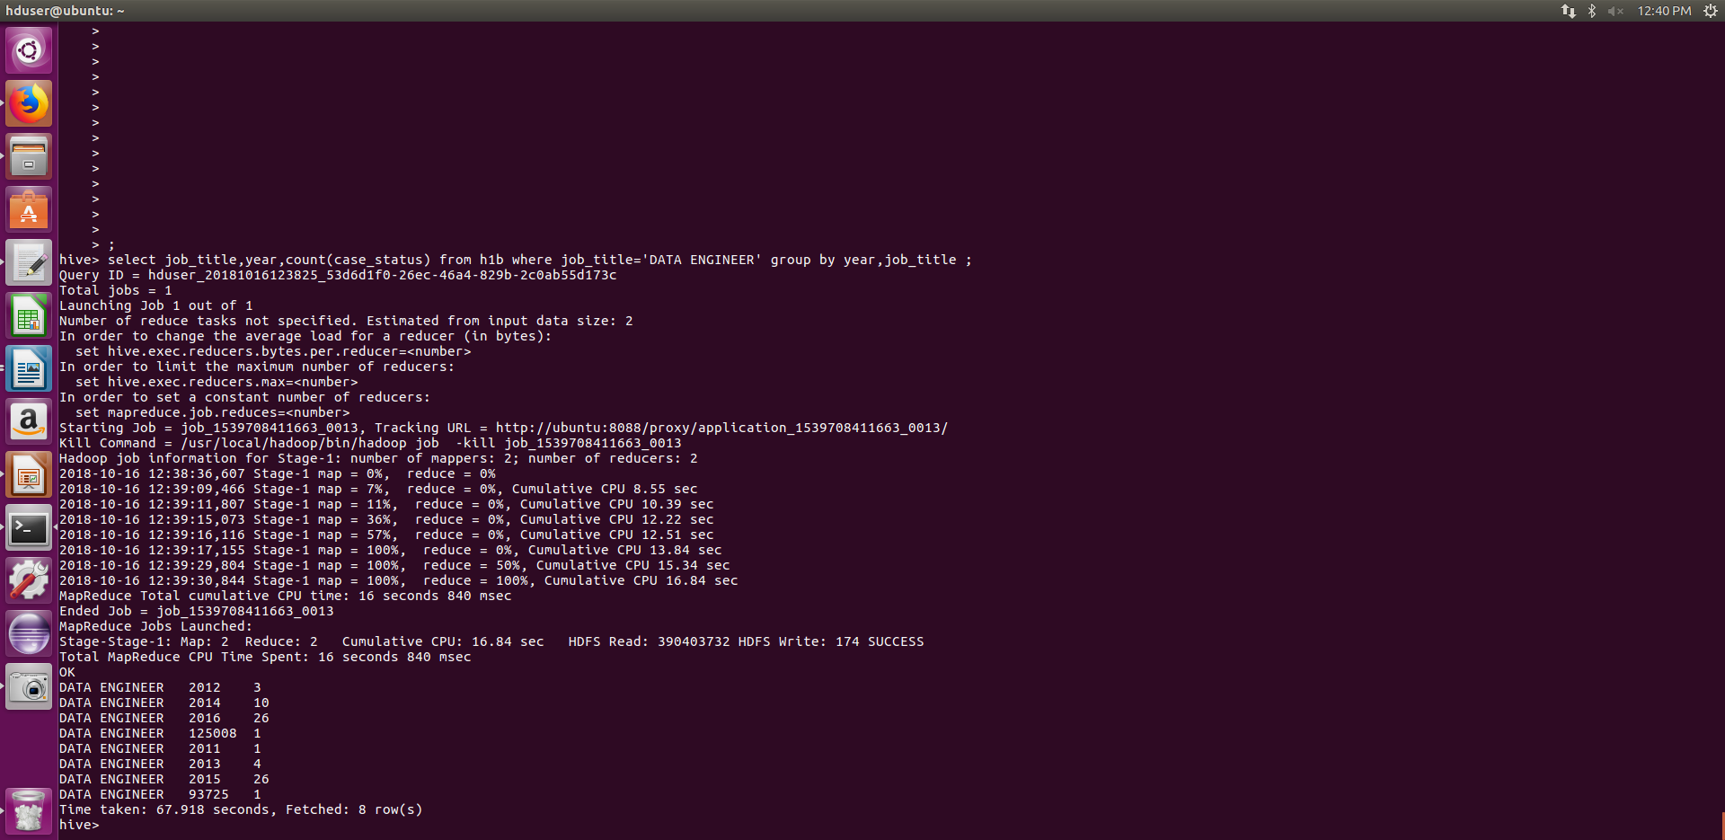
1 b) Find top 5 job titles who are having highest growth in applications.

select job_title,count(job_title) as c ,year from h1ba group by year,job_title order by c desc limit 5
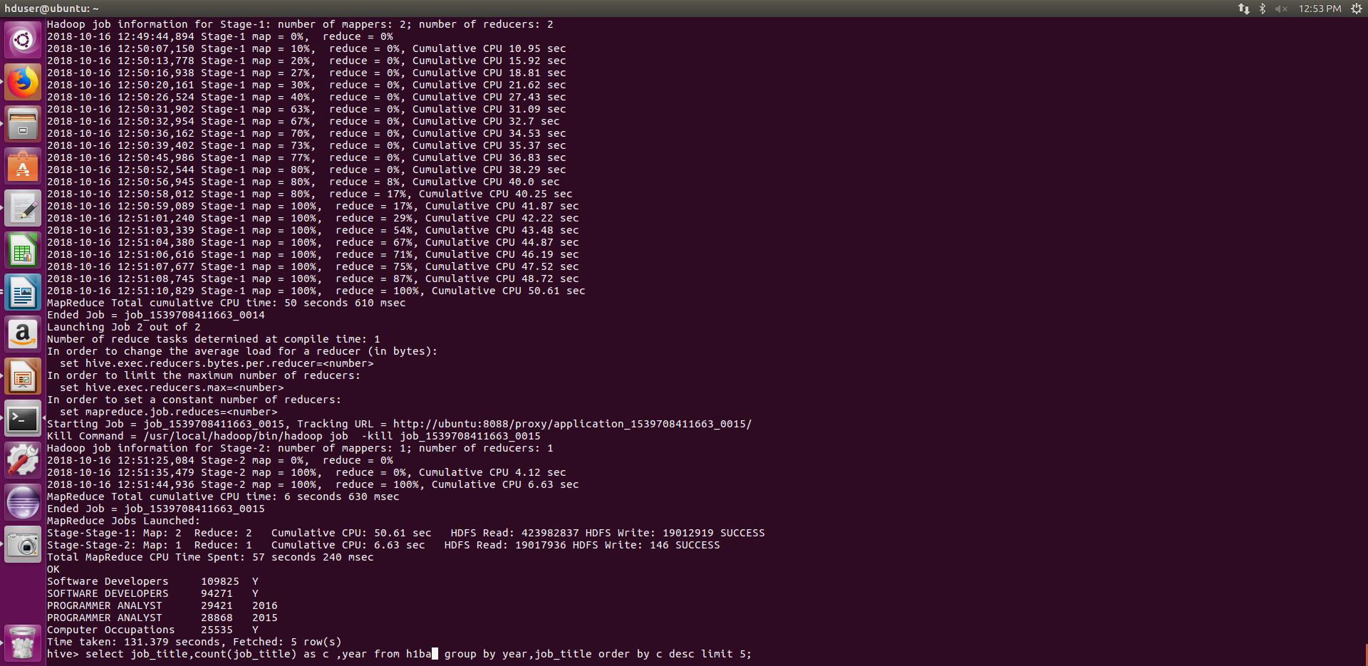

8) Find the average Prevailing Wage for each Job for each Year (take part time and full time separate)

select avg(prevailing_wage),job_title,year from h1ba group by job_title,year

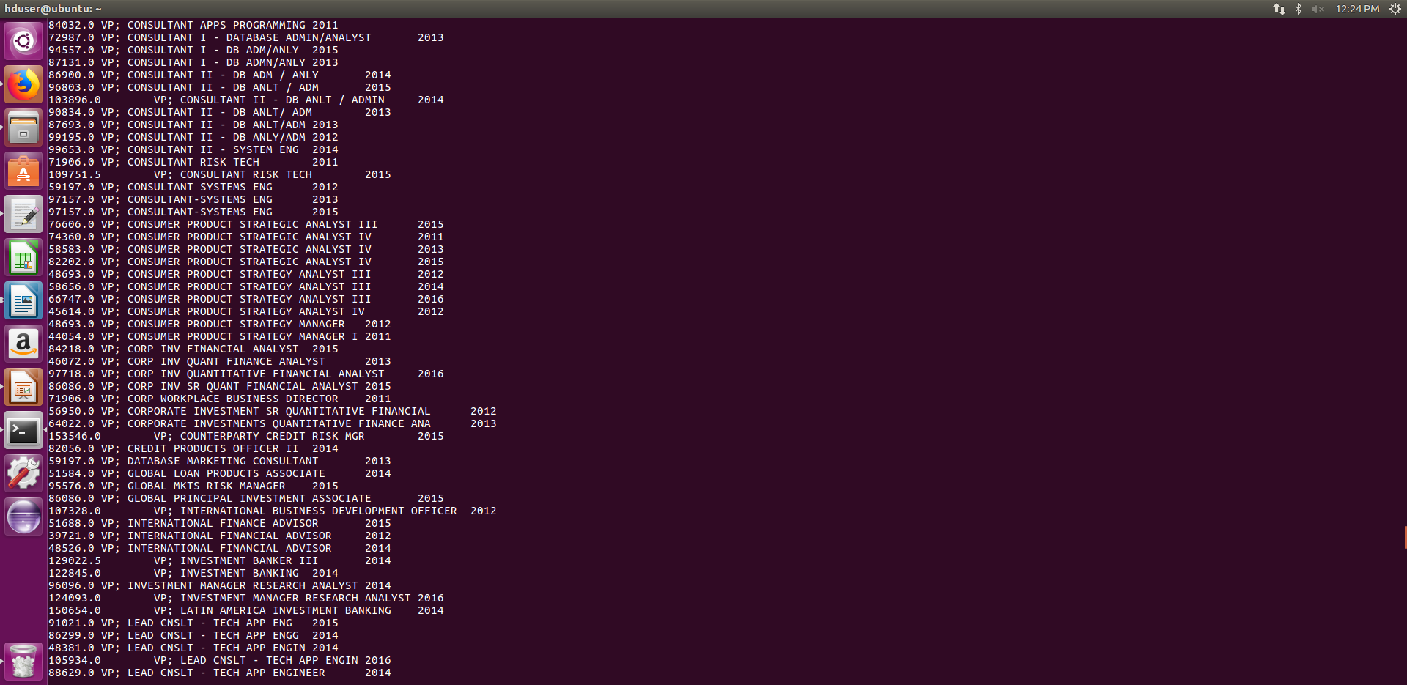
9) Which are top ten employers who have the highest success rate in petitions?

select employer_name,ROUND((count(*)*100/3002048),2) as c1 from h1ba where case_status='CERTIFIED-WITHDRAWN' or case_status='CERTIFIED' group by employer_name order by c1 desc limit 10
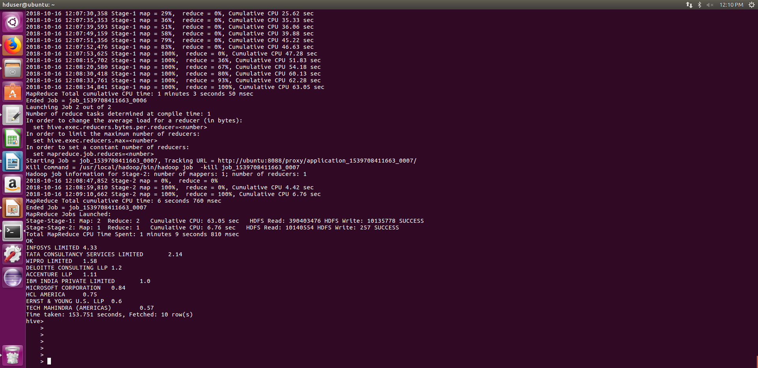
10) Which are the top 10 job positions which have the highest success rate in petitions?

select job_title,ROUND((count(*)*100/3002048),2) as c1 from h1ba where case_status='CERTIFIED-WITHDRAWN' or case_status='CERTIFIED' group by job_title order by c1 desc limit 10

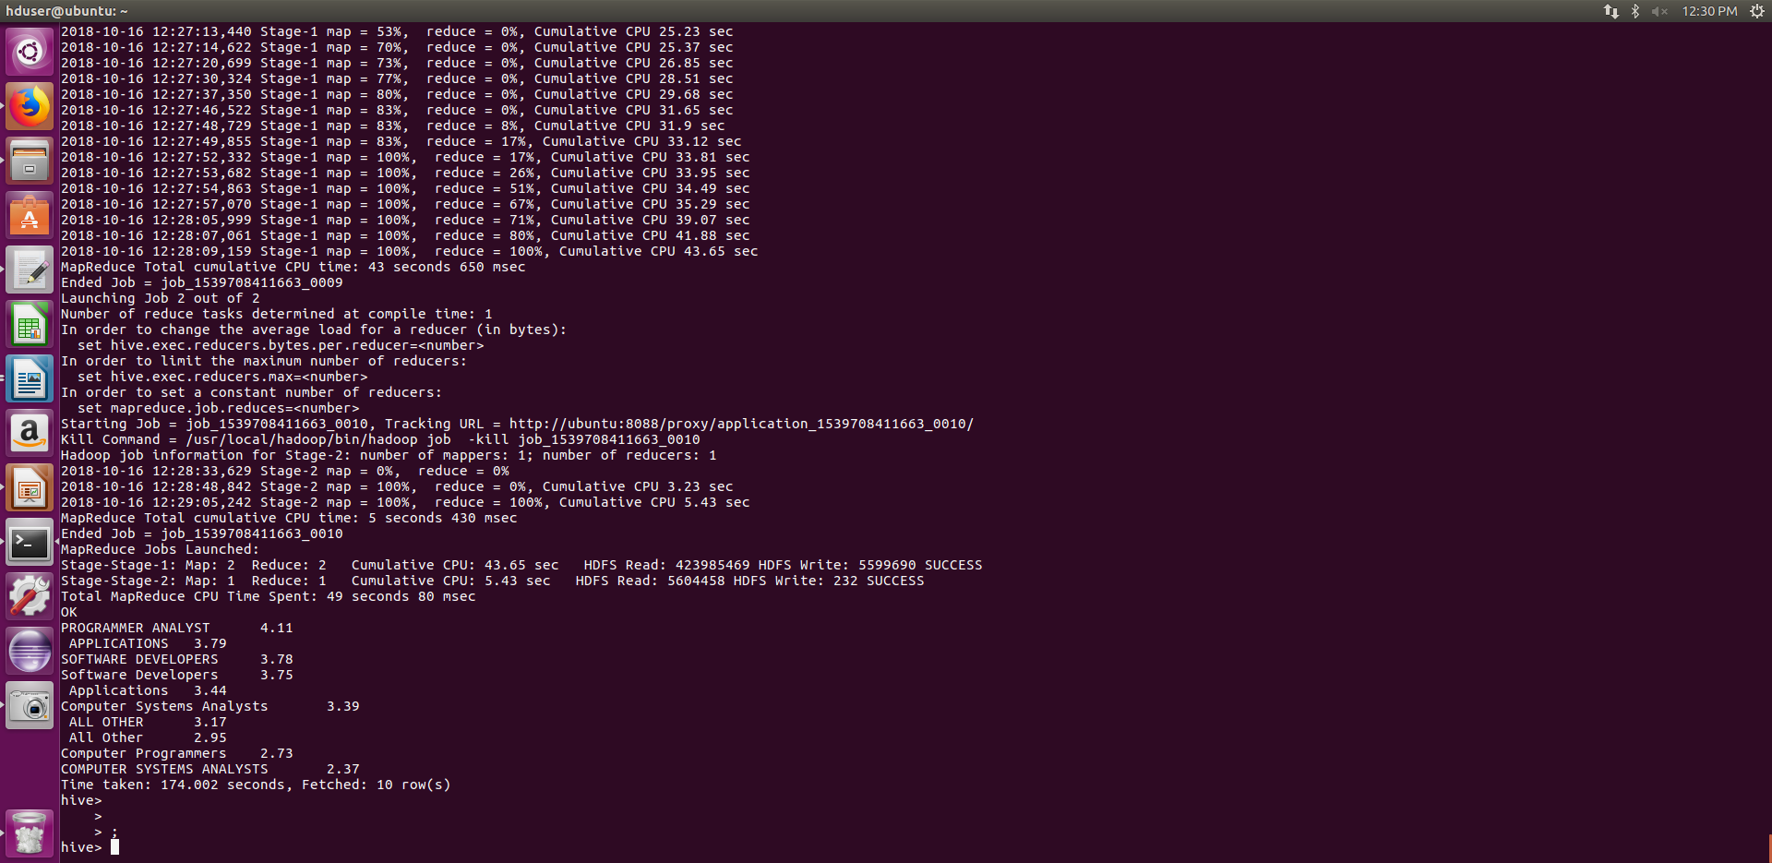
PIG

2 a) Which part of the US has the most Data Engineer jobs for each year?

a = load 'file:///home/divya/Documents/project/h1bs1' using PigStorage (',') as (id,cs,empname,socname,soccode,jobtitle,ftpos,wage,year,loc,lat,long);

b= filter a by jobtitle=='DATA ENGINEER';

c= foreach b generate jobtitle,year,loc;

split c into res1 if (year==2011) , res2 if (year==2012), res3 if (year==2013), res4 if (year==2014), res5 if (year==2015);

d= group res1 by ($1,$2);

e= foreach d generate group, COUNT(res1.$0);

f= group res2 by ($1,$2);

g= foreach f generate group, COUNT(res2.$0);

h= group res3 by ($1,$2);

i= foreach h generate group, COUNT(res3.$0);

j= group res4 by ($1,$2);

k= foreach j generate group, COUNT(res4.$0);

l= group res5 by ($1,$2);

m= foreach l generate group, COUNT(res5.$0);

n = order e by $1 desc;

o = order g by $1 desc;

p = order i by $1 desc;

q = order k by $1 desc;

r = order m by $1 desc;

s = limit n 1;

t = limit o 1;

u = limit p 1;

v = limit q 1;

w = limit r 1;

aa= union s,t;

bb= union aa,u;

cc= union bb,v;

dd= union cc,w;

dump dd;

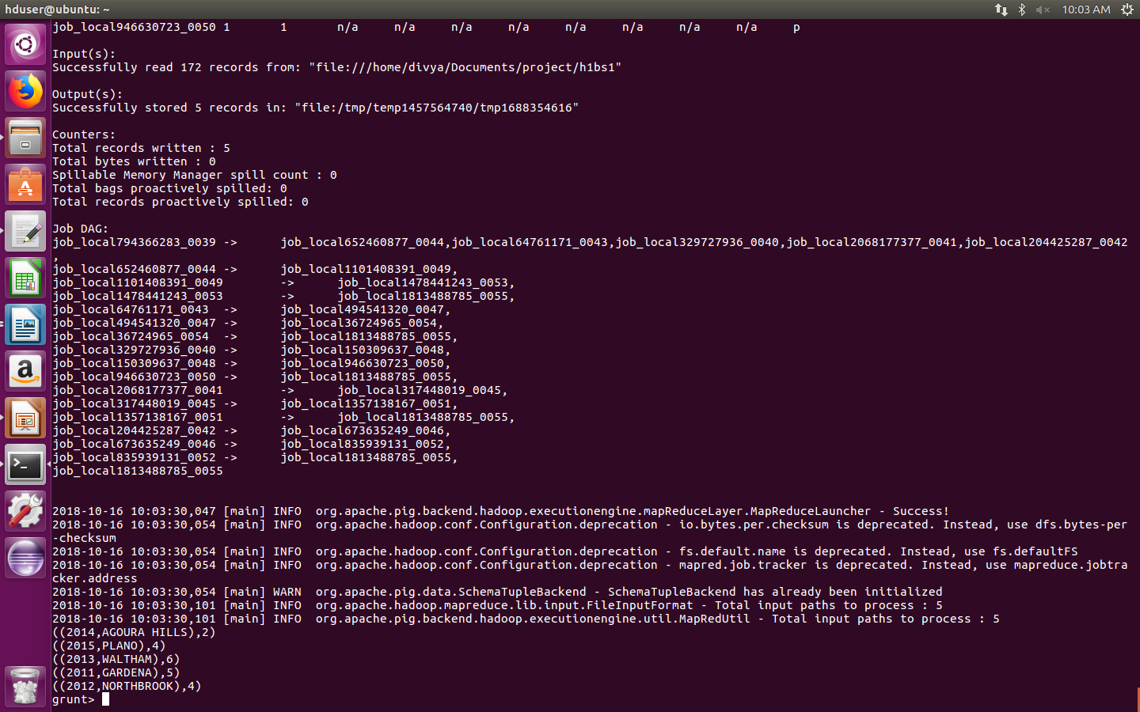
2 b) find top 5 locations in the US who have got certified visa for each year.

a = load 'file:///home/divya/Documents/project/h1bs1' using PigStorage (',') as (id,cs,empname,socname,soccode,jobtitle,ftpos,wage,year,loc,lat,long);

b= filter a by cs=='CERTIFIED';

c= foreach b generate loc, cs,year;

split c into res1 if (year==2011) , res2 if (year==2012), res3 if (year==2013), res4 if (year==2014), res5 if (year==2015);

d= group res1 by ($0,$2);

e= foreach d generate group, COUNT(res1.$1);

f= group res2 by ($0,$2);

g= foreach f generate group, COUNT(res2.$1);

h= group res3 by ($0,$2);

i= foreach h generate group, COUNT(res3.$1);

j= group res4 by ($0,$2);

k= foreach j generate group, COUNT(res4.$1);

l= group res5 by ($0,$2);

m= foreach l generate group, COUNT(res5.$1);

n = order e by $1 desc;

o = order g by $1 desc;

p = order i by $1 desc;

q = order k by $1 desc;

r = order m by $1 desc;

s = limit n 5;

t = limit o 5;

u = limit p 5;

v = limit q 5;

w = limit r 5;

aa= union s,t;

bb= union aa,u;

cc= union bb,v;

dd= union cc,w;

dump dd;

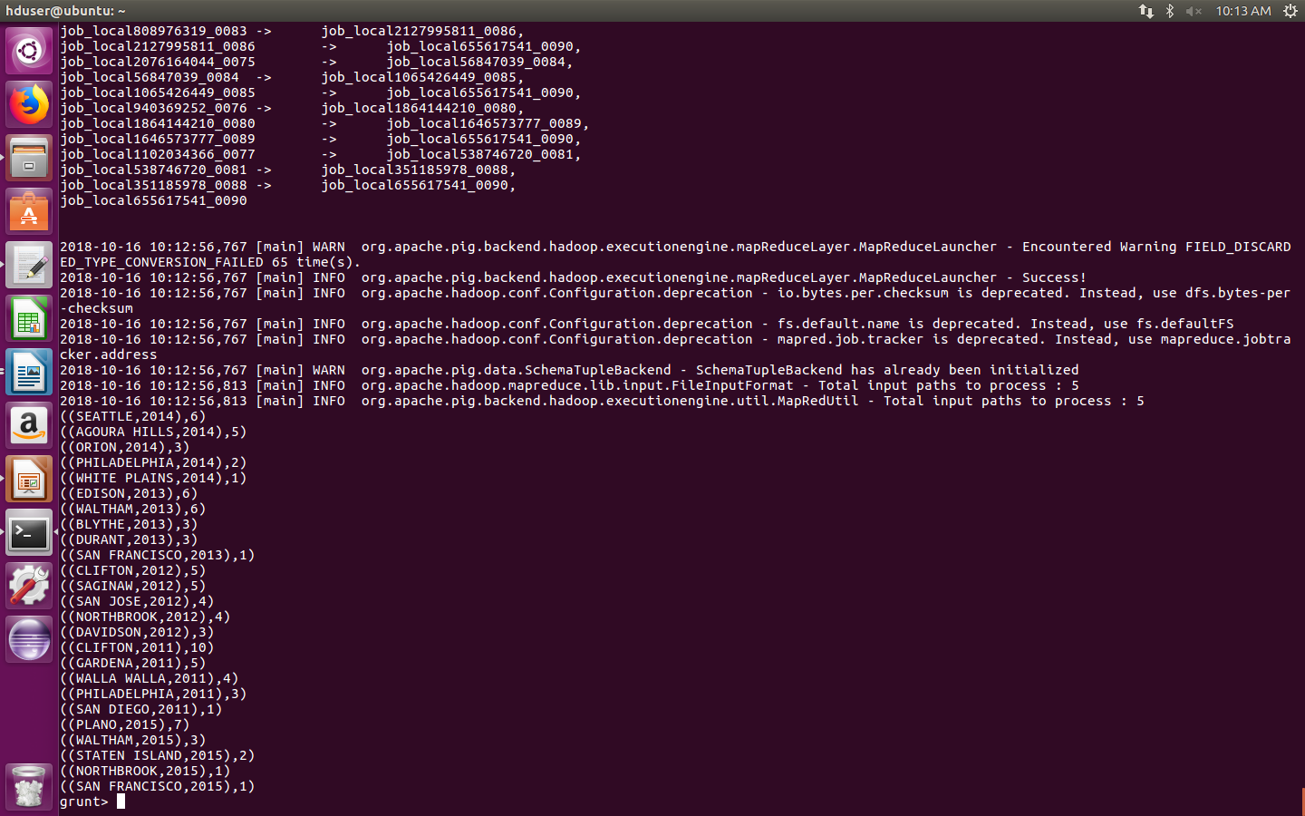
4)Which top 5 employers file the most petitions each year?

a = load 'file:///home/divya/Documents/project/h1bs1' using PigStorage (',') as (id,cs,empname,socname,soccode,jobtitle,ftpos,wage,year,loc,lat,long);

c= foreach a generate empname, cs,year;

split c into res1 if (year==2011) , res2 if (year==2012), res3 if (year==2013), res4 if (year==2014), res5 if (year==2015);

d= group res1 by ($0,$2);

e= foreach d generate group, COUNT(res1.$1);

f= group res2 by ($0,$2);

g= foreach f generate group, COUNT(res2.$1);

h= group res3 by ($0,$2);

i= foreach h generate group, COUNT(res3.$1);

j= group res4 by ($0,$2);

k= foreach j generate group, COUNT(res4.$1);

l= group res5 by ($0,$2);

m= foreach l generate group, COUNT(res5.$1);

n = order e by $1 desc;

o = order g by $1 desc;

p = order i by $1 desc;

q = order k by $1 desc;

r = order m by $1 desc;

s = limit n 5;

t = limit o 5;

u = limit p 5;

v = limit q 5;

w = limit r 5;

aa= union s,t;

bb= union aa,u;

cc= union bb,v;

dd= union cc,w;

dump dd;

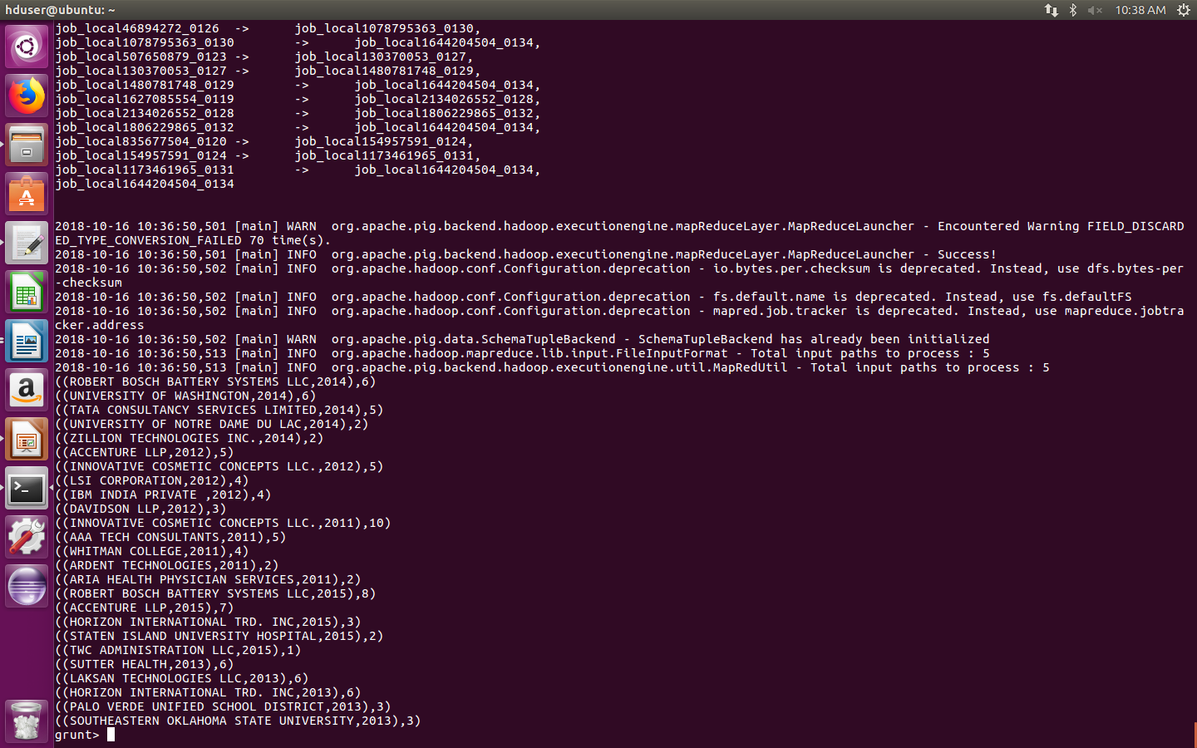
7) Depict the number of applications for each year

a = load 'file:///home/divya/Documents/project/h1bs1' using PigStorage (',') as (id,cs,empname,socname,soccode,jobtitle,ftpos,wage,year,loc,lat,long);

c= foreach a generate cs,year;

split c into res1 if (year==2011) , res2 if (year==2012), res3 if (year==2013), res4 if (year==2014), res5 if (year==2015);

d= group res1 by ($0,$1);

e= foreach d generate group, COUNT(res1.$0);

f= group res2 by ($0,$1);

g= foreach f generate group, COUNT(res2.$0);

h= group res3 by ($0,$1);

i= foreach h generate group, COUNT(res3.$0);

j= group res4 by ($0,$1);

k= foreach j generate group, COUNT(res4.$0);

l= group res5 by ($0,$1);

m= foreach l generate group, COUNT(res5.$0);

n= union e,g;
o= union n,i;
p= union o,k;
q= union p,m;

dump q;

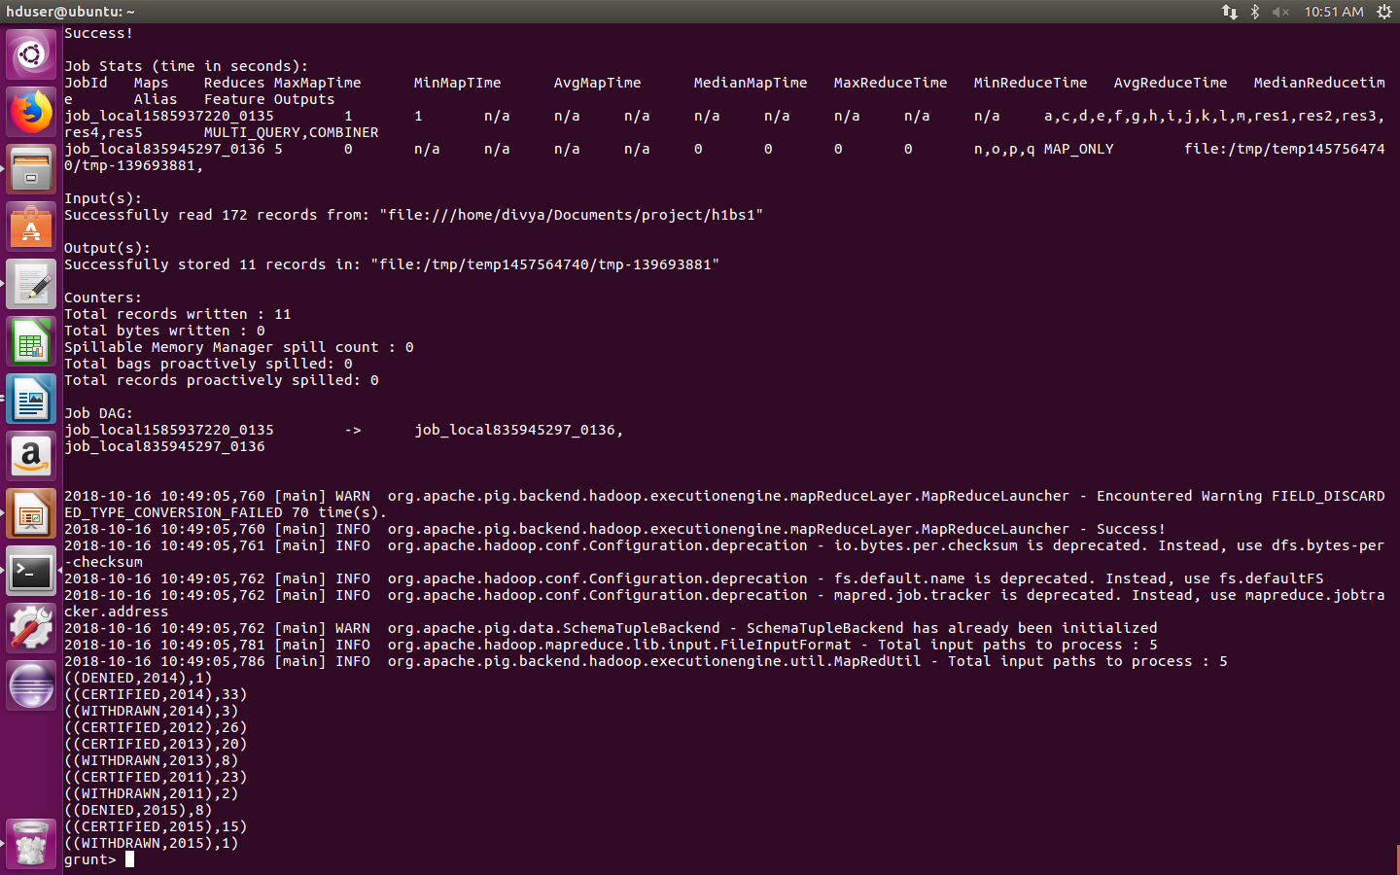
SQOOP

11) Export result for question no 10 to MySql database.

Hive> insert overwrite directory '/niit' select job_title, ROUND((count(*) * 100/3002048),2) as c1 from h1b where case_status = "CERTIFIED" or case_status= "CERTIFIED-WITHDRAWN" group by job_title order by c1 desc limit 10;

hduser: $ sqoop export --connect jdbc:mysql://localhost/db1 --username root --password 'root' --table h --export-dir /hanoi/000000_0 --input-fields-terminated-by ',' ;
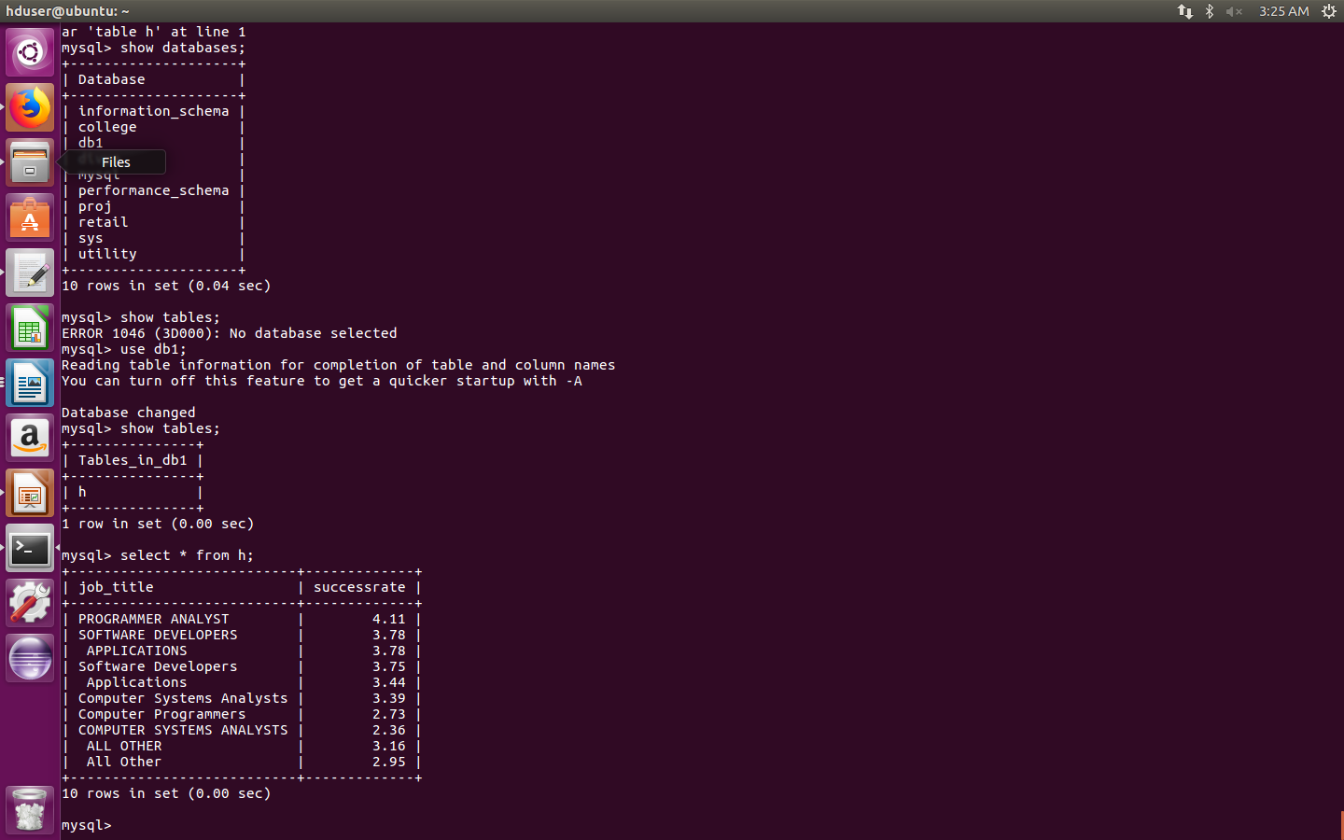

CONCLUSION

Thus, using tools like mapreduce java, pig, hive, sqoop, flume etc. we were able to perform the necessary analysis on big datasets have millions of records. It also proved to be very efficient, time-saving and easy to process the data including unstructured data.

The availability of Big Data, low-cost commodity hardware, and new information management and analytic software have produced a unique moment in the history of data analysis. The convergence of these trends means that we have the capabilities required to analyze astonishing data sets quickly and cost-effectively for the first time in history. These capabilities are neither theoretical nor trivial. They represent a genuine leap forward and a clear opportunity to realize enormous gains in terms of efficiency, productivity, revenue, and profitability.

