KHS Portal

Website: [‎4/‎21/‎2020 1:31 PM] Lindy Sodenkamp:

[https://sapportal.khs.com/lp_pa(bD1kZSZjPTAxMCZkPW1pbg==)/plogin.do?sap-unique=100022](https://sapportal.khs.com/lp_pa%28bD1kZSZjPTAxMCZkPW1pbg==%29/plogin.do?sap-unique=100022)

Partner number:LI00089339

Username: REXNO02

Password: rex2016

Contact: Mr. Hillringhaus, Email:  [frank.hillringhaus@khs.com](mailto:frank.hillringhaus@khs.com), Tel. 0231/569-1782

How do I process an order ?

Go to "Orders" on the home page.

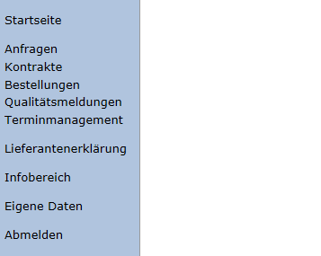

Here you can find all open orders.

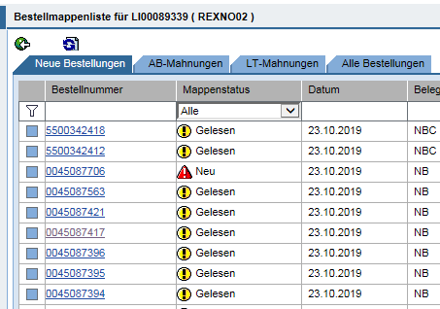

We now store the orders on the server.

The order is entered.

If all information such as price + delivery time is known, we confirm the order in the KHS portal. To do this, we go to the first line and enter the desired order number.

Search for an order (in this example 45073988)

Go to the order number

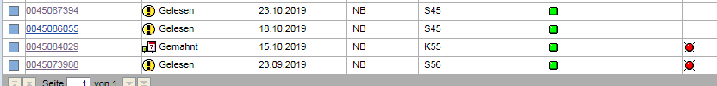

Go to the "Order Confirmation" tab

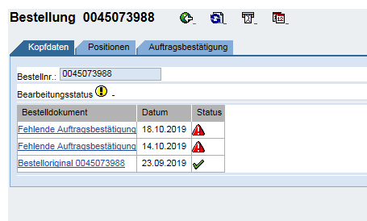

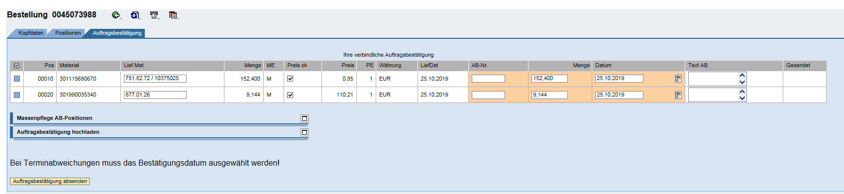

Field "Lief.mat. " Please check our code and, if necessary, change or supplement it

Field "Price 🡪 ok" Is our price correct ? If so, leave hooks in the box. If no then remove the hook and enter the correct price in the "Text AB" field

Field "AB No." 🡪 Enter our order number

Field "Quantity" 🡪 If we have the same quantity as ordered, do not change. If we have another quantity then please enter the correct quantity

Field "Enter 🡪 our delivery date date on date

If all this has been checked, we can send the "Order Confirmation".