[ExceptionDemo.java](https://vscode.dev/github/DivyaRasania/SDEV200-B1B/blob/main/ch10/YouDoIt/ExceptionDemo.java)

dialog box 1
 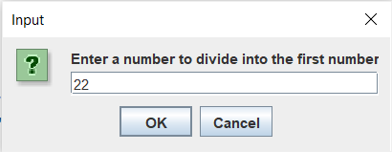

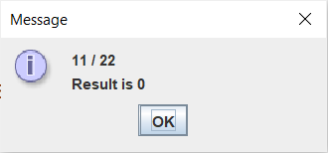

[ExceptionDemo2.java](https://vscode.dev/github/DivyaRasania/SDEV200-B1B/blob/main/ch10/YouDoIt/ExceptionDemo2.java)

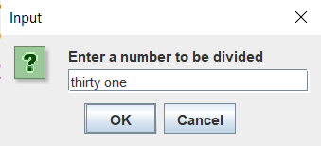

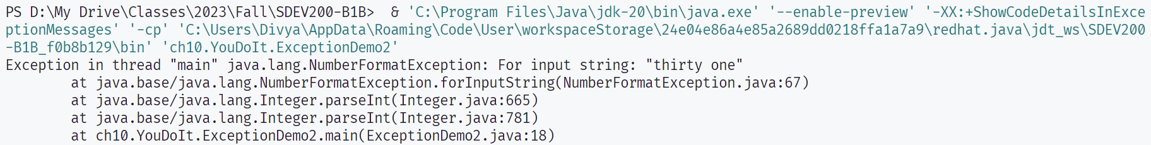

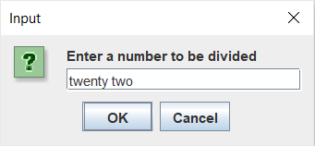 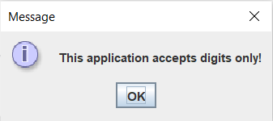

[Menu.java](https://vscode.dev/github/DivyaRasania/SDEV200-B1B/blob/main/ch10/YouDoIt/Menu.java)

[PickMenu.java](https://vscode.dev/github/DivyaRasania/SDEV200-B1B/blob/main/ch10/YouDoIt/PickMenu.java)

[PlanMenu.java](https://vscode.dev/github/DivyaRasania/SDEV200-B1B/blob/main/ch10/YouDoIt/PlanMenu.java)

[VegetarianMenu.java](https://vscode.dev/github/DivyaRasania/SDEV200-B1B/blob/main/ch10/YouDoIt/VegetarianMenu.java)

[PlanVegetarianMenu.java](https://vscode.dev/github/DivyaRasania/SDEV200-B1B/blob/main/ch10/YouDoIt/PlanVegetarianMenu.java)

[CalculatorDemo.java](https://vscode.dev/github/DivyaRasania/SDEV200-B1B/blob/main/ch10/YouDoIt/CalculatorDemo.java)

