**Collocation answers**

**Divya Trichy Ravi**

**● How complete your program is. Even if your program is not complete or you are getting  
compilation errors, you will get partial credit proportionally. Just mention clearly and  
accurately how far you got.**

1. The program was constructed using the given clear instruction.
2. The collocations.py contains two user-defined functions pmi and chi-square.
3. These two functions read the data, process it and extract the core features and own features.
4. To run this program download the zip file SBD_HW1 and extract it.
5. Place it in a respective directory and open command prompt inside that directory.
6. Using this command python collocations.py colloctions.txt.
7. Here the two different functions
   1. PMI – Pointwise Mutual Information
   2. Chi-square

● **If your program is complete, the top 20 bigrams along with their chi-square scores, in  
reverse order of the scores.**

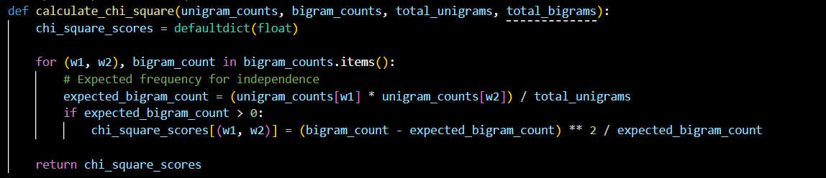

|  |  |
| --- | --- |
| **Bigram** | **Chi – Square Values** |
| Golf Course | 428743.0000 |
| multi-spired castle-like | 428743.0000 |
| Traveling Abroad | 428743.0000 |
| Three-month T-bill | 428743.0000 |
| Competing asset-allocation | 428743.0000 |
| Mill Playhouse | 428743.0000 |
| Perfect Witness | 428743.0000 |
| Witness Aidan | 428743.0000 |
| Stockard Channing | 428743.0000 |
| Final Days | 428743.0000 |
| Brideshead Revisited | 428743.0000 |
| schizoid horror | 428743.0000 |
| Performances kicks | 428743.0000 |
| Polished hooves | 428743.0000 |
| Shiny Nikes | 428743.0000 |
| Glory Enough | 428743.0000 |
| Ku Klux | 428743.0000 |
| Klux Klan | 428743.0000 |
| Latest Period | 428743.0000 |
| slow-growth low-profit | 428743.0000 |

● **If your program is complete, the top 20 bigrams along with their PMI scores, in reverse  
order of the scores.**

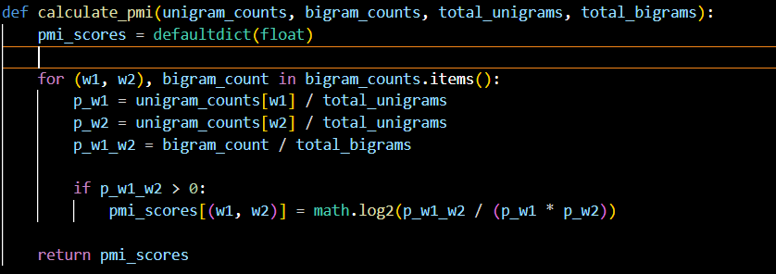

|  |  |
| --- | --- |
| **Bigram** | **PMI -Values** |
| Golf Course | 18.7098 |
| multi-spired castle-like | 18.7098 |
| Traveling Abroad | 18.7098 |
| Three-month T-bill | 18.7098 |
| Competing asset-allocation | 18.7098 |
| Mill Playhouse | 18.7098 |
| Perfect Witness | 18.7098 |
| Witness Aidan | 18.7098 |
| Stockard Channing | 18.7098 |
| Final Days | 18.7098 |
| Brideshead Revisited | 18.7098 |
| schizoid horror | 18.7098 |
| Performances kicks | 18.7098 |
| Polished hooves | 18.7098 |
| Shiny Nikes | 18.7098 |
| Glory Enough | 18.7098 |
| Ku Klux | 18.7098 |
| Klux Klan | 18.7098 |
| Latest Period | 18.7098 |
| slow-growth low-profit | 18.7098 |

● **A brief discussion of which of the two measures you believe works better to identify  
collocations, based on your analysis of the top 20 bigrams produced by each measure.**

Therefore, when it comes to determining the effectiveness of Chi-square and PMI in identifying collocations within big datasets, Chi-square is somewhat better suited for handling this. The strong robustness that it possesses in handling large sizes means its test of independence is ideally more effective in bringing on board crucial word associations that cut across in diverse contexts. Chi-square is different from PMI because the latter is sensitive to data sparsity and frequently occurring common words, which tend to give misleading results; Chi-square provides meaningful outcomes without easily being distorted by the size of the dataset. Therefore, the Chi-square method is the favorite option when it comes to large datasets where reliable statistical analysis is necessary in the search for truly correct collocations.