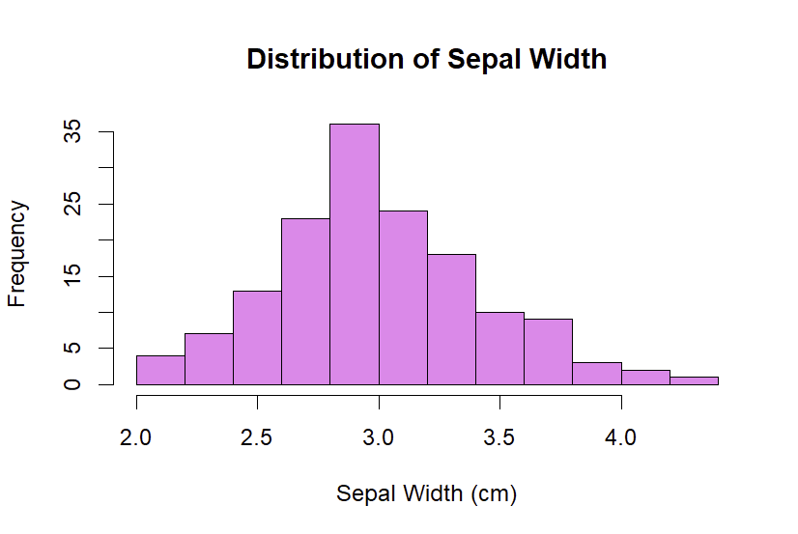
- The dataset consists of four numeric variables (Sepal.Length, Sepal.Width, Petal.Length, Petal.Width) and one categorical variable (Species).
- To explore the numeric variables, I created a histogram of Sepal.Width.
- While Sepal.Width was chosen for visualization, the other numeric variables (Sepal.Length, Petal.Length, Petal.Width) can also be analyzed using similar plots. The categorical variable Species contains three categories: setosa, versicolor, and virginica.

- Range: 2.4
IQR: 0.5
25th percentile (Q1): 2.8
75th percentile (Q3): 3.3

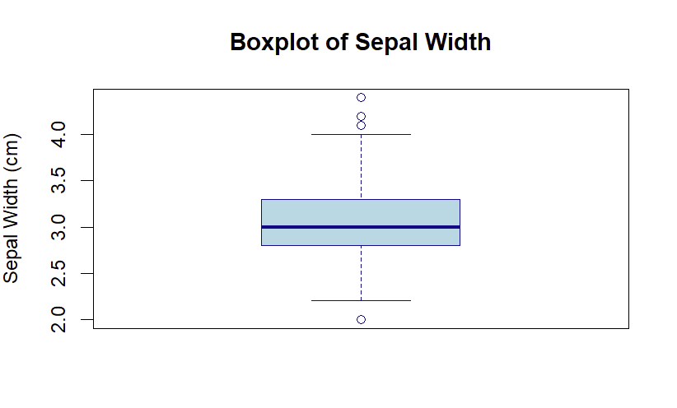
The distribution of Sepal Width is slightly right skewed. The histogram shows a longer right tail, and the boxplot confirms this with outliers on the higher end of the scale.

- Variance: 0.189979418344519
Standard Deviation: 0.435866284936698

