BAR GRAPH
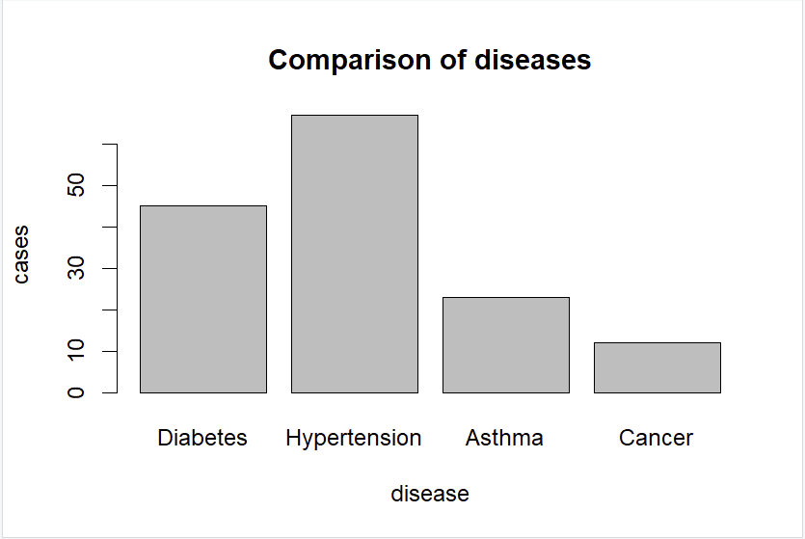
The bar chart shows the number of cases for each disease. Hypertension has the highest number of cases, while Cancer has the lowest.

PIE CHART
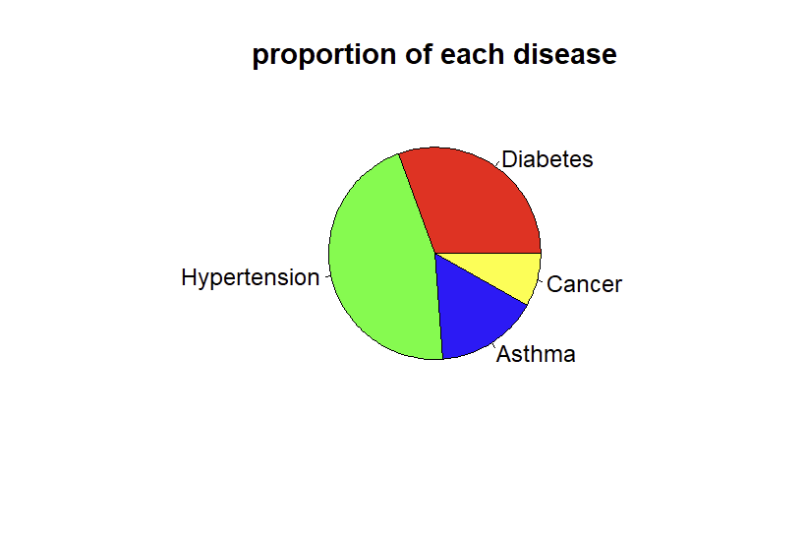
The pie chart illustrates the proportion of cases among diseases. Hypertension accounts for the largest share, while Cancer represents the smallest share.
LINE GRAPH
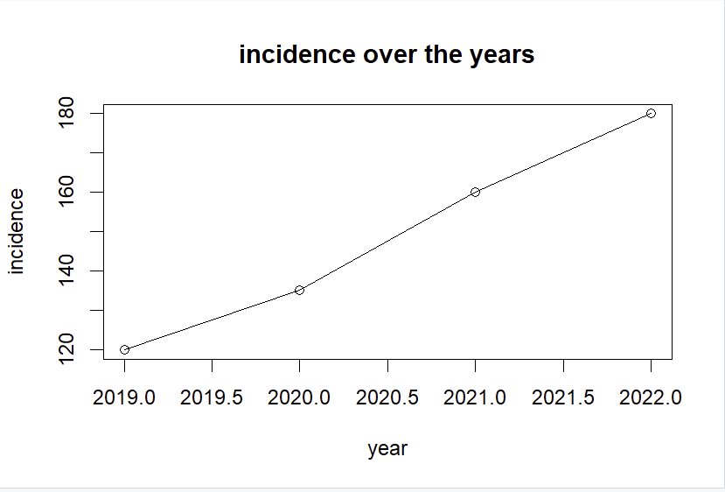
The line graph displays disease incidence from 2019 to 2022. The incidence steadily increases over time, and reaches highest point in 2022.

