Data loading and exploration
- There aren’t any missing values.

Interpretations:

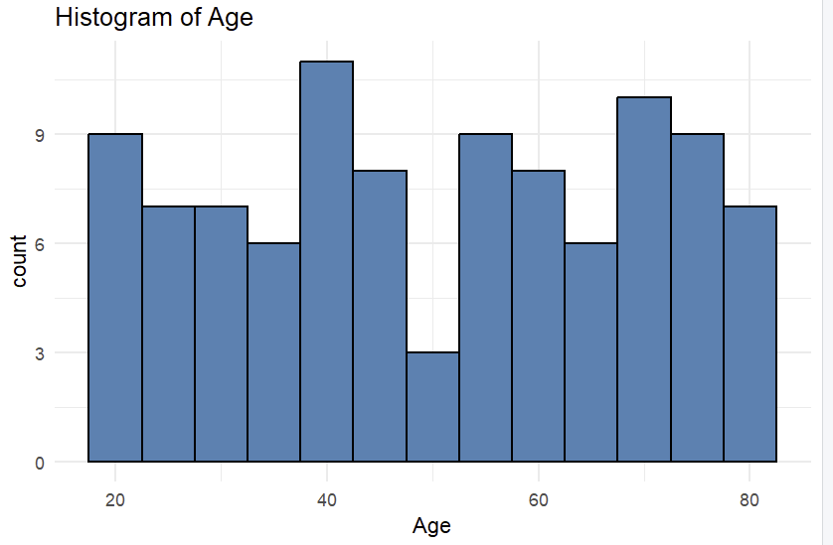
Ages are spread widely from 19 to 79, with no strong peaks, suggesting a well-distributed age range. This allows analysis across young, middle-aged, and older adults.

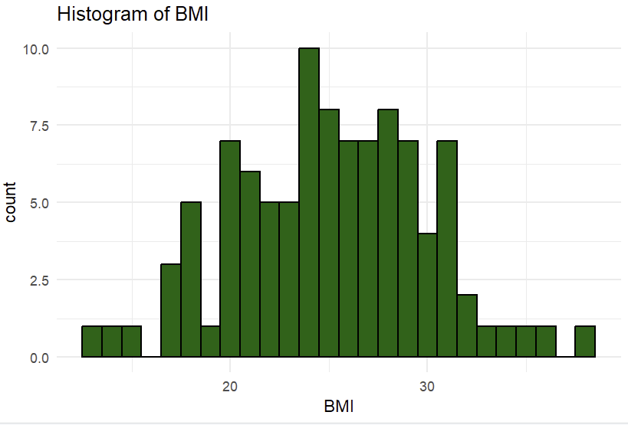
BMI values are mostly between 20 and 30, showing a roughly normal distribution with few very low or very high values. This suggests the sample includes primarily healthy to overweight individuals.
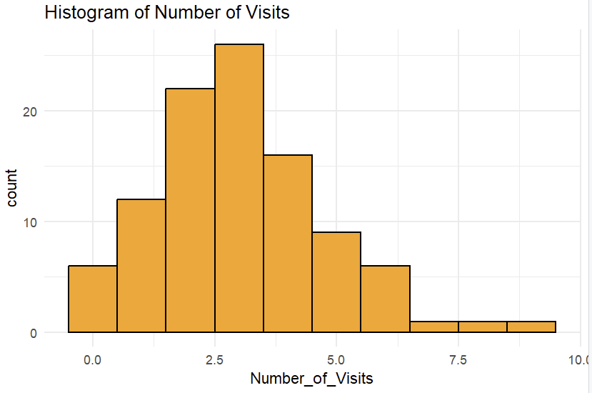
Most patients visit the hospital 2–4 times per year, with fewer high-frequency visitors above 6 visits. The distribution is slightly right-skewed due to a small number of frequent visitors.

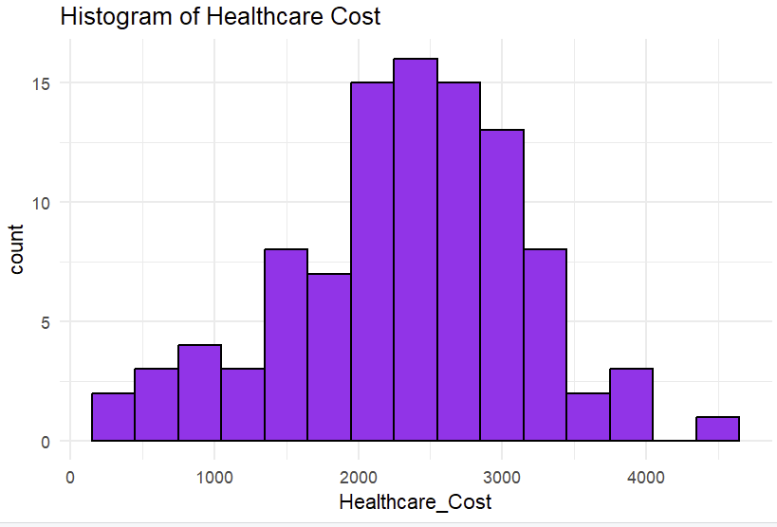
Healthcare costs cluster between $1500 and $3000, with fewer patients having very high or very low expenses. The distribution is moderately right-skewed, indicating some high-cost outliers.
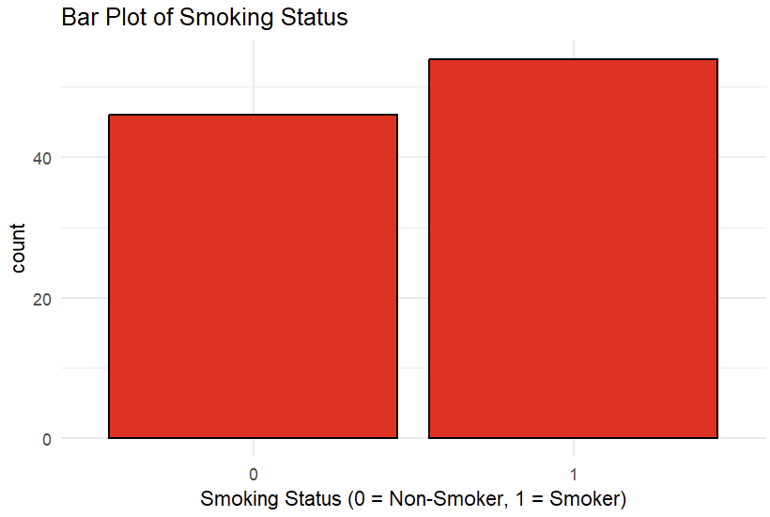
The dataset contains slightly more smokers than non-smokers. This provides a balanced comparison group for analyzing smoking effects on healthcare cost.

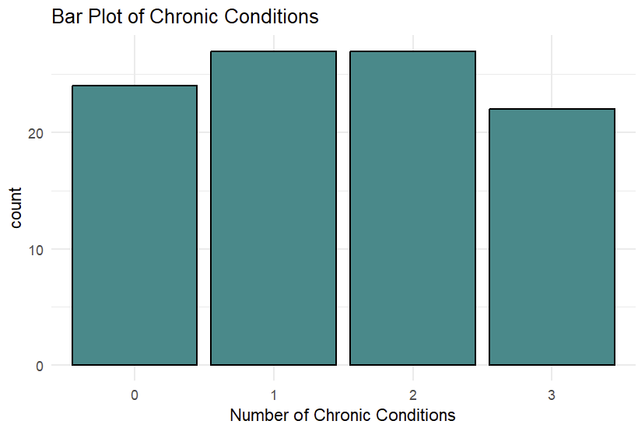
Most patients have 1 or 2 chronic conditions, while fewer have 0 or 3. This indicates that chronic illness is common in the sample and may influence healthcare cost.

Define and fit the model
Based on data exploration:
- Number_of_Visits - Likely significant
  - More hospital visits usually lead to higher healthcare costs.
- Chronic_Conditions - Likely significant
  - Patients with more chronic illnesses typically incur higher costs.
- BMI - Might be moderately significant
  - Higher BMI can indicate health risks that increase medical expenses.
- Age - Could be significant
  - Older patients often require more healthcare services.
- The regression model explains about 50% of the variation in healthcare costs and is statistically significant overall (p < 0.001).
- Age and chronic conditions are significant predictors, indicating that older individuals and those with more chronic illnesses incur higher healthcare costs. BMI and number of visits show weak, borderline significance, suggesting they may have some influence but are not strong predictors in this model.

Interpret the Results
1. Impact of Each Predictor on Healthcare_Cost
Age
- Coefficient: 27.44
- Interpretation:
For every 1-year increase in age, healthcare cost increase by about $27.44, holding all other variables constant.
- Older patients tend to incur higher healthcare expenses.
BMI
- Coefficient: 20.99
- Interpretation:
For each 1-unit increase in BMI, healthcare cost increases by about $20.99, assuming other variables remain constant.
- Higher BMI is associated with slightly higher healthcare costs, but this effect is weak.

Number_of_Visits
- Coefficient: 60.81
- Interpretation:
Each additional hospital visit is associated with approximately $60.81 higher healthcare cost on average.
- Costs tend to rise with more frequent use of healthcare services.

Chronic_Conditions
- Coefficient: 158.62
- Interpretation:
Each additional chronic condition increases healthcare costs by about $158.62, holding other factors constant.
- Chronic illness is strongly associated with higher medical expenses.

2. Statistical significance:
- Age: Age is statistically significant (p < 0.05), meaning older patients tend to have higher healthcare costs.
- BMI: BMI is not statistically significant (p > 0.05), so its effect on healthcare cost is not strong or reliable.
- Number_of_Visits: Number of visits is not statistically significant (p > 0.05), indicating only a weak or uncertain impact on cost.
- Chronic_Conditions: Chronic conditions are statistically significant (p < 0.05), showing that more chronic illnesses strongly increase healthcare costs.

3. Model Fit Evaluation
R-squared = 0.5238
- The model explains 52.38% of the variation in healthcare costs.
- Indicates a moderate fit.
Adjusted R-squared = 0.5038
- After adjusting for the number of predictors, the model still explains 50.38% of the variability.
- Suggests the predictors included meaningfully contribute to explaining healthcare costs.

Model diagnostic and assumptions
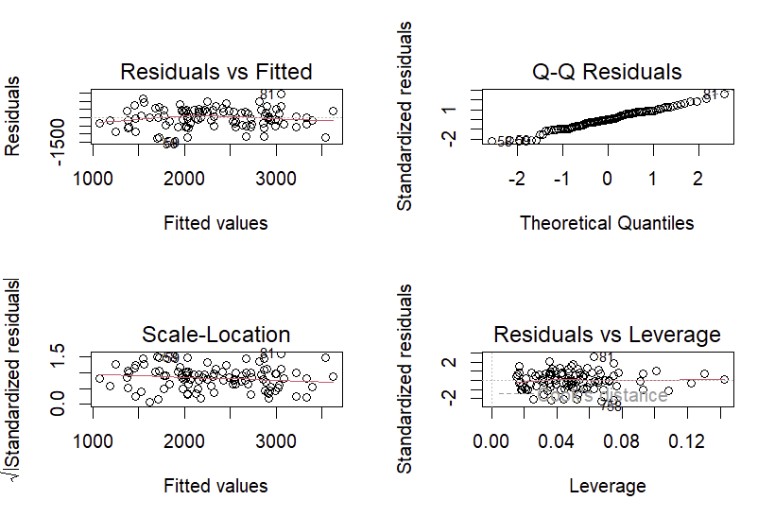
1. Linearity (Residuals vs Fitted)
The residuals appear randomly scattered with no clear pattern, suggesting the linearity assumption is reasonably met.
2. Normality of Errors (Q–Q Plot)
Most points follow the diagonal line with slight deviations at the ends, indicating the residuals are approximately normal.
3. Homoscedasticity (Scale-Location Plot)
The spread of residuals is even across fitted values, showing no major heteroscedasticity issues.
4. Outliers & Influence (Residuals vs Leverage)
A few points show higher leverage, but none exceed Cook’s distance, meaning no strongly influential outliers.

Refining Model: The refined model, which includes only Age and Chronic_Conditions, is simpler and more interpretable since it retains only the statistically significant predictors. Although the Adjusted R² decreased slightly from 0.5038 to 0.4798, indicating a small reduction in explanatory power, the refined model still captures most of the variation in healthcare costs. Removing BMI and Number_of_Visits did not substantially harm the model’s performance, showing they were not contributing meaningful predictive value. Overall, the refined model is more concise, easier to interpret, and remains statistically strong despite the slight drop in fit.

