2.
1.
- Enrichment map of differentially expressed genes between treated and untreated at 12 hours
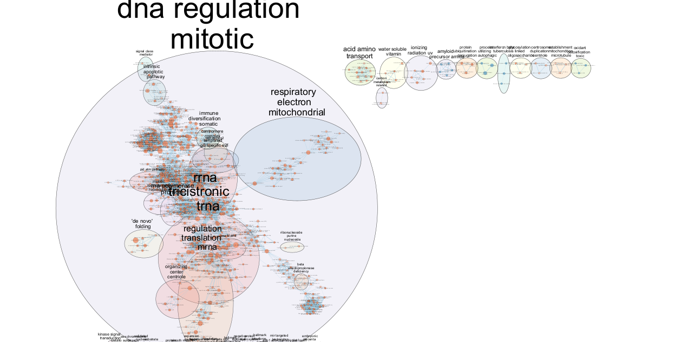
At 12h, estrogen is rapidly activating genes tied to transcriptional control and protein synthesis classic early response genes.

- Enrichment map of differentially expressed genes between treated and untreated at 24 hours
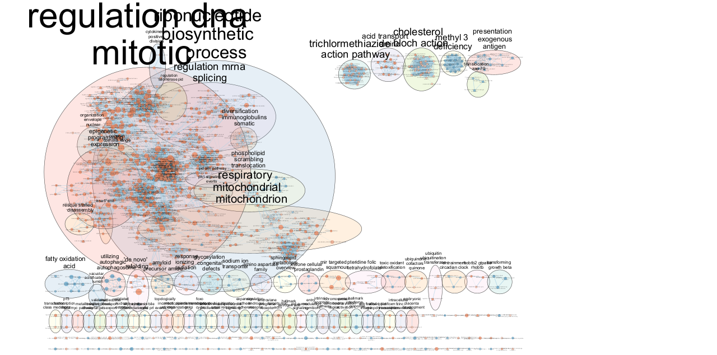
At 24h, the cell is responding to earlier signaling by activating long-term programs like metabolism, immune signaling, and chromatin remodeling.

2. Comparing the heatmaps at 12h and 24h reveals a temporal shift in biological response to estrogen. At 12h, the response is dominated by early transcriptional programs including mRNA processing, tRNA biosynthesis, and mitotic entry. By 24h, these processes broaden to include mitochondrial metabolism, immune signaling, and epigenetic regulation.
This highlights the importance of analyzing timepoints independently, as combining them could mask transient or sequential effects. Early gene activation (12h) initiates transcription, while later responses (24h) implement downstream cellular changes like metabolic remodeling and immune signaling.
Therefore, in estrogen treatment studies, time-resolved analysis is crucial to capture dynamic, phase-specific biological responses.

