Velvet Data: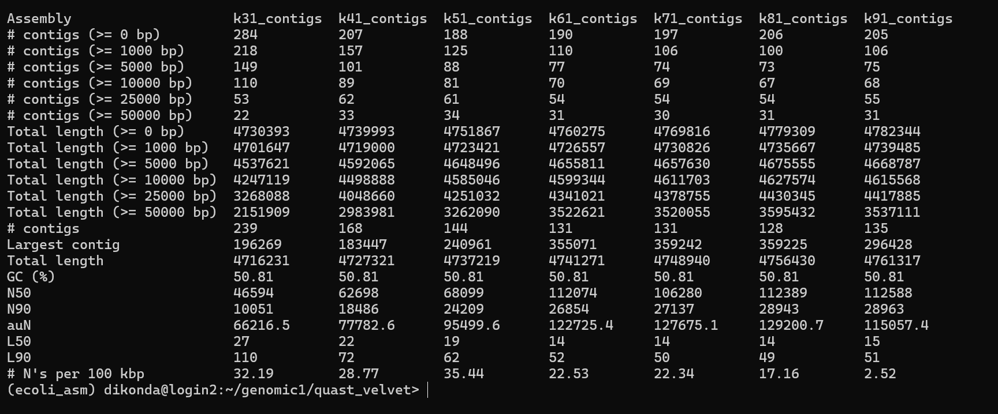
Oases Data:
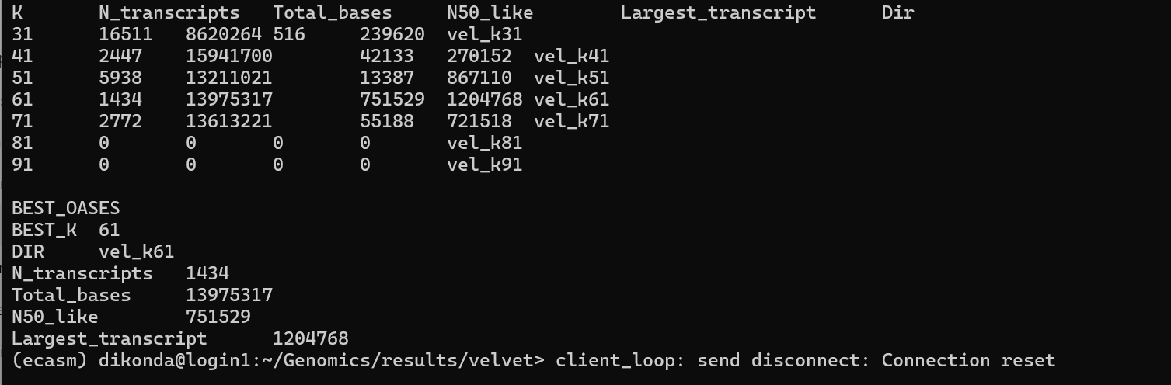
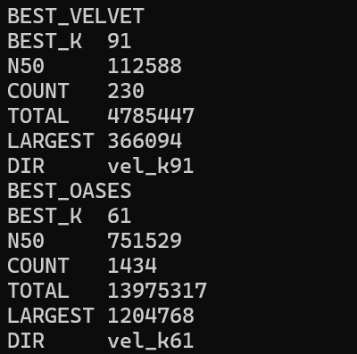
- Genome assembly was performed using both Velvet and Oases at multiple k-mer values (31, 41, 51, 61, 71, 81, and 91).
- For Velvet, the optimal assembly was achieved at k = 91, with an N50 of 112,588 bp, 230 contigs, a total assembly length of 4.79 Mb, and the largest contig measuring 366,094 bp.
For Oases, the best performance was obtained at k = 61, yielding a much higher N50-like of 751,529 bp, but with 1,434 transcripts and a total base count of 13.98 Mb, with the largest transcript at 1,204,768 bp.
- Although Oases produced longer N50 values, it is designed primarily for transcriptome assembly and generated many more fragments, inflating total assembly length beyond the expected E. coli genome size. In contrast, Velvet generated a more accurate, coherent genome assembly closer to the known size (4.6 Mb).
- Therefore, Velvet is the more suitable assembler for this genome dataset.

