CREATE TABLE Items(

ItemId INT PRIMARY KEY,

ItemName VARCHAR(15)

)

CREATE TABLE Shop(

ShopId INT PRIMARY KEY,

ShopName VARCHAR(25)

)

CREATE TABLE UnitDetails

(

UnitID INT PRIMARY KEY,

Unit VARCHAR(15),

Counts INT

)

CREATE TABLE OrderSalesDetails(

ItemId INT,

ShopId INT,

UnitID INT,

Quantity INT,

UnitPrice INT,

SalesDate Date,

CONSTRAINT fk_itemid2 FOREIGN KEY(ItemId)

REFERENCES Items(ItemId),

CONSTRAINT fk_shopid FOREIGN KEY(shopId)

REFERENCES Shop(shopId),

CONSTRAINT fk_unitId FOREIGN KEY(UnitId)

REFERENCES UnitDetails(UnitId)

)

INSERT INTO Items(ItemID,ItemName)

VALUES(1,'Bar-One'),

(2,'Kitkat'),

(3,'Milky Bar'),

(4,'Munch')

INSERT INTO Shop(ShopId,ShopName)

VALUES(1,'Amal Stores'),

(2,'Jyothi Stores'),

(3,'Indira Stores')

INSERT INTO UnitDetails

VALUES(1,'Piece',1),

(2,'BoxPack',28)

INSERT INTO OrderSalesDetails(ItemId,ShopId,UnitId,Quantity,UnitPrice,SalesDate)

VALUES(1,1,1,100,10,'2018-10-05'),

(2,1,1,200,15,'2018-10-05'),

(3,1,1,50,5,'2018-10-05'),

(4,1,1,150,10,'2018-10-05'),

(1,2,2,10,280,'2018-10-10'),

(2,2,2,30,420,'2018-10-10'),

(3,2,2,40,140,'2018-10-10'),

(4,2,2,20,280,'2018-10-10'),

(1,3,2,50,280,'2018-09-15'),

(2,3,2,70,420,'2018-09-15'),

(3,3,2,30,140,'2018-10-15'),

(1,1,1,150,10,'2018-09-15'),

(2,1,1,250,15,'2018-09-15'),

(4,1,1,200,10,'2018-10-15')

--Q1.2

SELECT TOP 1 ItemName,SUM(Quantity*UnitPrice) AS Revenue FROM Items i

INNER JOIN OrderSalesDetails o

ON i.ItemId=o.ItemId

WHERE MONTH(SalesDate)=10

GROUP BY i.ItemName

ORDER BY Revenue DESC

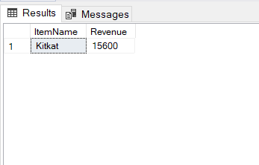

--Q1.3

SELECT TOP 1

i.ItemName,

SUM(o.Quantity) AS TotalQuantitySold

FROM

Items AS i

INNER JOIN OrderSalesDetails AS o ON i.Itemid = o.Itemid

INNER JOIN Shop AS S ON o.shopid = s.Shopid

WHERE

s.ShopId = 1

AND DATEPART(Month,o.salesdate)=10

GROUP BY

i.ItemName

ORDER BY

TotalQuantitySold DESC

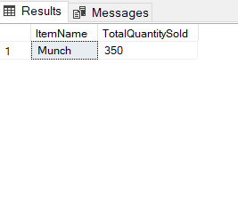

--Q1.4

SELECT

i.ItemName,

SUM(o.Unitprice * O.Quantity) AS TotalRevenue

FROM

OrderSalesDetails AS o

INNER JOIN Items AS i ON o.Itemid = i.Itemid

WHERE

DATEPART(MONTH,o.salesDate) = 10

GROUP BY

i.ItemName

HAVING

SUM(o.Unitprice * o.Quantity) > 10000

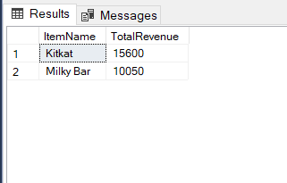

--Q1.5

SELECT TOP 1

S.Shopname,

SUM(o.UnitPrice * o.Quantity) AS TotalRevenue

FROM

Shop AS S

JOIN OrderSalesDetails AS o ON S.ShopId = o.ShopId

JOIN Items AS I ON o.Itemid = I.Itemid

WHERE

DATEPART(MONTH,o.salesdate) = 10

GROUP BY

S.ShopName

ORDER BY

TotalRevenue DESC

