CREATE TABLE Manufacturer(

MfName VARCHAR(30) PRIMARY KEY,

City VARCHAR(20),

State VARCHAR(20)

)

CREATE TABLE Employee(

EmployeeId INT PRIMARY KEY,

EmpName VARCHAR(30),

Area_code VARCHAR(10),

Phone VARCHAR(10),

Email VARCHAR(25)

)

CREATE TABLE Computer(

SerialNumber INT PRIMARY KEY,

Mfname VARCHAR(30),

Model VARCHAR(20),

Weights DECIMAL(4,2),

EmployeeId INT

CONSTRAINT fk_MfName FOREIGN KEY(Mfname)

REFERENCES Manufacturer(Mfname),

CONSTRAINT fk_Empid FOREIGN KEY(EmployeeId)

REFERENCES Employee(EmployeeId)

)

INSERT INTO Manufacturer (MfName, city, state)

VALUES

('Anu', 'south dakota', 'africa'),

('Manu', 'Kozhikode', 'india'),

('Sanu', 'Ernakulam', 'India');

INSERT INTO Employee (EmployeeId, EmpName, area_code, phone, email)

VALUES

(1, 'Asha', '412', '9846852510', 'asha@gmail.com'),

(2, 'Minnu', '226', '7576456332', 'minnu@gmail.com'),

(3, 'Ammu', '124', '8064536786', 'ammu@gmail.com');

INSERT INTO Computer (SerialNumber, Model, Weights, EmployeeId, MfName)

VALUES

(101, 'Model1', 8.5, 1, 'Anu'),

(102, 'Model2', 8.4, 2, 'Manu'),

(103, 'Model3', 10.7, 3, 'Sanu');

--Q1

SELECT MfName

FROM Manufacturer

WHERE city = 'South Dakota';

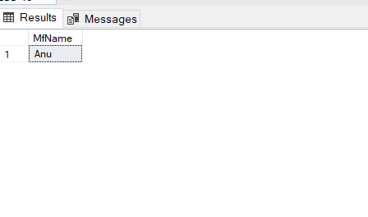

--Q2

SELECT AVG(Weights) AS 'average weight' FROM Computer;

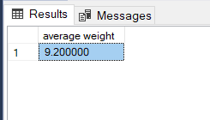

--Q3

SELECT Empname FROM Employee WHERE Area_code LIKE '2%';

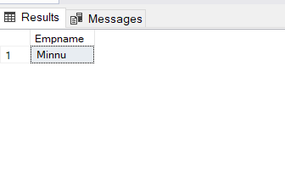

--Q4

SELECT SerialNumber

FROM Computer

WHERE weights < (SELECT AVG(weights) FROM Computer);

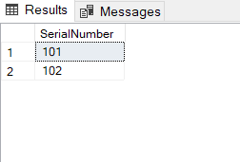

--Q5

SELECT MfName FROM Manufacturer WHERE MfName NOT IN (SELECT MfName FROM Computer)

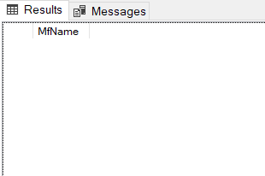

--Q6

SELECT e.EmpName, c.SerialNumber, m.City FROM Employee e

JOIN computer c ON e.EmployeeID = c.EmployeeID

JOIN manufacturer m ON c.MfName = m.MfName

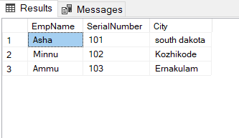

--Q7

CREATE PROCEDURE ComputerDetails

@EmployeeId int

AS

BEGIN

SELECT Computer.SerialNumber, Manufacturer.mfname, Model, weights

FROM computer

INNER JOIN employee ON Computer.EmployeeId = Employee.EmployeeId

INNER JOIN manufacturer ON Computer.MfName = Manufacturer.MfName

WHERE Employee.EmployeeId =@EmployeeId;

END;

EXEC ComputerDetails @employeeid=3

