**WEEK_3_Spring Core_Maven**

**Exercise 1: Configuring a Basic Spring Application**

**POM.XML**

<dependencies>

<!-- Spring Core -->

<dependency>

<groupId>org.springframework</groupId>

<artifactId>spring-context</artifactId>

<version>5.3.34</version>

</dependency>

</dependencies>

**BookRepository.java**

package com.example.Repository;

public class BookRepository {

public void saveBook(String bookName) {

System.out.println("Saving book: " + bookName);

}

}

**BookService.java**

package com.example.service;

import com.example.Repository.BookRepository;

public class BookService {

private BookRepository bookRepository;

public void addBook(String bookName) {

System.***out***.println("Adding book: " + bookName);

bookRepository.saveBook(bookName);

}

}

**LibraryManagementApplication.java**

package com.library;

import org.springframework.context.ApplicationContext;

import org.springframework.context.support.ClassPathXmlApplicationContext;

import com.library.service.BookService;

public class LibraryManagementApplication {

public static void main(String[] args) {

ApplicationContext context = new ClassPathXmlApplicationContext("applicationContext.xml");

BookService bookService = context.getBean("bookService", BookService.class);

bookService.addBook("The Alchemist");

((ClassPathXmlApplicationContext) context).close();

}

}

**OUTPUT:**

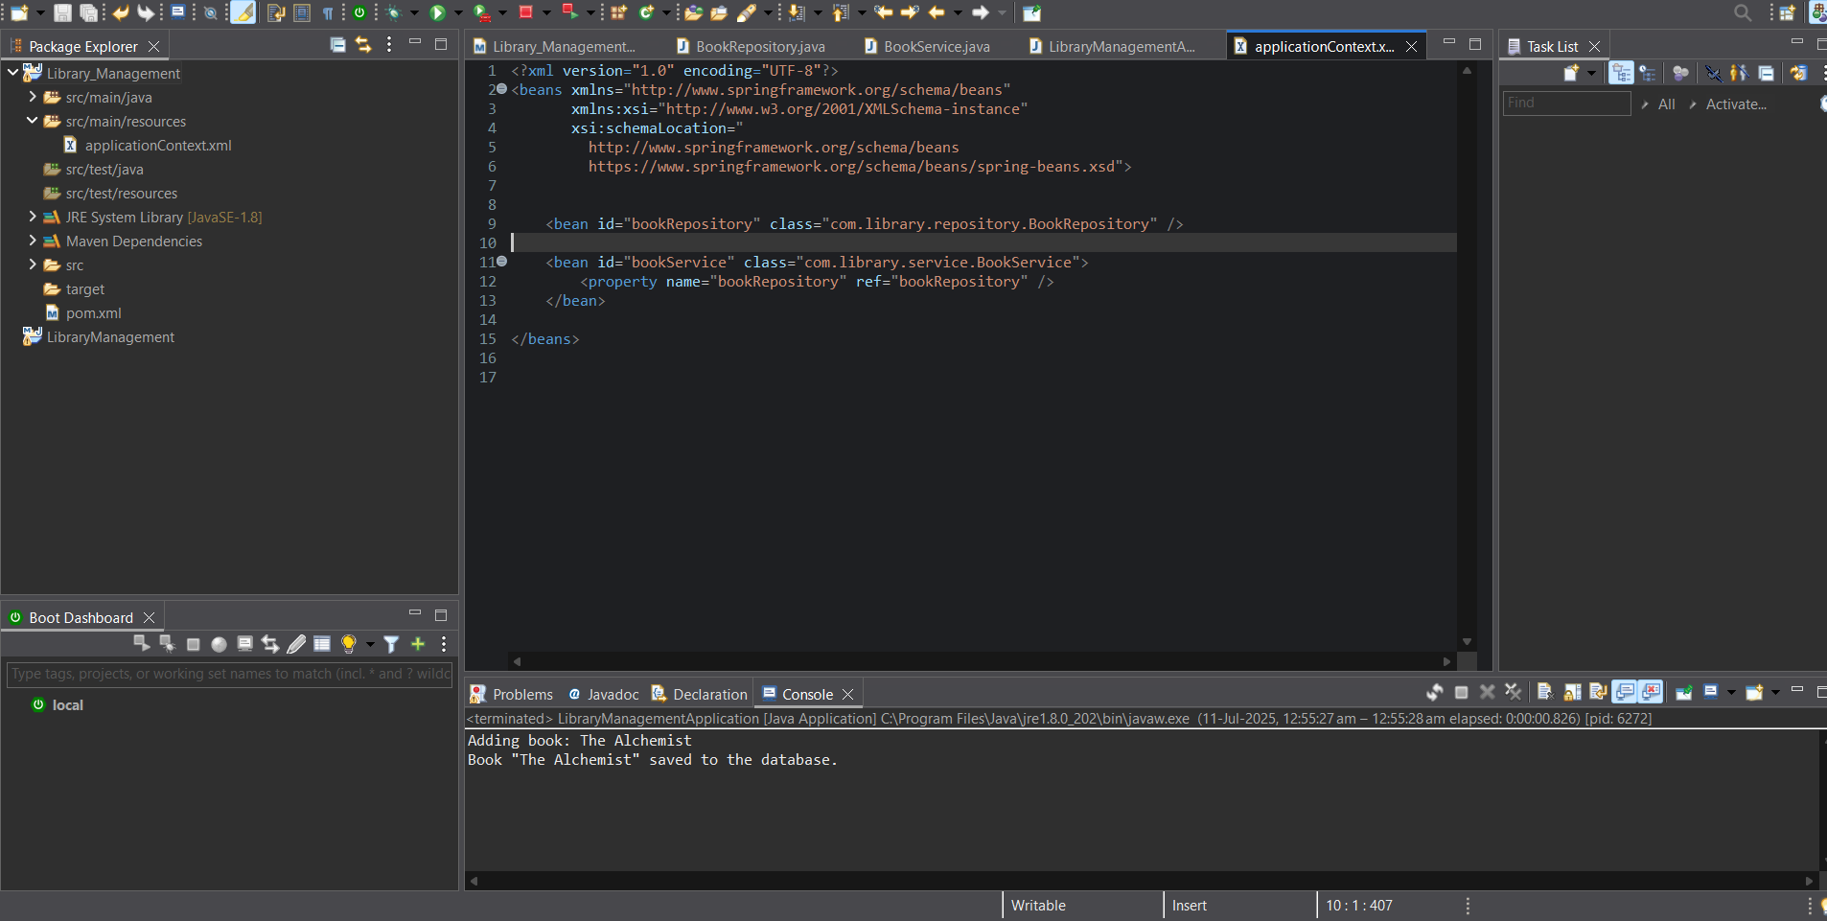

Exercise 2: Implementing Dependency Injection

**POM.XML**

<dependencies>

<!-- Spring Core -->

<dependency>

<groupId>org.springframework</groupId>

<artifactId>spring-context</artifactId>

<version>5.3.34</version>

</dependency>

</dependencies>

**BookRepository.java**

package com.example.Repository;

public class BookRepository {

public void saveBook(String bookName) {

System.out.println("Saving book: " + bookName);

}

}

**BookService.java**

package com.example.service;

import com.example.Repository.BookRepository;

public class BookService {

private BookRepository bookRepository;

//for dependency Injection

public void setBookRepository(BookRepository bookRepository) {

this.bookRepository = bookRepository;

}

public void addBook(String bookName) {

System.***out***.println("Adding book: " + bookName);

bookRepository.saveBook(bookName);

}

}

**LibraryManagementApplication.java**

package com.library;

import org.springframework.context.ApplicationContext;

import org.springframework.context.support.ClassPathXmlApplicationContext;

import com.library.service.BookService;

public class LibraryManagementApplication {

public static void main(String[] args) {

ApplicationContext context = new ClassPathXmlApplicationContext("applicationContext.xml");

BookService bookService = context.getBean("bookService", BookService.class);

bookService.addBook("The Alchemist");

((ClassPathXmlApplicationContext) context).close();

}

}

OUTPUT:

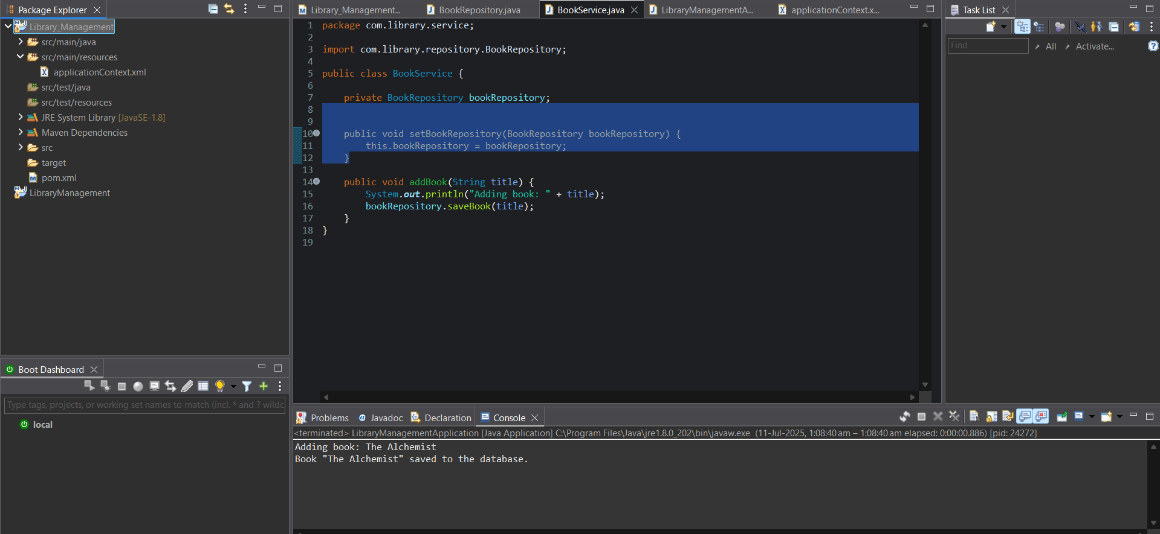

**Exercise 4: Creating and Configuring a Maven Project**

**POM.XML**

<project xmlns="http://maven.apache.org/POM/4.0.0"

xmlns:xsi="http://www.w3.org/2001/XMLSchema-instance"

xsi:schemaLocation="http://maven.apache.org/POM/4.0.0

http://maven.apache.org/xsd/maven-4.0.0.xsd">

<modelVersion>4.0.0</modelVersion>

<groupId>com.library</groupId>

<artifactId>Librarymanagements</artifactId>

<version>0.0.1-SNAPSHOT</version>

<packaging>jar</packaging>

<name>Librarymanagements</name>

<url>http://maven.apache.org</url>

<properties>

<project.build.sourceEncoding>UTF-8</project.build.sourceEncoding>

</properties>

<dependencies>

<dependency>

<groupId>junit</groupId>

<artifactId>junit</artifactId>

<version>3.8.1</version>

<scope>test</scope>

</dependency>

<dependency>

<groupId>org.springframework</groupId>

<artifactId>spring-context</artifactId>

<version>5.3.27</version>

</dependency>

<dependency>

<groupId>org.springframework</groupId>

<artifactId>spring-aop</artifactId>

<version>5.3.27</version>

</dependency>

<dependency>

<groupId>org.springframework</groupId>

<artifactId>spring-webmvc</artifactId>

<version>5.3.27</version>

</dependency>

</dependencies>

<build>

<plugins>

<plugin>

<groupId>org.apache.maven.plugins</groupId>

<artifactId>maven-compiler-plugin</artifactId>

<version>3.8.1</version>

<configuration>

<source>1.8</source>

<target>1.8</target>

</configuration>

</plugin>

</plugins>

</build>

</project>

**OUTPUT:**

